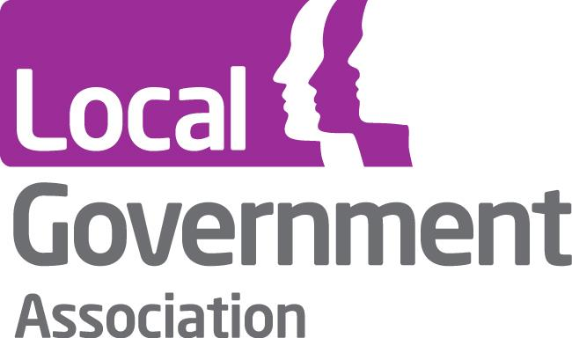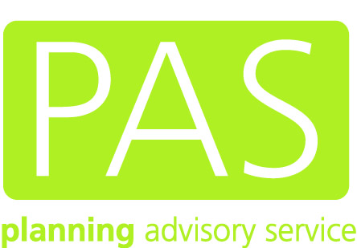

Strategic Planning in Coastal West Sussex and Greater Brighton

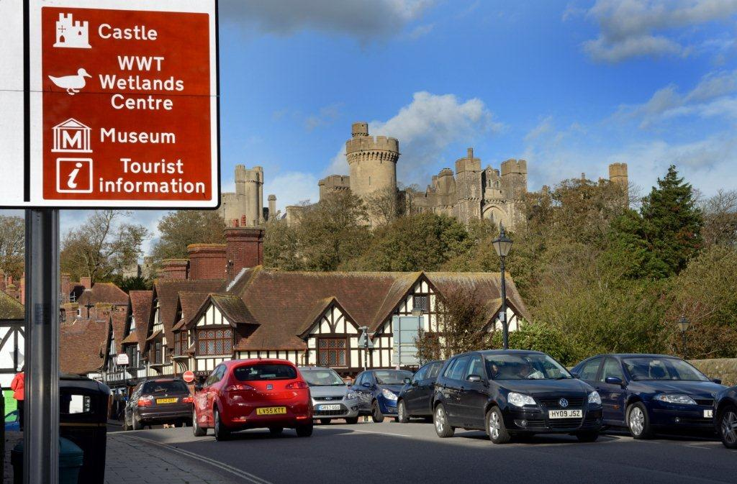

Introduction
The local planning authorities (LPAs) in Coastal West Sussex and Greater Brighton (CWS&GB) recognised the need to have a joint approach to strategic planning, following the revocation of the South East Plan. Their response was to get together and produce a Local Strategic Statement (the Statement) (October 2013). This non-statutory document aims to provide a strategic planning and investment framework for the area and to help demonstrate at local plan examinations that the authorities have satisfied the duty to cooperate. Its coverage reflects the Coastal West Sussex Housing Market Area.
This case study sets out the evolution of the Statement and the implications for strategic and local planning in CWS&GB and potentially in the wider area.

Why was the Local Strategic Statement needed?
The Statement was seen as an important mechanism for the LPAs to manage strategic issues as well as forming evidence on the duty to cooperate.
With most of their towns and cities sandwiched between the English Channel and the South Downs National Park, which itself covers most of the area , the LPAs in CWS&GB face significant constraints to their future growth. This had been recognised in the South East Plan which had discounted objectively assessed needs by 30% to recognise natural constraints. All the LPAs agreed that a joint approach was needed on planning across the area and one of the most important outcomes of the process has been the joint agreement of the parties on what ‘sustainable growth’ means for the area, and what the short, medium and long term priorities are.
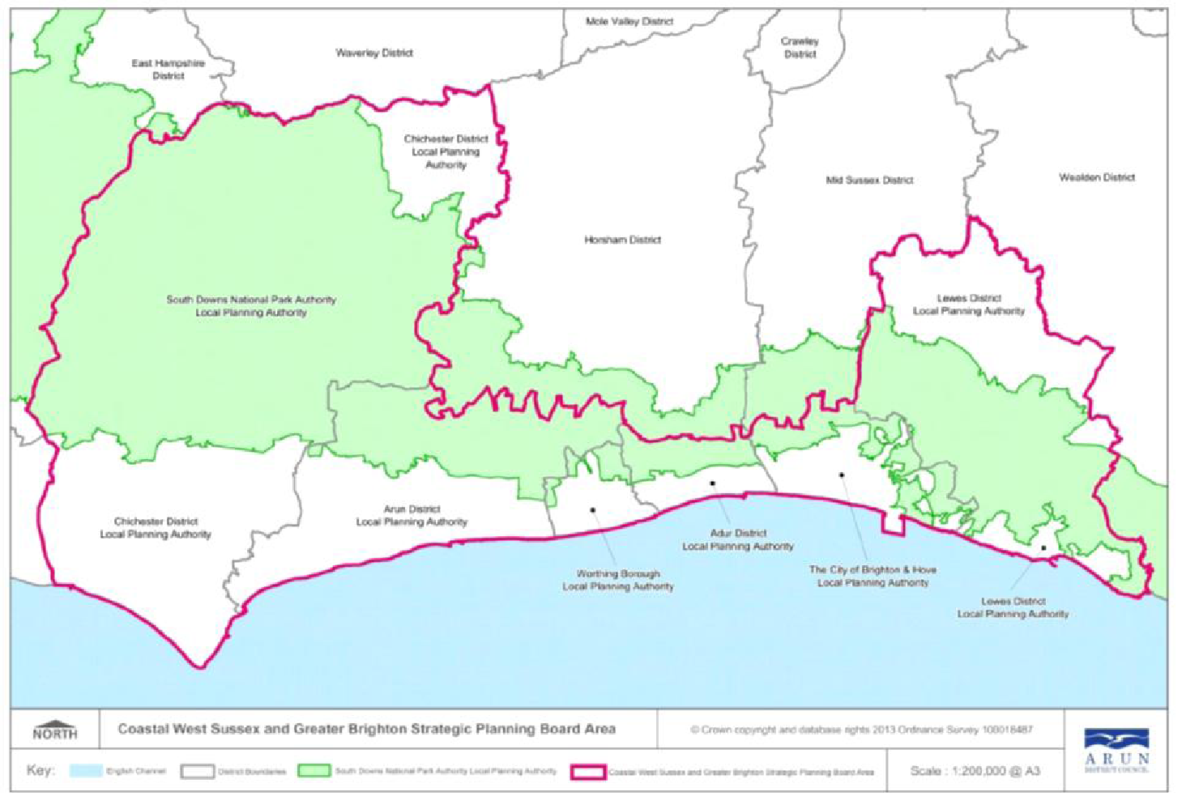

The Statement provides:
- a framework to help integrate and align the investment priorities and plans of public and private sector bodies, including the Local Economic Partnership (LEP);
- a clear set of priorities for funding opportunities; and
- a mechanism for contributing to and coordinating work on strategic planning and economic activity in the wider area.
Caroline Wood, Director of the Coastal West Sussex Partnership, said: “The Statement is more than just being about housing numbers. As well as strengthening partnership working, the spatial priorities have provided a building block for inclusion in Coast to Capital LEP’s Strategic Economic Plan.”
James Appleton, Executive Head of Planning Regeneration and Wellbeing at Adur and Worthing, agrees: “The Statement goes beyond housing to economic development and jobs. It will improve our position in terms of fighting for resources and funding through the LEP.”
Ian Parkes from the Coast to Capital LEP states that “Setting out in the Statement specific priorities for investment in the coastal area has been very helpful.”
How was the Statement developed?
Working across boundaries on strategic planning matters is not new territory for these LPAs. There is a long history of joint working through the South East Plan’s Sussex Coast Sub-Regional Strategy.
The Statement was managed by the CWS&GB Strategic Planning Board (the Board), which includes the LPAs of Adur, Arun, Brighton & Hove, Chichester, Lewes, Worthing, and the South Downs National Park, plus West Sussex County Council. It grew out of the work of the long-standing Coastal West Sussex Partnership (the Partnership). This economic partnership brings together leaders from business and the public sector to work together to strengthen the coastal economy. Although there is no formal relationship between the Partnership and the board, they work very closely together; a few Members attend both and the Chair of the Board will be invited to join the CWS Partnership Board.
The Partnership commissioned an Employment and Infrastructure Strategy (February 2012). This recommended that, for a ‘place-based’ approach across the area, more formal joint working arrangements would be needed.
In response, after a study into governance arrangements, the LPAs established, in October 2012, the Board to work in parallel with the Partnership. It comprises lead members from each of the LPAs, usually those with a planning portfolio. It is advisory only as decision-making remains with the individual bodies. It has agreed Terms of Reference and a Memorandum of Understanding between its members. The Board’s remit is to:
- identify and manage spatial planning issues that impact on more than one local planning area; and
- support better integration and alignment of strategic spatial and investment priorities, ensuring that there is a clear route through the statutory local planning process.
In January 2013 the Board agreed that a new framework was needed to guide strategic planning decisions, the Local Strategic Statement. All authorities wanted the Statement to:
- have a direct influence on individual local plans
- highlight the strategic challenges along the coast, with possible ways of addressing these.
- be ‘evidence-based’ and
- be deliverable, with importance attached to the need for a delivery plan.
A vital part of the evidence for the Statement was an assessment of the area’s housing needs and potential barriers to delivery. The ‘Duty to Cooperate Housing Study’ was commissioned by Arun DC on behalf of all the LPAs and all LPAs paid towards its cost.
The study critically reviewed the objectively assessed needs for each LPA. It concluded that:
- the area is highly constrained due to being tightly bound by the English Channel and the South Downs National Park; and
- meeting its housing needs will become increasingly challenging.
The Statement was prepared by an independent consultant, working with the Board’s strategic planning officers’ group. The consultant, Catriona Riddell Associates, provided the Board’s members with a broader context and helped them to understand that the importance, relevance and content of the Statement. An external consultant was used in order to provide the necessary resource, speed, expertise, and most importantly impartial advice.
The Statement was developed between January and October 2013. Three workshops were held, one with stakeholders and the other two with politicians, involving planning and economic development portfolio holders. It was widely consulted on and, given its spatial and infrastructure dimensions, includes a Sustainability Appraisal.
The models for the Statement were the Cambridgeshire Partnership and, more locally, the Gatwick Diamond Statement. Catriona Riddell sees the differences from the other strategies as being that this Statement:
- is more spatially specific;
- includes strategic place-based delivery plans, including working with the Partnership/ LEP and the new funding mechanisms in a delivery and investment framework which is being developed with the CWS Partnership; and
- is more evidence based.
Karl Roberts, Assistant Director at of Planning & Economic Regeneration at Arun, is very clear that without the Board, the Statement would not have been developed so quickly. Karl also felt that having an independent outside voice in the consultant was important in gaining member buy-in: “The input of the consultant was influential in painting a picture of what was needed”.

What does the Statement say?
The Statement sets out a shared vision, four overarching Strategic Objectives for the period 2013-2031 and five Spatial Priorities for delivering these in the short to medium term (2013-2020), based on the ‘place-based’ approach. The Strategic Objectives are:
- Delivering sustainable economic growth
- Meeting strategic housing needs
- Investing in infrastructure
- Managing environmental assets and natural resources
As a result of the Statement, the LPAs:
- acknowledge the clear challenges in relation to infrastructure and pressures on land supply.
- are working together, through their own local plans and strategies, to try to meet their objectively assessed needs in the short to medium term.
- are working closely with authorities in the wider sub-region to consider longer term options for meeting needs.
- will use this work to inform the current and next round of local plan reviews.
Karl Roberts comments that: “The Statement is not ‘mother hood and apple pie’, but so far it is more aspirational than concerned with the detail of schemes. It has been better to get agreement on something rather than going too far and get nothing. Half of nothing is still nothing.”
Mike Holford (Strategic Planning and Monitoring Manager at Brighton and Hove) agrees that the need to find a consensus was challenging in an area which is very diverse geographically (a very large urban area to more rural areas) and politically (Brighton & Hove is the only council that is not conservative controlled). This meant that there had to be compromises over the Statement.
What issues were addressed along the way?
In order to achieve consensus the process was seen as a series of incremental steps in joint planning by the LPAs, rather than big bang decisions taken by the Board. The remit of the Board has been agreed by all councils but it is not the Leader of the Council (in most cases) or Chief Executive who sit it. As a result the fledgling voluntary board needs to ensure it retains the faith of its constituent authorities. There has been very little disagreement at the meetings of the Board but there has been robust debate and healthy nomination pitches for the chairmanship. The Board has handled tricky issues such as Gypsy and Travellers and the objectively assessed need for housing and has based prioritisation on the reality of evidence in terms of the state of readiness for projects to go forward.
Members were very much involved in decisions about the Statement and played a strong scrutiny role. Arun councillors challenged the housing study findings, using their own consultants to check the figures; eventually, however, they were accepted.
The geographical coverage of the Board, and therefore of the Statement, has been an area of discussion. Initially the Board comprised just the West Sussex authorities and the National Park Authority. Brighton and Hove City Council was included following the Brighton City Deal bid (also covering Lewes (within East Sussex), Adur and Worthing). Lewes DC were invited as observers, but later included as full members, reflecting functional geography as well as the Coast to Capital LEP.

Mike Holford was “pleasantly surprised” that there had been no dispute at officer level - “it all went incredibly smoothly”. There was also political agreement that the housing requirement could not be met, although less so on what to do about it in the long term.
Ian Parkes welcomed the role of the Statement in this respect: “On the vexed issue of housing, what was great about the Statement was that it set out what further housing numbers could be achieved if specific infrastructure blockages were dealt with. That meant we could then bid for growth funding for the transport and land assembly projects.”
What resources were required?
There was not a great deal of new expenditure on the Statement because the strategic work was required by the LPAs for developing their individual local plans. Simon Meecham, who chaired the strategic officers group, commented that “We did the work smarter and more efficiently and this has helped us to build a shared evidence base for the sub-region’’

Arun took a lead role and the organisational support provided by the Coastal West Sussex Partnership was crucial. Karl Roberts commented: “There is only one board meeting per quarter but even getting that organised is demanding. We would have struggled without the small Partnership team doing the minutes and organisation”.

Caroline Wood commented: “It is always challenging to get people to put in work outside their ‘day job’, but in this case it worked well because it was building on work that the chief planning officers had already started. The Employment and Infrastructure study was a relatively small piece of work, costing just £5,000 shared between the Partnership and the County Council and commissioning a consultant to work on the Statement was also good value for money.”
James Appleton commented that both his members felt the exercise had been good value for money, while Mike Holford observed that Brighton and Hove had already been proposing to do something along these lines. Pooling resources therefore made sense.
What is the status of the Statement?
The agreement of projects in the Statement has helped to underpin their inclusion in Local Plans, CIL schedules, planning applications and bidding documents.
The Statement is not a Development Plan Document but is now the key sub-regional framework for the LPA’s. It is also a material consideration in planning applications and will form a strategic context for local plans, depending on where they are in the process. It is to be referred to in the submission Local Plans for Chichester, Arun and Lewes/ South Downs (a joint strategy) and as context for the emerging South Downs National Park Local Plan. It was used in evidence at the Examination into the Brighton Local Plan but at that stage was only in draft. Inspectors will consider the weight to attach to it when further plans are examined, but Simon Meecham (Head of Planning Policy and Conservation at Arun) reports that “a senior Inspector was impressed by the Statement and believes it will demonstrate that Arun have met the duty to cooperate”.
Mike Holford believes that the Statement partly fills the gap left by the demise of the South East Plan but tends to reflect what is in the local plans rather than direct them. James Appleton said that the Statement helped them to understand the wider picture for the Adur Local Plan, and would assist with the review of the Worthing Core Strategy. However both recognise the problems of local plans being at different stages and of the ever-changing demographic projections, which could be used by developers to increase housing figures that have not been ‘fixed’ through a statutory process.
Karl Roberts described how the Statement has recently been used as a material consideration in a planning application for dwellings at Nyton Road, Westergate. Officers had negotiated a contribution towards highways improvements, but needed to hang this off an approved policy. Since the Arun Local Plan has not yet been submitted, the Statement was used instead as a material consideration. Counsel for the applicant had a different view on this, but this was not in the end tested because the application was refused against officers’ recommendation.
Both Mike Holford and James Appleton see the Statement as having a role in supporting proposals for major development, such as that at Shoreham Harbour, although the weight it will have in resisting development on other sites might be limited.
What are the next steps?
The next step is to deliver the programme and monitor the framework. Key tasks are:
- Prioritisation of strategic sites
- Resolving long term housing land needs
- Targeting of investment – what infrastructure is needed, where
A Monitoring Framework and Delivery and Investment Framework (DIF) for the statement are being developed to support its implementation and ensure local plan policies arising from the agreed strategic priorities remain viable and can be delivered. Once the Delivery and Investment Framework is in place, it will assist the Partnership and the LEP in bidding for funds to help facilitate both employment and housing development in the short to medium term.
One issue to address in the future relates to the parts of West Sussex outside the Coastal strip. Mid Sussex (part of the Gatwick Diamond LSS) was found not to have met its duty to cooperate in relation to CWS & GB. As a consequence the scope of the Statement might be widened in future to include the rest of West Sussex, or even further. For now, however, all participants feel that the current geography is best basis for the Statement.
Conclusions: What lessons were learned?
The process has moved very quickly in just over one year and is viewed by all involved as a positive outcome of joint working. Some key reasons for success are:
- It has built on existing structures for joint working at officer level.
- It has established an effective Member group to address difficult political issues.
- It has been realistic in its aims (e.g. ‘possible ways’ to address strategic challenges)
- It has used an incremental process which respects individual authority, in order to achieve consensus.
- Most of the LPAs are under the same (Conservative) political control, with the exception (the Green Party in Brighton and Hove) adopting a consensual approach.
- It has made use of a very strong working relationship between the local authorities and the economic partnership.
- The input of a jointly funded external consultant, who has brought resource, speed, knowledge but most importantly an independent perspective to the process.
- The group has been flexible and evolved to reflect functional geography and alliances.
- It has not been over-ambitious but has been specific enough to enable priorities to be set through the DIF and the LEP Strategic Economic Plan.
- Even where the Statement has been questioned by some parties this has been done in an objective, evidence based way.
- It has had a high level support and commitment from senior officers who have committed significant time and resources to the work from existing highly constrained budgets.
In future there is a need to work out how it can go on to being part of the core work programme, with proper allocation of resources. The Statement must become part of the ‘day job’.
There was a consensus amongst all parties that the Statement has been worthwhile. Karl Roberts comments that the Statement proves that authorities can come together to work collaboratively in the absence of specific guidance, exactly as the Government has been encouraging.
All parties recognise that there are still difficult issues, such as long-term housing growth and where it will go, to be addressed. Roberts commented that “The Statement was sticking a foot in the door. It will now be easier to push the door open slightly”.
But its value goes wider than just ticking the duty to cooperate box and addressing housing numbers. It is seen as an important tool in helping deliver the infrastructure required to enable economic as well as housing growth in this highly constrained part of the country.
In Catriona Riddell’s view the area displays one of the closest relationships between an economic partnership and local authorities; the Partnership has been an integral part of the development of the Board and the Statement and will also be key in ensuring its delivery through the DIF and links to the LEP.
Ian Parkes from the LEP observed: “There is pressure on us to collaborate on strategic issues across boundaries. This is a very good example of joint working. It will be used in the Strategic Economic Plan as evidence to demonstrate cross-boundary working.”
Caroline Wood reflects the views of all that the Statement should continue: “This has been a worthwhile process but we are only at the beginning of it. It can be made more effective by giving the joint bodies more authority and greater autonomy in the future. Then they can start making a real difference.”

