LGA/DCLG Business Rates Retention Steering Group paper – 3 October 2017
Issue
- To deliver an update to the Steering Group on the Fair Funding Review.
Update since the election
- Since the Queen’s Speech, DCLG Ministers have pledged continued commitment to the Fair Funding Review to address concerns about the current methodology for determining councils’ relative funding needs at LGF settlements. The Review’s outputs will not require legislation in order to be implemented.
- After discussion with DCLG Ministers, the Review is working to 2020/21 as a potential date for implementation. Although still under consideration, there would be several reasons for doing this:
  - The Review is exploring a single formula approach and a service-specific approach in tandem. 2020/21 would allow us to complete a research exercise which would unlock multi-level modelling as a statistical technique for measuring relative need for Children’s services. This is discussed below.
  - The election has impacted the Review’s original timetable. 2020/21 allows for more time to consult with local government on certain key decisions, and ensures the new methodology is informed by sufficient engagement with the sector.
  - It may better align with the current Spending Review cycle including the current multi-year LGF settlement.
  - It would allow the Review to factor the latest data update to the Index of Multiple Deprivation, which may be the optimal way of adjusting funding allocations for relative levels of deprivation. It is updated every few years and the next is due in summer 2019.
- A potential timeline to 2020/21 can be found at Annex A.

Progress since February
- At the last update to the Steering Group in February we summarised the responses to last year’s Call for Evidence and recapped recent agenda items from the Needs and Redistribution technical working group (TWG), which were based around cost drivers and how to measure relative need.

- Since then the Review has:
- responded to representations made to the Call for Evidence by confirming a set of principles which will guide its work across three areas: measuring need, treatment of resources, and approach to transition,
- continued engagement with local authorities to test ideas and opinions,
- reengaged the TWG to make progress on the ‘need’ and ‘resources’ workstreams, including:
  - a summary of the analytical options appraisals DCLG is conducting for developing a single formula approach as well as service specific approaches,
  - the methodologies available for adding an ‘Area Cost Adjustment’ to funding allocations to reflect factors such as local labour costs,
  - papers on how to factor rurality and deprivation in funding formulas, and
  - a paper scoping the issues surrounding how to make a fair adjustment for relative ability to raise income through council tax and as well as through sales, fees and charges.
- The Review’s guiding principles can be found at Annex B.
Children’s services research
- DCLG and the Department for Education are launching a project to carry out a large data collection exercise on Children’s services at a low geographical level.

- The aim is broadly twofold: to keep open the option of a service specific approach to Children’s services which deploys multi-level modelling – possibly the most robust statistical technique available; and gather useful data on cost and demand pressures in the sector.

- The programme will be scoped in full once a provider is appointed; however our current expectation is that it will be completed in the summer of 2019.

- A multi-level model would address concerns that simple regression models using past expenditure data do not capture the underlying demand for certain services. This technique would use small area data to understand how different characteristics which drive the need to spend affect the amount spent on different areas within local authority boundaries (such as rural or non-rural). It therefore determines the weightings of cost drivers and thus local authority allocations independent of the level of funding the authority has received in the past. We will circulate a summary note to the Needs and Redistribution technical working group in due course.

- Once a provider is appointed, we will assist them to develop an engagement plan to find a representative selection of local authorities to be involved with the project. We would welcome input from the Steering Group and TWG to manage that process.

Forward look
Consultation on relative need
- DCLG aim to publish a technical consultation on relative need later this autumn. It will set out principles and the framework for future progress before seeking sector response to questions on the following key areas:

- An overview of potential future approaches,
- the ‘common cost drivers’ for local government, identified through earlier engagement with the TWG and wider sector, as the basis for a foundation formula,
- the potential ‘service specific cost drivers’ for local government to supplement the foundation formula, also identified through engagement with the sector as well as other Government departments, and
- the potential statistical methodologies that could be used to ‘weight’ funding formulas and cost drivers, including expenditure-based regression, multi-level modelling and others.

- This is an opportunity for local government to tell us what the biggest drivers of spending are which need to be reflected in future funding distributions, and we encourage authorities to ask service managers from across the organisation to input into a response.
Technical working group
- The TWG is due to discuss the following DCLG items over the next few months:

- an options appraisal paper for how to develop a single or foundation formula,
- an update on the Review’s progress on relative resources, including possible approaches to Local Council Tax Support, and
- an overview of the findings of the Review’s smaller work strands looking at the best options for constructing formulas for certain specific services.
Technical papers
- Officials are continuing to update Ministers on the Review’s progress. From Spring next year, this will lead to a planned series of published technical papers which would look in more detail at key issues of the Review for the wider local government sector, and others, to respond to. These papers would be informed by engagement with the TWG, and we would seek to commission input from members. Although still to be decided, they could include:

- how to adjust LGF settlement funding allocations for councils’ relative ability to raise local income, including council tax,
- principles and methodologies for how to transition to new funding baselines upon implementation, and
- aspects of measuring relative need such as the approach to deprivation or rurality.

- These papers will offer another way for the sector to shape the outcome of the Review as we continue to target a fair and collaborative methodology.

Annex A - potential timetable to 2020/21 implementation

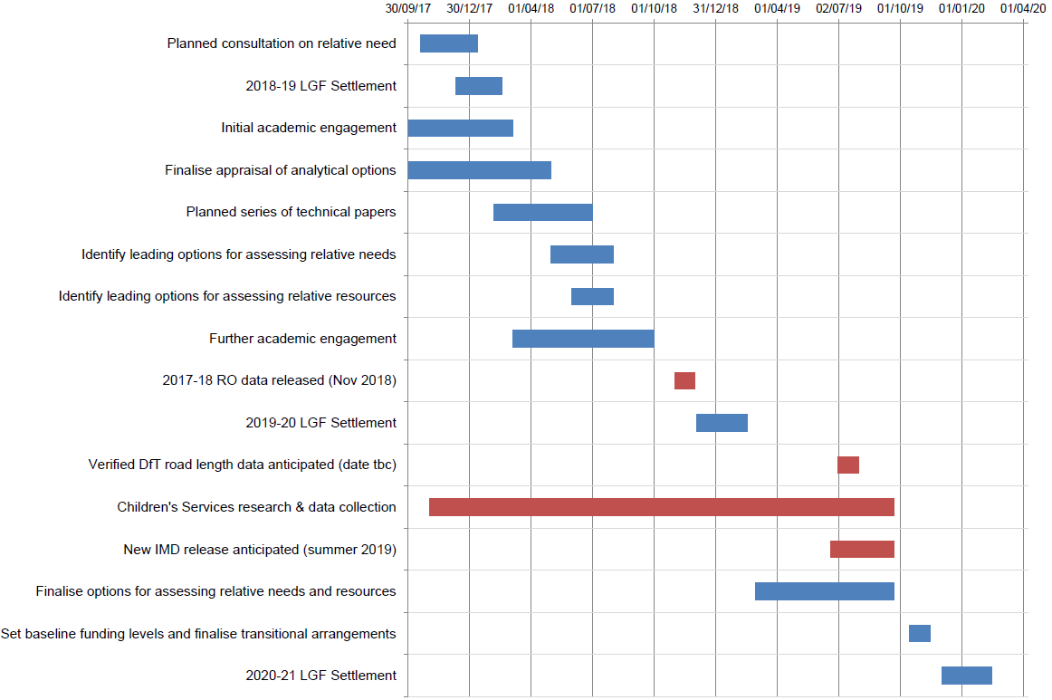

Annex B - Guiding principles for the Fair Funding Review
Last year the Review published a Call for Evidence which received 209 responses including 179 from local authorities. It included 14 questions that were designed to explore respondents’ views on the key issues that the Fair Funding Review will need to address: how to measure relative needs, how resources should be taken into account, the approach to transition and the geographical level at which need should be assessed.
We received a wide range of views on these important questions. A summary of these responses and the Government’s response to these issues will be published alongside a further technical consultation.
Based on the responses received to this Call for Evidence the Government has identified a set of principles to guide the work of the Fair Funding Review. These represent the framework which the Government will use in designing a new relative needs assessment methodology, having considered the responses to this consultation:
- Simplicity – the overall number of formulas used within the current methodology, along with the layers of complexity contained within them, means that they are little understood and may no longer hold the same relevance as when they were introduced. This Review is an opportunity for bold, clear thinking to identify the most important factors that drive the ‘need to spend’ on local services, and is aiming to produce a relative needs assessment that is as simple as is practicable,

- Transparency – it should be straightforward for those affected by the relative needs assessment to understand what factors have influenced the levels of funding received by a local authority so that they can hold their local representatives to account for the decisions that they make. To support this we will make the link between local circumstances and funding allocations more visible,

- Contemporary – the new relative needs assessment will be based on the most up-to-date data that is available. To facilitate more frequent updates, as far as practicable the funding formula will be based on data that can be regularly updated at planned intervals. If the collection of data or other technical requirements mean that desirable changes cannot be made when the Review is implemented, the Government will consider whether and how to phase these in at a later date whilst providing councils with financial certainty,

- Sustainability – an evidence-based approach will be deployed to identify the factors which drive costs for local authorities today and in the future. The new funding formula must, as far as is practicable, anticipate future demand for services,

- Robustness - the new funding formula should take into account the best possible objective analysis, and

- Stability – the funding formula should support predictable, long-term funding allocations as part of a multi-year settlement. Local authorities’ long-term financial planning and service delivery will also be assisted by temporary transitional arrangements to their new relative needs baseline to ensure there are no undue year-on-year changes in funding.

