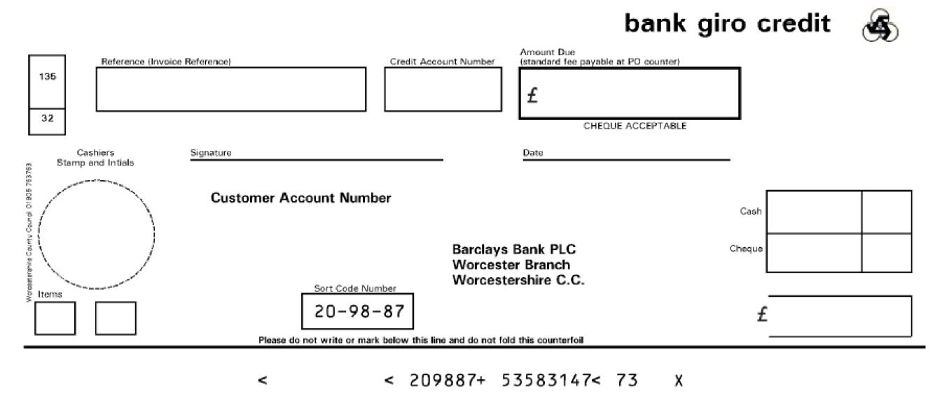

xxxx

xxxx

XXX

xxxx

xxxx

Bacs Payments to Sort Code xxxxxx - Account xxxxxxxx. Please Quote your Invoice Reference on All Payments. Please submit payment promptly in accordance with our payment methods overleaf. Remittance Advices should be sent to email address

VAT Reg No: GB 705 6721 42

Email: payadultsocialcare@worcestershire.gov.uk

Invoice Reference: xxxx

Customer Account Number: xxxx

Invoice Date/Tax Point Date: xxxx

Payment Due Date: xxxx

Your Reference: xxxx

**Every penny you pay goes back into providing your care. Each day care workers pay thousands of visits and deliver thousands of hours of care arranged by Worcestershire County Council for Worcestershire residents who need it most.**

Jean Smith

123 Letsbe Avenue Worcesershire

WC1 123

**Please note if payment is not received by the payment due date shown above we reserve the right to charge interest and administration costs**

**YOUR CARE SERVICE INVOICE**

For enquiries please contact:

**You pay**

**SUB TOTAL**

**VAT TOTAL**

**INVOICE TOTAL**

**238.24**

**0**

**238.24**

**1.0**

**0**

**238.24**

**238.24**

**Price**

**VAT**

**Net amount £**

**Quantity**

Social Care Payee Reference 200239631: Fairer Charging billing to service users

FAIRER CHARGING NON RESIDENTIAL As detailed on Invoicing Advice Doc Ref 3982262

Xxxxx xxxx xxx

**Press**

**Option 4**

**Description**