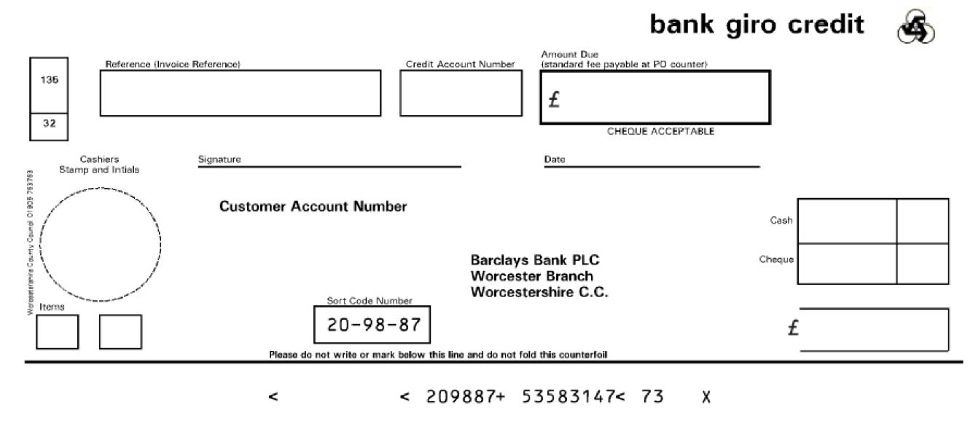

xxxx

xxxx

XXX

xxxx

xxxx

VAT Reg No: GB 705 6721 42

Email: payadultsocialcare@worcestershire.gov.uk

Invoice Reference: xxxx

Customer Account Number: xxxx

Invoice Date/Tax Point Date: xxxx

Payment Due Date: xxxx

Your Reference: xxxx

**Please note if payment is not received by the payment due date shown above we reserve the right to charge interest and administration costs**

**We have paid your care providers to ensure access to your care continues without change. As per our agreement, your contribution to pay this month is: xxx**

**YOUR CARE SERVICE INVOICE**

Jean Smith

123 Letsbe Avenue Worcesershire

WC1 123

For enquiries please contact:

**You pay**

**SUB TOTAL**

**VAT TOTAL**

**INVOICE TOTAL**

**238.24**

**0**

**238.24**

**1.0**

Bacs Payments to Sort Code xxxxxx - Account xxxxxxxx. Please Quote your Invoice Reference on All Payments. Please submit payment promptly in accordance with our payment methods overleaf. Remittance Advices should be sent to email address

**0**

**238.24**

**238.24**

**Price**

**VAT**

**Net amount £**

**Quantity**

Social Care Payee Reference 200239631: Fairer Charging billing to service users

FAIRER CHARGING NON RESIDENTIAL As detailed on Invoicing Advice Doc Ref 3982262

Xxxxx xxxx xxx

**Press**

**Option 4**

**Description**