Payments and Client Charging Team
Adult Services and Health Directorate
County Hall, Spetchley Road, Worcester WR5 2NP
Date: xxx
Email: payadultsocialcare@worcestershire.gov.uk

Dear xxx
Please find enclosed your first invoice and billing advice for your personal care.
We have paid your care providers to ensure access to your care continues without change. As per our agreement, your contribution to pay this month is: xxx

Xxxxx xxx xxx
Press
Option 4
Customer Account Number: xxx
Invoice Reference: xxxx
Payment Due Date: xxx
You owe: xxx

Have this information to hand when contacting us or making a payment:

Next steps
Please pay your invoice in 2 easy steps:

CHECK your invoice.

CHOOSE your preferred payment method found on the back of your invoice, and pay this month’s contribution.

Many residents receiving care in their home also find that Direct Debit is the easiest and safest way to pay each month. To set-up your Direct Debit, please contact us on xxxxx xxx xxx. As we cannot collect an invoice by Direct Debit until it has been set up, the enclosed invoice should be paid by an alternative payment method. These are detailed on the reverse of your invoice.

It’s not possible for me to pay this invoice
We want you to continue receiving the best possible care in your home. So if you are having trouble making payments, don’t panic. Call us on our helpline xxxxx xxx xxx to speak to a friendly advisor. We are open: Monday to Friday 8:30am • 5:00pm. Lines are usually least busy between 2pm-3pm.
Yours sincerely,
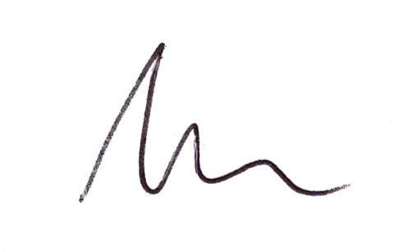
Ashley from your Payments and Client Charging Team

www.worcestershire.gov.uk
Please recycle this item after use

