Scoping report

LGA Behavioural Insights Programme:

Reducing energy usage among homeowners consortium

September 2022

Table of Contents
Project aim and the purpose of the scoping report 1
Project timeline 1
Background and context 1
Scoping research 2
Residential survey 2
Review of existing literature 2
Expert interviews 2
Residential survey: selected findings 3
Research phase: selected findings from the residential survey 3
Research phase: selected findings from the residential survey 4
5
Research phase: barriers and enablers associated with reducing energy usage 5
Barriers 5
Enablers 7
Behavioural trial design phase: overview 8
The three interventions 8
‘Share the Warmth’ Kent challenge 8
Neighbourhood challenge 8
‘How-to’ clips with real-life people 9
Behavioural trial design phase: selected intervention 9
Share the warmth 9
The intervention consists of: 9
An online training and goal-setting platform. 9
Reminder emails. 9
Follow-up survey. 10
The messenger effect 10
Randomised elements 10
Intervention delivery channels 10
Outcomes and impact measurement 10
Next steps 11

Project aim and the purpose of the scoping report

The Behaviouralist was commissioned by the LGA to (1) design and scope a behavioural insights trial to reduce energy usage amongst low to middle income residents in Kent and to (2) provide training via monthly workshops to nine participating councils and the NHS team to develop their ability to apply behavioural insights across their work.

The purpose of this scoping report is to provide insights from the work conducted during the research and behavioural trial design phases. We also discuss the feasibility of delivering an impactful and evidence-led research project with the consortium of councils from Kent. The contents of this scoping report do not represent the final plan for the project.

Project timeline

- July 2022: Project kick-off
- August 2022: Conduct research
- September 2022: Design behavioural trial
- October to December 2022: Trial launch
- January to March 2023: Learn, adapt and scale.

Background and context

With the global increase of energy prices, councils across the UK are faced with the behavioural challenge of supporting large numbers of residents in the acquisition of practices that will reduce their energy-related costs. The UK has already seen an increase of more than 50 per cent of the share of households in fuel poverty in just over six months, as of the start of April 2022 (See the NEA website). In addition, the consortium of local councils in Kent are anticipating a rising demand for advice regarding energy reduction as well as an increase in complaints due to the limited support and funding available.

Today, councils across the UK offer support to the most vulnerable households in the form of fuel and food voucher schemes. However, these schemes act only as short-term relief and are available to a limited number of households, making the approach unsustainable in the long run. Residents can, however, save hundreds of pounds per year by implementing low-cost, simple changes to their homes and lifestyles (See the Energy Saving Trust). Behavioural interventions therefore present a unique opportunity to support households during the energy crisis.

This project focuses on working alongside a consortium of nine Kent councils and the NHS to deliver a successful behavioural trial to help residents reduce their bills and make a positive environmental impact.

Scoping research

In August 2022 the consortium engaged in several strands of research activities with the primary purpose to identify (1) common behavioural barriers associated with low-cost energy saving behaviours and (2) evidence-based behavioural techniques to help people overcome these barriers.

The research activities were as follows:

Residential survey
The consortium launched a survey that involved more than 1800 residents in Kent (72.6 per cent female, 66.5 per cent aged between 30 and 60, 74.3 per cent homeowner, and 23.7 per cent with annual income between £25k and £45k) and examined local attitudes and beliefs linked to specific energy-saving behaviours and saving energy at home in general.

Review of existing literature
We conducted an extensive literature review of academic journals, grey literature and materials provided by the Kent consortium to identify key low-cost energy saving behaviours and the associated barriers and enablers.

Expert interviews
We conducted eight semi-structured interviews of professionals working in the energy domain (see panel on the right). The purpose of these interviews was to obtain a deeper understanding of the common challenges associated with saving energy and faced by low to middle income households.

Experts from the following organisations participated in the interviews
- Groundwork UK, Green Doctors
- Greater South East Net Zero Hub
- Kent Energy Efficiency Partnerships (KEEP)
- Kent Council - Fuel Support Steering Group
- Energy Savings Trust (EST)
- Children and Families Ltd

Residential survey: selected findings

Reducing energy use is extremely important to 50 per cent of low- and middle-income residents in Kent and Medway who participated in the survey.

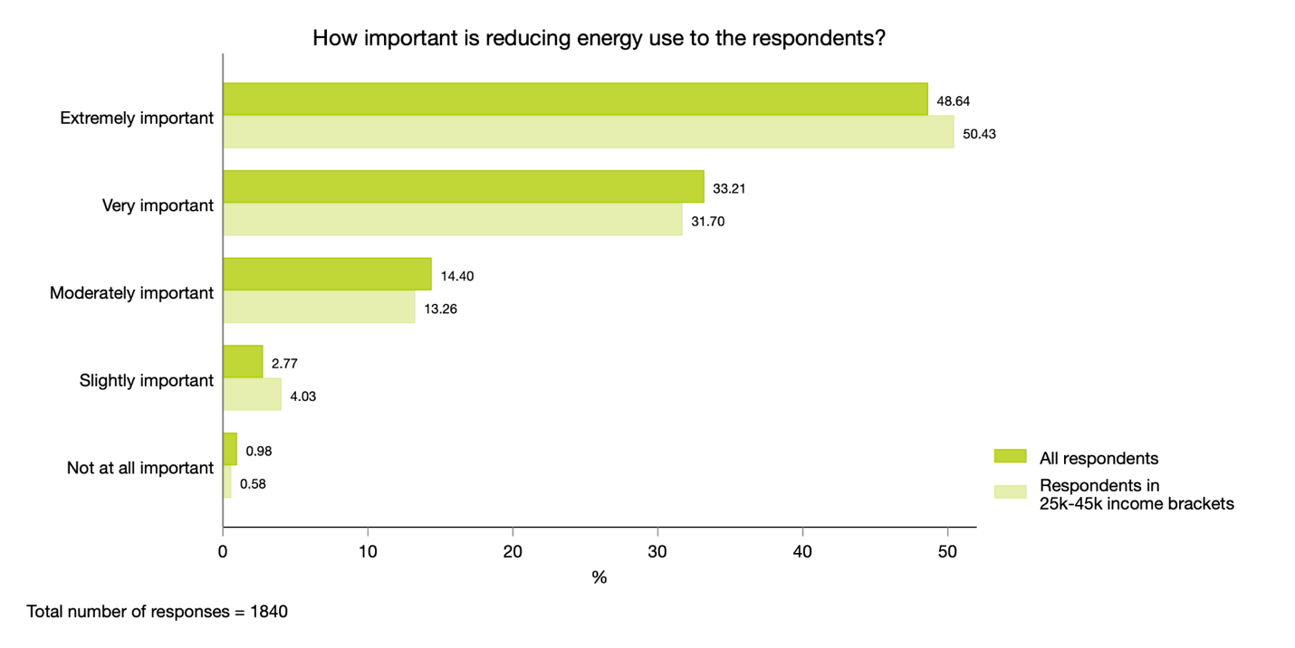Additional 32 per cent indicated that reducing energy use is very important to them.

Research phase: selected findings from the residential survey

The survey shows that the perceived importance of saving energy has shifted dramatically.

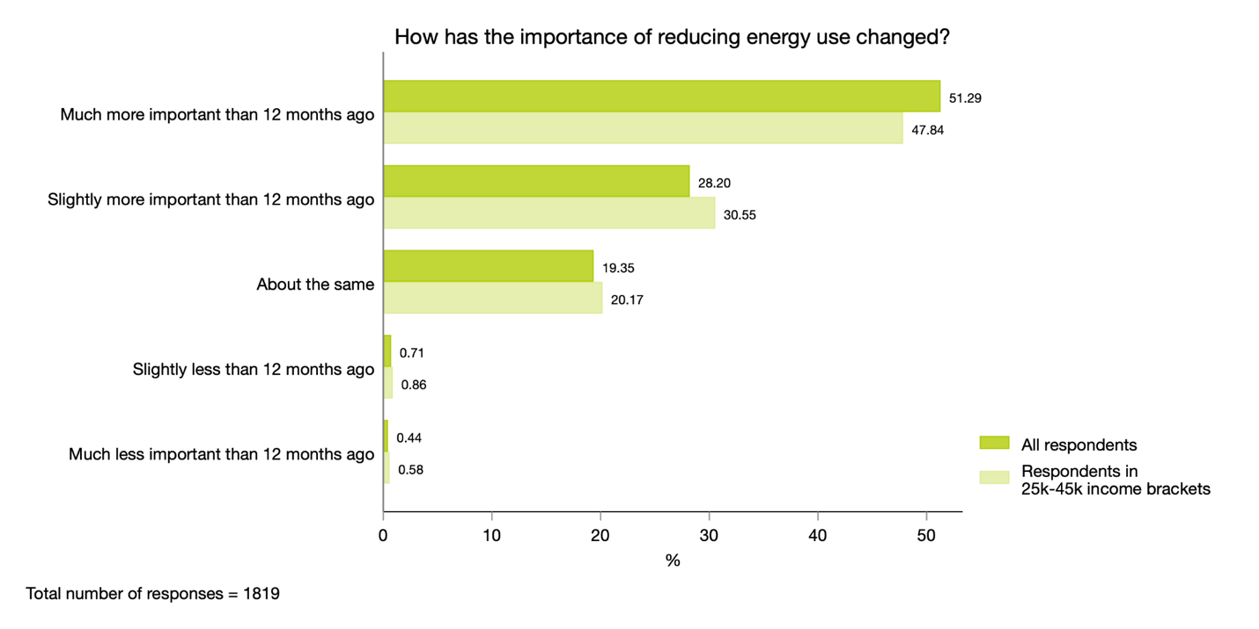Reducing energy use is more important than it was 12 months ago for more than 78 per cent of low- to middle-income residents who participated in the survey.

Research phase: selected findings from the residential survey

Which energy-saving behaviours do respondents eng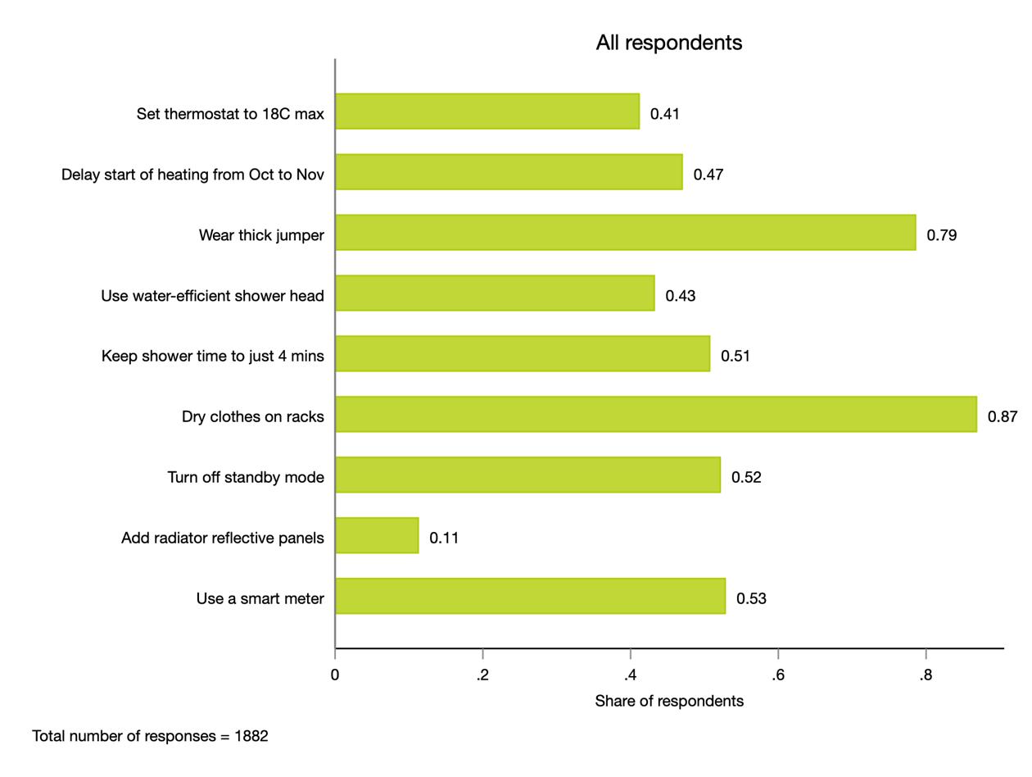age in?

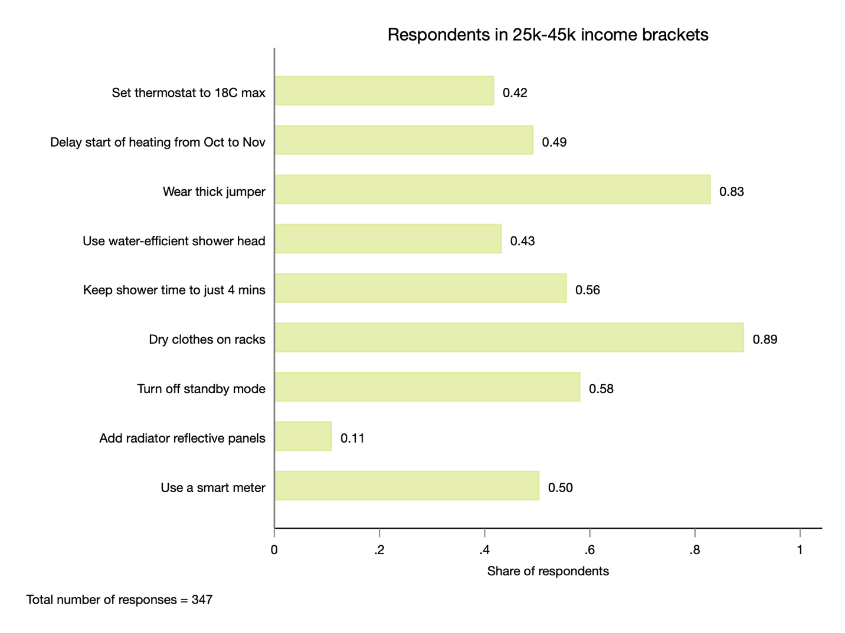

Research phase: barriers and enablers associated with reducing energy usage

We identified a number of barriers and enablers linked to saving energy at home.

This was done through the review of existing literature, expert interviews and an analysis of the open-ended responses in the residential survey.

Barriers

Barrier name | Description
Belief  (lack of self-perceived need) | Individuals do not believe that they need to make their homes more efficient.
Cultural barriers | Cultural factors may not always normalise certain energy saving behaviours
Decision heuristics | Individuals may know little about how energy use is related to their behaviour and so may tend to rely on simple heuristics that are not always accurate, like assuming bigger appliances consume more energy.
Government’s failure to adhere to net-zero targets | Some individuals are sceptical about the government’s ability to meet targets. They may think that any personal contribution may not be deemed worth the effort.
Inconvenience | Energy-efficient behaviours such as having appliances switched off at the wall can present an inconvenience for individuals, thus decreasing engagement.
Individual discount rate | Impatient individuals (those with higher discount rates) tend to buy less energy-efficient devices, which might be cheaper to purchase but more expensive to operate in the long term.
Inertia | Individuals are irrationally reluctant to move from the status quo and are more comfortable with outcomes that are known with certainty, like continuing with the existing behaviours, than those that are uncertain, such as the future energy savings stemming from behaviour change.
Information overload | Individuals are constantly exposed to too much information from a great variety of sources, leading to disillusionment and a feeling of not knowing what to do.
Infrastructure | Some individuals do not have the choice of using more energy efficient means (e.g. the property only has electrical heating).
Lack of engagement with technology in older generations | Older individuals may be reluctant to use online resources and access information online which may be helpful for saving energy.
Lack of knowledge | Individuals may not know how to reduce energy use or, if they do, how to carry out energy-efficient behaviours, like operating the thermostat remote.
Lack of trust | Individuals may not trust new and unfamiliar campaigns and interventions instead seeing them as scams.
Language barriers | Individuals who do not have English as their first language find it difficult to engage with information and access support.
Misinformation | Individuals may have been exposed to misinformation or myths regarding their home appliances which in turn leads to reduced trust.
Necessity | Some individuals rely on the constant use of electrically-powered equipment due to health reasons or disability.
Perceived costs of energy efficiency improvements | The high costs of making a household energy-efficient represent the most commonly perceived barrier.
Short-term thinking | Individuals may focus singularly on the next bill rather than thinking of reducing energy consumption in the long run.
Time constraints | Individuals may perceive lack of time as an obstacle when considering making changes to their houses’ energy efficiency,
Unwillingness of children and teenagers | Children and teenagers are often reluctant to switch off their gaming consoles and may have a variety of appliances (e.g. TVs and consoles) running in different rooms.

Enablers

Enabler name | Description
Appeal to emotions | Using emotional framing that speaks to individuals’ inherent motivations to carry out these behaviours (instead of rational messaging about carbon emissions).
Channels of communication | Using channels of communication that individuals already engage in, for example school boards.
Comparison options | Tools and easily-available information that compare prices of different appliances while also comparing prices for different gas and electricity suppliers.
Concerns about energy bills | Individuals with an increased concern towards their energy bills are twice as likely to give a lot of thought to saving energy at home.
Ease of implementation | Offering equipment-based solutions that do not require additional set-up efforts.
Low-cost solutions | Informational strategies are especially effective when pro-environmental behaviour is relatively convenient and not very costly in terms of money, time, effort or social disapproval, and when individuals do not face severe constraints on behaviour.
Monetary savings information | Showing individuals how much money they could be saving per year/month by engaging in energy-saving behaviours.
Pro-environmental attitudes | Homeowners who see themselves as pro-environmental are more likely to have lower heating and electricity costs.
Protecting the planet for the future | Aimed at parents and grandparents, referencing children or future generations in communications will help to motivate behaviour change.
Provide information/ advice that is relevant | Providing only relevant information and tips rather than implementing a ‘one-size fits all’ approach.
Providing information that enables choosing suitable options | Providing individuals with information that allows for the comparison between two energy-consuming activities, for example the cost of making a meal in the oven versus making the same meal in an air fryer.
Social norms | Using social norms, word of mouth and examples of residents that have followed certain tips leading to positive changes.
Solutions without compromise in safety and comfort | Prioritising and emphasising solutions that reduce energy use without compromising safety and comfort levels
Using positive reinforcement | Using positive reinforcement to celebrate positive changes already made and to encourage new energy-efficiency behaviours
Using simple messages | Ensuring that communications reflect language already used by the public and avoiding less-familiar terminology (e.g. ‘carbon neutral') to help reduce cognitive strain and increase the likelihood that individuals will engage with the message.
Using trusted messengers | Using messengers that people trust and value, for example. community wardens and parish Council.

Behavioural trial design phase: overview

In this phase we worked with the Consortium to develop ideas for behavioural solutions to help low- to -middle income homeowners reduce their energy usage.

The behavioural solutions were developed in an ideation workshop held with the Consortium members on the 7th of September 2022.

The three interventions

‘Share the Warmth’ Kent challenge

- Description: The Consortium would design a campaign that empowers people to check that their friends and family have put in place simple, low-cost measures to keep their home warmer. The campaign would provide people with tips, help them decide which people they will reach out to, and then follow up with an evaluation survey.
- Behavioural barriers addressed: Lack of trust and cultural barriers (will rather listen to my friends), time constraints, information overload, lack of knowledge (do not know how to save energy) and perceived costs of energy efficiency improvements
- Outcomes to measure: Self-reported energy behaviours, how many people reached out to, which messaging is most effective in getting people to join the challenge

Neighbourhood challenge

- Description: People would help their neighbourhood to get more energy efficient. The campaign would encourage each individual to set up personalised goals to implement low-cost energy saving behaviours. Parishes could see how many people from other parishes are participating in the challenge.
- Behavioural barriers addressed: Cultural barriers, inertia, lack of knowledge, perceived costs of energy efficiency improvements
- Outcomes to measure: Self-reported energy behaviours, how many neighbourhoods and homeowners sign up, which messaging is effective

‘How-to’ clips with real-life people

- Description: The councils would encourage homeowners to record short how-to clips on how to implement different energy behaviours at home. These would be re-shared by councils on social media, together with polls, quizzes and other social engagement elements.
- Behavioural barriers addressed: Lack of knowledge, inertia, perceived costs of energy efficiency improvements
- Outcomes to measure: Views, clicks, and likes associated with the videos and poll replies and quiz scores

Behavioural trial design phase: selected intervention

After the ideation workshop, The Behaviouralist internally evaluated all three intervention ideas and met with the individual members of the Consortium to discuss their preferences for the final intervention.

The Consortium consensually decided to proceed forward with the Share the Warmth concept.

Share the warmth

A behavioural intervention that empowers people to help their friends
and family put in place simple measures to keep their homes warmer

The intervention consists of:

An online training and goal-setting platform.
The platform will provide training (through videos and interactive exercises) on five low-effort energy efficiency measures. It will prompt participants to set a goal to reach out to their close friends and family in the next four weeks and help them implement these measures and make their homes warmer.

Reminder emails.
Participants will receive weekly prompts (if they opted in) to remind them about their pledge to reach out to their friends and family in the upcoming four weeks.

Follow-up survey.
At the end of the four-week period, participants will receive an evaluation survey that will collect self-report data, such as how many others did the participants engage with and which behaviours did they help them to implement.

The messenger effect

People are more likely to take energy-saving advice from friends and family than from Internet websites or government-led initiatives.

At the heart of this intervention is nudging people to act as trusted messengers - and help their close friends and family.

Randomised elements

The intervention will contain a number of randomized elements. First, to evaluate the impact of providing energy-saving tips on knowledge, we will randomly assign participants to either the control group (where participants first take the quiz and then go through the ‘training’) or the treatment group (where participants first go through the ‘training’ and then take the quiz).

Second, we will test out different messaging to identify which messages are the most effective in encouraging participants to commit to helping others save energy. The different message versions will most likely leverage the following elements:
- Social norms (where we highlight that many others are committing to help)
- Extrinsic incentives (where we provide the opportunity to win a voucher if they commit)
- Altruistic appeals (where we appeal on participants’ intrinsic motivation to help others)

Intervention delivery channels

- Local councils’ social media (e.g. Facebook, Twitter, Next Door). We will develop social media posts to prompt people to sign up to the online challenge.
- Staff and parish council newsletters. We will reach out to parish councils, NHS staff and other groups that would be able to share an invite to the challenge with their local communities.

Outcomes and impact measurement

We will measure the programme’s success through collecting data on the following primary measures:
- Does the training increase participants’ knowledge of the measures they can take to reduce their own (and their friends’) energy bills?
- Which messaging is the most effective in getting people to sign up for the challenge and making them commit to reaching out to their friends and family?
- How many other people did the participants reach out to as part of the challenge; which energy efficiency measures did they help to implement (self-reported)?
- How do the self-reported actions translate to total money and emissions saved?

We will also collect data on the following secondary measures:
- How many people downloaded the checklist of recommended actions provided by the online platform?
- How many people committed to reach out at least to one person in the following four weeks?
- How many people shared the link to the challenge with their friends?
- How many people participated in the Kent challenge and from which areas?

Next steps

We have the following key recommendations and main takeaways from the work carried out during the scoping phase:

The Behaviouralist recommends that the trial goes ahead.

Following the submission and acceptance of the scoping report, we will develop the intervention materials (the online platform, reminder emails, and the follow up survey). The trial should launch in the second half of October.

All consortium members are fully engaged in the project and have the capacity to assist with the intervention.

