Jean Smith
123 Letsbe Avenue Worcesershire
WC1 123

Payments and Client Charging Team
Adult Services and Health Directorate
County Hall, Spetchley Road, Worcester WR5 2NP
Date: xxx
Email: payadultsocialcare@worcestershire.gov.uk

URGENT REMINDER
Account status: Investigation pending
Dear xxx
Have this information to hand when contacting us or making a payment:

Our records show that the amount of XXXX for your contribution for your care service is still outstanding and you
have yet to contact us.
Press
Option 4
Xxxxx xxx xxx
To avoid further charges, please pay this amount in the next
14 days.
Customer Account Number: xxx
Invoice Reference: xxxx
Payment Due Date: xxx
You owe: xxx

Every penny you pay goes back into providing your care.
Each month, care workers pay thousands of visits and deliver thousands of hours of care arranged by Worcestershire County Council for Worcestershire residents who need it most.

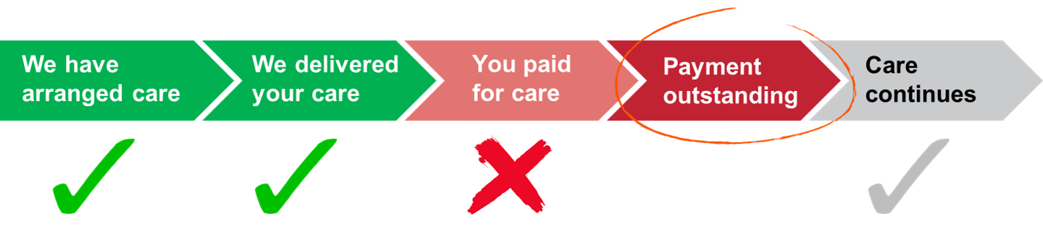

To pay this bill, choose your payment method overleaf or call us on our dedicated helpline xxxxx xxx xxx.
If you have paid in the last 7 days, please accept my apology and ignore this letter.
Yours faithfully,
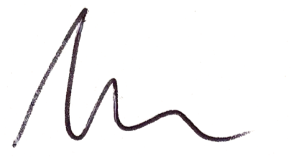
Ashley from your Payments and Client Charging Team

Details for currency GBP Great Britain Pounds
Tran date Reference Lgnd Original Balance Outstanding Balance Due Date
xxx xxx xxx xxx xxx xxx
xxx xxx xxx xxx xxx xxx

