

Payments and Client Charging Team   
Adult Services and Health Directorate   
County Hall, Spetchley Road, Worcester WR5 2NP

Date: xxx   
Email: payadultsocialcare@worcestershire.gov.uk

Jean Smith

123 Letsbe Avenue Worcesershire

WC1 123

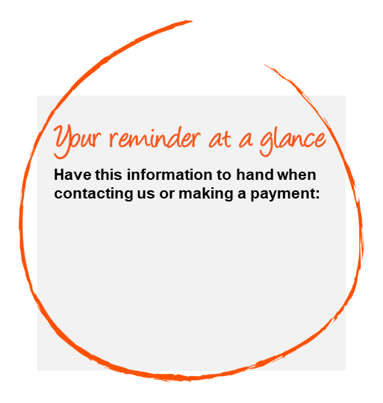

**URGENT REMINDER**

Account status: Investigation Pending

Dear xxx,

Our records show that the amount **xxx** for your contribution for your care service is outstanding.

**IF THIS LETTER IS IGNORED:  
INVESTIGATION WILL COMMENCE IN 14 DAYS.**

**Failure to do so may also result in legal action being taken in order to secure payment. If legal action should become necessary you will be liable for the costs involved.**

To pay this bill, choose your payment method overleaf or call us on our **dedicated helpline xxxxx xxx xxx.**

If you have paid in the last 7 days, please accept my apology and ignore this letter.

Yours faithfully,

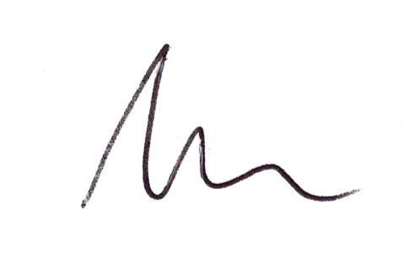

Ashley from your Payments and Client Charging Team



**Press**

**Option 4**

Xxxxx xxx xxx

**Customer Account Number: xxx**

**Invoice Reference:** xxxx 

**Payment Due Date: xxx**

**You owe: xxx**

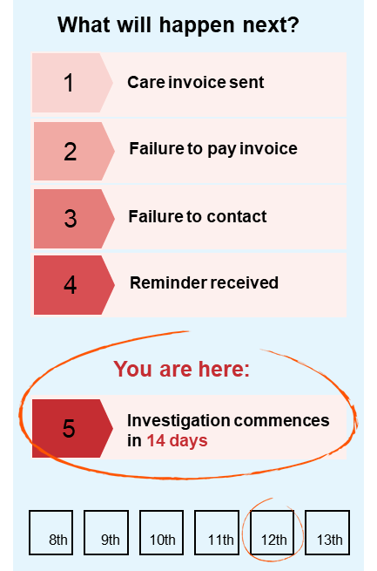



Details for currency **GBP Great Britain Pounds**

**Tran date Reference Lgnd Original Balance Outstanding Balance Due Date**   
**xxx** **xxx** **xxx** **xxx** **xxx** **xxx**  
**xxx** **xxx** **xxx** **xxx** **xxx xxx**

**Total: xxx**