Table of Contents
Introduction 2
Section 1 What is Health in All Policies? 3
Section 2 How can HiAP help? 9
What shared outcomes can HiAP contribute towards? 9
What problems and scenarios HiAP can help with? 10
How can HiAP help meet statutory duties? 11
How can HiAP help us be more efficient and productive? 12
Section 3 How do I develop a plan for HiAP? 14
What is the scope and opportunity for HiAP? 14
What do you understand about your population and how their health could be affected? 18
Who will you collaborate with? 20
What do you hope to achieve through HiAP? 23
What HiAP activities and tools will you apply? 24
What does a strategic approach to HiAP look like? 25
What governance and accountability are needed? 26
How will progress be understood and communicated? 27
Section 4 What tools can I use to apply HiAP? 27
Section 5 How do I measure and communicate progress? 33
What challenges exist to measuring and communicating progress in HiAP, health and wellbeing? 33
What does good look like? 34
What tools exist? 35
How do I measure progress in adopting a HiAP approach? 38
How do I measure progress in improving the wider determinants of health? 40
Section 6 Frequently asked questions and common misconceptions 41

Introduction

Every decision councils make can affect people’s health and wellbeing, and health equity: from building homes and neighbourhoods, to how we deliver services and work with communities.

Health in All Policies (HiAP) is a practical way to bring this thinking into everyday work, whatever your role, team or department.

This resource is primarily for councillors and officers working in all types of local authority in England, who are new to HiAP, but it will also add value to people who are already on the journey. ‘Councils’ refers to all types of local authority, including strategic (also known as combined) authorities.

It explains what HiAP is, why it matters, and how it can help tackle local challenges. It shows simple ways to plan, choose tools, measure what works and tell the story of what you’re achieving.

HiAP isn’t about creating more work, it’s about doing what you already do, but with a clearer focus on health and health equity. And you don’t have to use the words ‘Health in All Policies’: you just need to routinely think about what you do and how this could affect the health and wellbeing of people who live and work in your communities and, in turn, society and the economy.

Your local public health team, the Local Government Association and organisations such as the Health Foundation can help you get started. Pick one idea, one step or one tool and use this resource to make health and health equity core to how you and your council works, day to day.

Section 1 What is Health in All Policies?
A practical approach to improving health, wellbeing and health equity

Health in All Policies (HiAP) is a practical approach that helps improve people’s health and health equity by making health and wellbeing part of everyday decision-making.

HiAP is based on a simple, evidence-based concept: that the conditions we’re born into, grow, live, work and age in, and our access to power, money and resources, shape our physical and mental health and wellbeing, and have a powerful influence on health inequities. Our health is only partly the result of the health or social care we receive.

Health and wellbeing

The longstanding definition of health from the World Health Organisation (WHO) formulated in 1948 is ‘a state of complete physical, mental and social well-being and not merely the absence of disease or infirmity’. This was an important definition in that it considered health as something positive rather than an absence of disease.

However, this definition does not recognise that many people live with a long-term condition and can be healthy. It is best, then, to consider health and wellbeing as being about what makes us feel good physically, mentally, socially, and spiritually. It is about how we react to the strains and stresses of life and are not only resilient to them but have the potential to bounce back even stronger.

It is also important to acknowledge that there is some distance to travel for mental health to be given equal priority to physical health, in society and in public services, and that we must move towards helping everyone to stay mentally well. Councils play a key role in supporting mental health across all ages in their communities: see ‘Must know: is your council doing all it can to improve mental health?’
The wider determinants of health

The wider (also known as social) determinants of health are the social, economic, cultural and environmental factors that impact a person’s physical and mental health, and wellbeing, all of which can, potentially, be modified to improve health. These factors include homes, jobs, healthy food and friends: councils have a significant role in relation to all these. For more information about the role of local government, refer to the LGA’s ‘social determinants of health and the role of local government’ guide.

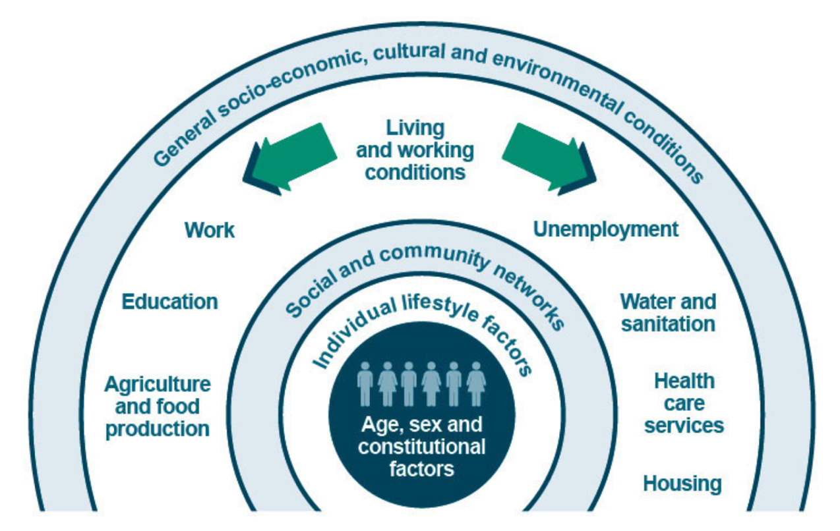

The wider determinants are increasingly referred to as the ‘building blocks of health’, a metaphor used to increase understanding about how a healthy society or place is shaped the wider determinants.

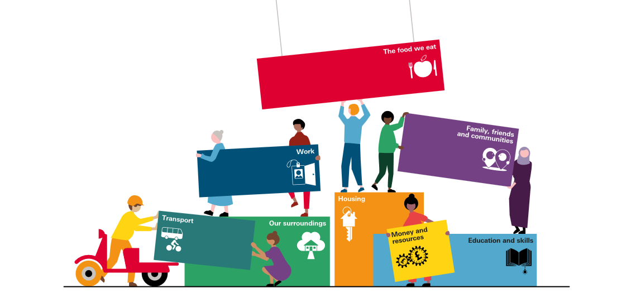
Source: Health Foundation 2024

A life course approach

The wider determinants of health affect us in different ways at different stages of our life. A good HiAP approach will adopt a life course approach: it will consider how decisions have potential to impact on the health and wellbeing of the population across the life course, paying attention to important life transitions where people may ‘fall through the gap’ if the conditions in which they live are unable to support and protect them.

Such an approach also ensures consideration to the health and wellbeing of children and young people in decisions on the wider determinants of health: the World Health Organisation advocates for a ‘children in all policies’ approach.

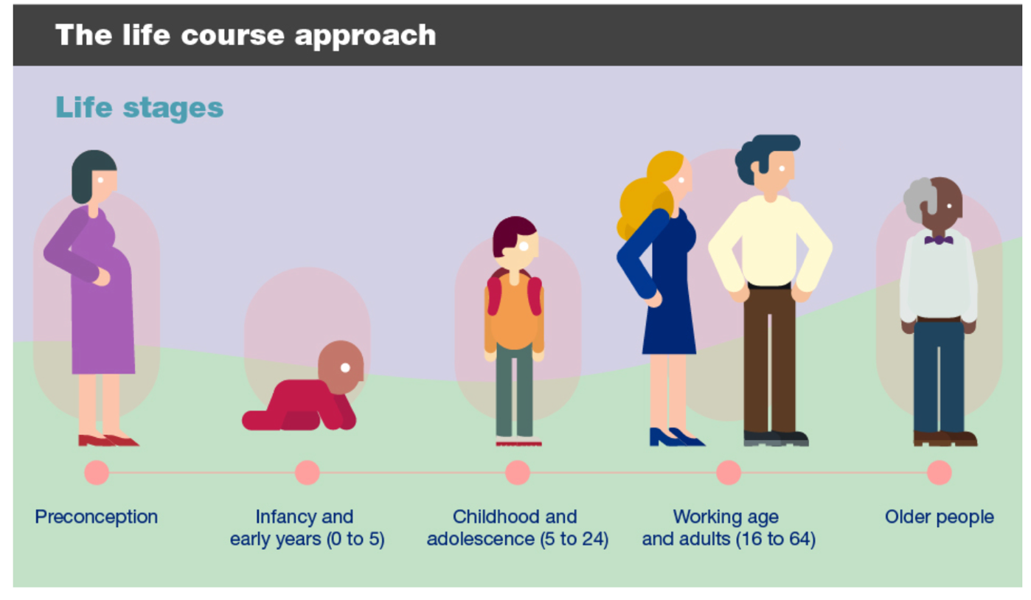

By way of example:

- In the early years, the physical environment plays a critical role in enabling parents and carers to focus on providing the best possible care and nurture, free from stress. A warm, stable home promotes physical and mental health and wellbeing. Transport planning can create safe walking routes and access to social support networks and services, whilst green and blue spaces can enable play and development.
- During adolescence, education and social support continue to play a vital role. Positive relationships with peers and mentors can help young people develop a sense of identity and purpose. Access to education and extracurricular activities can also provide opportunities for personal growth and development. An affordable and supportive home environment is important as young people transition to adulthood and independence.
- In adulthood, factors such as employment, income, and social support become increasingly important. A stable job and a supportive social network can contribute to a sense of well-being and security. Access to healthcare is also crucial for maintaining physical and mental health.
- In later life, wider determinants such as income, social support, and access to healthcare continue to impact on quality of life. Older adults who have strong social connections and access to healthcare are more likely to experience a sense of well-being and fulfilment.

A life course approach emphasises early intervention and prevention and can enable the exploration of equitable solutions.

For more information about the life course see Health matters: prevention – a life course approach.

Possible addition of Oxfordshire case study on housing and health assessment: CYP

Health inequalities and health equity

A good HiAP approach explicitly considers health inequalities: the unfair and avoidable differences in health across the population, and between different groups within society. Health inequalities arise because of the conditions in which we are born, grow, live, work and age.

If we want to enable everyone to achieve their potential, to live happy fulfilling lives, we must consider that some communities may need more or different support or resources to achieve the same health and wellbeing outcomes. The ideal is that the barriers to good health would be removed for everyone so that we all benefit, but this is not always possible. This is health equity. Health equity is repeatedly referred to in this resource as there is evidence of a tendency for HiAP to focus only on improving health.

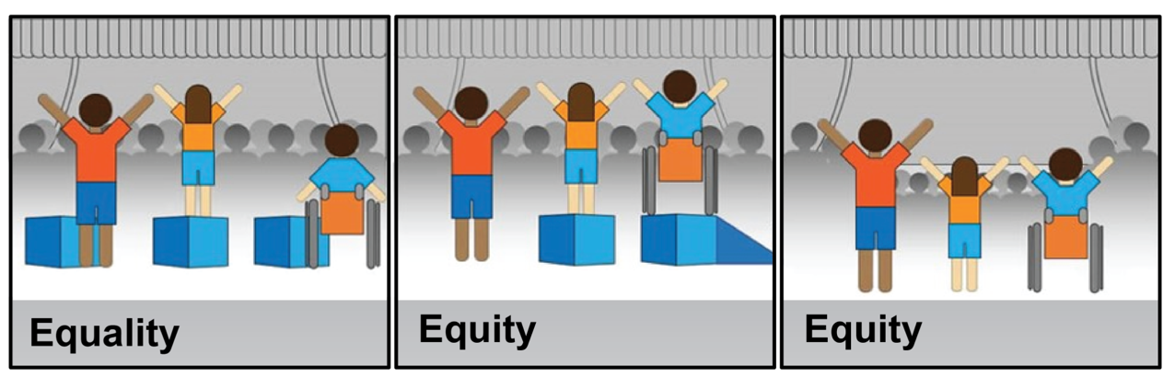
Source: All Our Health

For more information about understanding and addressing health inequalities, and how the wider determinants of health can shape the health outcomes of people in your community, refer to the LGA’s ‘Place and health: Bridging the gap in health inequalities’.

A practical approach to prevention

The wider determinants of health are also referred to as ‘the causes of the causes’ of ill-health and health inequalities.

Considering the population’s health and wellbeing, health equity in all council functions and decisions, and collaboration with partners, applying a HiAP approach is a means by which councils can identify opportunities to prevent ill-health through providing the right conditions for good health and wellbeing. Action on the wider determinants of health is considered to be ‘primordial prevention’ which aims to address the root causes of health problems.

The LGA’s ‘Making the case for prevention: a must know for elected members’ advocates for the adoption of a HiAP approach as a useful framework for developing prevention strategies.

Case study: London Boroughs of Richmond and Wandsworth: embedding a HiAP approach through a prevention framework focused on addressing health inequalities.

A practical approach to achieving shared outcomes

A HiAP approach is an outcomes-based (or outcomes-focused) approach and enables consideration to both improved health outcomes and health equity and other desirable outcomes such as inclusive growth, resilient communities, an end to homelessness, and safer neighbourhoods.

Identifying such shared outcomes – also referred to as co-benefits or ‘win-wins’ – is a strong basis for collaboration across council teams, professions and with partners.

A collaborative approach

To support healthier decisions in these areas, HiAP offers a framework for collaboration: a way for people working in different systems, sectors and organisations to come together, share an understanding of challenges and opportunities, and work towards shared outcomes.

HiAP has two main components:

- Collaboration: people from across sectors, services and communities come together to build relationships, share knowledge, and solve problems together using a range of tools and activities to suit the context.

- Tools and activities: a range of practical methods that can be used to bring health and health equity into decision-making, from capacity building to health impact assessments to community participation.

You don’t need to involve everyone, or use every tool, all at once and for every decision. You start with what makes sense for your goals, context, capacity and your relationships.

A growing and evolving approach

Our understanding of the social and economic costs of health inequalities continues to grow. HiAP is considered more important than ever to pursue health equity and social justice, not just population health. The increase in councils adopting Marmot principles is testament to this (see Building fairer towns, cities and regions: Insights from Marmot Places) and more councils have become part of the World Health Organisation’s Healthy Cities movement.

There is increasing recognition that the HiAP tools and collaborative approaches can enable progress in achieving wider goals, from mitigating the impact of extreme weather events and building more resilient communities, to inclusive growth in local economies.

HiAP is being adopted in designing and improving frontline services, in organisational development, in systems, and in strategic planning.

Health in all practice

Below are three examples of initiatives adopted by councils that could be considered as HiAP (dependent on the extent to which HiAP principles have been adopted and tools applied).

A psychologically or trauma informed approach in service delivery recognises the extent, impact and effect of trauma on an individual and responds sensitively to it. This approach is typically found in services targeted towards people who have likely experienced one or more traumatic events, for example domestic abuse, experience of the criminal justice system, care experience and homelessness – people who are highly likely to also experience multiple disadvantage and health inequalities. It can also be recognised as an approach to reframing all related areas of policy e.g., housing, justice, welfare, education as levers to improve health and health equity.

Case study Notts Include case study re: trauma informed approach.

The development of family and youth hubs (and other co-located multidisciplinary services targeted to improving outcomes) offer an opportunity to consider the potential for integrating health, care and support services with wider determinant services such as leisure.

Case study: Dudley council: co-locating a family hub spoke in Halesowen Leisure Centre

‘Making Every Contact Count’ is an initiative many councils have adopted whereby frontline staff across a range of public services are trained to have healthy conversations.

Case study: Leicester’s response to the cost of living challenges builds on established MECC initiatives, alongside a refreshed approach to community engagement

The value of HiAP to working more efficiently is of great interest. Research into the effectiveness and cost-effectiveness of the application of HiAP continues to emerge, including through councils’ work with the NIHR funded Health Determinants Research Collaborations (HDRCs) which aim to boost research capacity and capability within local government, embed a culture of always using evidence when making decisions and use research findings to understand how decisions impact on health and health inequalities.

Definitions and framing HiAP

One of the challenges experienced by people who wish to explore or adopt a HiAP approach in their council is how best to describe it, relevant to the local context.

The most-oft used definition is from the World Health Organisation (WHO) endorsed 2013 Helsinki Statement:

“An approach to public policies across sectors that systematically takes into account the health implications of decisions, seeks synergies, and avoids harmful health impacts in order to improve population health and health equity. It improves accountability of policymakers for health impacts at all levels of policy-making. It includes an emphasis on the consequences of public policies on health systems, determinants of health and well-being.”

The Health Foundation describes HiAP as “an established approach to improving health and health equity through cross-sector action on the wider determinants of health: the social, environmental, economic and commercial conditions in which people live.”

The Institute of Health Equity (UCL),home to Marmot Places, suggests that HiAP “means that the health implications of decisions across government and society—education, housing, planning, employment—are explicitly considered in order to promote equity in health.” HiAP is a central tenet of the Marmot approach.

More recent practice has framed HiAP as a dynamic, relational approach to working across sectors to achieve shared goals and mutual benefits, with a growing emphasis on equity, participation, and local adaptation. The Association of State and Territorial Health Officials (ASTHO) in the United States defines HiAP as “a collaborative approach that integrates and articulates health considerations into policymaking and programming across sectors, and at all levels, to improve the health of all communities and people”.

This diversity of framing reflects both the flexibility of the HiAP approach and the importance of aligning terminology with local priorities, values and audiences. Although US-based, Framing Health in All Policies: terms that resonate describes different perspectives on the use of ‘Health in All Policies’ which may be helpful to the approach you adopt locally. Councils choosing to become a Marmot place or WHO Healthy City, and/or adopting a community specific ambition for a strapline are examples of this (examples e.g. Fairer, healthier Liverpool).

HiAP might already be happening where you are

Taking an outcomes-based approach to complex problem solving, strategic planning and commissioning in councils is not new: HiAP is simply a means to ensure that health and health equity are explicit outcomes, alongside others.

Councils, their service providers and their partners employ a multitude of professionals who are trained to understand the impact of their role and services on health and wellbeing and health equity, such as environmental health officers and occupational therapists, and there will be many frontline officers who see this impact on daily basis in their work with residents. Recognising the capacity and good practice already in place is an important first step in planning a more systematic approach.

It is recommended that you talk to your local public health team about HiAP, alongside this resource; there may be relevant training or other capacity building on offer to you.

Section 2 How can HiAP help?
HiAP isn’t new or additional work. It is a better way of working that helps councils tackle real and complex problems with more impact, better use of resources and stronger relationships, while helping to meet legal duties.

The value of HiAP is demonstrated in the diagram below:
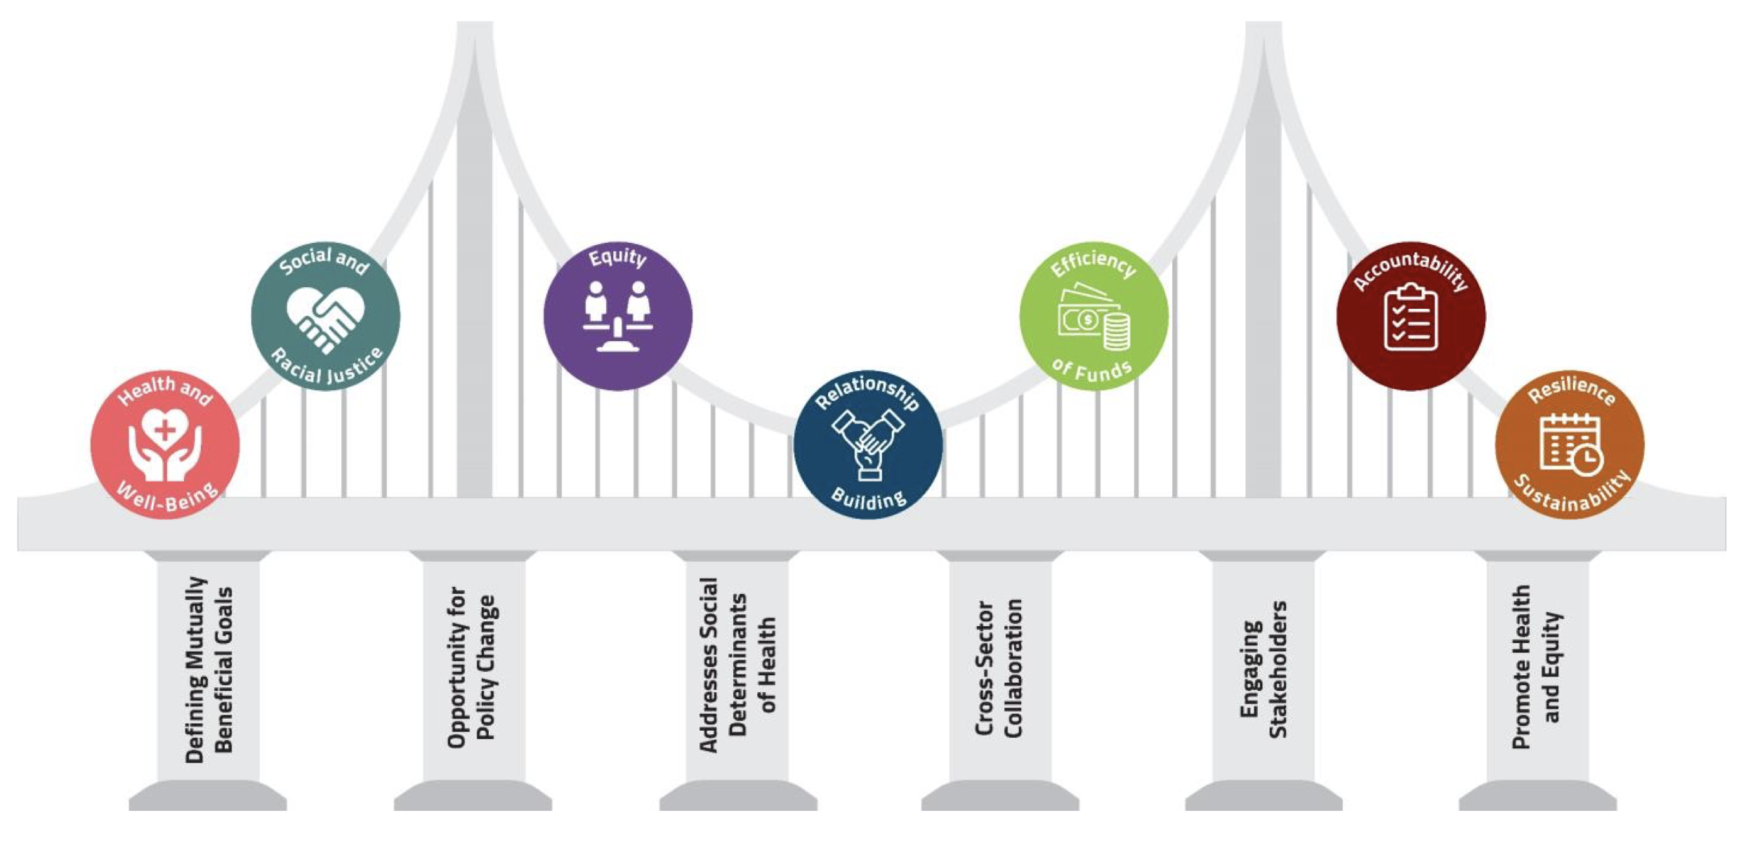
Source: ASTHO 2022 https://www.astho.org/globalassets/report/the-value-of-health-in-all-policies.pdf

What shared outcomes can HiAP contribute towards?

HiAP isn’t only about improving health and health equity, although that’s at its heart. Done well, it creates co-benefits: practical ‘win-wins’ that help councils, stakeholders and residents make funding go further.

Examples
- Homes: affordable, warm, safe and stable homes mean better mental and physical health and independence, lower health and care costs, fewer days off school and work, and stronger local economies.
- Resilient communities: family, friends and communities are the cornerstones of our everyday lives and play an important role in shaping our health and wellbeing. Greater social capital – relationships and trust – is also associated with more effective public services and inclusive economies.
- Employment and economic growth: a good quality job pays enough to meet basic needs, but it also provides reliable employment, job satisfaction, fair pay and work-life balance. Healthier, fairer communities attract businesses and investment, support a stronger workforce, and reduce the long-term cost of crisis services.
- Transport: available, reliable and affordable transport supports the other building blocks of good health, such as connecting us to work and public services. Good transport options can enable exercise, employment and road safety. Active travel routes encourage physical activity, reduce air pollution and make places more attractive to live and work.
- Environment and climate: policies that cut emissions and improve air quality also protect health, build resilience and help councils meet Net Zero targets.
- Sport and leisure: sport and physical activity are known to improve physical and mental health and wellbeing, but it has also been shown to improve educational attainment, work productivity, social trust, belonging and community engagement. See the LGA’s Sport and leisure: promoting health and wellbeing through public services for further information and case studies.

HiAP helps councils plan for these co-benefits, so good intentions become clear, joined-up action.
Health in the planning system

The planning system shapes the places we live and work in, the opportunities and the choices we make. In setting land use priorities for places over the next 20 years, planning policies and decisions influence the wider determinants of health: good homes and easy access to parks and greenspaces; pleasant and safe routes for walking, wheeling and cycling; jobs, shops, schools and other vital infrastructure.

For more information about health and planning, including case studies, refer to:

Empowering healthy places: Unveiling the powers and practices of local councils in fostering healthy neighbourhoods (LGA)

What good local spatial planning for healthy places looks like (ADPH)

Planning for healthy places: a practical guidance for local authorities on embedding health in Local Plans and planning policies in England (TCPA)

Developing healthier places: a guide for councils who would like to secure health benefits from new development (LGA and TCPA)

Building health equity: the role of the property sector in improving health (Institute of Health Equity)

What problems and scenarios can HiAP help with?

Local councils and their stakeholders deal daily with complex issues that often don’t fit neatly in one department or sector. HiAP helps when:

- organisations and teams need a reason to come together, to align work and break down silos
- there is potential for policy aims to conflict, for example, balancing housing growth with green space, or transport access with air quality
- resources are tight, and there’s a risk that work is being duplicated
- policies may have unintended consequences, such as making life harder for some groups
- confidence in decision-making is low
  - data quality (quantitative and qualitative) can be improved
  - there’s low trust or buy-in between partners, services or communities
- workforce retention and recruitment is challenging
  - people feel they are not making a difference to people’s lives and there’s a need to improve workforce morale
  - the wider determinants are affecting access to work, for example high cost of housing close to work, or lack of affordable transport.

The World Health Organisation (WHO) suggests three policy situations where HiAP is especially valuable:

- The issue is important for health and wellbeing — for example, climate change, housing quality or transport access.
- There’s sound evidence that policy action can make a difference.
- The solution is politically and socially acceptable, making collaboration realistic.

HiAP is well suited for tackling complex or ‘wicked’ problems, where the causes and solutions are shared across many sectors, from improving air quality to tackling child poverty. HiAP is a ‘systems approach’ because it recognises the interconnectedness of factors which influence health and wellbeing and health equity and promotes a collaborative approach to policy-making.

‘Taking a systems approach to create place-based change: seven learnings from the Shaping Places for Healthier Lives’ provides useful guidance that can be read alongside this resource.

Two examples of the application of a systems approach are:

Case study: Applying HiAP to setting a tobacco, alcohol and drugs strategy: Southampton City Council

Case study: Child healthy weight in Sefton: addressing the social determinants through whole systems working

How can HiAP help meet statutory duties?

Councils must meet a range of legal and policy responsibilities. HiAP can help by providing clear, structured ways to build these duties into everyday decision-making.

There are an estimated 1,300 duties on local authorities; we have listed those that apply to all council functions, and those for select specific functions, chosen for the level of priority and resources assigned locally and nationally.

In developing and implementing a plan for HiAP locally, developing a good enough understanding of the legal and regulatory framework within which specific policies are developed and guided will be important. Ask yourself:

- What is the intended outcome/s of legislation, guidance and regulation?
- What are the specific requirements placed on councils e.g., publication of a plan every five years, annual reviews etc.?
- What is said about how councils should meet the requirements e.g., through collaboration, a needs assessment etc.?

Duties that apply across the whole council

Legislation and statutory duty | How HiAP helps
Health and Social Care Act 2012 | The Act places a duty on local authorities (county and unitary) to improve the health of their populations; HiAP helps meet this public health duty. See also the LGA’s Councillors guide to LA PH responsibilities
Public Services (Social Value) Act 2012 | HiAP provides tools to show wider social, economic and wellbeing benefits when commissioning or procuring services. See also the LGA’s Social value – achieving community benefits toolkit
Equality Act 2010 and Public Sector Equality Duty | HiAP enables health equity to be built into decisions alongside protected characteristics; it helps explore intersectionality. See also the LGA’s Place and health: Bridging the gap in health inequalities
Local Government Act 1972 | The Act places a statutory duty on local authorities at county, unitary and district tier levels to provide a range of services to their communities, many of which have a direct impact on health e.g., environmental health, housing, food safety. HiAP can help explore how effective these services are in serving communities.

Examples of legislation, policy and guidance linked to specific council functions

Function | Legislation, policy and guidance | How HiAP helps
Planning (spatial planning) | Planning legislation and National Planning Policy Framework (NPPF)  The Planning and Infrastructure Bill proposes a duty on strategic planning documents to have regard to effect on health and health inequalities | Brings public health intelligence and insight into strategic, local and neighbourhood plans; strengthens the evidence for healthy, sustainable places.
Housing and homelessness | Housing Act 1996  Homelessness Reduction Act 2017 | Enables targeted policy and programme making to improve thermal comfort and accessibility; to reduce hazards in the home including overcrowding; to support tenancy sustainment, prevent and respond to homelessness.
Adult social care | Care Act 2014 | Supports adult social care to contribute to the creation of strong and resilient communities and identify opportunities for joined-up prevention work which could improve outcomes for people and reduce demand for costly crisis care.
Children’s Services | Children and Families Act 2014 & SEND Code of Practice | Encourages joint working between education, health and social care to improve outcomes for children and families.
Transport | Transport Act 2000 & 2008 | Helps join up transport, active travel and air quality planning with wider wellbeing and climate goals.

How can HiAP help us be more efficient and productive?

HiAP doesn’t just deliver big long-term benefits, it can simplify day-to-day work within a council, and in partnership with stakeholders:

- Saves time and effort by cutting duplication and streamlining how people plan, assess and deliver.
- Supports the development of more effective data collection and analysis, in turn improving confidence in decisions.
- Solves problems earlier, avoiding costly fixes down the line.
- Builds trust within communities, teams and with stakeholders, improving buy-in and accountability.
- Makes decisions stronger
  - Bringing together evidence, insight and experience from different stakeholders
  - Identifying gaps in knowledge and action to address these.

Even in times of constrained budgets, HiAP can help councils do more with what they have by aligning priorities and spending where it has greatest impact.

HiAP and working with NHS partners

Our health is only partly the result of the healthcare we receive. It does not begin in hospitals but in homes, streets, parks and schools, and that’s why HiAP exists: to ensure that decisions taken about the wider determinants of health consider the population’s health and wellbeing, and health equity. So why would you collaborate with NHS partners to take a HiAP approach?

The simple answer is that bringing NHS partners to the HiAP table is an opportunity to turn parallel ambitions into shared outcomes. Not only will councils and the NHS be better able to deliver on prevention, equity and financial sustainability while improving residents’ lives, a HiAP approach provides a framework for integrating action to improve work and health outcomes, amongst others.

From the council’s perspective
- The NHS holds more granular intelligence about the population’s health and wellbeing which, if harnessed effectively through a HiAP approach, could better inform council (and partner) decisions that have the potential to benefit, or harm, the population. Not only could this prevent ill-health, and associated social care needs, it could contribute to more effective use of available resources. In practical terms this could look like the use of NHS data alongside council and energy company data to inform targeted activity to address cold, damp and mould, preventing respiratory conditions and social isolation.
- The new Neighbourhood Health Service offers an opportunity to develop good integrated services that go beyond co-locating services to pooled budgets for multi-disciplinary teams that can act on the wider determinants of health alongside other identified health, care and support needs.
- In addition to being a significant local employer, in many places the NHS is also a large landowner and will have some interest in/leverage over the wider determinants of health, from the use of land to contribute to inclusive growth and genuinely affordable homes, to increasing access to green and blue space for local communities.

From the NHS’ perspective
- HiAP is a collaborative approach to prevention, centred on communities. Shifting from sickness to prevention, and hospitals to community, are two of the three planned shifts for the NHS, described in the 2025 10 Year Health Plan. For this plan to succeed, it will be essential that the NHS and its partners collaborate with councils to deliver for communities.
- Not only do the wider determinants of health drive inequalities (including mental health inequalities), they also contribute to inequalities in access to, experience of and outcomes from health care, whether this be digital access and literacy or precarious housing. Working with councils and their partners is an opportunity to understand this relationship in more depth and explore solutions that will benefit everyone.
- Workforce recruitment and retention is a significant challenge for the NHS in many localities, and several Integrated Care Boards (ICBs) have identified barriers such as transport and housing. A HiAP approach seeks shared outcomes: working with councils to address these barriers would likely improve outcomes for the NHS and wider public sector workforce, and community.

Refer to Fit for the future: 10 Year Health Plan for England for further information.

Section 3 How do I develop a plan for HiAP?
A plan for HiAP does not need to be perfect: the key is to start somewhere, be realistic and build trust as you go.

Keep it proportionate.
- If you are starting out and wish to apply the approach to a relatively small policy, programme or service area, you may just need a good action plan.
- If you have grander ambitions- perhaps you’re applying the approach to a particularly complex problem requiring systems or organisational change, or you want to take a strategic approach to embedding HiAP in your organisation and everything you do- this will likely need a more detailed work programme and governance.

The steps here are relevant to anyone with an interest in developing a plan, but particularly officers, whether working in corporate policy or a specific policy area such as transport, leisure or planning, or in a service area where policy shapes frontline practice such as regulation or housing options.

It is important to note that these steps need to be revisited throughout the delivery of the plan, taking on board feedback and learning; it should be an iterative process. Steps do not always need to be followed in order either.

What is the scope and opportunity for HiAP?

HiAP can be applied at different levels, described slightly differently in published guidance.

In summary, HiAP can be applied at:

- System level: a local authority Health and Wellbeing Board, Integrated Care System or other strategic partnership commitment to embed HiAP. Also, at a Strategic Authority level.
- Organisation level: a whole-council commitment to embed health in all major strategies, budgets and partnerships (this can be at county, unitary or district tiers). NHS partners may also have made relevant commitments e.g., to prevent ill-health, or improve health equity, through addressing the causes.
- Directorate / policy / programme area: a single department, directorate or senior team agreeing to build health into their decision-making, for example housing, transport, planning, leisure or climate.
- Service or team level: frontline work to deliver policies, like environmental health, development control, licensing, leisure or community outreach, that directly affects people’s everyday health.
- A geographic area: this may be at a ‘place’ or neighbourhood level, which could be defined with communities and/or organisations who serve these communities, for example social landlords or primary care providers.

Understanding the extent to which there is already support for HiAP at different levels, and thinking about your influence, will help you identify who you need to collaborate with on the next steps and why they could be interested.

For learning from taking a systems approach to shaping places for healthier lives, see the LGA’s publication.

Case study: Cheshire and Merseyside’s collaborative model to reduce health inequalities and improve population health

The way in which local government is organised will also make a difference, for example in areas with two tiers of local government – county and district councils – responsibility for services is split between the two. Responsibility for public health lies with the county council, whilst responsibility for many of the wider determinants of health, from leisure services to housing and environmental health, lies with the district council. Collaboration between the two is essential to success in HiAP. Further information can be found in ‘How is local government organised?’ and ‘The district council contribution to public health’. This is a developing picture in the context of Local Government Reorganisation.
Devolution and HiAP

The devolution of powers and resources from central government to local leaders, and closer to communities, presents an opportunity to improve health and wellbeing, and health equity.

With greater freedoms and flexibilities at a local level, councils can work more effectively to improve public services for their area, and the conditions in which people live and work.

Local government reorganisation is a matter for councils and local areas to decide; considering the health and wellbeing of the population, and health equity, in this and subsequent decisions presents an opportunity.

Devolution deals to establish new Strategic Authorities (SAs) also present an opportunity; they will be responsible for taking decisions that have the potential to impact positively, or negatively, on the health and wellbeing of local populations, and health equity.

Also known as combined or combined county authorities (some of which have a Mayor), these are legal bodies enabling a group of two or more councils to collaborate and take collective decisions across council boundaries. Councils can be more ambitious in their joint working and take advantage of powers and resources devolved from national government, which include transport and local infrastructure, housing and strategic planning, environment, employment, economic development and regeneration. They will also have the ability to perform functions in health, wellbeing and public service reform.

Recognising that established Mayoral Strategic Authorities (MSAs) hold the levers for many of the wider determinants of health, the Health Foundation’s Mayoral Regions Programme (MRP) aims to support these and other SAs to make the most of these levers. Drawing on an evidence review, a toolkit is available to use, alongside examples of SAs working in partnership with councils on employment, transport, housing, the environment, community safety and arts and culture. This is also a useful resource for councils, in their own work and as they explore opportunities with their combined authorities.

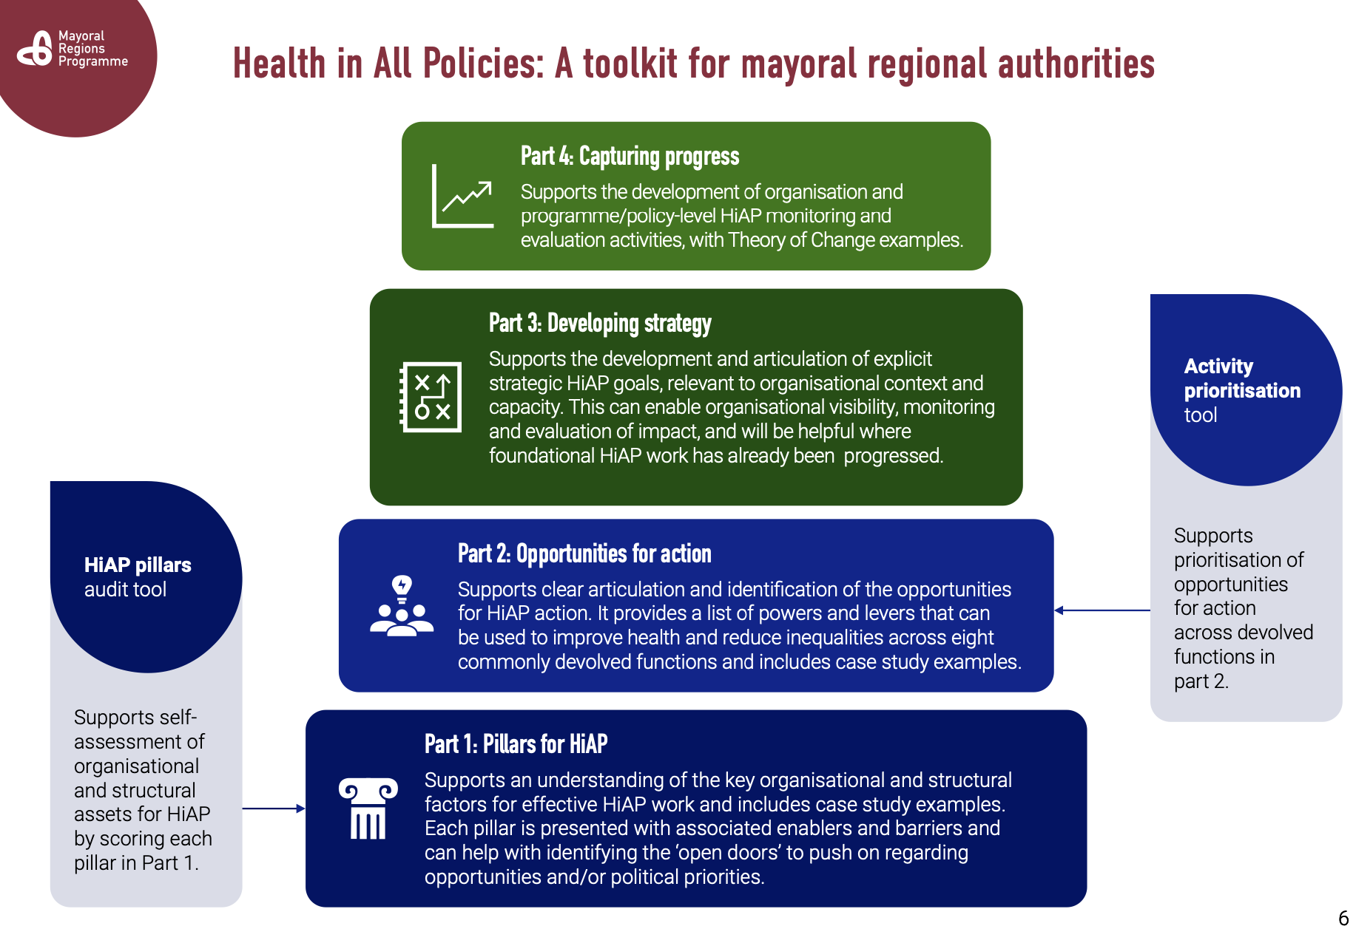

For more information on devolution see the LGA’s Devolution Hub.

Is there already local support for HiAP?

Before you start planning, you should first understand if ‘Health in All Policies’ is already something committed to, at some level and remembering that HiAP can be framed in different ways i.e., not using the specific words.

This can be done through working with your local public health team, and through a review of key documents for your locality such as the Health and Wellbeing Strategy, Integrated Care System (ICS) Joint Forward Plan or Corporate Plan. The Director of Public Health’s Annual Report can also provide an indication of interest in and commitment to HiAP, and the building blocks of health.

If you are working in a specific policy area, it is highly likely that the relevant plans already include words to suggest that the policy can contribute to improved health outcomes. This is useful – it gives you a hook - but it should not be read as ‘Health in All Policies is already embedded’, unless there is evidence of the effective use of HiAP tools in policy development, for example a health impact assessment was developed alongside and in collaboration (see section 4 for more information about the tools).

You should also look at your external stakeholders, who may already be applying this approach to some degree. Examples include the Police and Crime Commissioner (this function has been devolved to some Mayoral Strategic Authorities), Fire and Rescue Service, local colleges, culture and leisure partners and voluntary and community sector partners.

- Case study: working with a leisure provider.
- Health Foundation MRP case studies: policing, crime and safety – a public health approach to crime and violence reduction (GMCA, GLA, WMCA).

Is there a specific opportunity to consider health?

This step may be one you are able to answer initially on your own, and/or you may wish to collaborate with others during plan development to explore opportunities in more detail.

HiAP is simply an approach to effective policy-making. Whatever your area of interest, the development of new, or review and revision of existing, plans and policies, programmes, and services, should all be considered as opportunities (‘policy windows’) to consider health and health equity, in collaboration with others.

Mapping when opportunities in your area of interest/work will arise, who is leading on these, and the likely timetable for the work, are important steps to planning for HiAP, helping you identify when to bring people together, develop evidence and apply tools before work starts, not after something has been written.

Even if such events are many months or even years away, there is work that can be done earlier to inform this, particularly to understand more about the local population’s health, and health equity, and what the evidence suggests may be the health impacts – see next steps.

Case study: Suffolk County Council – using public health data to reduce alcohol availability and tackle health inequalities

The later section on vision and outcomes, describes systems mapping and theory of change: these exercises are likely to identify further opportunities to consider HiAP.

What if there are multiple opportunities?

Depending on your area of interest, there may be more than one opportunity, in which case you’ll likely need to prioritise.

The Health Foundation’s toolkit includes a prioritisation self-assessment tool that can be adapted to suit local priorities and circumstances.

Prioritising HiAP opportunities: suggested rating system
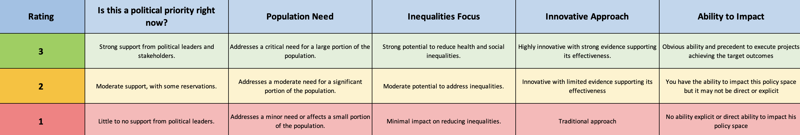
Source: The Health Foundation

What is your level of influence, and over who?

Being clear about the area/s you have influence in is also essential; HiAP is about collaboration, and you will need to enable this. This doesn’t mean it is something only those working in policy development can do; officers and teams working to deliver services also develop and deliver policy which affects people’s health, often in collaboration, including with people who use services.

What do you understand about your population and how their health could be affected?

The starting point to gain commitment to applying HiAP, whether this be within the council and/or from external stakeholders, is – at a high level - a shared understanding of the population’s health and wellbeing, and inequity, and how this may be affected by the plan, policy, programme or service.

More in-depth work to assess the health impacts comes through the application of specific tools described in section 4, in the process of the plan, policy, programme or service being developed or reviewed. However, some of these tools can be used in a ‘light-touch’ way in the planning stage, for example the health impact assessment tool.

Depending on your level of knowledge, it may be preferable to begin by reviewing what the evidence suggests the impacts of your policy or programme topic area could be, before looking to understand your local population and how they may be affected.

Your local public health team should be able to advise on the work you need to do to complete the next steps.

What do you understand about your local population’s health and wellbeing, and inequity?

Your first port of call is the Joint Strategic Needs Assessment (JSNA), analysis of key demographics, local/community health profiles and other research your public health team has undertaken to assess the health and wellbeing of the population. This information is the basis for all local planning to improve health and wellbeing, and there may already be topic specific information relevant to your area of interest, for example on housing, children and young people, physical activity, employment.

Remember that these sources are only as good as the data available to inform them:

- Headline information about your locality can be found on the government’s public health profile tool, Fingertips, but this may not be sufficiently granular or relevant.
- If a HiAP approach hasn’t been applied in your area of work before now, it’s likely you will discover room for improvement in what and how data about the health of the population is collected and used; this is a benefit of HiAP.

If you are reviewing and revising an existing plan, policy, programme or service, it is worth identifying if these were originally developed with some consideration to health and health equity and/or have generated some additional information which could be considered now. Such an example is a homelessness strategy: 2002 legislation required councils with local housing authority responsibilities to complete a homelessness review and publish a strategy every five years; the accompanying Code of Guidance has always recognised the need for this to consider the population’s health and wellbeing.

Finally, it’s useful to understand what the local health and health equity priorities are, for the council and stakeholders; demonstrating how your plan, policy, programme or service relates will help you gain support and focus your HiAP approach. The local Health and Wellbeing Strategy (or equivalent), Integrated Care System Joint Forward Plan, population and health-specific strategies and plans will help with this.

What does existing evidence suggest are the headline impacts of your area of interest on health and wellbeing, and inequity?

When it comes to the wider determinants of health, there are many sources of information about how these impact on health and wellbeing, and health equity. Starting points for evidence about the impact of wider determinants of health include:

- World Health Organisation
- Office for Health Improvement and Disparities
- Public Health Wales
- Public Health Scotland
- The Health Foundation
- The King’s Fund

It may be that professional and other national membership bodies and academics working in your area of interest have undertaken specific research to generate evidence. Examples include:

- Institute of Health Equity
- Town and Country Planning Association (TCPA) Healthy Homes Principles and evidence
- University of Oxford Transport Studies Unit

There’s also guidance about how best to frame these ‘wider determinant of health’ topics to generate support for action in these areas, which will be helpful for collaboration:

- Frameworks UK ‘Building blocks of health’ hub
- ‘Talking about homes: the foundation for a decent life’.

As with understanding your population’s health, and inequity, your local public health team should be able to advise on sources of evidence, including local research.

Finally, it is possible you won’t find answers to questions you and others may have about the potential impact of your topic area on the health of your population, and health equity. Whilst this can be challenging to gain support for HiAP, identifying gaps can also help build the case for using HiAP to generate new insight. It may lead to primary research ahead of policy development, including working with people and communities to gain new insight. Knowledge of gaps can inform which HiAP tools to use, and how to measure and communicate progress.

Who will you collaborate with?

HiAP requires collaboration across systems, sectors and professions (also referred to as inter-sectoral collaboration) and in councils, across directorates and teams.

What makes collaboration work well?

Effective collaboration doesn’t happen by accident; effectiveness depends on a few essentials.

Essentials for effective collaboration in HiAP

- Clear shared goals give people a reason to work together
- Visible leadership and political commitment, and governance, to keep work on track
- Good structures and clear roles make it easier to get things done
- Trust and strong relationships make tough conversations possible
- Shared data and evidence help people stay on the same page
- Involving communities makes sure the work stays relevant, and fair
- Sufficient time and capacity
- Culture of learning and adaptation.

Mapping everyone involved in, and affected by, your area of work will help you identify who you need to collaborate with to enable HiAP. Start with your existing map of stakeholders, but you must consider if these will bring you a perspective from people experiencing inequity. You may need to include with new stakeholders who bring a different perspective for HiAP to be effective.

Collaboration for health and health equity

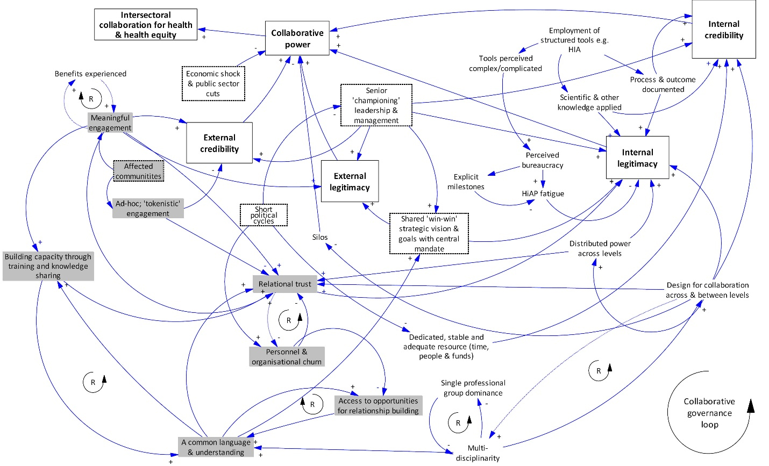
Source: Such E et al (2022)

Working with people and communities

Community engagement is a core component of all good policy-making to improve outcomes, and is essential to HiAP, whatever your area of interest and approach. It will:

- add insight to your knowledge of health and well-being and inequity, and how this could be impacted by changes to a policy, programme or service
- help test whether planned actions might unintentionally widen inequalities, something HiAP specifically aims to prevent
- bring fresh ideas and practical solutions
- raise awareness amongst the population of the factors that impact their health and well-being
- empower people to act, individually and/or as a community, drawing on their assets, to improve theirs’ and others’ health and wellbeing
- generate public support for changes that will improve health and wellbeing (this can be particularly useful should changes face opposition)
- increase transparency and public trust.

In planning and implementing HiAP you should look to relevant and recent community insight that can help inform your work, and – to begin with - to existing engagement mechanisms, working with relevant teams/individuals within the council, and voluntary and community sector organisations. The latter are among those stakeholders who may already be taking a HiAP approach without calling it this, and who may be supportive of you taking this approach in your area of interest.

Learning from the application of HiAP suggests that health equity can often get lost, and that this may be because not enough people experiencing inequalities have been involved in the process. You should recognise this in your planning for HiAP and explore the extent to which existing engagement mechanisms and voluntary and community sector partners can bring this voice.

Refer to the LGA’s resources on community engagement for more information and innovations.

Case study: Liverpool community voice

Have you the capacity to implement a HiAP approach?

Time, capacity and willingness to learn and adapt are common challenges to HiAP in councils, in turn a consequence of resource constraints, short-term funding and related deadlines, and ‘top-down’ reporting requirements. Whilst the latter may be outside the council’s control, HiAP is an opportunity to acknowledge and explore what these challenges look like for those working in your area of interest, with a view to developing local solutions.

Building and facilitating system capability to create healthy environments

Southampton City Council and East Sussex County Council employed specialist Healthy Places Officers to strengthen the public health and planning relationship build capacity for planning for health, andsupport local authorities to deliver health and wellbeing outcomes more widely, delivering on a HiAP agenda. Prior to this, intersectoral activity to build healthy environments was adhoc or reliant on individuals in both local authorities.

An independent evaluation found that postholders were engaging in a diverse range of policy areas including housing, transport and natural environments, leading to developments in intersectoral working, increased workforce capacity and emerging examples of more health relevant policies and plans in both authorities.

For more information see the NIHR funded evaluation
It is also worth considering the culture of your council: is it one that values and actively encourages collaboration throughout its work? Is this modelled, for instance through the Health and Wellbeing Board or other strategic partnerships? Is there system, corporate or stakeholder capacity to help you enable collaboration for HiAP?

A quick self-assessment of local capacity to implement HiAP will be helpful: the following table offers a simple basis that could be adopted and adapted for local council use in planning for HiAP, and during progress reviews.

Capacity for implementing a HiAP approach: self-assessment
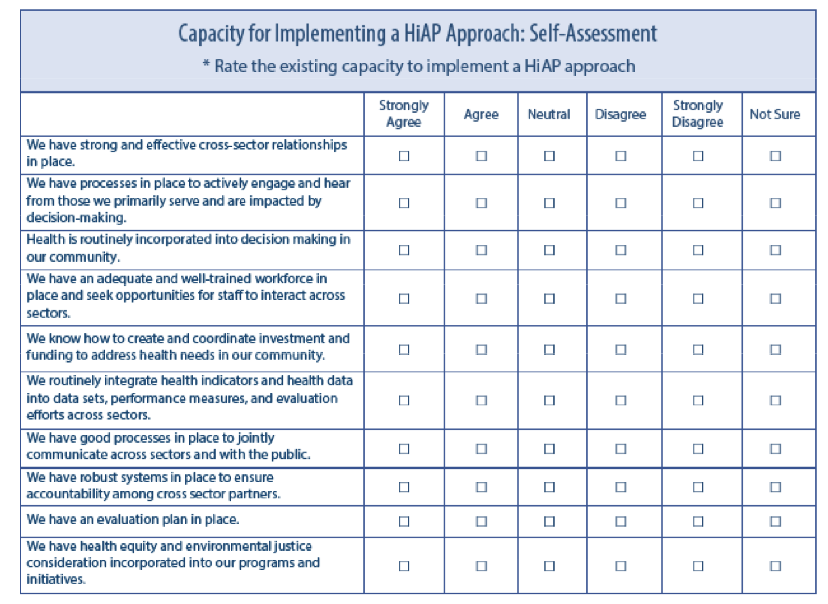
Source: NACCHO HiAP Quick Start Guide

Developing capacity and capability is a valid approach to enabling HiAP locally. Local public health and other teams e.g., spatial planning, are increasingly investing in this. It is also the case that colleagues working in service areas outside of public health may already be considering the population’s health and wellbeing, and health equity, in their work; identifying who these people are and how collaboration with public health can add value will likely enable a better use of time and resources.

Case study: Developing the future occupational therapy workforce in tackling health inequalities, Nottinghamshire County Council

What do you hope to achieve through HiAP?

To achieve health equity, agreeing a shared vision or purpose, outcomes or goals, are essential. They form the basis for effective collaboration, planning for HiAP, measuring and communicating progress.

A clear, shared vision is vital for making HiAP real, whether at systems or council level, or for a single policy or service area. It helps partners align their priorities and understand the benefits for their own goals, not just the goals of improved health and health equity.

A strong vision should link to existing local priorities, for example, those described in the Health and Wellbeing Strategy, or more specific plans such as for climate action or inclusive growth.

Setting a small number of shared outcomes or goals that everyone understands and feels ownership of can be a positive step, and they can build commitment and accountability. These could be framed around statutory duties or local legal powers. Co-producing outcomes with partners and communities also strengthen buy-in and trust: workshops, facilitated sessions or co-production exercises can be useful.
Tools to help plan for and implement HiAP

These are different but complementary tools.

Systems mapping and causal loops
Systems mapping is recommended as the starting point for HiAP. This is a means to understand complexity, and how things relate. It is recommended practice to enable you to consider the formal and informal relationships, influence and power that shape decisions every day. It can help you find practical entry points (opportunities) for applying HiAP, and with a more advanced understanding of the likely impact of change, you will be better able to select which opportunities to progress.

Theory of change
A theory of change helps you clarify the way forward. A practical way to develop a shared vision and clear outcomes, at all levels, this framework can help you explore how planned actions could lead to short and long-term changes, the underpinning assumptions (referring to the systems map), and who needs to be involved. Importantly, a discussion about what success looks like will help you identify how you will measure and communicate progress.

Logic model
A logic model is a simple way to break down your theory of change into clear parts. It sets out the resources you have, the activities you plan to do, and the short- and longer-term outcomes you expect. This can help teams and partners see the links between what they do day-to-day and the bigger changes you want to achieve. It’s also a useful tool for agreeing how you’ll track progress and show whether your actions are having the intended effect.

The Health Foundation’s toolkit provides further information and examples of shared strategic aims, and the use of the theory of change and logic models as a means to measure progress.

What HiAP activities and tools will you apply?

Once you have your scope, opportunity or opportunities, it’s important to choose tools that match your context, the scale and level of your HiAP ambition and support for this, capacity and expertise.

Section 4 introduces the most used HiAP tools and activities, some of which are best used together, for example community engagement in health impact assessments. Some can also be used as tools to measure success, covered in section 5.
Guidance suggests the following should be considerations in your appraisal of HiAP tools:

- Level of decision-making e.g., strategic or operational
- Complexity of the policy/issue
- Time, capacity and capability
- Legal or policy requirements (some contexts may require HIA by law)
- Appetite and buy-in from those you need to collaborate with
- Evidence available (for example, will there be enough data?)
- Familiarity with the tool (many tools are used in good policy-making, not just HiAP).

You should work with your public health team to appraise these. Expertise is needed to use some; if this doesn’t exist in your council, your public health colleagues may be able to advise how else this can be procured, for example working with academic partners.

A practical tip is to start with tools that you will be collaborating with and are already familiar with, then expand when confidence grows. For example, council decisions already require some form of impact assessment to have been completed (as a minimum to meet the Public Sector Equality Duty), and perhaps consideration to wider issues such as the environment and sustainability. Even if HiAP has not been adopted locally, it’s possible there will already be a ‘health consideration’ section in reports to members. Adopting the use of a health impact assessment tool is a logical next step and is most used by councils.

The use of integrated approaches, for example combining health with equality and climate impact assessments, may offer an opportunity to save time and duplication.

What does a strategic approach to HiAP look like?

A strategic approach to HiAP – one that has been developed with consideration to options that will enable you to achieve your vision - will help you embed HiAP in your organisation and local systems, enabling sustainable structural, procedural and culture change.

If you are just starting out in HiAP, being aware of example short term strategic outcomes in the context of a strategic approach aiming for systemic change, should be enough.

If you are already on the HiAP ‘journey’ and have used some HiAP tools and identified room for improvement in how your council and/or wider local system supports and enables HiAP, developing a strategic approach is likely your next step. This is something you should work with your local public health team to develop.

Outcomes from a strategic approach will differ between organisations and the local context. By way of example, the Health Foundation’s Mayoral Regions Programme (MRP) toolkit suggests strategic goals may include:

- Building an organisational mandate for HiAP
- Embedding HiAP as part of organisational culture and ways of working
- Prioritising opportunities for action in particular policy areas

The MRP toolkit also provides examples of activities to achieve these goals, alongside case studies. Further examples of potential outcomes from a strategic approach to HiAP can be found in ‘how do I measure and communicate success?’

Seven strategies, each with suggested tactics, are explored in the SOPHIA Guide for Health in All Policies Implementation, with a supporting strategy selector tool.

Seven strategies for implementing HiAP
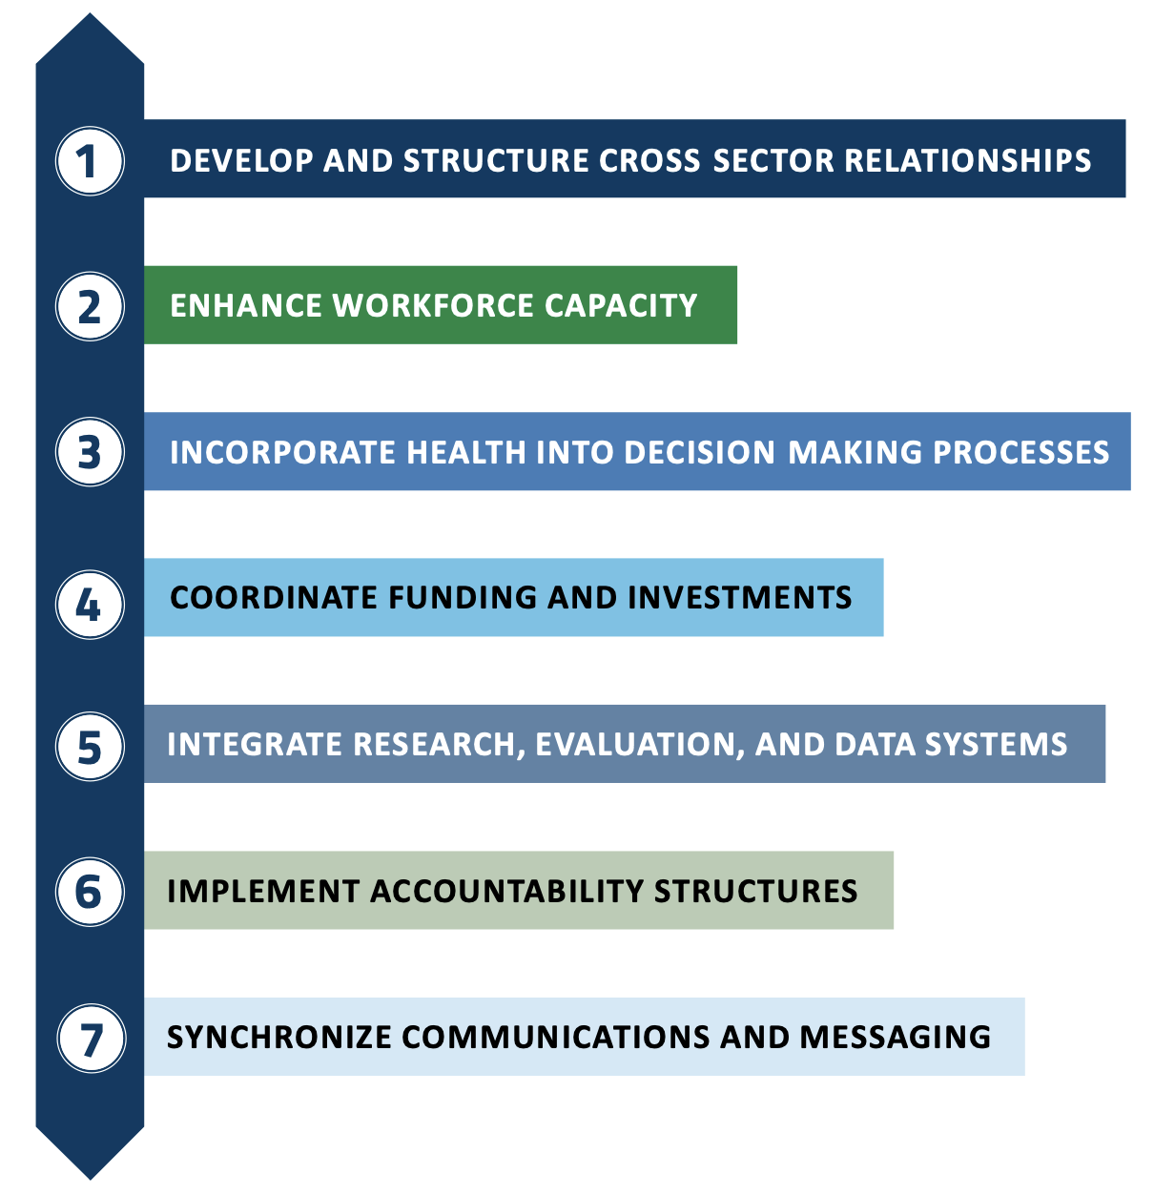
Source: NACCHO and SOPHIA

What governance and accountability are needed?
Whatever level you apply a HiAP approach at, as a councillor or officer, there will need to be some form of oversight for activities.

Governance arrangements should match your capacity, the need for collaboration, and ambition – they should be proportionate. Governance arrangements can help build shared ownership and trust, make it easier to follow through on actions, and show people the benefits of HiAP.

This doesn’t mean setting up new boards or adding layers of process.

- If you’re simply wanting to take a HiAP approach in the review of a service, include this action in your service plan and monitor and report on progress in the same way as other actions.
- If you’re looking to apply HiAP to a complex problem, necessitating collaboration with a wide range of stakeholders, or you want to develop a strategic approach to achieve systemic and cultural change, you will need to identify and assign responsibility for leadership, oversight and accountability to a governance ‘body’.

An effective Health and Wellbeing Board is well positioned to provide governance to a HiAP approach: for examples see ‘What a difference a place makes: The growing impact of health and wellbeing boards’.

How will progress be understood and communicated?
Setting out how you’ll capture and share progress from the start builds trust and helps keep health and health equity on everyone’s agenda.

Section 5 considers this in more detail, reflecting the importance and need for progress in this area to embed sustained consideration to health and equity in all policies.

Working with your local performance, communication and engagement teams could help ensure your approach is aligned with existing ways of working, and that you benefit from their experience and expertise.

Section 4 What tools can I use to apply HiAP?
Section 3 described how to choose the tools that fit your level, scope and capacity. This section begins with an introduction to capacity building, then introduces practical HiAP tools: when to use them, what they do and how they work in practice. Section 5 expands on how many of these tools can also be used to measure and communicate progress.

Capacity building
Many people work in public services because they want to improve people’s lives and make a positive impact on the community; HiAP enables people to do this, whatever their role in local government. Investing in capacity building helps create a culture where thinking about health and health equity becomes ‘just how we do things here’ and not an add-on.

Building capacity and confidence amongst people who have an influence over decisions that affect health and health equity, at all levels, are important to making a HiAP approach work. This can mean raising awareness, providing simple training or briefings for officers and councillors, and sharing practical tools that make it easier to act.

Many local public health teams offer support in this area: some run short workshops or bite-size sessions to help councillors and officers see how their own work links to health and health equity.

[Leics and Warwickshire case studies].

This resource itself is part of capacity building. It gives officers and councillors ideas for how to apply HiAP in their own role, and simple tools to get started.

Tool selection
Not every tool will be right for every situation; appraising what is realistic helps you focus effort where it adds value.

Several tools can be applied to some or all the stages of policy conception, development, implementation and review. Some tools are also used together, for example community engagement in health impact assessments. When specifying work for delivery by an external organisation, you might also request the use of one or more of these tools.

Many of the tools described here can also be used to:
- Plan for HiAP e.g., using a theory of change and prioritising which policies to focus on e.g., health lens analysis.
- Communicate how HiAP can help others
  - They may already be using some of these tools: an additional health perspective should be valued.
  - There may be a desire to use a tool, but not the expertise and/or capacity within the policy area: this may be something you can bring, for example through enabling community participation, or commissioning a complex evaluation.
- Measure and communicate progress in the application of HiAP to a particular policy e.g., a health impact assessment or social return on investment, or the overall approach e.g., a complex evaluation.

Tools to enable HiAP: for application to policies, programmes, services and interventions

The tools below can range from lighter-touch, desk-based activities to highly collaborative, participatory approaches.

You will also find practical templates, real-life examples and checklists in the WHO HiAP Manual, Health Foundation’s Mayoral Region Toolkit and NACCHO’s Quick Start Guide.

HiAP tool | Why and what | When to use | How to use |  | Other information
HiAP tool | Why and what | When to use | Least collaborative | Most collaborative
Health Lens Analysis (HLA) | To assess the potential health impacts of a proposed policy or decision and identify opportunities to improve its impacts on the social, economic and environmental  causes of health.  Similar methodology to health impact assessments. | Flexibly and iteratively, it can help shape early thinking and identify which policy areas to focus on, at the conceptual stage of developing policy and when policies are undergoing review.  Unlike a health impact assessment (HIA) it does not require a policy to be in existence. | Document review for rapid use. | Workshops bringing together people affected by the policy or intervention (residents, users, workforce), policy and decision makers, experts and public health input.  HEA should be co-designed to surface lived-experience equity issues. | Feeds into strategic documents with agreed amendments.
Health Impact Assessment (HIA) | To identify harms and positive impacts, it is a structured process – ideally participatory - to evaluate the potential health effects of proposals. | Flexibly and iteratively, during policy development, implementation and review (it can be used as a monitoring and learning tool). | Desk based assessment using a standard checklist, information about the population’s health and published evidence of impact. |  | Can be rapid, intermediate, or comprehensive based on resources.
Health Equity Assessment (HEA) (Health Equity Assessment Tool) | To enable an understanding of the impact of policies on health equity, an extension of the HIA focusing on effects on different population groups. | Flexibly and iteratively, at policy development and implementation stages to identify and mitigate equity concerns. It can also be used for monitoring and learning purposes. |  |  | Tracks before-and-after equity indicators over time.
Mental wellbeing impact assessment (MWIA) | To identify the mental wellbeing impact of policy, planning or specific programmes. | At the outset, or in the process of reviewing, policy, plans or programmes. | Desktop screening or assessment | Stakeholder workshops, engaging participants in identifying shared understandings of mental wellbeing, priority impacts and actions for improvement. | Take care to ensure consideration to people who already live with mental illness
Environmental and social impact assessments (ESIA) | To identify, predict and evaluate the potential significant positive and negative effects of a proposed project on the environment and society | When a project has potential for significant environmental effects; typically used in spatial planning. | Late-stage public consultation on environmental statements | Early and proactive participation as for HIA/HLA | UK planning legislation only requires strategic environmental assessment (SEA) and environmental impact assessments (EIA)
Environmental Outcomes Reports (EOR) |  |  |  |  | UK legislation replacing the EIA requirement with EOR to make simpler. In 2025 this is not yet an established tool, is in exploratory stage by MHCLG.
Memorandums of Understanding (MOUs) and partnership agreements | To formalise and make visible a commitment to working together to deliver shared outcomes (of which improved health equity is one).  A MoU or collaborative working agreement is a formal agreement between stakeholders, including teams and departments within a council, and between the council and stakeholders. They can define roles, resources, governance, progress reporting etc.. | At the outset of HiAP initiatives, during the early stages of policy planning to set the framework for collaboration and resourcing. | Developed primarily by one party and signed by other/s to make a visible statement. | Co-designed with all proposed signatories, including representative bodies of the end-user in the community (if possible/appropriate).  Published publicly by all signatories to signal commitment and enable accountability. | Can include review clauses and regular check-ins.
Theories of change | To help explore the steps to achieving goals, how and why change is expected in the current context, and assumptions, TOC provides an explanatory framework or map. | Can be used  - As part of developing an overarching plan for HiAP activities  - In relation to specific policies  - As the basis for learning and evaluation.  It may assist with developing relationships, identifying resources and prioritising activities. | Desk-based development in isolation from others, for internal use e.g., learning, not to develop relationships (however, this may be a useful basis for a workshop). | Workshop-based mapping of outcomes and assumptions, in collaboration with stakeholders at all levels. | Highlights implicit assumptions and aids stakeholder consensus on change pathways.  Guides selection of appropriate indicators and evaluation designs.
Logic models | This often sits alongside a theory of change, showing the practical steps to achieving goals.  To describe the sequence of what an interventions intended outcomes are i.e., if we provide X, the result will be Y.  A logic model provides a descriptive framework or map. |  |  |  | Guides selection of appropriate indicators and evaluation designs.
Social Return on Investment (SROI) | To place a value on social, health, environmental outcomes, SROI can help understand and make an economic case for changes to improve health equity. | Typically, post-implementation or during policy review (reliant on outcomes and indicators having been established at an early stage e.g., through TOC or logic model), SROI can also be used to predict how much social value will be created if activities meet their intended outcomes. | Use of a desk-based tool (SROI or cost-benefit analysis). | The first principle of SROI is to identify and involve stakeholders in understanding outcomes and value. | Requires clear boundaries (what is included/excluded) and sensitivity testing of key assumptions.
Appreciative Inquiry (AI) | To identify assets to build a shared vision, AI is a strengths-based participatory approach. | Early in planning – this could be for an HiAP approach or specific policy area - to mobilise stakeholders around successes. | N/R | Facilitated appreciative inquiry workshops. | Fosters a positive culture and complements problem-focused tools.
Community engagement | To enable policies to be rooted in the reality of residents, including how they experience the effects of policies on theirs, and their community’s health and wellbeing.  Can take many forms. | A core component of HiAP and should be used in planning for HiAP, and alongside other HiAP tools.  Throughout policy development, but also during and post-implementation. | Drawing on existing community insight. | Workshops, focus groups, surveys, citizen juries. | Needs quality facilitation, accessible materials and recognition of the cost to participants of contributing.
Data dashboards & integrated indicators | To enable transparency and accountability, to share progress, monitor and learn, web platforms can aggregate health, social, economic, environmental metrics. | During implementation and ongoing review: data dashboards help track what’s happening and show progress. |  | Designed in partnership to reflect diverse audience needs. and inform relevant decisions. | Best with interpretive narration for non-technical audiences.

Section 5 How do I measure and communicate progress?
Good measurement and communication keep HiAP alive: showing small wins, building trust and helping you make the case for investment.

Section 3 recommends that measuring and communicating progress should not be an afterthought. It should be considered as you develop your plan for HiAP and choose tools: many of these can be used both to enable consideration to health and health equity and to measure and communicate the progress made because of applying the HiAP approach.

It can be complicated to understand where to start and how to measure and communicate progress in both the implementation of HiAP and the difference this makes to health and wellbeing, and health equity.

Although the concept of HiAP has existed for many years, research and guidance on measuring progress is relatively recent: growing evidence suggests that being able to capture and communicate progress is essential to effective intersectoral collaboration for health equity. It is important to understand that this is an evolving field and there is no ‘one size fits all’ approach.

Whatever your approach, this section aims to help you understand the options and signpost you to supporting guidance. Working with your public health team will also be important; as a profession this is a particular area of expertise.

What challenges exist to measuring and communicating progress in HiAP, health and wellbeing?

There are challenges to measuring progress, and for this to enable intersectoral collaboration. Recognising these challenges, and considering how they can be overcome locally, in designing your approach to HiAP in whatever form, is essential.

- There are different tools in the HiAP toolbox, and you may be applying one, some or all of them: each of these tools may require different measurement approaches and indicators.
- Outcomes can take a long time to evidence, and it is difficult to attribute these to a specific intervention, including HiAP. The outcome may also be preventative: this is notoriously difficult to measure.
- Numerical outputs are not always effective proxy measures of progress: the number of health impact assessments completed, or the number of people who attended a workshop, do not alone tell you if you’re on your way to improved health equity and other outcomes.
- The local context and systems make a difference to progress in HiAP: evaluations that seek to understand ‘what works, for whom, and in what context?’ demand specialist skills and resources.
- There can be limited local capacity to engage in first establishing and then capturing measures of progress on a regular basis: metrics need to be co-designed, so these reflect local priorities and feel meaningful to people; whilst case studies and storytelling are effective means of demonstrating small, incremental ‘wins’, these take time to generate.
- Some datasets don’t capture what you need or they’re hard to link: linking can be challenging for a multitude of reasons (health data in particular), yet it’s essential for understanding the full impact of cross-sector policies; new or revised measures may require changes to how people work, how data is captured and shared.
- Without regular review points, supported by appropriate governance, measurement is often an after-thought rather than an integral part of decision-making.
- Measures often stay hidden from policymakers, those involved in delivering the policy/programme/service, and to the public: without transparency and accountability, there is less likelihood that the value of HiAP as a process will be understood and support for the approach in the long-term.

What does good look like?

Good practice is a combination of clear governance, the right measures and ways to bring these to life.

Progress in your HiAP approach needs to be measured and communicated in terms of ‘small steps’ and ‘big impact’.

In summary, an effective measurement and communication strategy will:

- Bring together multiple tools under a unified framework, with clear governance, data infrastructure, and reporting rhythms.
- Combine hard metrics (process and outcome indicators) with rich qualitative narratives (stories) to resonate with diverse audiences.
- Embed evaluation into everyday decision-making so that every policy cycle naturally produces both the data and stories you need to demonstrate value.
- Be co-designed and delivered in collaboration; everyone understands why it is important to learn and to communicate progress.

In more detail, a council that has chosen to adopt a ‘Health in All Policies’ approach across the organisation would have the following in place to effectively measure and communicate progress:

- Shared vision and goals, at relevant level/s e.g., system, organisation, policy, programme, service, underpinned by a co-designed, governance owned and embedded, monitoring and communication framework.
- A cross-sector review mechanism, e.g. regular steering group to review progress against agreed indicators, troubleshoot and authorise changes in direction.
- Metrics are built into council key performance indicators and formally reported (just as finance and other performance targets) in relevant governance papers e.g., to Cabinet or the Health and Wellbeing Board.
- An integrated data infrastructure capable of
  - capturing relevant information from across sectors and linked with other datasets and/or underpinned by data sharing agreements/protocols
  - generating regular data to inform an information dashboard or other interface that allows progress to be easily understood by multiple audiences
  - telling a story about progress i.e., there is analysis of available information.
- Capacity and capability to enable effective research, analysis and communication.
- A mixed-methods approach to measurement and communication
  - Quantitative metrics to measure process outputs and outcomes.
  - Qualitative insight such as case studies and storytelling that capture ‘small wins’ and stakeholder feedback on how HiAP has changed decision-making.
  - Process, formative and impact evaluations and other evaluation tools (see table)
  - Complex evaluations to unpack ‘what works, for whom, and in what context’ e.g., realist/process evaluations, and to attribute changes e.g., a pilot or ‘test and learn’ to compare wards with and without an active-travel pilot (see text box)
- Regular, transparent, reporting and communication. This could include:
  - Scorecards: simple infographics showing performance against top-line KPIs for a wide audience, with more detail available for internal governance.
  - An annual HiAP impact report designed for councillors, partners and the public: narrative combining dashboard snapshots, logic model progress, case studies and lessons learned.
  - Tailored briefings: one-pagers for different audiences for example: for leaders - cost-savings; service directors - performance improvements; community groups - tangible local benefits.
  - Storytelling campaigns: short videos or infographics highlighting human stories e.g., a resident whose asthma improved after a low-traffic neighbourhood scheme.
  - Peer learning events: ‘show & tell’ sessions where HiAP pioneers share progresses and pitfalls with peers within or from other councils.

What tools exist?

There are many approaches to measuring progress: choosing the right option is an area where colleagues working in public health and academic partners should be able to provide support. The approach should be reasonable and proportionate to your ambitions, capacity and context, and this should be kept under review as you make progress.

Key considerations in selecting tools

- What is the purpose, and what question you want to answer? Is it, for example ‘did we do what we said we would do?’ (process evaluation) or ‘did it make a difference?’ (outcome evaluation). Do you need real-time feedback to improve what you do, as you’re delivering (formative evaluation), or do you want a final verdict (summative evaluation).
- What are the characteristics of the tool? Is it a mature tool e.g., a health impact assessment? Is it a small pilot or something larger? What is the timeframe for application of the tool?
- What data needs to be and is available? Is there existing data, or will new data need to be collected? Will data need to be linked/shared?
- What resources and capacity do you have access to? Who do you have access to commission and deliver the research? What is the period for the research, and how much funding is available?
- Who are the stakeholders and audience? What do decision makers need e.g., to make the case for future investment? What forms of communication do audience members respond to best e.g., residents may prefer case studies and stories?
- What are the governance requirements? When do evaluation milestones need to be met (should be in the project plan)? When do findings need to be presented to governance meetings to inform decisions?

Below are commonly used tools and approaches to learning and evaluation, many of which can also be used as the basis for considering health and health equity in policies (section 4).

HiAP tool | Primary forms of evaluation
1. Health Impact Assessment (HIA) | Process evaluation: Examines whether the HIA followed established steps (screening, scoping, appraisal, recommendations, monitoring) and was completed in a timely manner. | Formative evaluation:  Gathers stakeholder feedback during HIA development to improve the quality and relevance of the assessment. |  | Summative or outcome evaluation:  Tracks how many HIA recommendations were adopted and ties those to downstream health or policy changes (e.g., changes in air quality, physical activity rates).
2. Health Equity Impact Assessment (HEIA) | Equity-focused evaluation:  Measures differential impacts across subpopulations (e.g., by income, ethnicity, disability) to see if the HEIA reduced or narrowed inequities. |  | Before and after comparisons: Compares equity-sensitive indicators (e.g., service uptake, morbidity gaps) before and after the HEIA-informed policy.
3. Health Lens Analysis (HLA) | Step-by-step fidelity review:  Assesses adherence to the HLA five-step process, often via document review and key-informant interviews. |  | Action-tracking evaluation:  Monitors which cross-sector actions negotiated during the HLA were implemented.
4. Policy Audit & Mapping | Gap analysis:  Reviews existing policy documents for inclusion of health considerations—quantifying “% of policies with health language” |  | Benchmarking:  Compares against best-practice templates or neighbouring or peer councils to identify areas for improvement.
5. Multi-Criteria Decision Analysis (MCDA) | Decision-process evaluation:  Documents how health, economic, social, and environmental criteria were weighted and scored—often via meeting observations or surveys of decision-makers |  | Retrospective validation:  Compares predicted versus actual performance on the chosen criteria once the policy is in place
6. Social Return on Investment (SROI) Analysis | Economic evaluation: Calculates the ratio of social value created (e.g., cost savings in health/social care, productivity gains) to the investment made. |  | Cost-benefit and sensitivity analyses:  Tests how robust the SROI ratio is to changes in key assumptions (e.g., discount rate, attribution of benefits).
7. Memorandums of Understanding (MOUs) / Partnership Agreements | Governance evaluation:  Tracks adherence to MOU terms—meeting frequency, cross-budget contributions, agreed deliverables. |  | Network analysis:  Uses social-network metrics to assess the strength and density of inter-agency relationships established by the MOU.
8. Logic Models & Theories of Change | Logic-model monitoring:  Monitors inputs, activities, outputs, and early outcomes against the model’s milestones. |  | Contribution analysis:  Uses qualitative and quantitative data to assess the plausibility that observed outcomes stem from the mapped activities.
9. Appreciative Inquiry (AI) | Participatory evaluation:  Conducts follow-up workshops to see whether the strengths‐based actions identified through AI were mobilised and sustained. |  | Narrative outcomes assessment:  Captures stories of change that illustrate the positive shifts in relationships, culture, or practice.
10. Participatory Budgeting & Community Co-Design | Process & engagement evaluation:  Measures levels of community attendance, diversity of participants, and satisfaction with the process. |  | Impact evaluation:  Assesses whether community-selected projects delivered on promised health or social outcomes
11. Data dashboards & integrated indicators | Use analytics:  Tracks dashboard use, page views, and reports generated by different departments. |  | Decision-reference evaluation:  Surveys policymakers to determine how often and in what ways they used the dashboard data in decision-making.
12. Case studies & storytelling | Qualitative case evaluation:  Develops in-depth narratives, using interviews and focus groups to document process, challenges, and perceived impacts. |  | Outcome harvesting:  Identifies and verifies unexpected as well as planned outcomes arising from the case.
13. Peer learning & mentoring | Network learning evaluation:  Surveys participants on knowledge transfer, confidence gains, and practice changes resulting from mentoring. |  | Progress tracking:  Compares mentee councils’ HiAP milestones (e.g., new MOUs signed, HIAs completed) pre- and post-mentorship.

Complex evaluations

A complex evaluation combines qualitative and quantitative methods to answer questions like “what works, for whom, and under what circumstances?”

These are particularly relevant if your HiAP approach is multi-layered i.e. you are applying more than one HiAP tool at the same time and/or you are taking a strategic approach with the intention of enabling systemic and cultural change.

An example could be you are embedding a public-health practitioner in a planning team, conducting health impact assessments and launching a community co-design workshop all at once. You need to understand not just whether things changed, but how they changed, why some tools succeeded, and others didn’t, and what made the difference – for example political support, staff capacity, community trust).

A complex evaluation shines a light on the less visible mechanisms of HiAP, helping you refine strategies, tailor support, and replicate progress in other settings.

Examples of complex evaluation approaches used in relation to HiAP include:

- Realist evaluations: useful for understanding which tools in a HiAP package worked [Ref Pawson et al]
- Developmental evaluation: useful during early stages of applying HiAP tool e.g., community engagement, to learn and adjust the course of action
- Systems mapping and causal loop analysis: useful to enable stakeholders across different systems to understand how these interact, and how changes in one part of the system may affect another part; can identify which points to change, and unintended consequences. See the ‘collaboration for health and health equity’ diagram for an example of a systems map and causal loop diagram relevant to HiAP.

How do I measure progress in adopting a HiAP approach?

‘What does a strategic approach look like?’ introduces examples of goals that you may wish to set when you are at the stage of wanting to enable culture change in your organisation or local system so that HiAP becomes business as usual.

The next table describes further examples of outcomes you may wish to measure, from those that might be relevant to the short term and discreet application of HiAP to a service or single policy area, to those relevant to enabling organisational and structural change.

Potential outcomes of HiAP activities
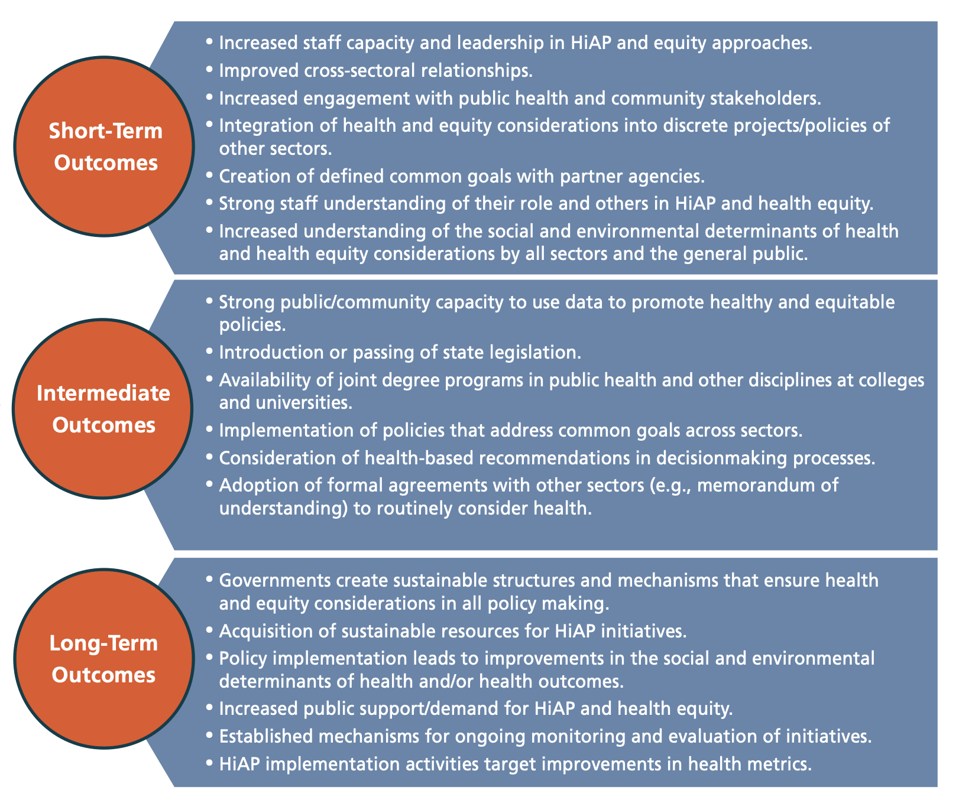
Source: ASTHO Health in All Policies: a framework for state health leadership.

Example metrics alongside some of these outcomes are described here, with further examples found in Health in All Policies Evaluation Guidance.

Outcome / goal | Process metric | Outcome metric
Improved cross-sectoral relationships | Relationship quality and frequency of collaboration with local public, private and non-profit stakeholders  Number of sectors engaged in partnership | Increased number of stakeholders that understand HiAP principles and practices, and the value of this approach
Consideration of health and health equity is incorporated in decision making processes | Stakeholder agreement on which opportunities are most amenable to HiAP  Number of health impact assessments (or other HiAP tool) initiated/underway/completed | Increased percentage of health and health equity assessment recommendations are incorporated into policies, programmes, plans and services  Increased percentage of policies, programmes, plans, and services that incorporate HiAP language, perspectives and goals
Increased transparency in, and availability of intelligence to inform, decision making that impacts on health and wellbeing, and health equity | Number of public, private, and non-profit stakeholders sharing data to enable a better understanding of the health and wellbeing of the population, and health equity  Number of community-facing data sharing tools created e.g., dashboards, reports, newsletters, case studies | Stakeholders have an increased understanding of the health and wellbeing of the population, health equity, and the correlation between their work/activities  Increased awareness of the difference being made to the population’s health and wellbeing, and health equity

How do I measure progress in improving the wider determinants of health?

The starting point is the Fingertips tool ‘Wider determinants of health’ profile, established specifically to provide the public health system with intelligence regarding the wider determinants of health to help improve population health and reduce health inequalities. In addition to highlighting relationships between wider determinants and other risk factors and health outcomes, it also provides a set of indicators which describe a range of wider determinants of health and enable a comparison of these factors between areas.

A number of Marmot places have created local indicator sets to monitor local inequalities and the impact of local interventions: more information can be found at the Institute of Health Equity: monitoring and evaluating progress.

Recognising that it can be a challenge to monitor progress on the wider determinants of health, and to support the adoption of HiAP internationally, the World Health Organisation has developed an operational framework for monitoring social determinants of health equity.

Your local public health team will be well placed to support you on identifying appropriate measures for your locality.

Section 6 Frequently asked questions and common misconceptions
To help address questions you or others may have about why you should adopt a HiAP approach, this section provides the most common questions and concerns from councillors and officers.

- I’m not responsible for health: it’s not in my job title or portfolio
If your decisions shape the places people live, the services they use, or the support they receive, they influence health and wellbeing. Whether you're designing housing policy, setting licensing conditions, shaping budgets or providing a frontline service, your decisions have the potential to affect residents’ health and wellbeing. HiAP helps you explore and connect what you do to improving the population’s health and health equity.

- I’m not an expert on health
You don’t need to be. This isn’t about medical knowledge; it’s about recognising that the work you do has an impact on people’s lives and working with others to strengthen that. Public health teams and wider stakeholders, including the community, can help with evidence, ideas and tools. It’s a shared process, not something you have to do alone. You bring your own essential expertise in planning, housing, transport, finance or other areas; HiAP simply helps you make the connections, ask the right questions, and work with others to get better outcomes.

- What is the public health team’s job?
Health in All Policies (HiAP) is a shared responsibility, and many of the decisions that affect health are made outside of the public health team. Public health teams generate and can signpost you to information about the health of the population and evidence of the relationship between your area of work and health. They can also offer expert advice and support on planning, the use of tools and measuring progress; further support may be available, subject to their capacity. HiAP is about making the most of everyone’s contribution—housing, planning, transport, education, finance, and others. HiAP simply helps you get the most value and fairness out of the work you already do.

- We already think about health in what we do, what’s different about this?
HiAP helps you go deeper and more systematically. Instead of assuming health is already ‘in the mix,’ HiAP offers tools and approaches to check for unintended impacts, address inequity, and strengthen benefits. Considering health inequity is also essential to meeting the Public Sector Equality Duty. HiAP also helps make the health impacts of your work visible to colleagues, communities, and funders.

- We already fill in a ‘health considerations’ or ‘health impact assessment’ section when we submit reports—what’s different about HiAP?
That’s a good start, but HiAP is about more than filling in a box. It encourages upstream thinking in policy, programme and service development, not just form-filling having already reached a conclusion. Instead of asking about health after decisions are made, HiAP helps you consider health and health equity early on, when proposals can still be shaped. It also supports more meaningful collaboration, helping people work across systems and sectors and council departments to get better outcomes, not just better paperwork.

- Isn’t this just a repackaged Equality Impact Assessment?
No, though it complements and strengthens it. An Equality Impact Assessment (EqIA) focusses on protected characteristics; HiAP looks more broadly at the social, economic, environmental and policy factors that shape health and wellbeing. Used together, they ensure both legal compliance and better outcomes. Positive practice is to integrate health and health equity impact assessment (HiAP tools) with other assessments including EqIA, environmental or sustainability impact to create a more rounded, efficient approach. Used well, they help meet statutory duties and improve decision-making.

- Won’t this slow us down, particularly the need to collaborate?
It’s true that collaboration takes some time up front, but it can save time later by avoiding duplication, preventing problems, and reducing friction between people and teams. HiAP isn’t about involving everyone in everything. It’s about focusing effort where it adds value, asking the right questions early, and building relationships that help decisions move more smoothly. Done well, it leads to better results and fewer delays. It can also help reduce future service demand by preventing problems early.

- We don’t have the time or capacity for this
That’s exactly why HiAP matters. It’s not about adding new work, it’s about working smarter, not harder. HiAP can create win-wins across departments: whatever your area of work, it has potential to help you achieve your outcomes, whether this be economic growth, reducing homelessness, climate change resilience, alongside health outcomes. It can also prevent costly mistakes and reduce future demand for services. There are options for you to start small, using quick tools or pilots, and build over time. Working with public health colleagues, you may discover additional capacity, for example to carry out research in partnership with local academic institutions.

- How do we know it works?
There’s strong evidence from the UK and internationally that HiAP helps deliver better health, fairer outcomes, and long-term savings. Councils using HiAP have seen improvements in housing, air quality, school readiness, and resident engagement. It’s a pragmatic approach backed by results.

- Do we have to do this?
While there’s not currently a single duty that says ‘you must do Health in All Policies’, it helps meet existing legal duties like the duty to improve public health duty (Health and Social Care Act 2012) and the Public Sector Equality Duty, and policy specific requirements for example net zero or inclusive growth requirements. It’s also increasingly expected by partners, residents, and the government; the latter is proposing a general HiAP duty on new strategic (combined) authorities.

- Will we be judged or inspected on this?
Not currently for HiAP explicitly, but the approach can help you and those you collaborate with perform better in areas of work and metrics that are inspected or reported. For example, Ofsted considers child wellbeing; the Care Quality Commission looks at place-based partnerships; the Regulator of Social Housing requires providers to co-operate to promote social, environmental and economic wellbeing. We also know that residents expect and benefit from joined-up services. HiAP helps you show how you’re delivering on shared outcomes.

- How will people know if we’re making progress?
HiAP can help measure and communicate progress more effectively, building trust. Section 5 explains how to keep measurement proportionate. The key is to show small wins, share stories, and build evidence that your work makes a difference, for health, equity and local priorities.

- Isn’t this just good policy-making?
Yes, particularly for complex problem solving. And HiAP helps you do more of it, more consistently. It gives you the tools, evidence and support to make fairer, more joined-up decisions. It turns good intentions into better processes and better outcomes.

