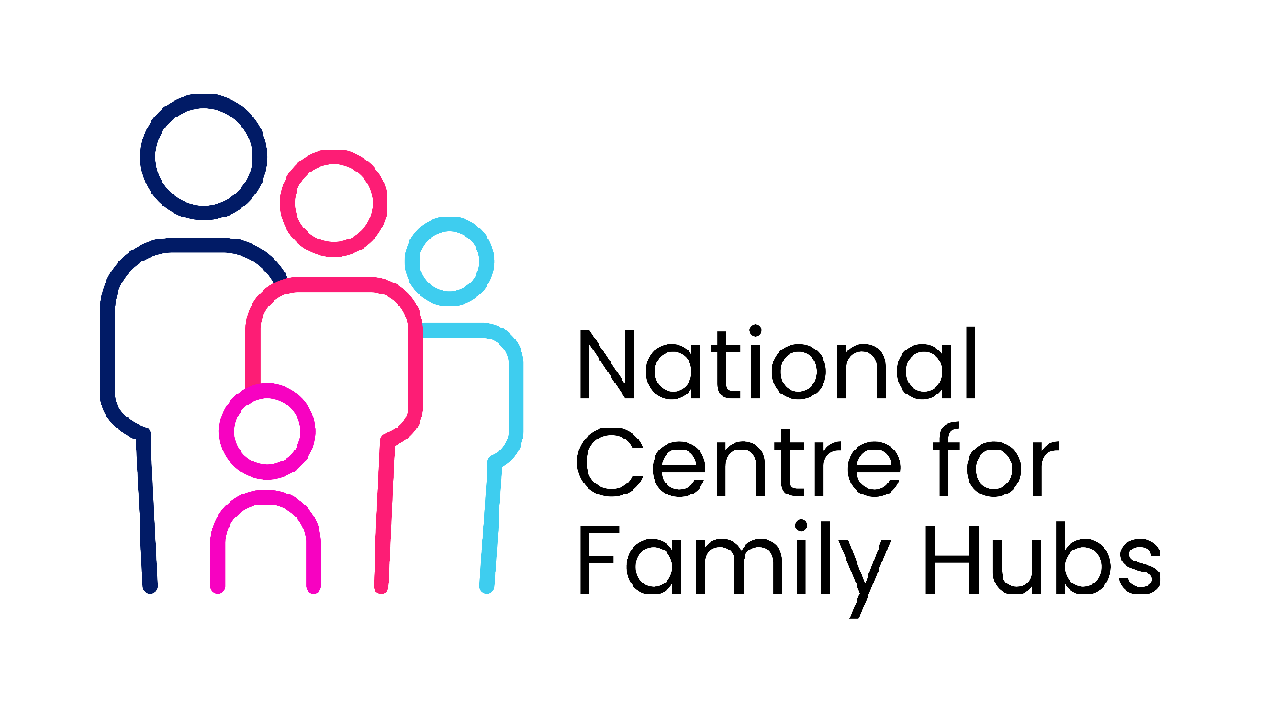Family Hub Volunteer Code of Conduct Agreement
1. Purpose
This Code of Conduct sets out the standards of behaviour, professionalism and responsibility expected of all volunteers at the Family Hub. It helps ensure a safe, respectful and supportive environment for children, families, staff and volunteers.
All volunteers are required to read, understand and agree to this Code as a condition of volunteering.

2. Our Values
Volunteers are expected to uphold the Family Hub’s values by:
- Treating all children, families, staff and volunteers with dignity and respect
- Acting in a way that promotes safety, trust and inclusion
- Supporting the Family Hub’s vision to strengthen families and communities

3. Professional Behaviour
As a Family Hub volunteer, you agree to:
- Act in a professional, reliable and responsible manner at all times
- Follow the guidance of staff and work within your agreed volunteer role
- Arrive on time and inform the Hub as soon as possible if you are unable to attend
- Maintain appropriate boundaries with children, young people and families
- Avoid behaviour that may bring the Family Hub into disrepute
Volunteers must not:
- Use inappropriate, offensive or discriminatory language or behaviour
- Be under the influence of alcohol or drugs while volunteering
- Accept gifts or money from families without permission from a member of staff
- Provide personal contact details to service users without approval

4. Safeguarding and Duty of Care
Safeguarding is everyone’s responsibility. Volunteers must:
- Follow the Family Hub’s safeguarding and child protection procedures at all times
- immediately report any safeguarding concerns, disclosures or worries to a member of staff
- Never promise to keep secrets from children or families
- Work openly and transparently and avoid situations where they are alone with a child unless agreed and risk-assessed
Volunteers must not:
- Discipline children physically or verbally
- Take photographs or videos of children or families using personal devices
- Transport children or families unless explicitly authorised

5. Confidentiality and Information Sharing
During your volunteering, you may have access to personal or sensitive information. Volunteers must:
- Keep all information about children, families, staff and the organisation confidential
- Share information only with authorised staff and only when appropriate
- Store any information securely and return any documents when requested
- Follow data protection and confidentiality policies at all times
Confidentiality must be maintained even after volunteering ends, unless there is a safeguarding or legal duty to share information.

6. Equality, Diversity and Inclusion
Volunteers are expected to:
- Treat everyone fairly, regardless of background or personal characteristics
- Respect differences in culture, faith, identity, family structure and experience
- Challenge discrimination appropriately or report concerns to staff
Discriminatory, bullying or harassing behaviour will not be tolerated.

7. Health and Safety
Volunteers must:
- Follow health and safety guidance and risk assessments
- Use equipment safely and as instructed
- Report accidents, near misses or hazards immediately
- Take reasonable care of their own safety and that of others

8. Use of Social Media and Communications
Volunteers must:
- Not post photos, videos or information about families, children or the Family Hub on personal social media
- Not comment publicly on Family Hub matters without permission
- Maintain professional boundaries in online communication

9. Raising Concerns and Whistleblowing
Volunteers are encouraged to speak up if they:
- Have concerns about unsafe practice
- Witness behaviour that breaches this Code
- Are worried about the welfare of a child, family member or colleague
Concerns will be taken seriously and handled appropriately.

10. Breach of the Code of Conduct
Failure to follow this Code of Conduct may result in:
- Additional support, guidance or training
- Temporary suspension from volunteering
- Termination of the volunteer role in serious cases

Volunteer Declaration
I confirm that I have read and understood the Family Hub Volunteer Code of Conduct. I agree to follow the expectations set out in this document and understand that failure to do so may result in action being taken.
Volunteer Name: __________________________
Signature: _______________________________
Date: _______________________________
Volunteer Role (if known): ___________________________

