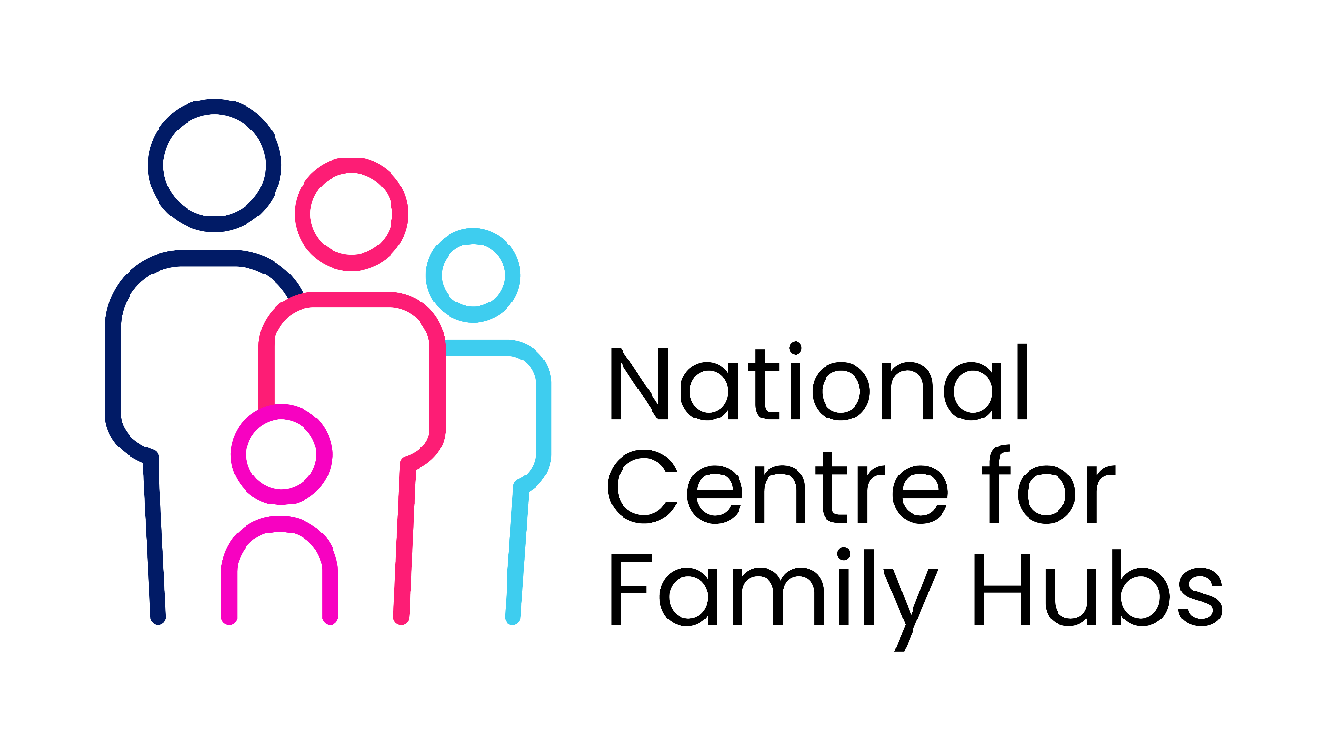
Communication Plan Template
This Communications Plan Template provides a structured framework for Family Hubs and Libraries to coordinate their messaging. It ensures that staff, parents, and community partners understand how the two services work together, what programs are available, and how to access them.

CO-BRANDED COMMUNICATIONS PLAN TEMPLATE
Project Title: Family Hubs & Libraries Integration Initiative
Date: [Insert Date] | Review Date: [Insert Date]
1. Objectives
- Awareness: Raise visibility of integrated Family Hub and Library services among local parents and carers.
- Engagement: Increase attendance at joint sessions (e.g., Hub-supported stay-and-play sessions hosted at the library).
- Internal Alignment: Ensure staff in both services use consistent language and understand referral pathways.
2. Key Target Audiences
- Universal Audiences: Parents, carers, and guardians of children aged 0–19 (up to 25 for SEND).
- Targeted Audiences: Expectant parents, isolated carers, low-income families, and families requiring digital inclusion support.
- Internal Stakeholders: Library frontline staff, Family Hub practitioners, health visitors, and volunteer networks.
3. Core Messaging Framework
- The "Elevator Pitch": "Your local library and Family Hub are working together to bring support closer to you. From free early years groups to expert parenting advice, we are here to help your family thrive."
- For Parents: "A warm welcome, fun activities for your kids, and access to friendly family support—all under one roof at your local library or hub."
- For Staff: "By connecting our services, we make it easier for families to get the right help at the right time, reducing the need for them to repeat their stories to multiple departments."
4. Communication Channels & Tactics
In-Venue Marketing (Physical)
- Co-branded Signage: Banners and posters placed at library entrances and Family Hub reception areas.
- Information Kiosks: Dedicated "Family Hub Corners" inside libraries featuring leaflets on health, housing, and parenting courses.
- Pop-Up Desks: Family Hub outreach workers hosting drop-in advice sessions inside library spaces during peak family hours.
- Use of the BSIL Logo: Follow the Department for Education guidelines for using the BSIL logos. https://campaignresources.dhsc.gov.uk/campaigns/best-start-in-life/best-start-in-life-brand-and-campaign-awareness/brand-guidelines/
Digital & Social Media
- Cross-Promotion: Libraries tag Family Hub social accounts in "Rhymetime" posts; Family Hubs promote library digital resource schemes.
- Unified What’s On Guide: A shared, downloadable monthly PDF calendar hosting all events across both venues.
- Direct Messaging: Inclusion of Family Hub updates in existing library email newsletters and vice versa.
Community Outreach & Partners
- Professional Networks: Toolkits distributed to health visitors, midwives, and local schools to ensure they signpost families to both venues.
- Community Champions: Briefing local parent volunteers to spread word-of-mouth updates in neighbourhood groups.
5. Key Messaging Calendar (Sample Layout)
Phase / Month | Key Message / Campaign Focus | Primary Channels | Target Audience | Lead Responsibility
Month 1 | "Launch of New Joint Timetable" | Social media, flyers at checkout, staff briefings | Universal Parents | Joint Comms Team
Month 2 | "Free Digital Skills for Parents at the Library" | Library PCs, Hub family support workers | Low-income/Digitally isolated | Library Digital Lead
Month 3 | "Healthy Start / Weaning Hubs at the Library" | Midwife clinics, Hub newsletter | Expectant/New parents | Family Hub Health Team
6. Crisis and Enquiries Protocol
- Media Enquiries: All press requests regarding the partnership must be directed to [Insert Council/Authority Press Office Contact].
- Public Enquiries: General public questions should go to [Insert Shared Email Address/Phone Number].
- FAQ Sheet: Frontline staff will be provided with a live "Frequently Asked Questions" document to handle complex enquiries uniformly.
7. Evaluation & Metrics
- Digital Metrics: Website clicks on the joint timetable, social media engagement rates, and newsletter open rates.
- Footfall Metrics: Attendance numbers at joint library/hub sessions and the number of new library cards issued during hub events.
- Referral Metrics: Total number of families signposted from the library to the hub (tracked via the Data Sharing Agreement framework).

