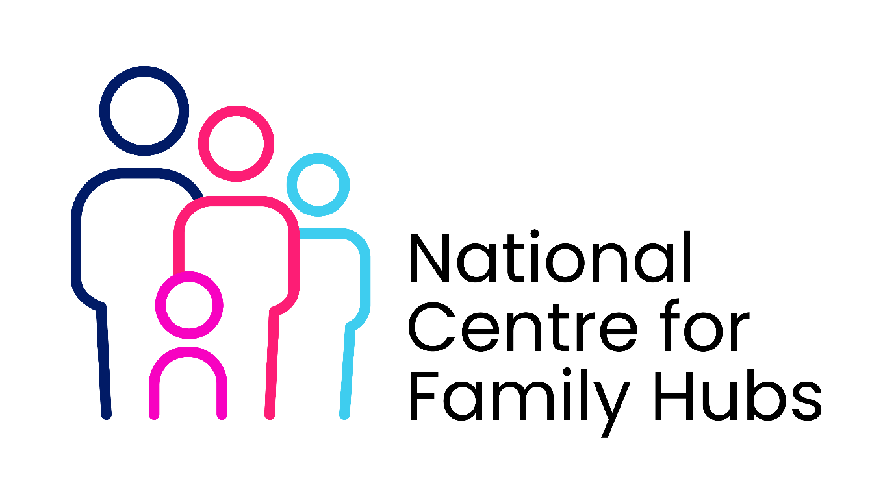

Core Knowledge for All Staff working with families impacted by parental imprisonment
All staff working within Family Hubs and partner organisations should have a shared baseline understanding to ensure consistent, high-quality support.
Impact of imprisonment on children
Practitioners should understand:
- The emotional impact (e.g. anxiety, shame, grief, confusion)
- Behavioural responses (e.g. withdrawal, anger, disengagement)
- Effects on development, learning, and school readiness
- The wider context of instability, poverty, and disrupted routines
What this means in practice:
- Recognising signs that may indicate parental imprisonment
- Interpreting behaviour as a potential response to trauma
- Responding in ways that are supportive rather than punitive

2. Trauma-informed practice
All staff should apply trauma-informed approaches, including:
- Understanding how trauma affects development and behaviour
- Creating safe, predictable, and trusting environments
- Avoiding re-traumatisation through language or processes
What this means in practice:
- Using calm, consistent communication
- Building strong, trusting relationships over time
- Adapting support to the child’s emotional needs

3. Reducing stigma
Practitioners must actively challenge stigma and ensure families feel safe accessing support.
This includes:
- Using non-judgemental language
- Avoiding labels or assumptions
- Promoting dignity, respect, and inclusion
What this means in practice:
- Creating environments where families feel welcomed and understood
- Supporting children to feel confident and not defined by their circumstances
- Ensuring services are accessible without fear of judgement

