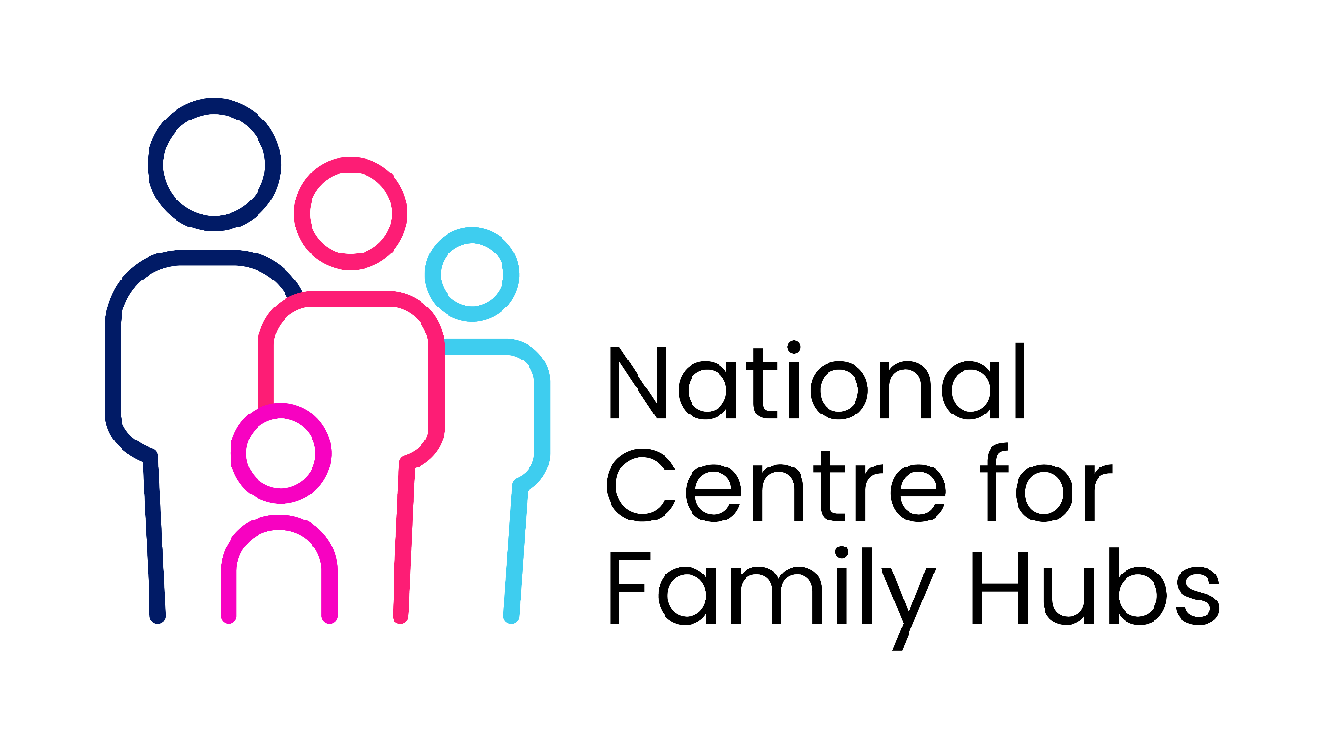
Data Sharing Agreement
This Data Sharing Agreement (DSA) Template establishes the legal and operational framework for sharing information between Family Hubs and Library Services. It ensures compliance with data protection laws (such as the UK GDPR and Data Protection Act 2018) while enabling seamless, holistic support for families.

DATA SHARING AGREEMENT (DSA)
Between [Name of Family Hub Service/Lead Authority] and [Name of Library Service]
1. Purpose and Objectives
- Primary Objective: To enable safe, lawful, and effective information sharing between Family Hubs and Libraries to improve outcomes for children and families.
- Specific Use Cases:
  - Cross-referring families to early years, digital inclusion, or welfare support.
  - Identifying low-income or vulnerable families eligible for targeted library/hub programs.
  - Co-delivering integrated services (e.g., matching hub outreach data with library bookstart sign-ups).
2. Legal Basis for Processing
- Family Hub Legal Basis: [e.g., UK GDPR Article 6(1)(e) - Public Task; Article 9(2)(g) - Substantial Public Interest for special category data].
- Library Service Legal Basis: [e.g., UK GDPR Article 6(1)(e) - Public Task under the Public Libraries and Museums Act 1964].
- Consent Framework: Where explicit consent is required (e.g., for direct marketing or non-statutory referrals), the specific, informed, and written consent of the service user will be obtained using a standard consent form.
3. Scope of Data to be Shared
- Personal Data: Names, dates of birth, contact details (address, phone, email), and family composition (names/ages of dependents).
- Special Category Data (Only where necessary): Ethnicity (for equity tracking), language needs, disability/SEN status, and specific vulnerability flags.
- Data Minimisation: Only the minimum necessary data required to fulfill the specific referral or service objective will be shared.
4. Data Transfer and Security Measures
- Transfer Methods: Shared data must only be transmitted via secure, encrypted channels (e.g., secure email, restricted access shared drives, or direct integration between case management systems).
- Access Control: Access to shared data is strictly limited to authorized personnel within both organizations who require it for their direct duties.
- Storage: Data must be stored on secure servers with robust password protection and multi-factor authentication (MFA).
5. Roles and Responsibilities
- Data Controllers: Both parties agree they act as [Joint Data Controllers / Independent Data Controllers] for the data shared under this agreement.
- Single Points of Contact (SPOCs):
  - Family Hub Lead: [Name, Title, Contact Info]
  - Library Service Lead: [Name, Title, Contact Info]
6. Data Retention, Breaches, and Review
- Retention Period: Shared data will be retained only for as long as necessary to fulfill the service purpose, in line with [Insert Authority Name] Retention Schedule, and securely destroyed thereafter.
- Data Breach Procedure: In the event of a suspected or actual data breach, the discovering party must notify the other party’s SPOC within 24 hours.
- Review Cycle: This agreement is valid for [e.g., 12 or 24 months] from the date of signing and will be reviewed annually.
7. Signatures and Agreement
By signing below, both parties agree to adhere to the terms, conditions, and legal obligations outlined in this Data Sharing Agreement.
For [Family Hub Service]:
Authorized Signature: ______________________ Name/Title: ______________ Date: _________
For [Library Service]:
Authorized Signature: ______________________ Name/Title: ______________ Date: _________

