Contents

Trial design 2

Treatment Email 1: For schools that rarely make referrals 3

Treatment Email 2: For schools that already refer 4

Treatment Email 3: For schools unlikely to have eligible children 5

Control email 1: For schools that rarely make referrals 6

Control Email 2: For schools that already refer 7

Control Email 3: For schools unlikely to have eligible children 8

# Trial design

The purpose of the trial is to establish whether a behaviourally informed email is more effective at eliciting early expressions of interest from schools for independent travel training, compared to previous communications (the control). It must be noted that since the service never advertised their provision via email, the control was created as an amalgamation of previous communications with individuals and it is therefore anticipated that the control will lead to a higher volume of interest compared to an average month.

A ‘matched’ control trial, or a trial where the schools are split into two groups with pre-defined characteristics (quasi-random approach), in this instance the same volume of schools and communication type is proposed. Out of 127 schools with 769 pupils on council provided transport, around two thirds had to be excluded due to certain eligibility criteria not being met, namely distance from Croydon and high level of need (too high to be travel trained). A final sample of 46 schools attended by 250 pupils was used.

Following a request from the service the treatment and control groups consisted of 3 different communication types, split by schools’ existing involvement with ITT: schools that already refer pupils to ITT, schools that never or rarely refer but are likely to have pupils that would benefit from ITT and schools that never or rarely refer but are unlikely to have pupils that would benefit from ITT.

The different communications types were used to ensure a continued positive relationship between schools and the service, by recognising positive behaviours or the presence of barriers out of their control that prevent the positive behaviours to minimise inappropriate negative feedback. Due to the high similarity of the three groups in conjunction with the low sample size, the letters are grouped together into control and treatment groups and no hypotheses are made on individual effect of different communication type.

Treatment Email 1: For schools that rarely make referrals

Subject: Response Required: Independent Travel Training, Invitation to Express Interest

Dear<<Insert Name>>,

**Don’t let your pupils miss out on the benefits of Independent Travel Training**

We have noticed that **you have not yet referred any pupils to Independent Travel Training (ITT)**, whilst other schools similar to yours have.

If you have any SEND pupils who would benefit from learning how to travel to school independently whilst gaining other vital life skills, please let us know as soon as possible. The **demand is very high** this year and we need to be aware of any further interest to plan accordingly.  

All you need to do is **reply to this email now** with the following information:

1.     1. Contact details of individual responsible for ITT referrals:

**Name:**

**Email:**

2.     2.  Please type **X** alongside your response in the table below:

|  |  |
| --- | --- |
| **Yes, we have pupils suitable for ITT and we are interested in applying** |  |
| **We have pupils who may be suitable, but need help deciding (please contact me)** |  |
| **None of our pupils are currently ready for ITT** |  |

**What to expect from Independent Travel Training:**

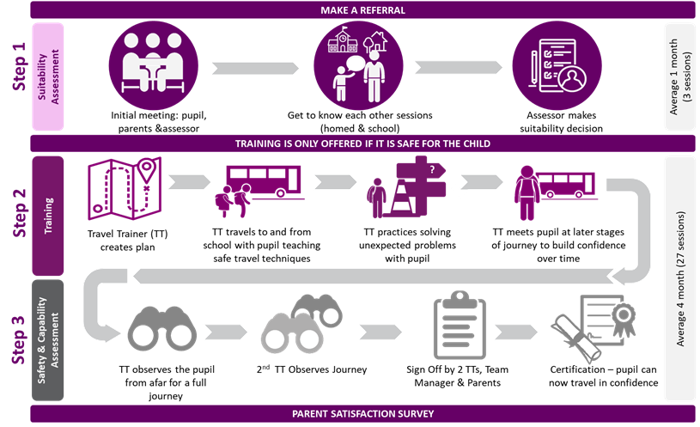

ITT is worth around £1,100 depending on need and is offered free to children who are currently in receipt of council provided transport, but we can provide a quotation for children who do not qualify, which can be funded through other channels such as their SEN delegated budget. For more details on who can benefit from travel training and what the program entails please see the attached leaflet.

We very much look forward to hearing from you and will reply within five working days of your email.

Kind regards,

Jackie

# Treatment Email 2: For schools that already refer

Subject: Response Required: Independent Travel Training Check In

Dear <<Insert Name>>

**Don’t let your pupils miss out on the benefits of Independent Travel Training**

**Thank you** for your continued support with travel training referrals and making sure your pupils don’t miss out on the opportunity to gain more independence.

If you have more SEND pupils who would benefit from learning how to travel to school independently whilst gaining other vital life skills, please let us know as soon as possible. The **demand is very high** this year and we need to be aware of any further interest to plan accordingly.  

All you need to do is **reply to this email now** with the following information:

1.     1. Contact details of individual responsible for ITT referrals:

**Name:**

**Email:**

2.     2.  Please type **X** alongside your response in the table below:

|  |  |
| --- | --- |
| **Yes, we have pupils suitable for ITT and we are interested in applying** |  |
| **We have pupils who may be suitable, but need help deciding (please contact me)** |  |
| **None of our pupils are currently ready for ITT** |  |

**What to expect from Independent Travel Training:**



 ITT is worth around £1,100 depending on need and is offered free to children who are currently in receipt of council provided transport, but we can provide a quotation for children who do not qualify, which can be funded through other channels such as their SEN delegated budget. For more details on who can benefit from travel training and what the program entails please see the attached leaflet.

We very much look forward to hearing from you and will reply within five working days of your email.

Kind regards,

Jackie

# Treatment Email 3: For schools unlikely to have eligible children

Subject: Response Required: Independent Travel Training Invitation

Dear <INSERT NAME>

**Don’t let your pupils miss out on the benefits of Independent Travel Training**

We have noticed that **you have not yet referred any pupils to Independent Travel Training (ITT)**.

We understand that the number of pupils who may be suitable for this type of support is low at <<school name>>, however if you have any SEND pupils who would benefit from learning how to travel to school independently whilst gaining other vital life skills, please let us know as soon as possible. The **demand is very high** this year and we need to be aware of any further interest to plan accordingly.  

All you need to do is **reply to this email now** with the following information:

1.     1. Contact details of individual responsible for ITT referrals:

**Name:**

**Email:**

2.     2.  Please type **X** alongside your response in the table below:

|  |  |
| --- | --- |
| **Yes, we have pupils suitable for ITT and we are interested in applying** |  |
| **We have pupils who may be suitable, but need help deciding (please contact me)** |  |
| **None of our pupils are currently ready for ITT** |  |

**What to expect from Independent Travel Training:**



ITT is worth around £1,100 depending on need and is offered free to children who are currently in receipt of council provided transport, but we can provide a quotation for children who do not qualify, which can be funded through other channels such as their SEN delegated budget. For more details on who can benefit from travel training and what the program entails please see the attached leaflet.

We very much look forward to hearing from you and will reply within five working days of your email.

Kind regards,

Jackie

# Control email 1: For schools that rarely make referrals

Dear Sir/ Madam

I am writing to you with regard to travel assistance available for pupils residing in the London Borough of Croydon.

Travel assistance takes many forms including Independent Travel Training, Personal Transport Budgets and council arranged transport. Taxi support is only given in exceptional circumstances in line with the eligibility criteria detailed in our travel assistance policy, which reflects central government legislation.

Where possible we support our students with progressing towards independence and have a team of trainers that provide an individual travel training program for students with special needs and/or disabilities. The program is free for all pupils eligible for transport support. With rising demand, I wanted to make sure you have all the information about independent travel training to help you identify children who can benefit from the program as early as possible. Please see the attached leaflet for details, I would be very happy to provide any further information you require.

Please note, the receipt of an EHCP does not confer an automatic entitlement to the provision of travel assistance by the Council. To qualify for assistance a child must be attending the nearest suitable provision to their home address and because of the complexity of their special educational needs and/or disability are unable to travel safely to school either by walking or on public transport.

If you think any of your students would benefit from independent travel training this year please let me know as soon as possible, to ensure we can consider your needs when planning. Where eligibility criteria are not met, independent travel training can be funded through alternative sources. The costs vary according to pupils’ needs, but for your guidance training comprising of a professional assessment and twenty one and a half hour sessions would typically cost around £1,100.

Many Thanks

Jackie Wright

# Control Email 2: For schools that already refer

Dear Sir/ Madam

I am writing to you with regard to travel assistance available for pupils residing in the London Borough of Croydon.

Travel assistance takes many forms including Independent Travel Training, Personal Transport Budgets and council arranged transport. Taxi support is only given in exceptional circumstances in line with the eligibility criteria detailed in our travel assistance policy, which reflects central government legislation.

As you are aware, where possible we support our students with progressing towards independence and have a team of trainers that provide an individual travel training program for students with special needs and/or disabilities. The program is free for all pupils eligible for transport support. We thank you for referring pupils to our service, however with rising demand, we wanted to make sure you have all the information about independent travel training to help you identify children who can benefit from the program as early as possible. Please see the attached leaflet for details, I would be very happy to provide any further information you require.

Please note, the receipt of an EHCP does not confer an automatic entitlement to the provision of travel assistance by the Council. To qualify for assistance a child must be attending the nearest suitable provision to their home address and because of the complexity of their special educational needs and/or disability are unable to travel safely to school either by walking or on public transport.

If you think any of your students would benefit from independent travel training this year please let me know as soon as possible, to ensure we can consider your needs when planning. Where eligibility criteria are not met, independent travel training can be funded through alternative sources. The costs vary according to pupils’ needs, but for your guidance training comprising of a professional assessment and twenty one and a half hour sessions would typically cost around £1,100.

Many Thanks

Jackie Wright

# Control Email 3: For schools unlikely to have eligible children

Dear Sir/ Madam

I am writing to you with regard to travel assistance available for pupils residing in the London Borough of Croydon.

Travel assistance takes many forms including Independent Travel Training, Personal Transport Budgets and council arranged transport. Taxi support is only given in exceptional circumstances in line with the eligibility criteria detailed in our travel assistance policy, which reflects central government legislation.

Where possible we support our students with progressing towards independence and have a team of trainers that provide an individual travel training program for students with special needs and/or disabilities. The program is free for all pupils eligible for transport support. We understand that the number of eligible pupils may be low at your school, however with rising demand for travel training, I wanted to make sure you have all the information about independent travel training to help you identify children who can benefit from the program as early as possible. Please see the attached leaflet for details, I would be very happy to provide any further information you require.

Please note, the receipt of an EHCP does not confer an automatic entitlement to the provision of travel assistance by the Council. To qualify for assistance a child must be attending the nearest suitable provision to their home address and because of the complexity of their special educational needs and/or disability are unable to travel safely to school either by walking or on public transport.

If you think any of your students would benefit from independent travel training this year please let me know as soon as possible, to ensure we can consider your needs when planning. Where eligibility criteria are not met, independent travel training can be funded through alternative sources. The costs vary according to pupils’ needs, but for your guidance training comprising of a professional assessment and twenty one and a half hour sessions would typically cost around £1,100.

Many Thanks

Jackie Wright