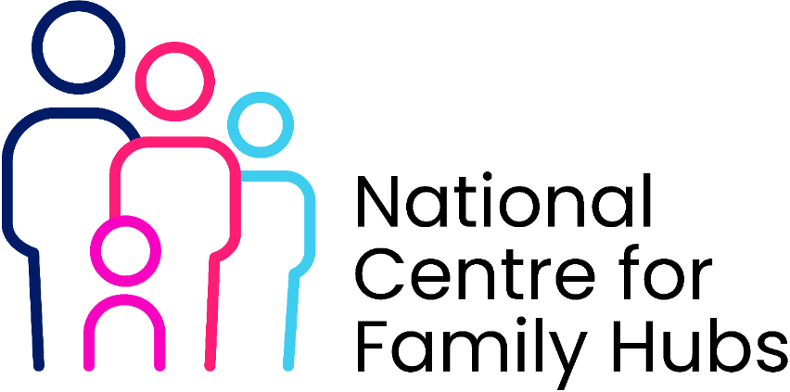

Family Hubs Volunteer Programme – Document Checklist
Name of Volunteer Date
☐ Volunteer role description
☐ Person specification
☐ Volunteer application form
☐ ID documents for identity verification
☐ Two references
☐ DBS check (standard or enhanced depending on role)
☐ Safeguarding and child protection declaration
☐ Code of conduct
☐ Safeguarding policy
☐ Health & safety policy
☐ Data protection / GDPR agreement
☐ Lone working policy
☐ Role-specific risk assessment
☐ Volunteer induction checklist
☐ Training records
☐ Volunteer agreement
☐ Supervision records
☐ Incident reporting forms
☐ Placement agreement / Memorandum of Understanding
☐ Hours log or competency evidence

