


Using behavioural insights to encourage energy efficiency
Final report
April 2023
Contents
Executive Summary 2
Introduction 6
Approach and methodology 6
Insight gathering 7
Trial and intervention design 16
Delivery of our trial 25
Trial Findings 29
Conclusions 40
Learning points and future planning 41

Appendices
Appendix A – trial data statistical output 44
Appendix B – Segment logic models 45



About Social Engine
Social Engine was established in 2015 to support organisations to adopt an evidenced-based and insight-led approach. We work with charities, local authorities, social enterprises and other social purpose organisations to overcome organisational challenges through engagement, research and the practical application of evidence into practice.
Our work involves applying behavioural insights to support service improvement across a wide range of policy and service areas in order to improve outcomes for individuals and communities.
www.social-engine.co.uk

Executive Summary

Project Aims
This project sought to explore:
- Why are home-owners not taking the necessary steps to retrofit their properties (rented or otherwise)?
- What messages and measures could be adopted to stimulate this change?

Approach and methodology
The project was delivered in four phases:
- Phase 1 – Project scoping and design
- Phase 2 – Evidence and insight gathering
- Phase 3 – Trial design & delivery
- Phase 4 – Analysis and reporting

Insight Gathering
Our evidence and insight gathering drew on a range of sources:
- A review of academic and practitioner research evidence
- Primary research conducted with residents in Devon, which received nearly 5,000 responses
- A review of available data and documents provided by Councils participating in the retrofitting consortium
- In addition, we were able to draw on our own knowledge of behavioural insights more broadly

Key findings
- Most people are open to the idea of adopting energy efficiency
- Understanding of retrofitting, net zero, carbon emissions and decarbonisation is low
- Despite the lack of clarity and understanding of retrofitting as a term, improving energy efficiency is something which is on people’s agenda.
- There are a number of potential ‘trigger points’ that provide opportunities to encourage the take-up of retrofitting measures.
- The cost-of-living crisis may also create another trigger point which could be used to encourage retrofitting
- It’s clear that the cost of living is a major feature of people’s lives at present

Influences and motivations
- Whilst being more environmentally friendly was felt to be a significant motivating factor, financial considerations were reported as being even greater influences by respondents.
- Three of the top five motivations related to financial factors
- Information was also a key consideration, with access to reliable information, knowing how long work would take and how much it would cost and knowing a reliable installer were all frequently perceived as being likely influences on behaviour

Barriers
- Key barriers to retrofitting include cost, structural factors such as the lack of available specialist installers, lack of trust in builders, lifestyle-related constraints, misconceptions and uncertainty about the technology, and split incentives between tenants and landlords

What works
- In reviewing 40 interventions and programmes, aimed to promote positive behaviours in relation to energy use, virtually all the interventions employed ‘simplification’
- Other commonly used levers included social and descriptive norms and the use of feedback mechanisms
- These interventions make use of behavioural techniques – which address people’s biases, heuristics and other psychological barriers - to drive behaviour change among their target audiences

Understanding our audience
- Segmentation analysis identified three groups: those who installed retrofitting measures, those considering them and those not interested (including those who rejected them before)
- Attitudes towards retrofitting correlated with income, housing tenure, type and affluence

Trial and intervention design
Having concluded our evidence and insight gathering phase, we began a collaborative exploration of potential interventions and devising plans to test them through a trial.
Key insights and design principles from our scoping work guided our intervention design:
- Limited local market capacity for independent retrofit and advice services
- Retrofitting perceived as complicated, disruptive, and unreliable
- Financial factors are primary drivers and people are anxious about household finances
- Retrofitting information is often complex, technical, with an overwhelming number of choices and associated costs
Consequently, the intervention should to be:
- Simple: Enable people to act independently without relying on specialist support
- Affordable: Emphasise inexpensive actions instead of costly investments
- Salient: Limit choice overload and clarify the best option
- Immediate: Focus on immediate savings rather than long-term savings

Generating and assessing intervention ideas
An ideation session with project leads aimed to codesign a range of intervention ideas. These ideas were assessed individually against criteria such as feasibility, impact, cost, time and measurability.
The assessment process identified seven strong ideas for the trial:
- Encourage use of Plan Builder on the new Energy Saving Devon website
- Develop relationships with big installers
- Advise people on immediate actions, e.g., DIY measures for £500
- Produce videos and social media content for DIY guidance
- Promote retrofit on a budget through social media and print
- Launch an insulating lofts to 270mm campaign
- Debunk myths and address misconceptions about retrofitting

Selecting our intervention idea
For our trial intervention we decided to focus on encouraging people to improve loft insulation, whilst incorporating elements of the ‘things you can do now for less than £500’ and ‘debunking myths’ into our plans.
This idea aligns with the four design principles: simple, affordable, salient and immediate.

Defining and measuring our intervention outcome(s)
Focusing on loft insulation posed measurement challenges – being able to track when people had installed insulation and also the likely lead-in time required to install insulation. Instead, the trial measured people's intention to act and whether people accessed information about loft insulation.
A loft insulation guide was developed, allowing for the capture of secondary outcome metrics like downloads and on-site analytics.

Delivery of our intervention
A social media advertising campaign was chosen as the delivery mechanism for the trial, since this offered greater opportunities to target the intervention at a specified audience and offered sufficient web traffic to achieve the sample size required.

Developing our intervention concepts and final designs
Our creative team developed a series of concepts for our intervention. There were two distinct approaches. The first compared the recommended depth of insulation required in lofts with imagery intended to be culturally resonant with the County, whilst the second emphasised the loss of heat through roofs due to poor insulation.
Since there was no obvious control condition to use, we decided to test the two approaches (two treatments and no control), with two variants of each. One variant emphasised a social norm whilst the other contained a loss aversion message.

Trial delivery
Facebook was chosen for the intervention because of its large scale and older user base. Four intervention versions were deployed over 4 weeks. A landing page on the Energy Saving Devon website was created, using our intervention imagery –mackerel and roof imagery – with information on installing loft insulation for those who engaged with the intervention by clicking the ‘learn more’ button.

Reach
The Facebook ad campaign reached a total of 205,324 people. Each variant of the intervention was delivered to between 42,000 and 59,000 individuals.
Gender and type of residence – urban or rural – were spread fairly evenly. The age of our sample reflected the age profile of Facebook users – with fewer young people and slightly more older people than the population.

Trial findings
- People were 42% more likely to engage with the interventions (as measured by click through) that featured an image of a roof, compared to those that featured a mackerel
- The intervention variants which used social norm messaging were more effective – by 20% - at eliciting user clicks compared to those that used monetary appeal and loss aversion
- As age increases, the likelihood of engagement with all four variants of our intervention also increases
- The click through rate is particularly high among people who are 65+ years of age, who were 2.5 times more likely than average to click the ‘find out more’ button
- Women were significantly more likely than men to click on any of the four variants of intervention
- The intervention variant which used roof imagery and social norm messaging was the most effective, increasing the likelihood of seeking loft insulation information by 50% compared to the other three variants
- Whilst the roof intervention elicited more user clicks, the mackerel intervention attracted a higher number of Facebook users’ comments

Conclusions
- Engagement levels varied across groups but intervention effectiveness was consistent
- Social norms were more effective than financial incentives and roof imagery outperformed the mackerel image in eliciting clicks
- The roof image combined with a descriptive norm was the most effective variant
- The roof imagery is useful for encouraging action, whilst the mackerel is effective at encouraging conversation

Learning points and future planning
The trial findings stress the importance of clear objectives and tailored approaches in communication and engagement for retrofitting. Different strategies should be adopted for engaged and disengaged individuals. For the engaged, the focus is on overcoming barriers towards retrofitting, while for the disengaged, stimulating debate on retrofit benefits and carbon reduction is crucial.
Local primary research identified three population segments and we developed logic models for engaging each of them in distinct, tailored ways. These models provide clear, evidence-based action plans enabling consortium members to apply them confidently beyond the period of this trial.
Above all, what matters most is that the participating councils feel equipped with the confidence to apply the learning from the project over the course of the past 12 months going forward.

Introduction

Background
Climate change requires everyone to rethink their role in reducing energy consumption and taking bold steps to prevent further environmental damage. Across the country, councils and other agencies are considering how best to engage and empower consumers in efforts to achieve net zero.
In Devon, six councils joined together to explore how their individual efforts to encourage the take up of residential energy saving measures might be enhanced by collectively developing a new approach based on behavioural insights.

Local context
Like many others, Devon residents are facing a cost-of-living crisis. Fuel poverty is rising and Devon has higher levels of fuel poverty (13.0%) than the UK (10.6%), with West Devon experiencing 15.2%. The Devon population is older in profile than average and has lower average earnings; there are also substantial health inequalities in the county.
At the same time, we are collectively facing a climate emergency and have a legally binding commitment to net zero by 2050. Achieving net zero requires ambitious and consistent steps. One area for focus is the energy performance and condition of home-owned and privately rented accommodation. Rising energy costs, as well as wider cost pressures, combined with poor residential home energy efficiency has a direct impact on dwellers’ ability to pay for life’s essentials. Still further, it has an impact on their health and wellbeing and ultimately the demand they place on public services.
To date, despite this personal impact, as well as substantial efforts to promote retrofitting, residents and landlords in Devon are not felt to be engaging in the numbers needed to ensure their homes are energy efficient, with steps such as insulation and draught proofing.
This project sought to explore:
- Why home-owners are not taking the necessary steps to retrofit their properties (rented or otherwise)?
and
- What messages and measures could be adopted to stimulate this change?

Approach and methodology
The LGA’s behavioural insights programme places an emphasis on codesign, collaboration and building the knowledge, confidence and skills of participating councils. We consequently designed our approach to incorporate a range of methods and mechanisms intended to support each Council’s project lead and their wider teams to develop skills, knowledge and experience of devising, designing and delivering a behaviourally informed trial.
Our methodology combined a mix of expert and technical guidance and support with an action learning approach that encouraged peer-learning and collaboration. A participant handbook, a series of consortium workshops, 1-2-1 coaching and co-production sessions were used to shape our outputs and collectively achieve our intended outcomes.
The project was delivered in four phases, with an iterative approach where each phase informs what follows [NB items in bold marked ‘w1, w2, w3 etc’ represent consortium workshops]:
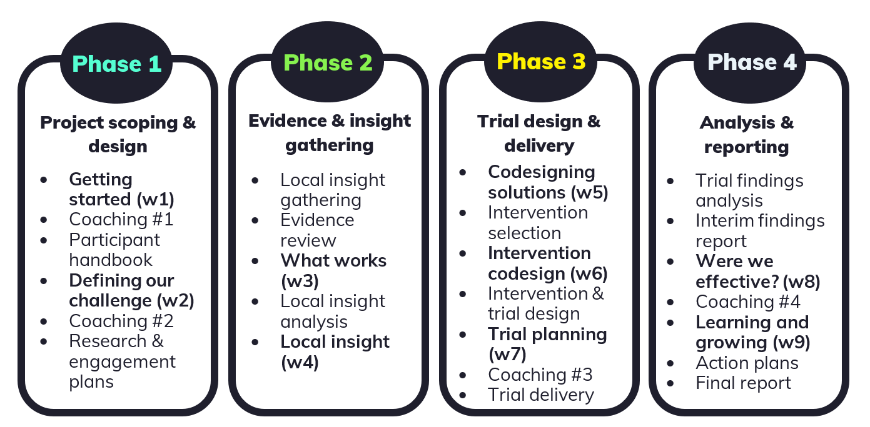

Table 1 - Four-phase iterative approach

Insight gathering
A key part of the project involved gathering evidence and insight to understand what is known about the influences on people’s decisions to retrofit their homes that could be used to inform our intervention design and plan our trial.
Our evidence and insight gathering drew on a range of sources:
- A review of academic and practitioner research evidence
- Primary research conducted with residents in Devon, which received nearly 5,000 responses
- A review of available data and documents provided by Councils participating in the retrofitting consortium
- In addition, we were able to draw on our own knowledge of behavioural insights more broadly.
The headline findings from our evidence and insight gathering are set out below. A detailed Insight Report, contains the full findings of our investigation.

Summary of findings
- Most people are open to the idea of adopting energy efficiency. In studies around one third of households (35%) had already adapted or were seriously considering adopting retrofitting measures, however within our local research this figure was even higher (61%).
- Understanding of retrofitting, net zero, carbon emissions and decarbonisation is low – only 41% said they know what retrofitting is (and that figure appears to be an overstatement as a number of descriptions indicated misunderstanding).
- Despite the lack of clarity and understanding of retrofitting as a term, improving energy efficiency is something which is on people’s agenda, with 72% currently considering retrofitting.
- There are a number of potential ‘trigger points’ that provide opportunities to encourage the take-up of retrofitting measures.
- Home improvements are one potential trigger point – offering the opportunity to incorporate retrofit measures into already planned renovations. One third of households are planning major home improvements over the next three years.
- The cost-of-living crisis may also create another trigger point which could be used to encourage retrofitting.
- It’s clear that the cost of living is a major feature of people’s lives at present - 93% are worried about inflation and 86% expect their household finances to worsen over the next 12 months
- Although around 40% say they are relatively financially well off and another 40% can cover the essentials, around 1 in 5 (19%) are already struggling financially

Influences and motivations
- Whilst being more environmentally friendly was felt to be a significant motivating factor, financial considerations were reported as being even greater influences by respondents.
- Three of the top five motivations related to financial factors, with 94% of respondents saying reducing the cost of energy bills was likely to influence them.
- Information was also a key consideration, with access to reliable information, knowing how long work would take, how much it would cost and knowing a reliable installer were all frequently perceived as being likely influences on behaviour.

Barriers
- Cost is by far the most common factor – with half the respondents to our survey citing it as a barrier to installing energy efficiency measures.
- Structural factors such as living in listed buildings or conservation areas were a barrier to installing retrofitting measures.
- Lack of trust towards builders was felt to inhibit take-up of retrofitting – knowing someone reliable, sufficiently knowledgeable and trustworthy was an important consideration.
- Factors relating to people’s lifestyles also served as a barrier to take-up, in particular a lack of time to research different options and find suitable installers caused to limit the take up of retrofitting, even where there was a desire to do so.
- People’s beliefs also created a barrier, for example perceptions of the technology as being in its infancy and therefore unreliable or too expensive, or misconceptions around the efficiency of measures (e.g., wall insulation causing dampness) served to reduce take-up.
- The ‘split incentives’ between tenants and landlords were a factor in rented properties, where the costs and benefits of installing retrofit measures fall between home owners and renters and act as a disincentive for investment.

What works?
- In reviewing 40 interventions and programmes, aimed to promote positive behaviours in relation to energy use, virtually all the interventions employed ‘simplification’.
- Other commonly used levers included social and descriptive norms and the use of feedback mechanisms.
- These interventions make use of behavioural techniques – which address people’s biases, heuristics and other psychological barriers - to drive behaviour change among their target audiences.

Understanding our audience
- Our segmentation analysis produced three distinct segments within our sample: those who had already installed retrofitting measures, those who were seriously considering them and a third group who were not considering installing retrofitting measures (comprised of those who had previously considered doing so and rejected it and those who were not considering them).
- We found that attitude towards retrofitting was closely associated with income, housing tenure and housing type and affluence.

Segmentation analysis from our primary research
In order to understand differences in attitudes, behaviours and characteristics of different sub-groups within our survey sample, that might help us to develop our intervention approach, we conducted segmentation analysis. We identified three different segments within the data based on responses to whether people had already installed retrofitting measures, were seriously considering doing so, or weren’t considering them – based on responses to questions which asked about intentions relating to specific retrofitting measures (wall insulation, roof insulation and floor insulation).
This analysis produced three distinct segments within our sample: those who had already installed retrofitting measures, those who were seriously considering them and a third group who were not considering installing retrofitting measures (comprised of those who had previously considered doing so and rejected it and those who were not considering them).
Our segmentation analysis involved looking at a range of variables for each segment to see whether they differed significantly from each other. We looked at demographic characteristics of each group, knowledge of retrofitting, whether they knew reliable builders, whether they were planning any major home improvements, trusted sources of information, their financial position and motivations for installing energy saving measures. This analysis produced some clear and distinct characteristics of each of our three segments.
Broadly, we found that attitude towards retrofitting was associated with income, housing tenure and housing type and affluence.

Our three segments
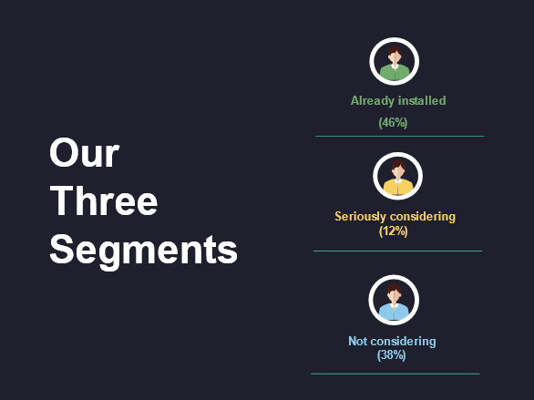

Table 2 - Three Segments. 96% of respondents fitted into one of our three segments, with just 4% falling outside of all of these.

Already installed
Those who had already installed retrofitting measures were the largest segment in our sample, accounting for almost half (46%) of survey respondents. They tended to be home owners (owning their homes outright – i.e. without a mortgage) and live in houses, more often detached houses. They were generally more affluent than average and also more likely to be retired and aged 65 or over. They were more likely to know what retrofitting was and to know reliable builders. They were also more likely than average to be having conversations about energy efficiency and to know other people who have already installed retrofitting measures in their homes. They also tended to be slightly more trusting of energy companies than other segments.

Seriously considering
Our second segment is the smallest of our three segments, accounting for 12% of our sample and comprised those who said they were currently seriously considering installing retrofitting measures. They tended to be of working age (25-44) and were more likely than average to be working full time. They were more likely to live in semi-detached or terraced houses and to have mortgages.
As with the already installed segment, they were also more likely to be aware of what retrofitting is, to say they knew reliable builders and to be having conversations about energy efficiency.
They were more likely to be planning significant home improvements in the next few years and were generally more likely to trust a range of sources of information including; local media/news, community energy groups, charities/community groups and Cosy Devon.
This segment was more likely to be motivated to install energy efficiency measures by a number of factors, but the availability of finance, being more environmentally friendly and access to reliable builders and information were particularly strong motivating factors.

Not considering
Our third segment, which accounted for 38% of our sample, comprised those who were not considering installing retrofitting measures or had previously considered them and rejected the idea. They tended to be less well off than average, with lower incomes and less job security; being more commonly on zero hours contracts, seeking work, unable to work or students. They were far more likely to rent their homes or live in social housing and more commonly live in flats. They were less likely to be planning home improvements and they were slightly less likely to be having conversations about energy efficiency or to know others who have installed retrofitting measures. They were also less likely to know a reliable builder. They are more likely to be ambivalent about a range of sources of information – being more likely to say that they neither trust nor mistrust them.

Characteristics | Already  installed | Seriously considering | Not  considering
Percentage of sample | 46% | 12% | 38%
Typical Age | 65+ | 25-44
Housing tenure | Owner (outright) | Owner (mortgage) | Renter (private or social housing)
Housing type | Detached house | Semi-detached or terraced house | Flat or maisonette
Income | Comfortable | Moderate | Less well off
Employment status | Retired | Working full-time | Less secure
Aware of retrofitting | ✓ | ✓ | ✗
Know reliable builder | ✓ | ✓ | ✗
Talking about energy efficiency | ✓ | ✓ | ✗
Know others with retrofit measures | ✓ | ✓ | ✗
Planning home improvements | ✗ | ✓ | ✗
Trusted sources of information | More likely to trust energy companies | Tend to be more trusting | Typically more ambivalent

Table 3 – Characteristics of segments

Conclusions from the evidence and insight gathering
The findings from the local research are consistent with much of the evidence from our literature review – which should be considered reassuring. They confirm widespread opportunities for increasing the uptake of retrofitting measures, with a significant proportion of people planning or at least open to the idea of making their homes more energy efficient.
A range of factors act as motivations for installing retrofit measures, including the availability of a range of reliable information and being more environmentally friendly, but the most significant factors are financial. Similarly, cost is the greatest barrier to take up.
Whilst concern about the cost-of-living crisis, rising prices and anxiety over household finances is almost universal, there are considerable differences in the levels of interest in and attitudes towards retrofitting. The strong correlation between affluence – and a range of associated variables such as housing tenure, employment status and housing type – and retrofitting intentions further underlines the importance of financial factors as an influence on behaviour.
Our segmentation analysis provides clarity on some of the key differences in motivations, trusted sources of information and trigger points that exist among our three segments. This presents opportunities for targeted engagement, framed around simplified messaging tailored to particular audiences.

Sample size calculations
Data shared with us provides the volumes of house characteristics and features relating to a range of retrofitting measures for the 10 Councils in Devon, both those within the consortium (South Hams, West Devon, East Devon, Exeter, Plymouth and Devon County Council) and those which were not (North Devon, Teignbridge, Torbay, Torridge and Mid Devon)
A total of 567,833 homes were identified across Devon within the dataset. However, for some retrofitting measures the totals given are less than this. Where this is the case, the totals are given and percentages are calculated using the total for that measure.
North Devon | Teignbridge | South Hams | West Devon | East Devon | Exeter | Torbay | Torridge | Plymouth | Mid Devon
46,763 | 62,748 | 45,554 | 25,847 | 69,902 | 58,570 | 67,745 | 32,795 | 121,399 | 36,510

Table 4 – Number of homes in Devon

The data included the energy efficiency classification of homes relating to a range of retrofitting measures, giving us an idea of how many households in each locality would benefit from particular retrofitting measures.
These figures enabled us to determine our potential audience/sample size for each retrofit intervention/measure (or set of measures – as there will be different solutions depending on the property, eg solid wall insulation or cavity insulation).
The measures which are contained within the data are:
- Wall insulation
- Roof insulation
- Floor insulation
- Window insulation
- Doors draft proofing
- Boiler efficiency
- Heating system

Walls
Details of wall construction type (e.g. cavity, solid brick, timber frame) and volumes of uninsulated walls (total and by type). The data also classified whether properties were insulated or not – either: insulated, uninsulated, part insulated. This provides us with a total for homes that could benefit from wall insulation. 43.8% of homes are listed as uninsulated (248,488 across the County).

Roofs
Details of the location of loft insulation – e.g. joists, flat roof, rafters, none etc – and the thickness of insulation (within a range of 12mm up to 400mm).
We used the Government guidelines which recommend 270mm of insulation (although 300mm is considered the norm in new builds) to determine whether a property be classified as ‘insulated’ or ‘uninsulated’. Those with 270mm or above were classified as ‘sufficiently insulated’ and those with less than 270mm as ‘uninsulated’.
Roof insulation figures are provided for 430,876 properties, with 11% of properties across the County being classified as unknown and just under one in eight (12.8%) recorded as insulated. This means that 76.2% of roofs (328, 264 properties) would benefit from insulation.

Floors
Included floor construction type (e.g. solid, suspended timber etc) and whether ‘as built’ or ‘retrofitted’. Only a tiny number of properties – around 1% - are recorded as having been insulated (5,264 out of nearly 498,330). The vast majority of properties (98.9%) are listed as ‘as built’.

Windows
This data category details the window type (e.g. single, double before 2002, double after 2002 etc) and multiple glazing proportion.
Properties with double or triple glazing (along with a very small proportion of homes which have secondary glazing) are defined as insulated whilst those with ‘single’, ‘mainly single’ or ‘some single’ are all deemed suitable for retrofitting.
16.9% of properties (95,767) are listed as uninsulated, whilst 83.1% of properties fall within the insulated classification.

Doors and draughtproofing
This includes the number of uninsulated external doors (1 or 2) and the number of homes with both draughtproofed doors and windows.
472,066 homes (83.1%) are listed as 100% draughtproofed doors and windows, meaning 16.9% (95,767) homes require some sort of draughtproofing and/or insulation to their doors and windows. 19% of homes (110,112 properties) are recorded as having 1 uninsulated door and 81% (457,721 properties) are listed as having 2 uninsulated doors. Given that all 567,833 properties in the dataset are classified as having at least one door which is uninsulated, it appears that these figures are not a reliable indication of door insulation, since it seems implausible that no properties across the entire County have completely insulated doors. Additionally, the figures for 100% draughtproofed doors and windows is precisely the same figure as that for properties with insulated windows (95,767), which suggests this figure may not accurately reflect the true nature of door insulation either.

Boiler efficiency
477,563 homes are included in this category. The boiler efficiency of each home is rated From A to G (A being the most efficient and G the least energy efficient). Boilers rated C or higher are deemed to be energy efficient, whilst those rated D to G are classified as being inefficient.
The vast majority of homes (89.7%, or 428,551 properties) have a boiler with a rating of A-C, whilst 49,012 properties (10.3%) have boilers with a rating of D or lower.

Heating system
This category contains the type of heating system (e.g boilers, storage heaters, heat pump etc), each property has. Whilst some systems, such as heat pumps, are energy efficient, others (such as boilers) may or may not be energy efficient. The majority of properties (84.1%) have boilers.
Since we cannot cross reference data in the boiler efficiency category with the type of heating system, to ascertain from this classification whether a system is energy efficient or not, the type of heating system is not considered suitable to us for analysis purposes.

Summary of energy efficiency by retrofit measure
Measure | Energy efficient | Not-energy efficient
Walls | 19,345 (56.2%) | 248,488 (43.8%)
Roofs | 55,042 (12.8%) | 328, 264 (76.2%)
Floor | 5,264 (1.1%) | 493,066 (98.9%)
Glazing | 472,066 (83.1%) | 95,767 (16.9%)
Doors and draughtproofing | 472,066 (83.1%) | 95,767 (16.9%)
Boiler | 428,551 (89.7%) | 49,012 (10.3%)

Table 5 – Summary of energy efficiency by retrofit measure

We compared these findings with the results from survey conducted with residents to see how similar the sample was to the data for the County as a whole.
We can see that the proportion of survey respondents who said they had insulated walls and windows is very close to the figures for the County.
Though we found some variation in the figures for energy efficient floors (1% in the County data vs 12% in our survey); it is feasible that this is the result of the way an EPC assessment (which is the basis for the County data) is carried out. If the assessor is not provided with physical or documentary evidence of insultation then the property is recorded as ‘as built’. This is likely to mean the actual figure is higher than the figure recorded in the data.
The significant variation between our survey response and the County data in the propotion of homes with insulated roofs (73% in our survey compared with just 13% in the County dataset), may also be a result of methodological differences. Using 270mm of insulation as the criteria for ‘energy efficent’ within the County data resulted in only a relatively small proportion of properties being classified as sufficiently insulated.
Our survey did not ask how well insulated a roof was, merely whether their roof was insulated. In answering this question, it seems highly likely that a significant proportion of people therefore responded that they did have an insulated roof, even if it fell well below our defined standard for ‘energy efficent’.
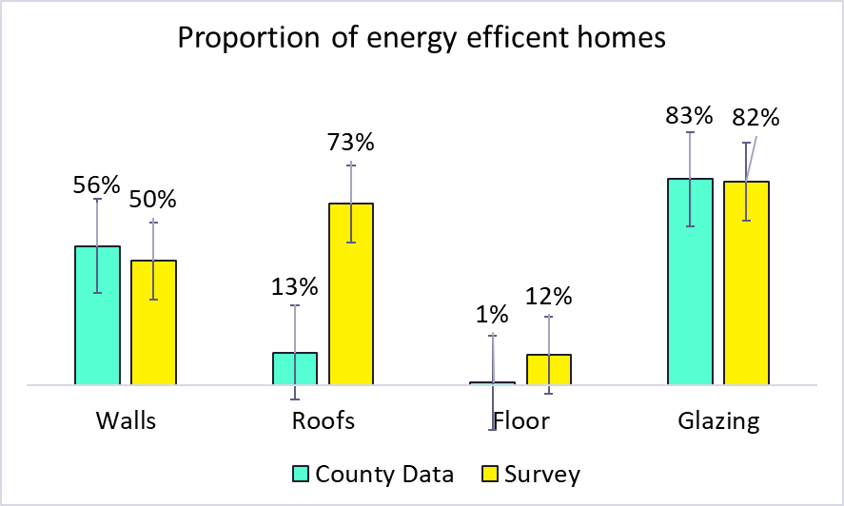

Figure 1 – Proportion of energy efficient homes

Measure | County Data | Survey
Walls | 56% | 50%
Roofs | 13% | 73%
Floor | 1% | 12%
Glazing | 83% | 82%
Doors and draughtproofing | 83% | n/a
Boiler | 90% | n/a

Table 6 – Retrofitting data
Other metrics which were considered as potential outcome measures for our trial – such as current levels of engagement with retrofitting – were difficult to quantify. Typically, engagement is through local Community Energy Groups and it transpired that they do not tend to record monitoring data to draw on, or were unable to provide it, and where data are recorded, this is not done in a consistent way across the County.

Trial and intervention design
Having concluded our evidence and insight gathering phase, we began a collaborative exploration of potential interventions and devising plans to test them through a trial.
A number of key insights and design principles from our scoping work guided our intervention design:
- There is limited local market capacity for independent retrofit and advice services
- Retrofitting is not widely understood and seen as complicated, disruptive and unreliable
- Financial factors are the primary driver and people are anxious about household finances
- Retrofitting information can appear complex and technical, with an overwhelming number of choices and associated costs
Consequently, our intervention ought to be:

- Simple – emphasising that people can do something for themselves, without being reliant on specialist support or installer (who may not be easy to source locally)
- Affordable – a call to action which is inexpensive and perceived as being affordable, rather than costing tens of thousands of pounds
- Salient – avoid people feeling overwhelmed by ‘choice overload’ and make the ‘best’ available option clear and easy to identify
- Immediate – focus on saving money immediately (‘this winter’) rather than needing to wait 10 or 15 years before seeing a return on investment

Generating and assessing intervention ideas
A facilitated ideation session with project leads from participating councils was used to codesign a range of intervention ideas. The intention was to produce a range of ideas for the consortium to develop subsequently, and to generate intervention ideas which though impractical for taking forward as part of the project, were worthy of future consideration. The ideas generated were then assessed individually against a range of criteria:
- Feasibility – how easy would it be to deliver the intervention in practice?
- Impact – how great a difference would the intervention be expected to make?
- Cost – how expensive would the intervention be to design and deliver? What resources would it require?
- Time – how long would the intervention take to prepare and deliver?
- Measurability – how easy would it be to evaluate the difference the intervention made?
For each criterion, interventions were scored on a five point scale - reflecting a continuum from the most to least desirable and the scores aggregated to give a total suitability score for each intervention. The suitability score was not intended to produce a definitive intervention for selection, but rather to ensure that the selection of our trial intervention was based on a comprehensive assessment of their respective merits.

Average scores
Intervention idea | Feasibility | Impact | Cost | Time | Measurability | Total
Encourage use of Plan Builder (on new Cosy Devon website) to produce bespoke action plans | 5 | 3.4 | 4.4 | 4.4 | 4.4 | 21.6
Develop relationships with big installers | 3.5 | 3 | 4 | 3.75 | 4 | 18.25
Advise people on ‘things you can do now’ – e.g. DIY measures for under £500 | 4.6 | 3.4 | 3.6 | 3.4 | 3.2 | 18.2
Produce videos/social media content showing people how to do things themselves (e.g. installing smart radiator valves) | 4.2 | 3.2 | 3.4 | 3.4 | 3.2 | 17.4
Retrofit on a budget – social media/print – exemplars with cheap & DIY measures | 4.4 | 3.6 | 3.6 | 3 | 2.6 | 17.2
A campaign focused on insulating lofts to 270mm – ‘less than that is not enough’ | 4.6 | 3.2 | 3.4 | 3 | 2.8 | 17
Myth debunking – content to allay fears and misconceptions about retrofitting | 4.4 | 3 | 4.2 | 3.2 | 2 | 16.8
Use ‘boiler end of life’ as a trigger point for installing a heat pump [Gas boiler installers may not have an interest in promoting heat pumps – need to find a way round this] | 2.6 | 3.2 | 3.2 | 3.4 | 3.6 | 16
Resurrecting a ‘green open homes’ programme/event | 2.8 | 3.4 | 2.8 | 2.8 | 3.4 | 15.2
Targeted social media content/local press articles with ‘real people’ to carry a ‘retrofit is for you’ type message | 4.2 | 2.6 | 3.2 | 2.6 | 2.6 | 15.2
Briefings/information for architects to encourage them to act as advocates | 3.6 | 3.4 | 3.2 | 2.4 | 2.6 | 15.2
Include retrofit information in Planning documents (info sent to applicants etc) | 3.8 | 2 | 3.6 | 3.6 | 1.8 | 14.8
Award scheme – linked to Trustmark/buying with confidence – for installers/builders/contractors | 3 | 3.2 | 2.6 | 3 | 3 | 14.8
Training for community champions – to advocate and support awareness and understanding of retrofitting | 3.6 | 3.6 | 2.6 | 1.8 | 3 | 14.6
Series of articles in local press/Council news - taking people ‘on a journey’ using normal people as retrofit messengers | 3.8 | 2.8 | 2.8 | 2.8 | 1.8 | 14
High profile messenger to endorse retrofitting – e.g. Kirstie Allsopp, Hugh Fearnley-Whittingstall or Sue Barker | 2.2 | 3.2 | 3 | 3 | 2.4 | 13.8
Training for tradespeople to recommend retrofit measures | 2.4 | 3.8 | 2 | 1.8 | 3.6 | 13.6

Table 7 – Intervention ideas and scores

Some of the ideas were similar, overlapping or lent themselves to being deployed in combination with others. And while some of them were felt to be less suited to be delivered within the constraints of the project (principally the need to design and deliver our trial in a short period of time), they were felt to have considerable merit for future implementation. The assessment process identified seven ideas that were felt to be strongest in terms of selection for our trial:
- Encourage use of Plan Builder on new Energy Saving Devon website
- Developing relationships with big installers
- Advise people on ‘things you can do now’ – e.g. DIY measures for £500
- Produce videos/social media content showing people how to do things themselves
- Retrofit on a budget – social media/print – exemplars with cheap & DIY measures
- Insulating lofts to 270mm campaign – ‘less than that is not enough’
- Myth debunking – content to allay fears and misconceptions about retrofitting

Selecting our intervention idea
For our trial intervention we decided to focus on encouraging people to improve loft insulation, whilst incorporating elements of the ‘things you can do now for less than £500’ and ‘debunking myths’ into our plans.
This idea met our four design principles:
Simple – The idea offers strong messaging potential, with scope to highlight the gap between common perceptions (‘my loft is insulated’) and the recommended level of insulation (‘you need 270mm’)
Affordable – Loft insulation is relatively inexpensive and offers a good ROI (return on investment). According to the Royal Institution of Chartered Surveyors (RICS) loft insulation costs a few hundred pounds and savings can be up to £300 per year.
Salient - Most insulation is inadequate – but people tend to believe that the insulation they have is sufficient. This perception gap lends itself to creating highly salient messaging.
Immediate – Loft insulation is considerably easier to install than most retrofit measures and does not require a specialist installer. Some people may be confident to install it themselves, but if not a handyman or non-specialist builder are likely to be able to install it.
The significant disparity between the findings from our primary research and the EPC report data relating to roof insulation was in stark contrast to the results for other energy efficiency measures – as highlighted in figure 2.
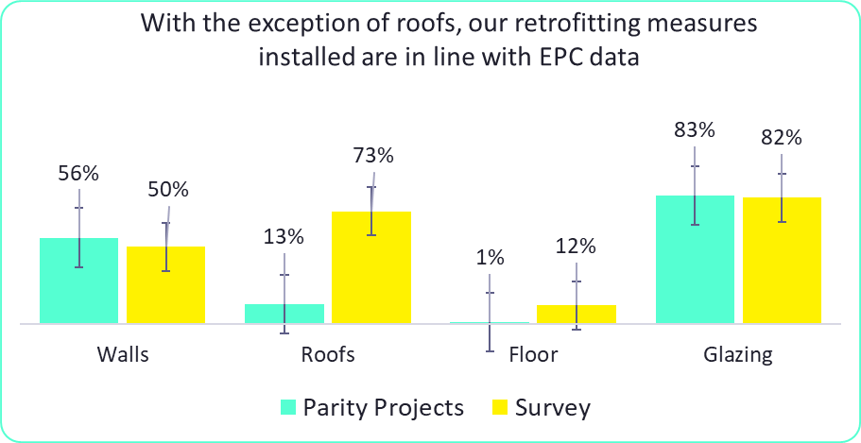

Figure 2 – Comparison retrofitting data from parity projects and survey

Defining and measuring our intervention outcome(s)
Nonetheless, focussing our intervention on loft insulation posed some specific challenges. The question of how to measure our trial outcomes was a particular challenge – as illustrated by the below average score the idea received for measurability in our intervention assessment scoring.
Monitoring whether or not people actually installed thicker loft insulation as a result of being exposed to our intervention was considered extremely problematic. Not only was there an indeterminant (and potentially lengthy) period of time between being exposed to the intervention and actually installing the insulation, but there was felt to be no practical way of collecting these data.
Instead, we decided to focus on people’s intention to act and whether they accessed information about loft insulation as our trial outcome measure. The rationale for this was that it was a pragmatic solution to the problem of measurement, gave us a metric that was possible to measure and was a useful proxy for our desired behavioural outcome.
If our intention was to encourage people to install additional insulation to a recommended thickness, then we needed to highlight the fact that most lofts were not sufficiently insulated. Without this knowledge people would be highly unlikely to take action. Consequently, it was felt that a desired behaviour once exposed to our intervention would be to access information about how to insulate your loft as a precursor to our ultimate aim of installing loft insulation.
We therefore worked with the subject specialists within the consortium to develop a guide to loft insulation which our intervention would direct people to. This also gave us the potential to capture a range of other secondary outcome metrics, such as downloads, dwell time (on pages where the information was held) and other on-site analytics.

Delivery of our intervention
Given the selection of whether someone accessed information about loft insulation as our trial outcome measure, the delivery of our intervention lent itself to a digital delivery approach. We considered either a web-based delivery mechanism and delivery through social media advertising.
Due to concerns about driving sufficient web-traffic to produce a large enough sample size, and the additional opportunities for targeting through social media advertising, we opted for a paid advertising social media campaign for our trial.

Developing our intervention concepts and final designs
Our creative team developed a series of concepts for our intervention. In addition to our four design principles, we tried to ensure the imagery was locally relevant and resonated with our audience. We developed two distinct approaches; the first compared the recommended depth of insulation required in lofts with objects and imagery which had local significance, the second emphasised the loss of heat through roofs due to poor insulation.

Design concepts
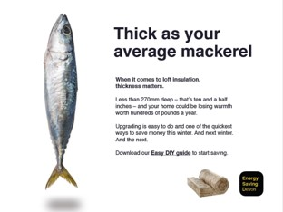

Image 1



Image 2

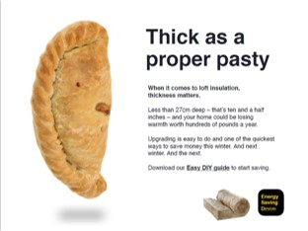

Image 3

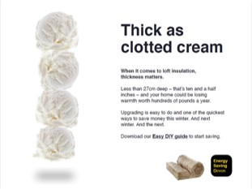

Image 4
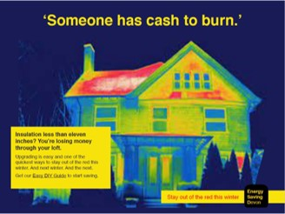

Image 5

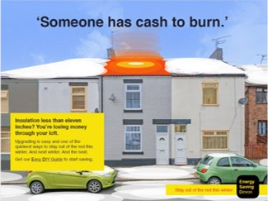

Image 6

Final designs
Since there was no obvious control condition to use, we decided to test the two approaches (two treatments and no control), with two variants of each. One variant emphasised a social norm (4 out of 5 homes lack sufficient insulation) and the other contained a loss aversion message (losing heat through your loft).
The decision was made to replace 'the money to burn' imagery concept with imagery of a roof coupled with a loss aversion message (losing heat through your loft). Although the 'cash to burn' imagery concept was a powerful idea with the potential to resonate with our target audience, it was not pursued due to concerns about political sensitivity, particularly when delivered by a local authority messenger. We felt that there was a risk that using such imagery could be interpreted literally and perceived as insensitive – which would clearly not align well with the values and messaging a local authority would wish to convey.

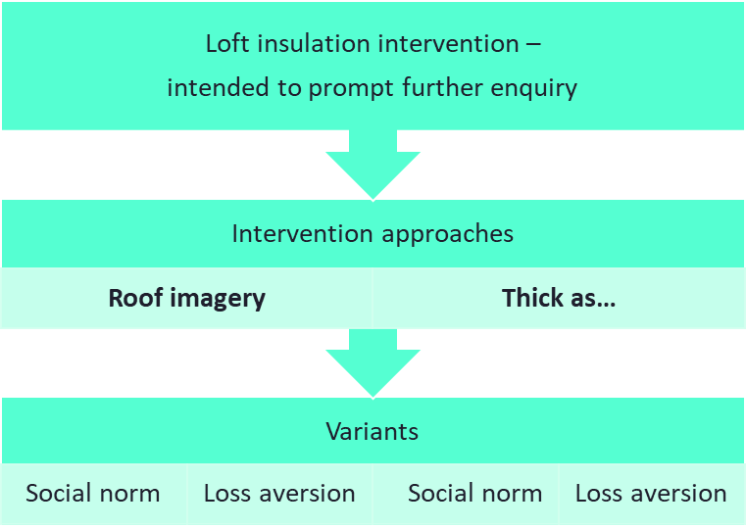

Figure 3 – Breakdown of intervention variants

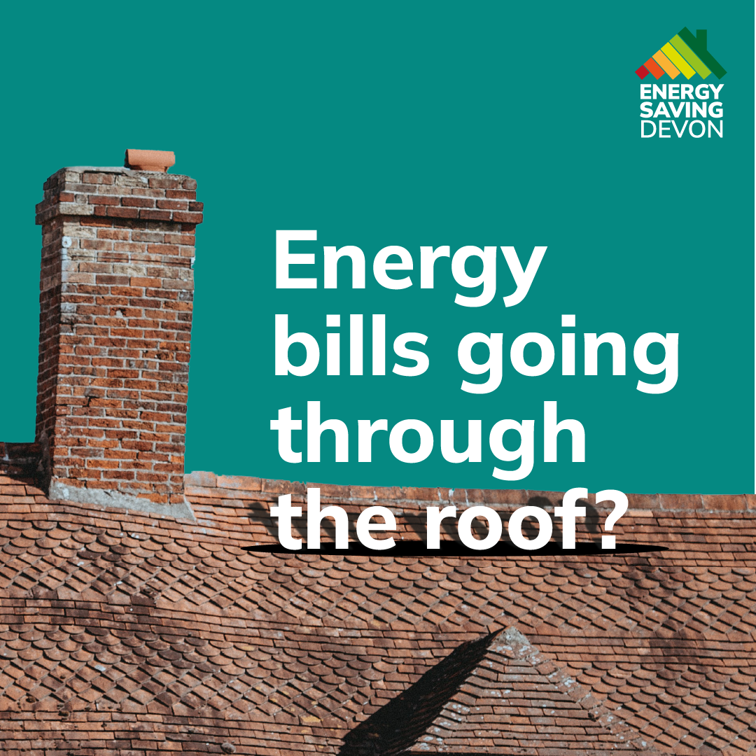

Image 7
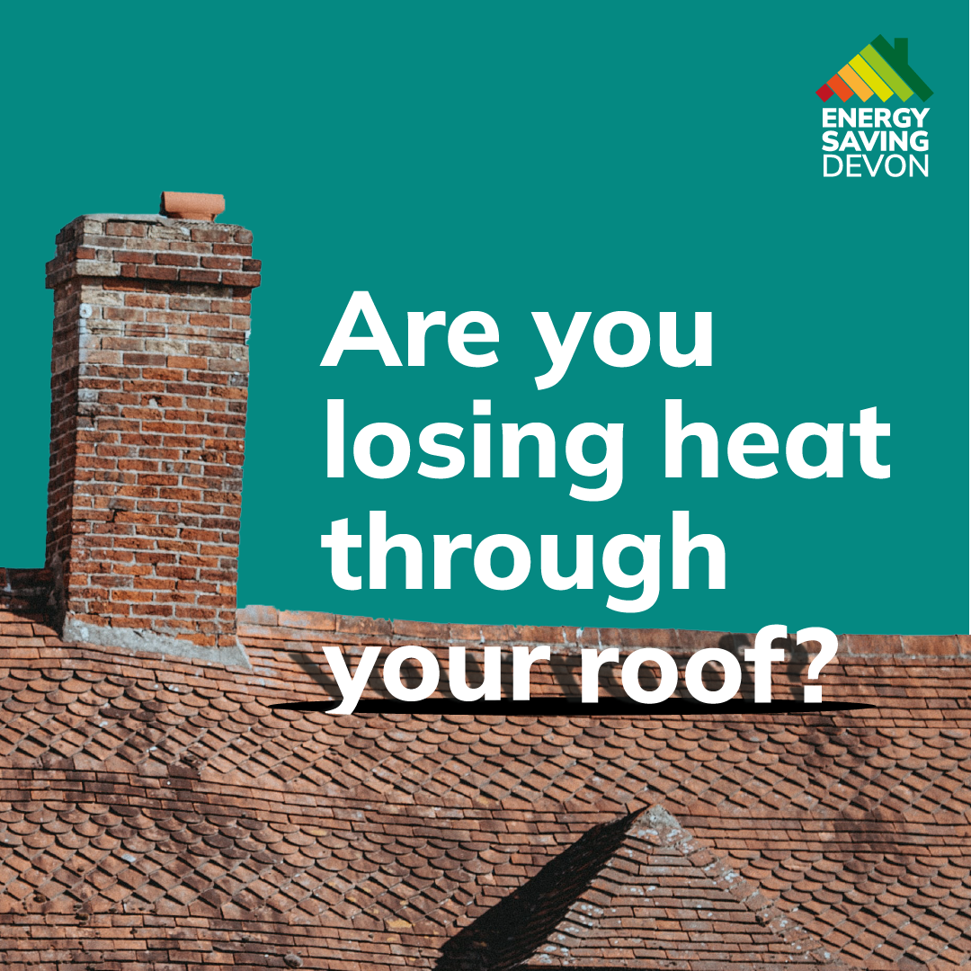

Image 8
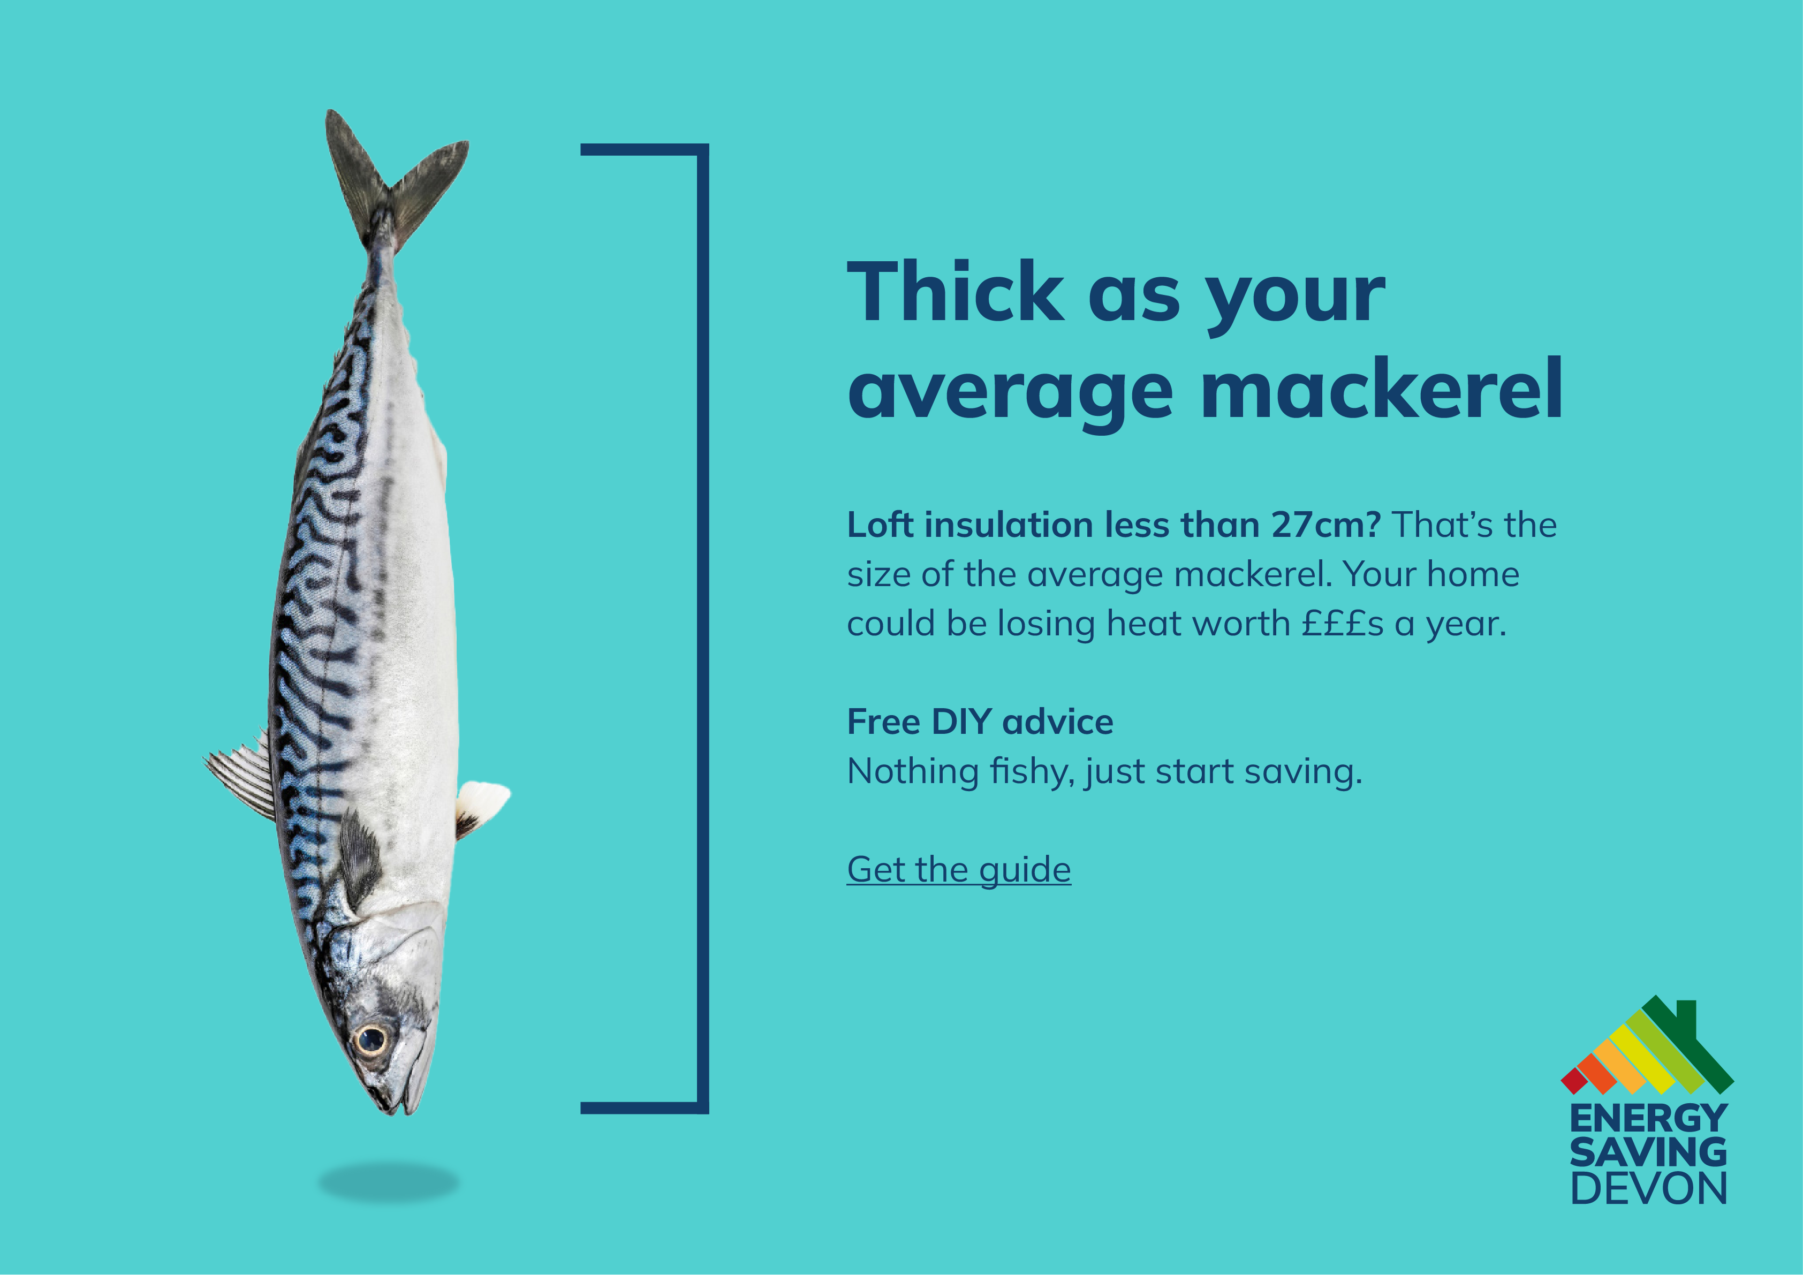

Image 9

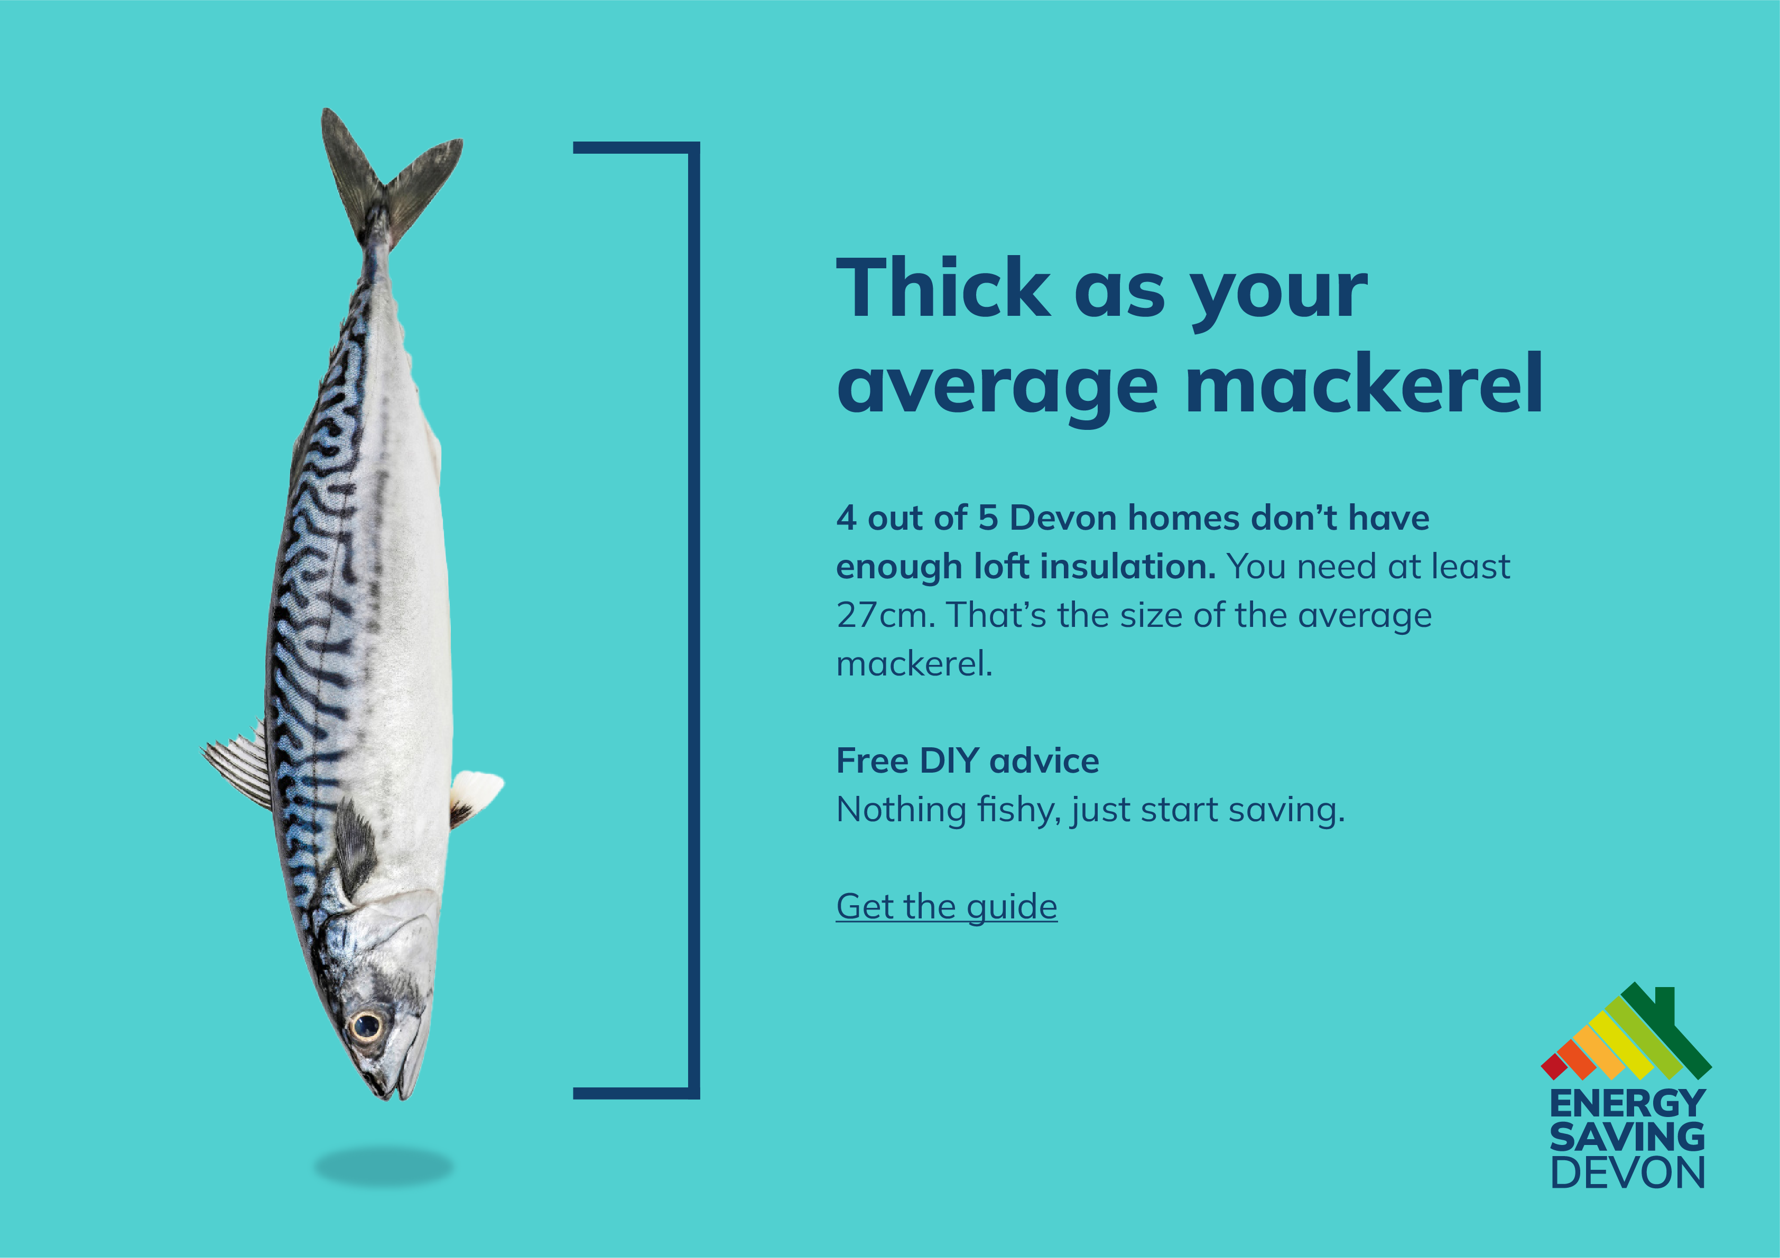

Image 10

Trial delivery
Facebook was chosen as the primary platform for delivering the intervention, as it offered large scale and an older user profile than other social media platforms. The four versions of our intervention (two approaches, each with two variants) were deployed over a four week period.
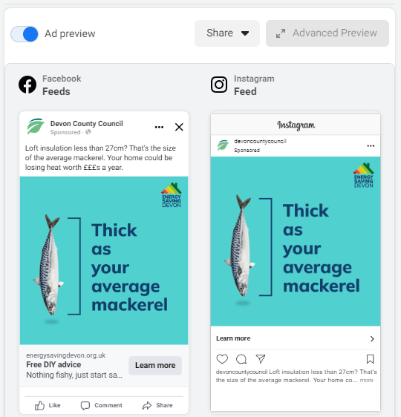

Image 11

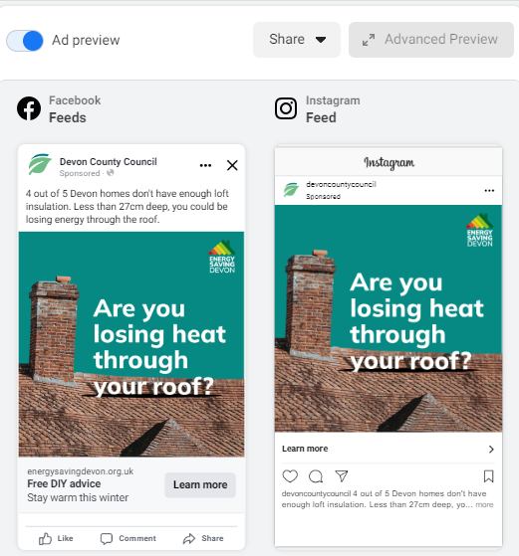

Image 12

A landing page on the Energy Saving Devon website was created, using our intervention imagery – one with the mackerel and one with the roof – with information on installing loft insulation for those who engaged with the intervention by clicking the call to action ‘learn more’ button.
Energy Saving Devon was a newly developed rebranding of the ‘Cosy Devon’ website and represented a new initiative - with no prior associations. The website's branding aligns well with the objectives of this project, as its title encompasses the full geographic area of Devon and conveys an understanding related to retrofitting and energy efficiency.

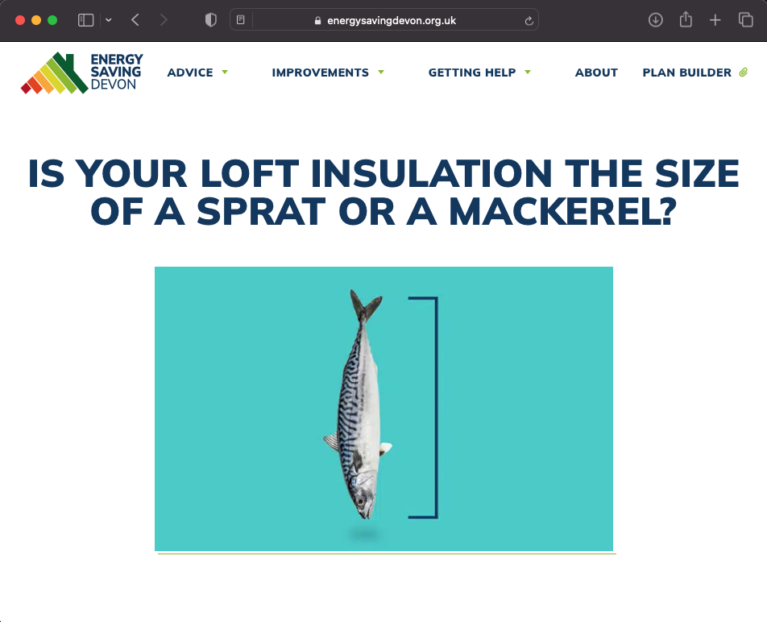

Image 13

Reach
The Facebook ad campaign reached a total of 205,324 people. Each variant of the intervention was delivered to between 42,000 and 59,000 individuals within Devon. 29% of the audience was exposed to the advertisement titled 'Mackerel - 4 out of 5,' while 28% viewed the 'Mackerel - Money' ad. The 'Roof - Money' ad was viewed by 23% of the audience, whilst 21% viewed the 'Roof - 4 out of 5’ ad.
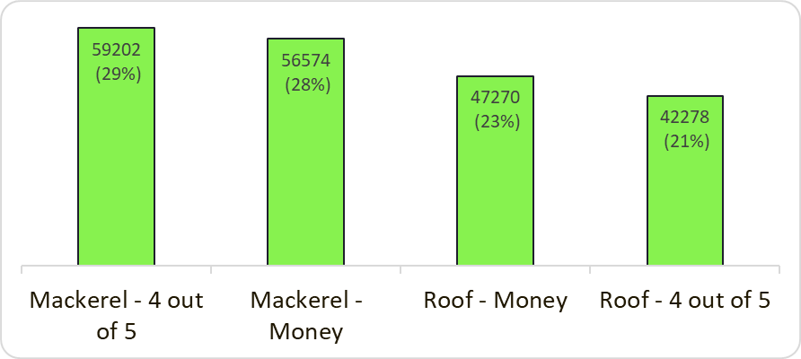

Figure 4 – Reach of variants

Our sample was broadly even as far as gender is concerned, with slightly more women (52%) than men (47%) being exposed to the intervention.
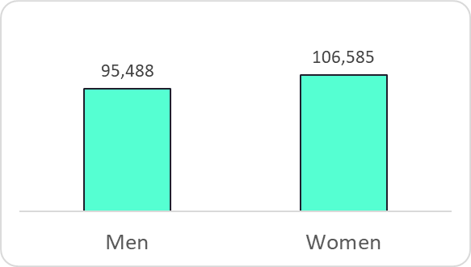

Figure 5 – Reach by gender

The age of our sample reflected the age profile of Facebook users – with fewer young people (under 25s) and slightly more older people (55+) than the population.
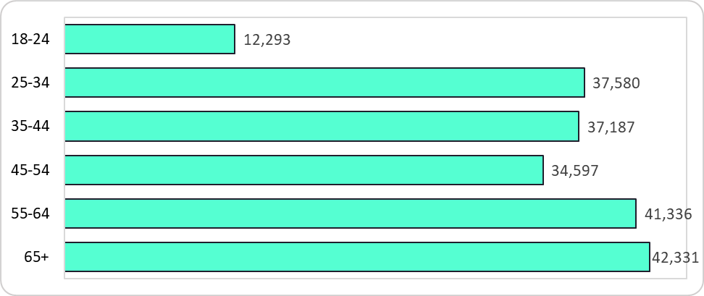

Figure 6 – Reach by age

Gender and age were relatively evenly spread, with slightly more men aged 25-54 and slightly more women aged over 65 within our sample.
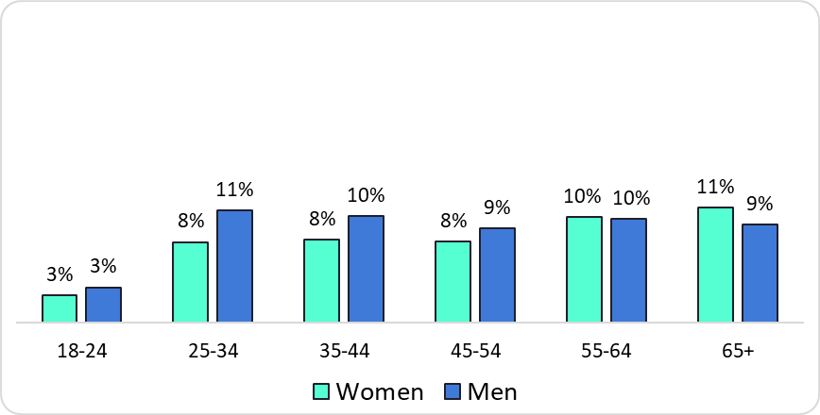

Figure 7 – Reach by age and gender

The Councils participating in the project – in line with the nature of Devon as a whole - reflect both urban and rural areas. We therefore separated the urban populations of Plymouth and Exeter, from the more rural areas in the rest of the County. Each of our interventions were delivered fairly evenly across these rural and urban areas, as the chart below illustrates.
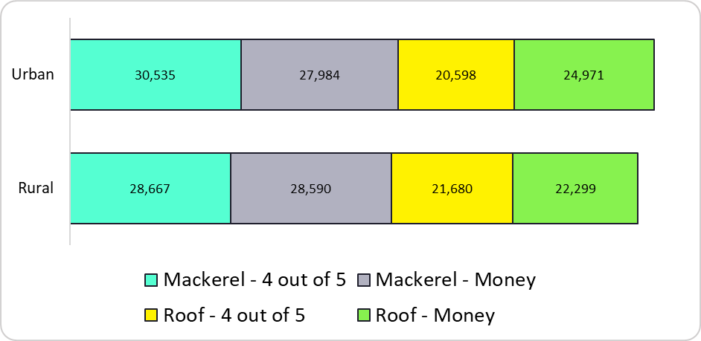

Figure 8 – Reach by location

Trial analysis
Our outcome measure for the trial was whether people engaged with our intervention. We measured engagement with our interventions through:
- Click through rate – where an individual clicked the link to seek further information about loft insulation
- Broader engagement with the intervention – which we measured through comments, reactions, and shares on social media.
As the intervention was delivered through Facebook, we were able to undertake some covariate analysis – based on the variables available through the site. These included urban and rural location, age and gender.

Trial Findings

Click-through rate
The four interventions received a ‘click through rate’ – that is the percentage of trial participants exposed to the intervention who clicked the ‘find out more’ button – of between 1 and 1.7 per cent.
Of the four intervention variants, the one which incorporated a visual of a roof and messaging that appealed to social norms elicited the highest number of clicks. Specifically, compared to the average click-through-rate of the other three variants (1.15%), the ‘roof – 4 out of 5’ (1.7%) variant received 51% more engagement.
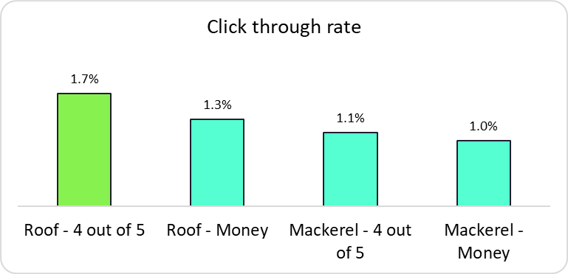

Figure 9 – Click-through-rate of different variants

In simple terms, people who saw the ‘roof – 4 out of 5’ variant were 1.5 times, or 50%, more likely to seek further information on loft insulation, than those who saw one of the three other intervention variants.
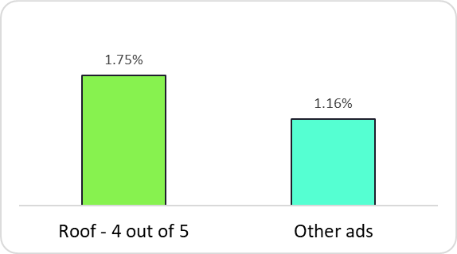

Figure 10 – Click-through rate comparison “Roof – 4 out of 5” and other ads

The results of a chi-square test indicate that this difference in click-through rate is statistically significant, with a p-value of less than .001.

Roof versus Mackerel
We compared the effectiveness of our two approaches – the roof imagery and the mackerel imagery – by combining the two variants of each approach. We found that people were 42% more likely to engage with the interventions (as measured by click through) that featured an image of a roof (1.5% click through rate), compared to those that featured a mackerel (1.1%). A chi-square test revealed that this result is statistically significant (p< .001)
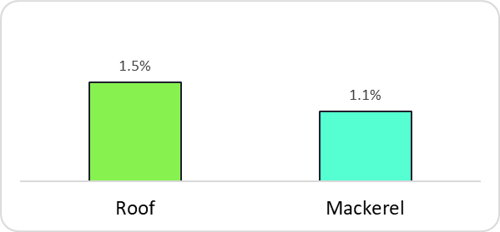

Figure 11 – Click-through-rates comparison roof versus mackerel variants

Social norms versus monetary appeals
We also compared the results from the variants which used social norm messaging with those which used a monetary appeal and loss aversion. We found that the variants which used messaging that appealed to social norms were more effective in eliciting user clicks, compared to the interventions that appealed to monetary motives.
In particular, the click-through rate (1.4%) for variants that appealed to social norms was 20% higher than the click-through rate (1.2%) for those that emphasised monetary appeals. Chi-square analysis showed that the higher click-through rate for social norms is statistically significant, with a p-value of p<.001
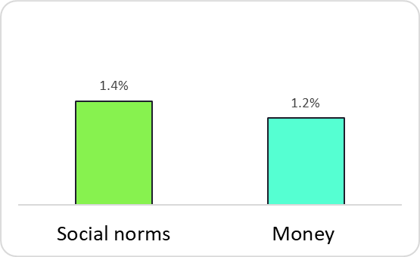

Figure 12 - Click-through-rates comparison social norms versus money messaging

Covariate analysis
We undertook covariate analysis to understand whether demographic variables resulted in differences in response rates to our interventions.
The availability of covariates within the trial data was limited to age, gender and urban/rural residence.

Age
As can be seen in the chart below, we found a strong correlation between age and click-through rate: as age increases, the likelihood of engagement with all four variants of our intervention also increases. The click through rate is particularly high among people who are 65+ years of age, who were 2.5 times more likely than average to click the ‘find out more’ button.
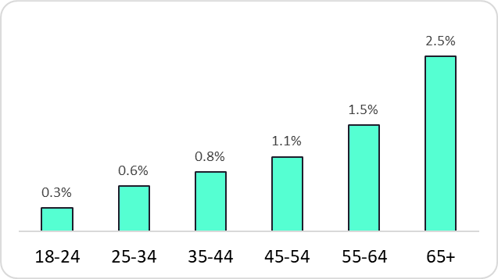

Figure 13 – Click-through-rates by age

When we look at response rates of different aged participants across our four variants of intervention, we found some interesting results. Participants who were 35+ years of age were more likely to click on the "roof 4 out of 5" variant, while no differences were observed in the click-through rate among the four variants among younger participants.
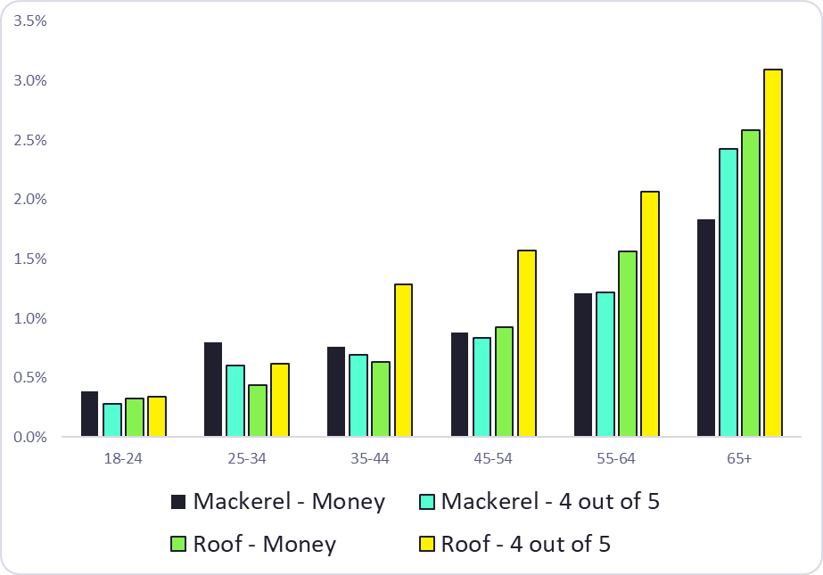

Figure 14 – Click-through-rate by age and variant

Gender
On average, women were significantly more likely than men to click on any of the four variants of intervention. In particular, the average click-through rate of women was 20% higher than the click-through rate of men. The results of a chi-square test indicated that this difference in click-through rate was statistically significant, with a p-value of less than .001.
Despite this tendency for women to engage with the intervention more than men, we observed no difference in the relative effectiveness of each variant between men and women. Those variants which used the roof were more effective than the mackerel, with the social norm proving to be more effective than the financial messaging.
The intervention with the roof imagery and social norm messaging was the most effective variant among both men and women.
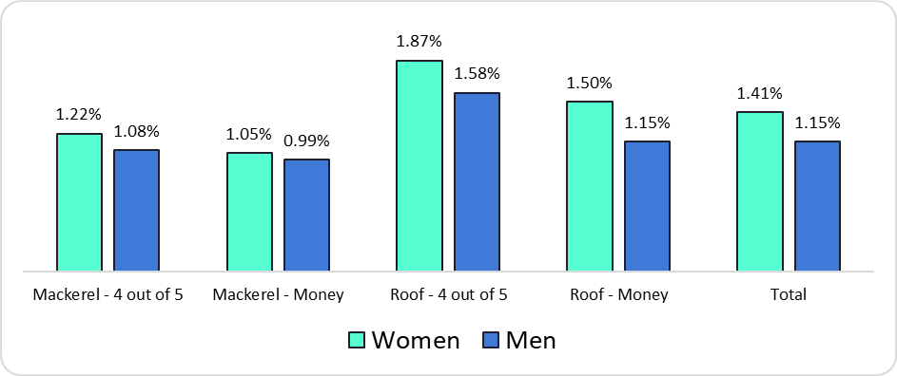

Figure 15 – Click-through-rate by gender and variant

Residence: urban versus rural
On average, rural residents were significantly more likely than urban residents to engage with the interventions by clicking the ‘find out more’ button. In particular, the average click-through rate of rural residents, was 24% higher than the click-through rate of urban residents. A chi-square test revealed that this result is statistically significant (p< .001).
Despite this difference in overall levels of engagement between those living in rural areas and those living in urban areas, we found no difference in the effect of different variants. The roof imagery outperformed the mackerel variants among both rural and urban participants and the social norm messaging was more effective than the monetary messaging across both groups.
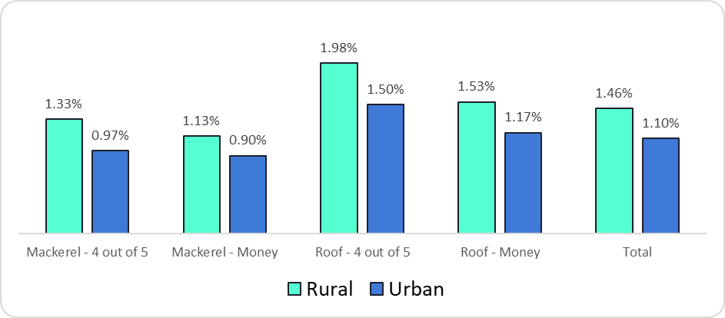

Figure 16 – Click-through-rate by location and variant

Rural analysis
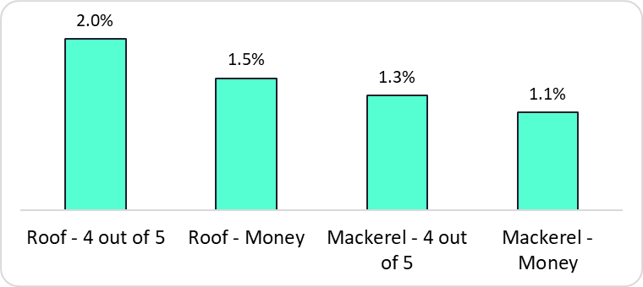

Figure 17 – Click-through-rate by variant (rural)

The variant with the roof imagery and the social norm messaging achieved a conversion rate of 1.98%, which was 51.1% higher than the other variants (1.31%).
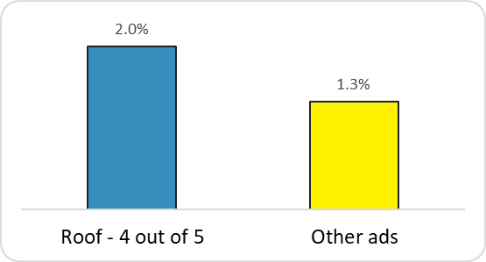

Figure 18 – Click-through-rate comparison “Roof – 4 out of 5” and other ads (rural)

The interventions which used the social norm messaging (1.61% conversion rate) was 23.3% higher than the conversion rate for the variants using a monetary appeal (1.3%).
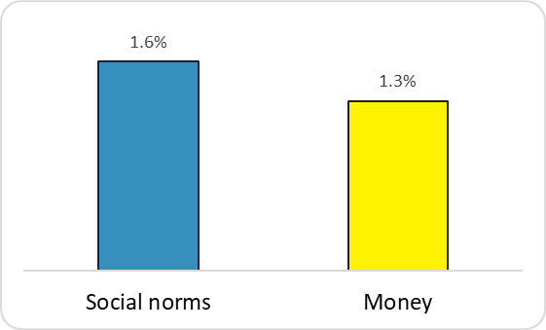

Figure 19 – Click-through-rate comparison social norms versus money messaging (rural)

The click through rate for the roof imagery variants (1.75%) was 42.8% higher than the conversion rate of those with the mackerel imagery (1.23%).
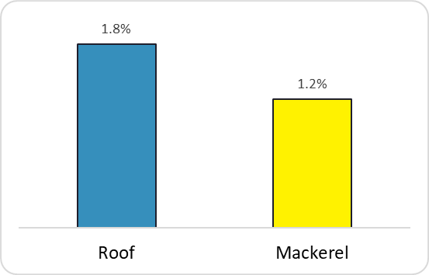

Figure 20 – Click-through-rate comparison roof variants and mackerel variants (rural)

Urban analysis
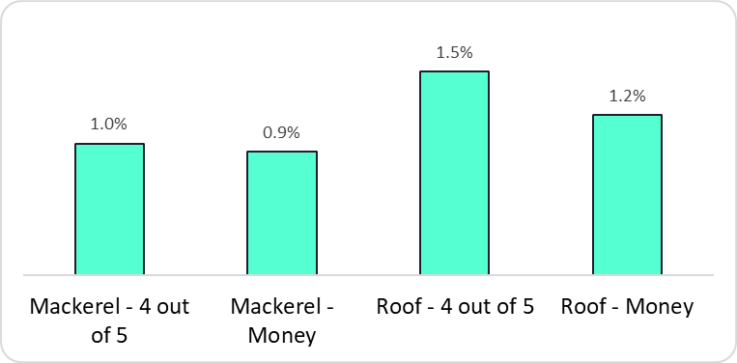

Figure 21 - Click-through-rate by variant (urban)

In urban areas, the variant with the roof imagery and the social norm messaging achieved a conversion rate of 1.5%, which was 48.44% higher than the other variants (1.0%).
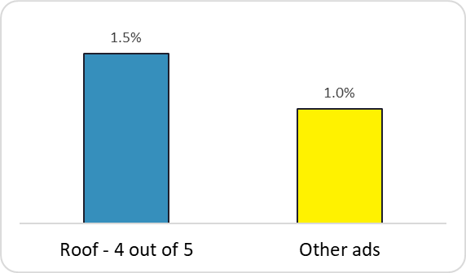

Figure 22 - Click-through-rate comparison “Roof – 4 out of 5” and other ads (urban)

The interventions which used the social norm messaging (1.18% conversion rate) was 14.37% higher than the conversion rate for the variants using a monetary appeal (1.03%).
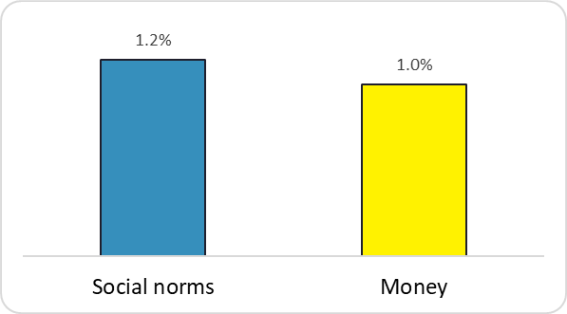

Figure 23 – Click-through-rate comparison social norms and money messaging (urban)

The click through rate for the roof imagery variants (1.32%) was 40.84% higher than the conversion rate of those with the mackerel imagery (0.94%).
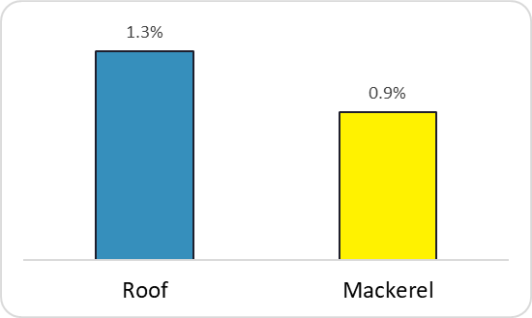

Figure 24 - Click-through-rate comparison roof variants and mackerel variants (urban)

Broader engagement
In addition to evaluating the effectiveness of our interventions through the proportion of participants that clicked the link to find out more information, we were also interested to understand how different variants elicited interaction online.
This broader engagement was evaluated by quantifying the frequency of comments and other interactions each intervention received.
We observed a significant difference in the number of comments the mackerel imagery received compared with the roof imagery. Our mackerel intervention (84 comments) received more than three times as much engagement as the roof intervention (24 comments).
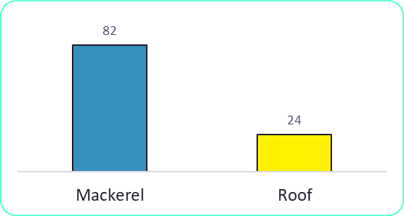

Figure 25 – Comments on mackerel and roof variants

Carrying out qualitative hand-coding of the comments we found that there were four main themes. Some focused on energy efficiency and specifically loft insulation, another group of comments were about council services and wider politics, a number of comments were about potholes and the state of the roads in Devon. However, as can be seen in the chart below, the most frequent subject was the image of the mackerel itself.
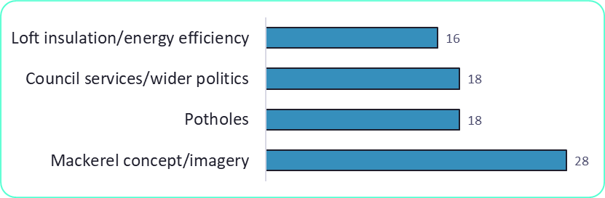

Figure 26 – Comments by theme

Mackerel
Most comments about the mackerel were humorous – highlighting the image’s novelty and deliberately incongruous salience. A smaller number of comments were incredulous.

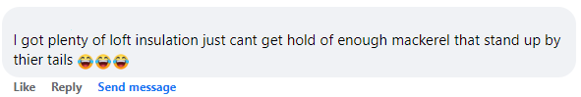

Image 14

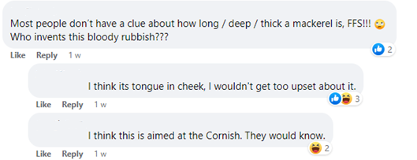

Image 15

Potholes
Some commenters saw it as an opportunity to talk about potholes and the state of the roads locally. The nature of the comments suggests this may be something of a ‘pet issue’. Nonetheless, they engaged with the intervention – mirroring the messaging used in the intervention in a comedic manner.

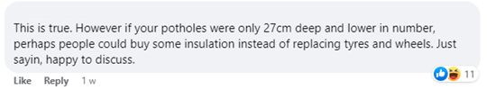

Image 16



Image 17

Loft insulation
A small but significant number of comments engaged with the interventions with specific concerns or issues relating to loft insulation and energy efficiency. Some people wanted to see more support to help households pay for retrofitting, including loft insulation, while others bemoaned the lack of local retrofit installers – both contextual factors to have emerged from the evidence and insight gathering findings.

Conclusions
Whilst we saw some variation in the levels of engagement across different groups – with older people, women and those in rural areas significantly more likely to respond and to seek more information – there was considerable consistency in the effectiveness of interventions.
Social norms were significantly more effective than messaging framed around a financial incentive and loss aversion. Whilst social norms are known to be highly effective at influencing behaviour in certain contexts, we might have anticipated a greater effect of monetary-based messaging in view of the cost-of-living crisis and rising energy prices (at the time). It may be that the salience of the social norm message – highlighting the widespread inadequacy of most loft insulation - is likely to have surprised many people, giving it additional ‘novelty’, which added to its impact.
Similarly, we found that the roof imagery was significantly more effective at eliciting clicks than the mackerel image – with the exception of among young people who were slightly more likely to respond to the mackerel. More traditional, less surreal imagery appears to be more effective at encouraging engagement, particularly among older people (who are more likely to be homeowners and therefore our primary audience for retrofit).
In combination, the roof image coupled with a descriptive norm was the most effective variant at encouraging people to seek more information about loft insulation. This variant received 50% more clicks than all other variants of our intervention.
However, there is another important finding from the trial results which might easily be overlooked by the headline findings. Whilst a social norm and roof imagery elicits more clicks than any other variant, the mackerel was far more effective at stimulating comments and interaction. The mackerel was nearly 3.5 times more effective at eliciting comments than the roof imagery.
This is important as we ought to recognise the respective starting points for distinct audiences and reflect the fact that these require different messages and objectives. For those who are already engaged with retrofitting, our approach merely needs to offer encouragement or information to remove some of the barriers to action – such as knowledge of how to do things for themselves, or access to reliable installers. For this group our objective ought to be encouraging them to take action: access the information they need and then install energy saving measures.
However, for those who are completely disengaged with retrofitting and are unaware of the importance or benefits of installing energy saving measures, we need to adopt a quite different strategy. For this audience, our objective ought to be to stimulate conversation and draw people in to talking about energy saving – in order to normalise such conversations. In these circumstances the mackerel appears to be significantly more effective than the roof imagery.
In essence, the trial findings suggest that the roof imagery is useful at encouraging action, whilst the mackerel is effective at encouraging conversation.
There does not appear to be any major difference in the intervention effect across gender, rural or urban residence or age (with a slight preference among younger people for the mackerel).

Learning points and future planning
The trial findings have highlighted the importance of having clear objectives in communication and engagement activities. The significant variation in how our interventions performed in relation to different outcomes – encouraging action compared with encouraging conversation – underlines the value of having a well-defined purpose and clarity of what we are trying to achieve.
Depending on where a particular person or audience are in their attitudes and level of engagement with retrofitting, we ought to adopt different strategies to reflect their differing starting points and our intended outcomes.
For those already engaged with retrofitting, our intention should be to help them overcome barriers to (further) action. Whereas for those who are currently disengaged with any notion of making their homes more energy efficient, we need to stimulate debate about the benefits and value of retrofit as well as broader conversations about carbon reduction. We cannot hope to achieve societal priorities around net zero without engaging those who currently see no value or have no interest in carbon reduction. The nature and scale of the challenge we face requires widespread adaptation and behaviour change from everyone – we simply cannot achieve these goals without the support and engagement of those currently disengaged.
It is therefore crucial to adopt a tailored approach to messaging and engagement activity, reflecting these different audiences with different starting points and with different (short term or intermediate) objectives. The trial findings provide valuable learning about the effectiveness of different approaches in achieving different outcomes.
This targeted approach is not something that has tended to guide the participating council’s activity or communications to date and is something that should now be considered and incorporated into future plans.
The local primary research we conducted as part of the project identified three segments among the local population. These provide a clear, evidence-based starting point for participating councils to develop future plans and embed a more tailored, targeted approach to engagement going forward.
To support this, we developed logic models as a method for consortium members to consider how they might engage each segment. These logic models (one for each of our three segments) were initially introduced within the final consortium workshop and then developed by Council project leads both individually and collectively. Using logic models helps provide a structure to incorporate key learning derived throughout the course of the project – from behavioural insights principles and knowledge and insights from our local research about our segments, through to our intervention ideas and trial findings.
The completed logic models for the ‘already installed’ and the ‘seriously considering’ segments are included in Appendix B. The consortium also discussed ways to engage the ‘currently disengaged’ segment, but concluded that this group were not an immediate priority to focus on and determined that they would revisit producing a logic model for this audience in due course.
The logic models now provide the basis for clear, evidence-based action plans and enable the consortium to build on the project learning with confidence in the future.
Consortium members will now focus activity on matching appropriate messaging, information and resources to personality types within the different segments in order to support these audiences to move forward on their journey – reflecting their different starting points, motivations and barriers they face.
Alongside the logic models, the consortium also discussed future collaboration and how they want to build on and share the learning from the project going forward. They aim to co-ordinate their activity with the wider Energy Saving Devon retrofit group in order to amplify activity and plug the gaps. The wider retrofit group brings together primarily, local authority officers who are delivering grant funded energy efficiency projects and the Community Energy Groups.
Another opportunity to open up the behaviour change focused consortium has been identified through other climate officers in Devon who sit on the wider Devon Climate Emergency tactical group. Three officers have already expressed an interest in this, which would give the new behaviour change partnership representation from councils throughout Devon.
This approach brings into scope a range of partners from across the County, including councils that were not part of the consortium. It will allow actors to combine resources, avoid duplication and provides opportunities to embed a behaviourally-informed approach more widely by facilitating the dissemination of project learnings about behaviour change and audience segments.
Above all, what matters most is that the participating councils feel equipped with the confidence to apply the learning from the project over the course of the past 12 months.
In particular, it is hoped that the consortium can build on what the project participants have learned about:
- The influences on behaviour and how to use them to devise resonant communications and messaging
- Different segments within local communities and their respective attitudes, values, behaviours and perceptions of retrofitting
- The trigger points and opportunities where people are more open to influence, in order to encourage our desired behaviours
- The benefits of clearly defined and distinct objectives targeted at different audiences – when we want to encourage action and when our aim is to stimulate discussion
- The value of experimentation – testing different approaches and adopting an iterative approach to learning in order to understand ‘what works’
- The limitations of a ‘one size fits all’ approach to engagement and messaging
- External factors that are likely to inhibit or enable positive behaviours among our communities and strategies to mitigate adverse effects, or make use of facilitating impacts.
It is clear that there are a number of contextual circumstances which would greatly benefit the take-up of retrofit measures by households, particularly addressing the skills shortage and supply of installers and the availability of finance and grants. It is hoped that these systemic barriers might be addressed through national government policy in the future.
Nonetheless, the project has highlighted the many opportunities for councils to support meaningful behaviour change within their communities to stimulate discussion and engage households in retrofitting, to normalise conversation about realising net zero through retrofitting and enable people to make improvements to the energy efficiency of their homes.

Appendix A – trial data statistical output
 | CTR | Relative uplift | Z-score | p value | Std error of difference
Roof - 4 out of 5 | 1.75% | 50% | 8.50 | < .001 | 0.0007
Other ads | 1.16%
Roof | 1.50% | 42% | 8.84 | < .001 | 0.0005
Mackerel | 1.10%
Social norms | 1.39% | 20% | 4.58 | < .001 | 0.0005
Money | 1.17%

URBAN | CTR | Relative uplift | Z-score | p value | Std error of difference
Roof - 4 out of 5 | 1.50% | 48% | 5.34 | < .001 | 0.0009
Other ads | 1.01%
Roof | 1.32% | 41% | 5.74 | < .001 | 0.0007
Mackerel | 0.94%
Social norms | 1.18% | 14% | 4.45 | .02 | 0.0006
Money | 1.03%

RURAL | CTR | Relative uplift | Z-score | p value | Std error of difference
Roof - 4 out of 5 | 1.98% | 51% | 6.52 | < .001 | 0.0010
Other ads | 1.31%
Roof | 1.75% | 43% | 6.76 | < .001 | 0.0008
Mackerel | 1.23%
Social norms | 1.61% | 23% | 4.04 | < .001 | 0.0008
Money | 1.30%

Appendix B – Segment logic models
The problem we seek to solve: Removing barriers to those who are interested but might fail to take action

Our target audience: Those seriously considering having retrofit measures fitted
Moderately well off, houses with mortgages, working age

CEGs doing HH engagement & whole house retrofit
Low cost loans for retrofit available across Devon (Lendology)
Likely budget - £8K
Committed Parish Councils
Energy Saving Devon brand & website
Data - survey findings
Data - Parity Projects
Digital tool to enable TA to select info that best suits their needs (DIYer vs trades, a plan etc)
Suitable info & messenger for each option – DIY, trades, plan & normative message.
Green open homes from WHRs, case studies & stories.
Partner activities with Lendology, Bradfords etc.
Resources
available
Activities
planned
Heat pump installed
Significant retrofit measure installation
Whole house retrofit
TA having conversations
TA having confidence in retrofit choices available
Increased awareness of builders / installers & availability plus DIY options
Using plan builder and retrofit guide to make suitable choices
Adopting smaller measures (e.g. loft, smart radiator thermostat etc)
Requesting wholehouse retrofit assessment
Short
Medium
Long
Outcomes - Impacts
Behavioural principles

Descriptive Norms and subjective norms
Priming – real people, real outcomes, storytelling (removing fear)
Messenger – someone ‘like them’, trusted

Assumptions
Home improvements in near future likely (trigger)
Boiler breakdown a trigger point / age of boiler concerns (trigger)
Buying / selling / insuring house (trigger)
This group just need a ‘nudge’ to tip them over the edge/take the plunge. They may tackle it differently depending on skills / personality.
External Factors
Skills shortage / Capacity of ESD & CEGs
Gov funding (eg boiler scrappage)
Cost of living
Time of year (seasonal)
Detractors (public discourse)

CEGs doing HH engagement & wholehouse retrofit
Low cost loans for retrofit available across Devon (Lendology)
Likely budget - £8K
Committed Parish Councils
Energy Saving Devon brand & website
Data - survey findings
Data - Parity Projects
Parish Council led activities
Green open homes from WHRs, case studies & stories
Engagement via sustainable community groups
Partner activities with finance providers and installers e.g. Lendology, Bradfords, Vaillant etc
Resources
available
Activities
planned
Heat pump installed
Deeper retrofit measure installation
Whole house retrofit
TA seeking information on additional retrofit measures
Requesting specific quotes from installers / providers
Exploring financing options such as Lendology
Requesting wholehouse retrofit assessment
Short
Medium
Long
Outcomes - Impacts
Descriptive Norms and moral norms – doing the right thing
Messenger – someone ‘like them’ and trusted
Incentive – partnership offers
Ego - % wholehouse retrofit leaders / energy security
Assumptions
This group just need signposting to deeper retrofit measures and to getting a wholehouse retrofit plan that they can work through at their leisure.
External factors
Skills shortage / Capacity of ESD & CEGs
Gov funding (eg boiler scrappage)
Cost of living
Time of year (seasonal)
Detractors (public discourse)
Behavioural principles
Our target audience: People who already have retrofit measures fitted
Older, more affluent, retirees, living in detached houses without mortgages

The problem we seek to solve: Encouraging those already engaged to go further and install more measures

www.social-engine.co.uk


Photovoltaics was also contained in the aggregated figures provided in a report, but the disaggregated data were not included when the data was extracted in raw form and we were therefore unable to include it in further analysis.
When carrying out an EPC, if an assessor cannot be absolutely sure that a floor is insulated (by seeing documentary or physical evidence) they enter “as built”. if the homeowner doesn’t know if the floor is insulated or can’t produce documentary evidence, then the insulation can’t be entered. If an assessor has entered “as built” for a floor, it is likely to be uninsulated in most cases.
Figures used are for the entire County, rather than just Councils within the Consortium
These figures are where no insultation currently exists, typically they are closer to £20-£40 where existing insulation of 120mm is in place.

