Adult Social Care Assurance
A guide to support the development of your adult
social care self-assessment

Part one: Introduction and
overview

Version 2.0
June 2023

The Local Government Association and Association of Directors of Adult Social Services are Partners in Care and Health (PCH) working with well-respected organisations.
PCH helps councils to improve the way they deliver adult social care and public health services and helps Government understand the challenges faced by the sector.
The programme is a trusted network for developing and sharing best practice, developing tools and techniques, providing support and building connections.
It is funded by Government and offered to councils without charge.
www.local.gov.uk/PCH

Document Control
This document is owned by Partners in Health and Care.

Version 2 reflects learning from Version 1 guidance produced in 2022 and piloted by the East Midlands Region. Updates reflect the learning from the pilot sites and the most recent guidance published by the Care Quality Commission (CQC).

Version | Key changes | Date of issue
Version 2.0

Top tips for the self-assessment

A | ccountable – for our own improvement and engagement in sector led improvement processes
S | pecific – to local context and circumstances because councils ARE different
S | upported by staff and partners – people are engaged in the development of our SA
U | sers, carers and their advocates are accorded greatest importance and highlighted throughout our SA
R | igorous –a balanced analysis of strengths and areas to improve
A | ction oriented –establishes our track record of improvement and sets out our plans to maintain/improve our performance
N | uanced around CQC’s four assurance themes so councils produce one ASC SA – using it for different purposes
C | oncise – with a clear focus on the outcomes achieved
E | vidence informed (including empirical, benchmarked and trend data)

Contents
Introduction 7
ASC self-assessment – the basics 8
Self-assessment and CQC assurance 9
Developing and completing the Self-Assessment 12
The self-assessment workbook and LG Inform 12
Summary 15
Appendix one: Project management and governance 17
Governance structure 17
Project structure 17
Project plan 18

Introduction
This document has been prepared by Partners in Care and Health (PCH) to support councils as they prepare for assurance of Adult Social Care (ASC) through assessment by the Care Quality Commission (CQC). It should be considered alongside the top tips for CQC assurance preparation produced by PCH.

It is comprised of two parts.

Part 1 provides an introduction and overview of self-assessment.
Part 2 is a workbook providing tools and templates which have been developed to support the self-assessment process. This is also supported by an excel workbook.

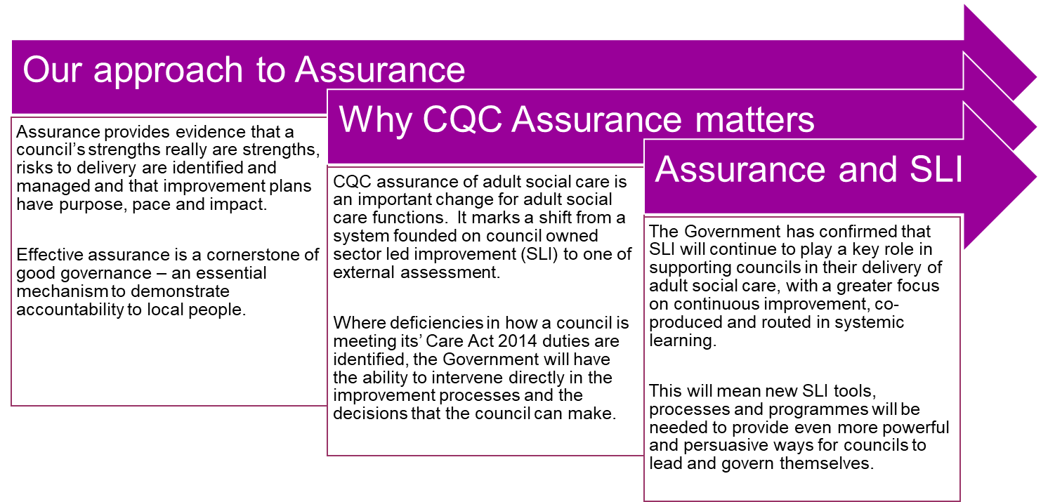
While self-assessment in ASC has been a longstanding, intrinsic, component of Sector Led Improvement (SLI), from April 2023 self-assessment will be undertaken in the context of CQC assurance. It is within that context that this guide and accompanying workbook has been developed.

The completion of an objective, honest and authentic self-assessment of a council’s strengths and areas for improvement is a valuable opportunity to focus improvement planning and delivery in a way that ensures local ownership.
By focusing on the CQC assessment framework themes, which in themselves reflect the requirements set out in Part One of the Care Act 2014 and other relevant legislation, the aim is that the self-assessment, if properly completed, will also meet the CQC “Local Authority Information Requirements” (LAIR) needs.
The workbook (Part 2) is supported by reports and datasets in LG Inform which will provide councils with easy access to data and insight relevant to the self-assessment. This can be used alongside local performance information and evidence-based discussion, triangulated with authentic feedback from people who draw on social care, to give a fair and balanced picture. Partners in Care and Health will also be producing specific guidance where need is identified to support councils in their preparation for assurance, for example the additional guidance developed in relation to unpaid carers. All these resources can be found here

ASC self-assessment – the basics
At its simplest, the ASC self-assessment process should provide a systematic framework to consider three key questions that enable a council to arrive at evidence-based judgements that can enable it to focus efforts to support improvement:

There are some important principles underpinning good self-assessment:
Always back up findings with evidence, recognising that what is asserted without evidence can be dismissed without evidence.
Triangulation of evidence from different sources is essential – this means considering the entire array of performance data, direct observation of practice/documents and, vitally in the case of adult social care, the balanced views of people with lived experience, staff, partners, and other stakeholders.
There is a difference between process assurance (evidence that the right plans, policies and procedures are in place, for example: Joint Strategic Needs Assessment (JSNA); prevention strategy; practice audit plan; complaints policy) and outcomes assurance (evidence of the impact achieved via these plans, policies and procedures, for example, extent of health inequalities; percentage of people approaching ASC who are successfully supported elsewhere; numbers of audits undertaken and percentage of audits rated positively; numbers of complaints received and percentage resolved at stage one).
Self-assessment must yield added value and establish the baseline from which improvement plans are developed with a clear governance framework to monitor the progression.
Be prepared to share findings from self-assessment as, when aggregated, these can play a key role in defining the composition and priority accorded to different elements of the ASC
sector led improvement offer and to inform and shape policy priorities.
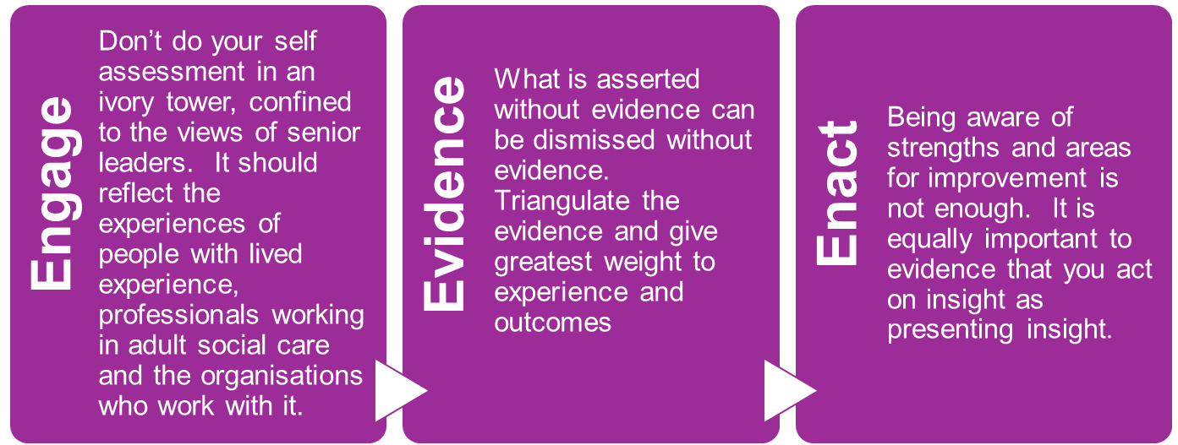
Self-assessment and CQC assurance
The assessment of adult social care by the CQC will focus on councils’ delivery of their duties as set out in the Part One of the Care Act 2014, specifically:
- pursuit of wellbeing
- preventing needs for care and support
- promoting integration of care and support with health services
- providing information and advice; promoting diversity and quality in provision of services (an efficient/effective market)
- meeting the duty of co-operation
- meeting needs; safeguarding adults
- effective transition from children’s services
- ensuring continuity of care and support when an adult moves
- managing provider failure and
- providing independent advocacy support.
The Care Act also links across to the Mental Health Act and the Mental Capacity Act – meaning that CQC will also assess ASC’s performance in these areas.
The interim guidance published by the CQC confirms the process that will be used for local authority adult social care assurance, confirming this will be in line with their single assessment framework based on a set of quality statements. The Assessment framework comprises nine quality statements, mapped across four overall themes. For each theme the CQC makes reference to the sections of the Care Act to which the quality statements relate and the required evidence. The four themes are set out below:

Theme 1: | Theme 2: | Theme 3: | Theme 4:
Working with people | Providing support | Ensuring safety | Leadership
This theme covers:  - assessing needs  - planning and reviewing care  - arrangements for direct payments and charging  - supporting people to live healthier lives  - prevention  - wellbeing  - information and advice  - understanding and removing inequalities in care and support  - people’s experiences and outcomes from care. | This theme covers:  - market shaping  - commissioning  - workforce capacity and capability  - integration  - partnership working. | This theme covers:  - Section 42 safeguarding enquiries  - reviews  - safe systems  - continuity of care. | This theme covers:  - strategic planning  - learning  - improvement  - innovation  - governance  - management  - sustainability.

The self-assessment templates and tools set out in Part 2 of this document reflect the CQC assessment themes. They have been developed to support councils to conduct and complete a self-assessment that meets the needs of the CQC “Local Authority Information Return” (LAIR). This specifically asks councils, in their self-assessment to:
- assess and make judgements about performance in relation to the CQC quality statements, using evidence to support judgements and progression
- highlight key successes
- identify any mitigating actions being taken to address the most pressing risks.
The CQC has also issued principles for the completion of the self-assessment, confirming that it expects the submitted LAIR to be no more than 20 pages and that:
- Statements should reflect local priorities, making explicit the link between priority and achievement, for how priorities link to the JSNA local innovation and good practice.
- Assessments should be supported by evidence that is explicitly referenced, and where possible using evidence based directly on the experience of people who use services and their carers.
- Learning from Children’s Services emphasises the importance of using the self-assessment as a tool for improvement.
Developing and completing the self-assessment
The learning from colleagues in Children’s Services, and those who have used the toolkit is that the processes deployed will matter and the early identification of a senior responsible officer and self-assessment lead will be essential. Appendix one offers a potential approach, building on learning from Children’s Services and pilot sites.
Securing very visible engagement with staff, people with lived experience and your key partners will mean there can be greater confidence in its contents and accuracy. It is important therefore to start conversations with all stakeholders early and to identify the people you want to sign off the final document, so they are engaged from the start.
There should be early consideration of the type and style of the final narrative document and against which it can be assessed. For example:

The degree to which it is |  | The degree to which it is ….
A document that has to be produced for CQC | …. | A “living” document and process that guides and informs priorities
A document that prompts helpful questions | …. | A document that provides assurance and answers questions
A document that marks the end of a process |  | A document that marks the start of a process
A technical document dominated by data |  | Narrative document, with little data
A hard read that might take time a while to digest |  | An easy read that can be read in one go

The self-assessment workbook and LG Inform
While recognising that each council will wish to ensure that the final self-assessment report reflects their corporate style and approach, Part two of this document offers a workbook, including checklists templates and links to data that support the gathering of evidence, to support the production of the self-assessment. It is based around a three-stage process, as summarised on the following page, however it should be used flexibly in the context of the locally agreed process to support preparation for assurance.
Reports are available in LG Inform to support the self-assessment. They are designed to provide an intelligence-based resource that enables effective comparison and benchmarking with other councils to inform and evidence the self-assessment. These have been shaped to reflect the core themes in the assessment framework. They cover:
Local context – including information about an area and its population, focusing on aspects directly and indirectly related to health and social care such as life expectancy, deprivation, employment. This also includes some measures that look at adult social care in the wider council context.
Activity and need – focusing on what we know about the activity and need for adult social care provision in an area.
Provision – drawing on data published by the CQC about registered locations providing a broad picture of social care provision looking at capacity, quality and the range and diversity of provision.
Workforce – linking closely with Skills for Care to draw out some key headline measures from their detailed workforce profiles.
All the data sources used will be maintained, updated and refreshed as they become available, and the reports will evolve based on feedback to give councils access to the latest and most useful intelligence available.

Stage 1: Initial assessment against CQC themes  Tool:  Quality statement checklists | There is a checklist for each CQC assessment theme which reflects the evidence, best practice and guidance highlighted in the CQC assessment framework. An excel version of the stage one checklist is available for councils who would find it useful.  - The checklists can be used to facilitate engagement at the start of the process to enable the development of the self-assessment to be progressed in a way that recognises strengths and areas for improvement based on evidence.  - The checklist for each quality statement can be completed by different constituent groups with ratings triangulated and evidence aggregated and/or completed through a workshop or working groups involving all stakeholders.  - When completed the checklists can provide an initial view about current performance, drawing out areas of strength as well as areas for improvement supported by evidence. They will also help in identifying where there may be gaps in evidence that will need to be addressed through the self-assessment process.  - A data pack has been developed to provide ready access to relevant ASC data sources.
Stage 2:  Summary self-assessment against CQC themes  Tool:  Self- assessment templates | These templates offer a means to draw on the findings from the checklists, to summarise the key themes for the final self-assessment document confirming areas of strength and the areas identified for improvement.  There is a template for each quality statement framed around three core themes, with a series of prompts offered:  - Ambition/vision and current performance  - Evidence used to understand performance.  - Plans to maintain or improve performance in this area
Stage 3:  Final self-assessment  Tool:  Template for final self-assessment | This template offers a framework and structure that councils may wish to use to produce the final self-assessment document. It is based on five sections, providing assurance on the process undertaken and ensuring links relevant reports and sources of evidence.  It covers five core areas:  Section A - A template to support the gathering together of key messages, setting out the local context and considering ASC’s key strengths, priorities for improvement and track record of delivery.  Section B –the self-assessment, using the CQC themes and focusing on the quality statements and key items from best practice and guidance  Section C – A template to confirm the process undertaken including sign off confirming the engagement process  Section D – The template to support the development of a document library – providing links to key plans, reports referenced in the self-assessment  Section E – A template to support the completion of an evidence library – providing links to all the performance information referenced in the self-assessment, plus all statutory returns.

Summary
While self-assessment in adult social care is not new, it is now being used in the context of CQC assurance. In support of this, Partners in Care and Health have worked alongside the CQC and with councils to develop a set of practical tools to support the completion of a local self-assessment which ensures engagement, reflects the primacy of evidence, and embeds assessment and assurance within a framework of sector led improvement.

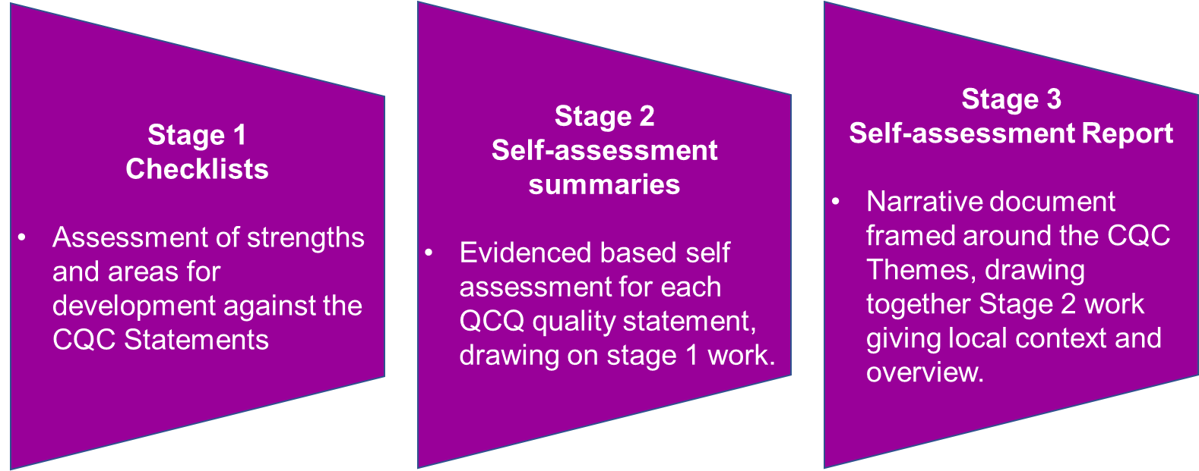

Appendix one: Project management and governance
The approach set out below is not intended to be prescriptive. It draws on learning from Children’s services self-assessments and adult social care pilot sites and recognises that ASC assurance is a corporate priority.
Governance structure
Councils should establish the governance according to their individual circumstances with the aim of ensuring corporate ownership and maximising the opportunity to draw in expert knowledge, experiences of colleagues, and engagement with partners and people with lived experience. This will enable them to identify their strengths, areas to improve and plans for maintaining and improving performance.
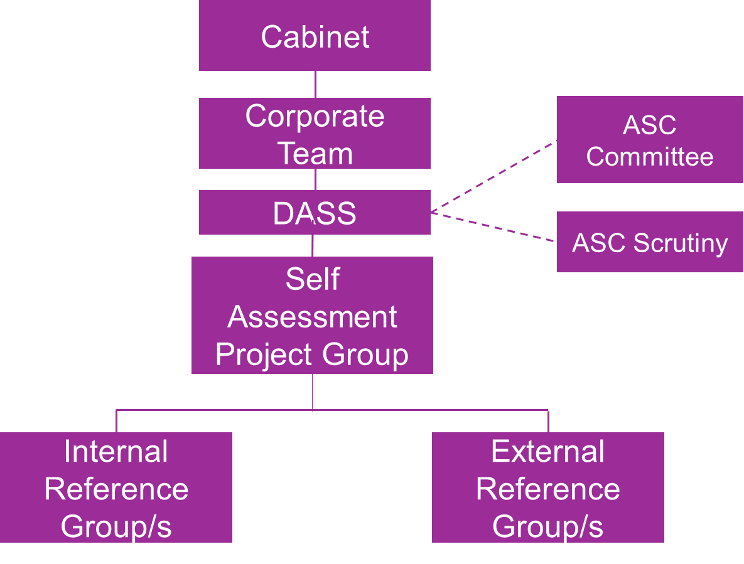
Figure one: Illustrative governance structure

Project structure

Adult social care self-assessment project group – this would be the group responsible for the project ensuring the effective coordination and development of the self-assessment. The group may include leads from professional practice and operations; commissioning; safeguarding; internal services; finance; HR/OD; and business intelligence. Depending on the structure of the department in which adult social care is based, it may include the Director of Public Health and Head of Housing.
It should have strong project management capability, and also include the person responsible for drafting the final self-assessment so that they develop a clear understanding of the findings from the self-assessment across the different elements and are then well equipped to ensure that the final report is coherent, evidence based, avoids duplication and engaging.
The Director of Adult Social Services (DASS) may either wish to chair the group, or it may report directly to the DASS.
Internal reference group – this group would be responsible for providing challenge and support, advising on, and participating in, the process of development. It should have a role in testing and refining the findings at each stage of the process. It might be appropriate to establish more than one Internal Reference Group to provide sufficient expert focus across different elements of the self and assessment and/or CQC assessment framework themes.
External reference group – this group would be responsible for providing challenge and support, advising on, and participating in, the process of development by testing and refining the findings at each stage of the process. It might be appropriate to establish more than one External Reference Group or consider how existing groups can perform this role to provide sufficient expert focus for each of the CQC assessment framework themes.
Project plan
A project plan should be developed. This should be realistic about the time it takes to undertake a meaningful self-assessment, particularly the first time.
The project plan should describe when and how the Corporate Leadership Team, Leader and Lead Member(s) for ASC will be involved recognising that ASC assurance is a corporate priority. For this reason, it is vital that the views of corporate colleagues and lead elected members inform the self-assessment and that they own the emerging themes and issues reflected in the final self-assessment. It should also confirm the formal sign off process that will be undertaken to ensure that the self-assessment document is recognised as valid by partners and has corporate ownership.
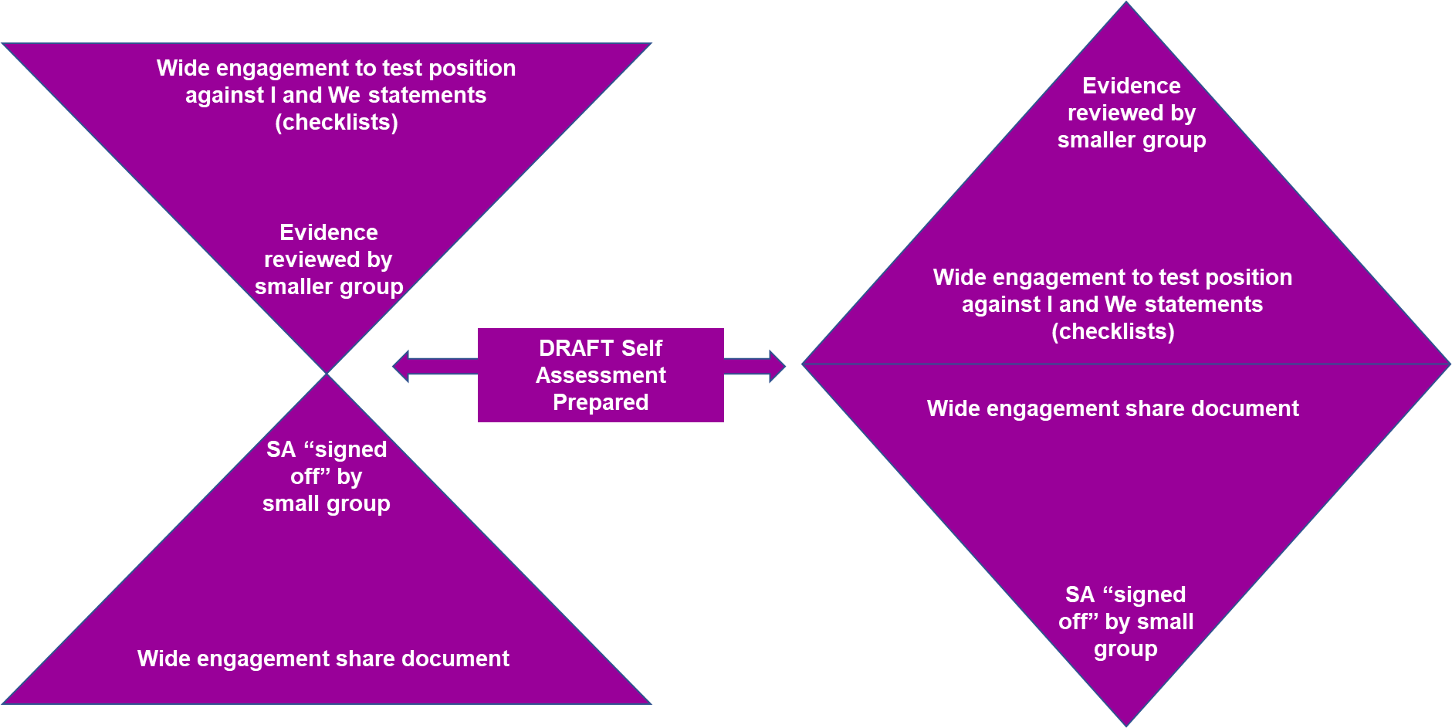
There should be early consideration of the approach that is going to be taken to engagement. Specifically, it is important to consider whether wide engagement will be undertaken at the start of the process to assess performance against the CQC themes, or whether this initial assessment will be undertaken by a smaller group and then tested with a wider group. Generally, early and wide engagement can be more effective and ensure wider ownership.

