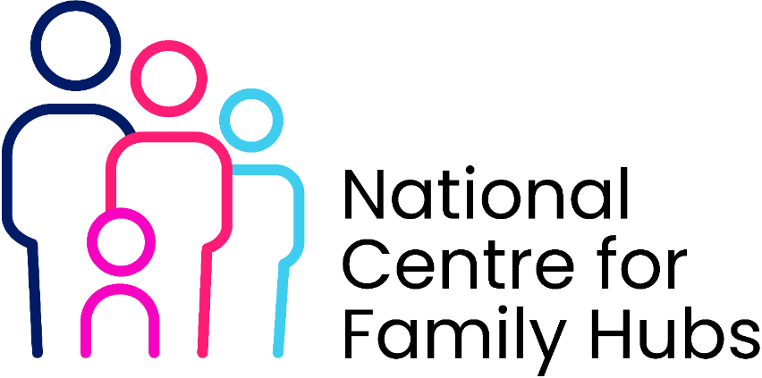
Family Hub Volunteer Induction Checklist
1. Pre-Induction (Preparation)
☐ Volunteer application received and reviewed
☐ References obtained and verified
☐ DBS check completed (where required)
☐ Right to volunteer confirmed (if applicable)
☐ Role description shared and agreed
☐ Volunteer agreement/contract signed

2. Welcome & Introduction
☐ Welcome email/pack sent
☐ Introduction to Family Hub:
- Vision, values, and purpose
- Overview of services (0–19 / 25 SEND as relevant)
☐ Tour of the Hub (physical or virtual)
☐ Introductions to staff and key contacts
☐ Assigned supervisor/line manager

3. Role-Specific Induction
☐ Explanation of volunteer role and responsibilities
☐ Expected time commitment and boundaries
☐ Key tasks and activities explained
☐ Shadowing opportunities arranged
☐ Clarification of what volunteers should not do (role boundaries)

4. Safeguarding & Compliance (Critical)
☐ Safeguarding children training completed
☐ Understanding of:
- Signs of abuse and neglect
- Reporting concerns (who/how/when)
- Local safeguarding procedures
☐ Code of conduct reviewed
☐ Confidentiality agreement signed
☐ GDPR/data protection briefing completed
☐ Health & Safety induction completed
☐ Lone working policy (if applicable)

5. Working with Families
☐ Understanding Family Hub approach (early help, whole-family support)
☐ Awareness of inclusivity, equality and diversity principles
☐ Cultural and faith sensitivity awareness
☐ Communication skills guidance (professional boundaries, respectful engagement)

6. Systems & Practicalities
☐ Access to relevant systems (if required)
☐ Training on booking systems, registers, or case recording (if applicable)
☐ ID badge issued (if applicable)
☐ Access to building/rooms arranged
☐ Expenses process explained

7. Policies & Procedures
☐ Key policies shared:
- Safeguarding
- Health & Safety
- Equality, Diversity & Inclusion
- Complaints
- Whistleblowing
☐ Incident reporting procedures explained

8. Support & Supervision
☐ Supervision arrangements agreed (frequency/method)
☐ Named contact for support and concerns
☐ Peer support or volunteer network introduced
☐ Wellbeing support information provided

9. Training & Development
☐ Mandatory training completed
☐ Additional training opportunities identified
☐ Skills/interests of volunteer recorded
☐ Personal development goals discussed

10. Final Sign-Off
☐ Volunteer confirms understanding of role and responsibilities
☐ Supervisor confirms volunteer is ready to start
☐ Induction checklist signed and dated

Optional (Best Practice Enhancements)
☐ Feedback collected after induction
☐ 4–6 week check-in scheduled
☐ Volunteer recognition/engagement plan shared

