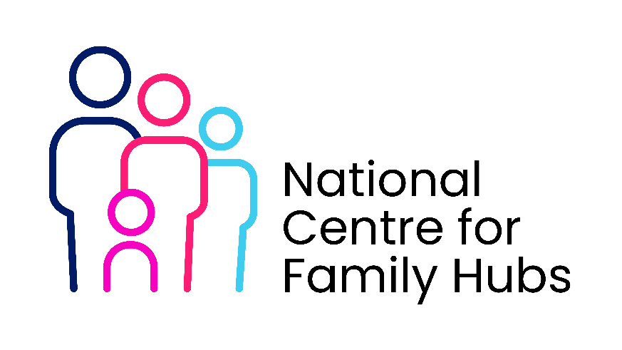

Invitation to Join the Family Hub Advisory Board
(Editable template)
Dear [Name],
I hope you are well. I am writing to warmly invite you to become a member of our Family Hub Advisory Board, representing the views and experiences of local toddler groups and the families you support.
As someone who works closely with parents and young children, your insight is incredibly valuable. Toddler groups play a vital role in strengthening early relationships, reducing isolation, and connecting families to wider community support. We believe your perspective would significantly enrich the board’s discussions and help shape services that genuinely reflect community needs.
About the Advisory Board
The Family Hub Advisory Board brings together parents, community partners, practitioners, volunteers, and local organisations. Its purpose is to:
- Provide insight into the experiences of families in our area
- Help shape the design, development, and improvement of Family Hub services
- Strengthen partnerships across local early years and community groups
- Ensure that family voice and community voice are central to our decision-making
Your Role as a Board Member
As a toddler-group representative, you would:
- Share feedback, observations, and lived experiences gathered from families attending your group
- Help identify emerging needs, gaps, or opportunities for early years and parent-child support
- Offer ideas on how the Hub and toddler groups can collaborate more closely
- Act as a link between the Family Hub and local families, where appropriate
- Support us in building a truly community-informed approach
Time Commitment
We aim to keep the advisory role manageable and family-friendly. The commitment includes:
- 4–6 meetings per year (around 1.5 hours each)
- Occasional optional opportunities to contribute to consultations, co-design workshops, or events
- Reading brief papers or updates in advance of meetings
We recognise your time is precious and want to ensure involvement is flexible and rewarding.
What You Can Expect from Us
- A welcoming, collaborative environment
- Clear agendas and well-facilitated meetings
- Opportunities to influence local early years support
- Support to participate in whichever way works best for you
- Recognition of the value you bring
Next Steps
If you are interested, we would be delighted to talk with you further and answer any questions you may have. Please contact me at [email / phone], or simply reply to this message, and we can arrange a convenient time to speak.
Thank you for the wonderful work you already do for local families. We would be thrilled to have your voice and experience represented within the Family Hub Advisory Board.
Warm regards,
[Your Name]
[Role / Family Hub Team]
[Organisation]

