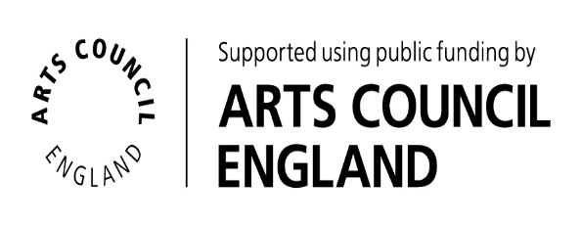

Leadership Essentials: Cultural Services Programme

PROGRAMME 10

Day One: Thursday 7 December 2017

Time | Topic | Presenter/s
9.00am | Welcome and Introduction to the programme | Mark Mower (LGA Associate) & Cllr Bryony Rudkin (LGA Councillor Peer)
9.35am | Leading Innovation  The challenges and opportunities for councils and the cultural sector, including devolution | LGA CTS Board Member
9.55am | The Cultural Landscape  What will the cultural offer look like in the future? Including ACE’s new funding arrangements, Culture White Paper and working in partnership with local government. | Phil Gibby, Area Director (South West), Arts Council England
10.15am | Q & A
10.30am | Break & networking
11.00am  12.00 noon | Theme: Culture contributing to council outcomes  Culture and growth  Case study 1: Core city council ‘devolution and new investment models’  Case study 2: North Somerset Council ‘Banksy’s Dismaland legacy’  Table discussion:  - How can cultural services deliver economic growth in your local area?  - ‘What opportunities are devolution deals and conversations presenting to developing new investment models for culture?’  Feedback & discussion | Claire McColgan, Director of Culture, Liverpool City Council  Mike Jackson, Chief Executive, North Somerset Council
12.45pm | Lunch
1.45pm | Local Leadership in a complex world  Followed by Q & A and discussion | Mark Mower
3.20pm | Break & networking
3.45pm  4.30pm | Culture and public health  table discussion:  - How is your council using cultural activities to improve public health?  - How can you improve partnership working with your portfolio holder for health; Director of Public Health and Health and Wellbeing Board?  Case study 3: ‘Integrating culture into public health’  Followed by Q & A and discussion | Alan Higgins, Director of Public Health, Oldham Council
5.00pm | Close
6.45pm | Pre-dinner reception | Co-hosted by LGA/Arts Council England
7.15pm | Pre-dinner speaker ‘How cultural organisations work with councils’ | Parminder Dosanjh, Creative Director, Creative Black Country
7.45pm | Dinner

DAY TWO: Friday 8 December 2017

Time | Topic | Presenter/s
9.00am | Welcome to Day 2 and recap of day one  table discussion:  ‘What are the big challenges for cultural provision in your council and how can what you heard on day one help you deal with this?’ | Mark Mower & Cllr Bryony Rudkin
9.35am | Theme: Different ways to deliver cultural services  Case study 4: ‘Cross sector partnerships’- Magna Vitae Trust and the Greater Lincolnshire cultural strategy  Case study 5: Kent County Council (internal commissioning) | James Brindle, Director & Doreen Stephenson, Chairman, Magna Vitae Trust for Leisure and Culture  Cllr Mike Hill, Cabinet Member for Community Services & Roger Wilkin, Head of Waste Management & Tony Witton, Arts & Culture Services Manager
10.45am | Break & networking
11.10am  11.40am | Case study 6: ‘Different delivery models’  Followed by discussion:  ‘What different ways is your council delivering or looking to deliver cultural services?’ | Susan Williamson, Head of library services, St Helens Council
12.05pm | Leading and supporting transformational change | Mark Mower
1.00pm | Sharing the learning and supporting others  - Arts Council support  - LGA support  - Evaluation | Paul Bristow, Director, Strategic Partnerships, Arts Council England  &  Cllr Bryony Rudkin
1.30pm | Programme closes & Lunch

