Hate Crime Behavioural Insights Trial
March 2021 – December 2022

Contents

Introduction ………………………………………………………. 3
Background ……………………………………………………….. 3
Evidence-Base …………………………………………………… 4
Rationale and Objectives ……………………………….…… 8
Trial implementation method……………………………….. 13
Programme Design ………………………………………..….. 16
Results ……………………………………………………………… 29
Assessment ……………………………………………………….. 34
Lessons Learned ……………………………………………….. 39
Research directions ……….……………………………………. 43
Appendices ………………..………………………………………. 44
- References and Sources
- Facilitator blogs
- Raw reoffending data

Introduction

The report summarises the development of a programme for hate crime perpetrators designed to offer an out of court disposal for educational and rehabilitative purposes.
The report will cover brief review of some of the key literature accessed to inform the design of the intervention/programme, the extracted stages and themes of each of the sessions in the programme, which specifically mapped onto the evidence base, the method of rollout and the sample and the results and findings in terms of qualitative and quantitative feedback from perpetrators that have completed the programme.
The report will conclude by summarising the findings in the context of the literature and the evidence base, with a key focus on issues with implementation given that feasibility and practicality of the programme is a major outcome for the pilot of this project.
Finally, some recommendations for further research and for future implementation of such programmes will be summarised.

Background

Definition
The Association of Chief Police Officers (ACPO) provided a definition of hate crime for England and Wales, which is:
“Any offence committed against a person or property which is motivated, in whole or in part by the offender’s bias against a race, colour, religion, gender, disability, sexual orientation or ethnicity.
It may also be where a person is targeted or selected because of their status, group characteristics or affiliation.”
- Home Office (2009)
The targets are those that are considered protected characteristics, as part of the Equality Act (2010).
Prerequisites for prosecution
In order for a hate crime to be prosecuted, there needs to be recognition the motivator was related to actual or perceived membership of a particular group (Sheppard, Lawshe & McDevitt, 2021)
Prevalence of hate crime
In the UK, year of 2018/19 there were 103,379 instances of hate crime reported, which works out as a 174.86 incidence rate (per 100,000) in the population) (Williams, 2021). This seems high compared to incidence rates of other large countries with diverse populations, such as 2.32 in the US and 5.71 Canada. In terms of violence, 24% of religiously motivated hate crimes were found to be violent in nature in England and Wales and this was slightly higher for racially motivated hate crimes (27%) (Corcoran et al., 2015; The Home Office, 2013).

Some research has suggested that the majority of hate crimes have been committed whilst under the influence of alcohol (Hamad, 2017), and that the first standpoint is often to support with alcohol-related issues over prejudice. This may be a factor that affects the successful prosecution and rehabilitation of hate crime offenders.
Local data largely reflects national data in indicating that perpetrators of Hate Crime are predominantly White, Male individuals between the age of 25-34 (e.g. English and Wales Crown Prosecution Service, 2011). Of 974 suspects, 202 were in this age bracket, closely followed by ages 35-44 (186) and younger individuals. The majority of Hate Crime incidents were linked to race and religion.
Cambridgeshire Constabulary has noted that 1,650 hate incidents were reported within Cambridgeshire between 1st December 2019 and 28th February 2021 and the vast majority of reported incidents (1,344) were racially based. The data indicates that since the pandemic (March 2020), incidents of Hate crime have increased for people with the following protected characteristics: disabled people, LGBTQ+ people, race, religion. These groups are already disproportionately adversely impacted by COVID-19 and tackling hate crime will accelerate a more inclusive recovery from COVID-19.

Evidence base
Overview
A broad literature review has highlighted several key areas that would likely help reduce recidivism of Hate Crime offences linked to race and/or religion. Factors identified overlap with those highlighted in Hate Crime programmes in other regions and countries, but targeting different offender cohorts, such as the ADAPT Programme, targeting racial Hate Crime offenders in Scotland (Felsinger, Fyfe & Smith, 2017; GREC, 2013) and SPARX-R for young offenders in New Zealand (Fleming et al., 2019).
Much of the evidence base used to understand and inform interventions for perpetrators of hate crime are the four main “typologies” of perpetrator proposed by McDevitt (2002) in the United States. Any attempts for rehabilitative programmes tend to have been based on these. In the current trial, these typologies were considered in the initial stages and form part of the first session, as they can provide some indications as to how best the facilitator can work with the individual. For example, Mission offenders, who have a strong internal motivation to commit Hate Crime, may benefit less from equality or diversity training, especially if this is not specifically tailored to an offender cohort (Sullaway, 2004) and in general, are less amenable to change (McDevitt et al., 2002).
Supporting psychological and social theories
- Self-Control Theory (Gottfredson & Hirschi, 1990) can be used to understand specifically why some individuals may offend, as not all from certain backgrounds that perceive a threat or difference go on to offend.
- Strain Theory and Structured Action Theory (Walters, 2011) can explain how “fear of difference can evolve and the role of self-control in this.
- Situational Action theory views self-control as a factor in the process of choice (Wikstrom, 2006), whereby in the presence of certain situational and contextual influences that affect a person’s ability to exert self-control, this can influence whether a person chooses to engage in criminal behaviour (Wikstrom & Treiber, 2007). Self-control in this context is viewed as the ability of the person to inhibit an action or urge in a particular circumstance, that may not be congruent with the person’s sense of morality, values, and longer-term goals.
- Power-Threat Hypotheses and Integrated Threat Theory (Alport, 1954; Blaylock, 1967; Stephan & Stephan, 2000) posits that the perception of threat towards an outgroup, whether this be considered “real” or “symbolic” threats can be influential in offending, particularly of note during times of austerity in the UK. For example, when an individual detects the existence of a threat, this can lead to negative emotional and physiological reactions, encouraging intercultural prejudices, direct hostility, negative attitudes and behaviours.
- Anger management approaches: Perpetrators may not have the emotional vocabulary to identify and distinguish emotional experiences, particularly those meeting criteria for Antisocial Personality Disorder (ASPD; Gawda, 2013), which constitute a high proportion of the offending population (63% of male remand prisoners in the UK; Singleton et al., 1998) and has been linked to higher recidivism (Larrotta-Castillo, Gaviria, Mora-James & Gomez-Abril, 2017). Anger can be expressed as a means of avoiding other unpleasant emotional experiences that are more difficult to identify and tolerate (e.g. NICE, 2018), as evidenced by the suggestion that shame could be at the root of hate crime offences, but instead, this is transformed into anger and aggressive behaviours (Hamad, 2019). Therefore, some broad emotional literacy to help the perpetrator start to label and distinguish emotions will be a key part of anger management.
The following approaches were used in conjunction with Behavioural Insights Theory:
- Cognitive Behavioural Therapy (CBT): The Hate Crime Behavioural Trial intervention was developed from a foundation of Cognitive Behavioural Therapy (CBT). There is a strong evidence base for CBT (for example, What Works research) and it has evidenced results in both a face to face and online capacity (NICE 2009).
- Strengths-Based Approaches: There is a wide base of evidence that supports the effectiveness of using Strengths-based approaches to bring about behaviour change. Evidence suggests that building confidence, self-esteem and supporting individuals to develop and build upon strengths is key to motivational change, and relates to functional aspects of: interventions enablement, educational and training functions of interventions on the behaviour change wheel.
- GROW: The GROW model is embedded within the content of the intervention in terms of the use of the following principles: establishing a SMART Goal, understanding perpetrators current reality, supporting them to evaluate and increase their options, and motivating them to find a way forward. This methodology is highly compatible with CBT, motivational interviewing, and strength-based approaches. Moreover, the GROW model extends to persuasion, modelling, and training aspects of intervention functions on the behaviour change wheel, via guided training towards specified targets. The facilitators apply this model by using a mentoring approach and empowering individuals to set their own goal/s and to map their own journeys towards a more positive, non-offending identity.
- Restorative Element: Restorative Justice Principles are incorporated into the content of the intervention within the exercises in which the intervention explores behavioural insights with regards to ‘The Victim’. For example, a written letter to the victim (that will not be sent) and/or an option to signpost to further facilitated restorative justice activities. This will link with incentivisation, educational and coercive aspects of the intervention functions on the behaviour change wheel.
Although some of the content bears some similarities to unconscious bias training, unconscious bias theory has not been incorporated specifically within the intervention. Government Initiative encouraged caution in the use of Unconscious Bias training by employers promoting positive attitudes towards diversity and inclusion. Specific recommendations were as follows:
- Recommended face to face delivery and that online platforms may not be appropriate.
- Passionate trainers/facilitators (rather than selecting based on skills/experience).
- Providing appropriate time – full day minimum.
- Making the training real – this is also why such an emphasis on examples/scenarios from those with lived experience of who have worked with/encountered hate crime offenders.
- Interactive activities to help the person learn to take the perspective of others.

However, as the intended use is significantly distinct from the practice referred to by Government Initiative, these recommendations are not viewed as relevant to the intervention developed within this trial. This is particularly because the basis for the ineffectiveness of Unconscious Bias training within workplace contexts on participants with opposing world views was linked to the perception of the training as generalised and the content not being viewed as relevant to participants. However, the proposed context for using this intervention is within the out of court disposal process and therefore the current programme is operating in the very different context of intervening with people in which this is clear awareness of a problem.
Typologies
The typologies that offenders are identified as having, can inform an understanding of the extent and intensity of their bias or prejudice and strongly influence how receptive they are to rehabilitation.
Across all typologies there are many common factors across hate crime offenders (e.g. Diaz-Faes & Pareda, 2022; Walters et al., 2016) - most individuals convicted of hate crimes have higher reactive and proactive aggression, subtle prejudice, homophobia, and social dominance orientation (Ramírez, Chiclana, Méndez & Ana Suárez, 2022). Prejudice, and bias specific to race or religion, appears to form only a small component or motivation of the offender. Therefore, rehabilitative programmes for hate crime offenders, broadly need to target issues that are general across offending, in addition to some specific bias and prejudicial factors.
Most offenders are thrill, defensive or retaliatory offenders, motivations that are viewed as most susceptible to behaviour change interventions. A very small percentage are ‘mission offenders’, who have a strong internal motivation to commit Hate Crime, and may benefit less from equality or diversity training, especially if this is not specifically tailored to an offender cohort (Sullaway, 2004) and in general, are less amenable to change (McDevitt et al., 2002).
Typology | Proposed Proportion of Offenders | Level of bias/prejudice | Description
Thrill | 66 % | Medium/  Low | Motivated primarily to experience excitement, or thrill; groups of young men with one or two ringleaders; often go outside neighbourhood; verbally abuse and/or physically assault; medium to low prejudice motivates selection of victim; sometimes young men under influence of alcohol; racist offending more likely to occur in groups, or have more than one perpetrator, such as peer bonding (gaining acceptance from others); impulsive, risk takers
Defensive | 25 % | Low | Perceived threat to their territory or turf if the main motivation; beliefs invading locations they compete for and taking jobs, or sponging off the state and thereby taking resources from others; anger and internalised shame likely a factor
Retaliatory | 8 % | Medium | This group of perpetrates feel that their group is directly under attack by an "outgroup;" Examples of this may be media stories or events that have documented terrorist attacks, where communities have been harmed.
Mission | 1 % | High | Tend to make it a purpose in life to target certain groups of people; driven by an ideology of hate (strong prejudicial views) and extreme violence; anger, socio-economic deprivation, internalised shame; mission offenders may provide the context of hate affecting justification of the other offender types to commit the crime

Digital interventions
Current research indicates Computerized Cognitive Behavioural Therapy-based programmes (CCBT), can be as effective as face to face delivery (Anderson & Cuijpers 2009). Interventions delivered via digital means in a health setting were found to have many benefits (Bishop, 2020).
The use of electronic programmes have been found to:
- Improve access, among young people.
- Reducing barriers such as travel, other restrictions or waiting lists.
- Provide a sense of anonymity, facilitating private access and reduced stigma around accessing support.

Moreover, digital interventions are cost and resource effective, allowing for large-scale application and empower individuals to address their own needs.

Rationale and objectives
Overview
As a result of the impact of hate crimes on victims and communities based on targeting personal characteristics, enhanced sentences are recommended. However, there is a very low sentencing rate for these crimes.
Research shows that is unlikely that simple punitive measures (such as a financial penalty) will deter or prevent further incidents, as it does not address the perpetrators underlying discriminatory attitudes, motivations or perspectives (Chakraborti and Garland, 2015). The intervention that has been developed and evaluated within this trial meets a significant gap within the restorative justice system, as there is no out of court disposal for perpetrators of hate crime. This means that the majority of offenders do not access rehabilitation.
Taken alongside the low sentencing rate, overall, this means that there is an insufficient supply of effective interventions to address these offences.
Trial objectives
The overall objective of the behavioural insights trial was to assess the impact of the trialled intervention on reducing recidivism rates of perpetrators of religiously and racially motivated hate crime offences within Cambridge City and Peterborough. The second cohort that was originally in scope of the trial was individuals involved in hate incidents. Specifically, the goal was to establish whether the intervention could produce a change in the motivation and behaviours of participants.
The trial involved the design of a rehabilitative educational tool based on behavioural science principles. The method of recruiting participants to the trail was via referrals from the Neighbourhood Policing team within Cambridgeshire Constabulary. Perpetrators were given the opportunity to participate in the trial, using the out of court disposal process, thereby avoiding prosecution. However, eligibility for participation was reliant on admission of motivation by prejudice or bias.
Having such a programme that creates an opportunity for learning and rehabilitation, would offer a means of reducing the number of hate crime offences in the longer-term.
Additional objectives were to determine whether the proposed intervention will be effective in:
- Reducing public sector demand linked to Hate Crime, including Police/Probation/MH and housing and those organisations that support victims due to a reduction of victims and desistence from those perpetrators whom have engaged with the behavioural insights trial
- Increasing confidence in reporting Hate Crime and Hate incidents reported in Cambridgeshire, Fenland and Peterborough
Target cohort
The identified Target Cohort is therefore: White Males, Age 13-44, with an index incident of Hate Crime related to race and/or Religion. The majority of the cohort, those aged 25-34 and 13-24, will likely benefit from the intervention delivered digitally due to increased likelihood of computer literacy, which will have been a core part of educational syllabus. Research has indicated that younger people, particularly adolescents, have found a preference, and benefit from, digital delivery of interventions (Fleming, 2019).
However, the variation of needs, motivations and capability between a 13 year old and a 44 year old perpetrator is likely to be significant. For this reason, a simpler, adapted version of the intervention will be developed for individuals under 17. This reduces the difficulties in standardisation and evaluation from a psychologist perspective.
The majority of hate crime incidents were linked to race and religion. As research indicates that these two factors are often interlinked in such incidents, the development of the Behavioural Insights Trial will focus primarily on this type of hate crime.
The trial will however not exclude perpetrators that commit offences based on race and religion but that also present with concerning views in relation to the additional protected characteristics e.g. sexual orientation, transgender or disability. We consider it pertinent to address all forms of explicit and implicit prejudice given the increasing prevalence locally in all categories.
The four typologies will be considered in the initial stages and will form part of the first session, as they likely indicate how the facilitator will work with that individual, and will have certain implications for the style of delivery.
Behavioural insights assessed
The current intervention has been developed in accordance with Behavioural Insights Theory and highlighted additional areas of focus, particularly due to potential variability in motivation and rehabilitation needs within the diverse cohort of perpetrators.
- Psychological Capability: Access to the Behavioural Insights Hate Crime programme will enable the perpetrator to develop new skills across all modules, and key elements of skill acquisition are contained in modules 2-4, but modules 1 and 5 are pivotal in providing information around the need for change and setting the scene for change by presenting relevant information about victim/perpetrator attributes. Additional factors such as mental health, substance misuse and family/peer difficulties will be considered in how they limit (or indeed increase) individual capability.
- Motivation: Aspects of this will be targeted as part of the Behavioural Insights intervention, including; the majority of the material from module 1, which defines hate crime and determines some motivational aspects of hate crime offences, as well as motivation for change (e.g. victim impact, stages of change); some of the reasoning dispositions and cognitive distortions addressed in module 3 may also address internal motivations to commit Hate Crime. Typologies will also be considered. Module 4 will seek to identify those individual emotional connections which shape individual actions in both positive and negative ways.

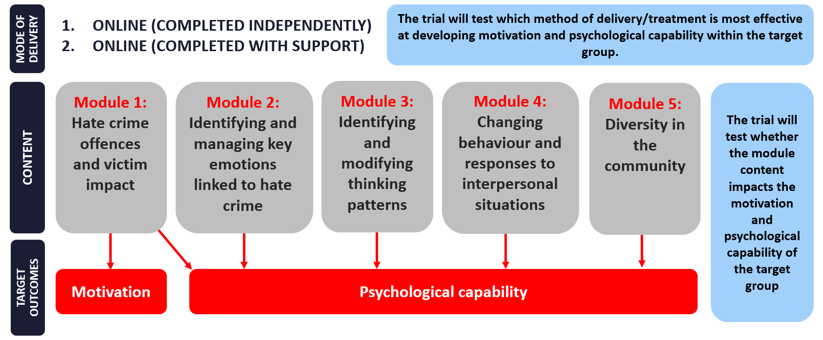
Participant Recruitment Process
The recruitment of participants is subject to the standard policing process for hate crime reporting, identification of a suspect and investigation leading to the designation of a crime and decision to prosecute or use an alternative approach, as set out below.
The intention was also to involve individuals involved in hate incidents, not designated crimes, in the trial via referrals from local schools to assess the impact on this cohort, but the lack of uptake of this method made this unviable.

Outside of scope of the trial
Additional Factors
In order to have the highest impact, evidence suggests that responding to racist, religious, and other hate crime needs to extend beyond evidence-based interventions, as depicted in the Behavioural Insights Model and Behaviour Change Wheel. To maximise impact, interventions should provide a holistic response to: socioeconomic, cultural and psychological factors, including deprivation, family dysfunction, extreme financial and life stress/illness, residential/cultural segregation, stereotypes/misperceptions, or myths about particular cultures and cultures of masculinity and criminality (e.g. GREC, 2013). In particular, factors such as socioeconomic status, mental health issues and substance misuse are prevalent within this cohort, therefore interventions must offer practical support to alleviate such issues.
Interventions which are educational without developing new skills to move away from such issues tend not to be effective (MacKenzie & Farrington, 2015). This intervention will therefore include signposting work and liaison with other local agencies.
Signposting
After completing the pre-programme questions, participants are provided with information and signposting to local resources, in addition to a grounding method.
This is in acknowledgement of the fact that, for offenders, traumatic life experiences, substance misuse and mental heath difficulties are more prevalent than the general population (Chiles, Von Cleve, Jamelka & Trupin, 1990; Senior et al., 2013).
Moreover, the reflective elements of the content could have the potential to be ‘triggering’ and/or the offender may need additional or broader support to that which the programme can offer.
Content & Wording for Signposting:
“This programme is intended for the purpose of guided self-help However, it would be advisable that if not with a professional, or facilitator you have someone close to you or trusted, that you could contact just to check in (even if you choose not to tell then about the programme).
It is strongly encouraged that you seek professional advice if anything comes up during this programme that you need more help and support with.
Despite attempts to avoid material that could be too emotive, some subjects may resonate with you personally. If this happens, we want you to know that you are not alone, support is here for you, and if you are struggling, please reach out for help The following contact numbers and
services can be a really good start if you feel unable to reach out to your GP or a friend/family member.
- Samaritans: Call for all mental health, 24hrs a day 365 days a year - 116 123
- Lifeline: Everyday 11am-11pm for listening support and information to someone experiencing mental distress - 0808 808 2121
- Mind Infoline: Call or text for help with all mental health challenges, Mon-Fri 9am-6pm- 0300 123 3393
- Shout: Text shout for support with a mental health crisis and other mental health challenges, 24 hours a day. 365 days a year – 85258
- The Kaleidoscope+ Group: The Kaleidoscope Plus Group have partnered up with Shout a charity in Solihull, to provide a 24/7 crisis text messaging service Text TeamKPG to 85258 for 24/7 support.
- Anxiety UK: Call for help with anxiety challenges, available Mon-Fri between 9:30am-6:30pm- 03444 775 774
- No Panic Youth: (For 13-20 year olds) Call Mon/Tues/Wed/Fri 3pm-6pm, Thurs and Sat 6pm-8pm for help and support for sufferers of panic attacks and OCD- 0330 606 1174
- LGBT+: Call everyday 10am-10pm-0300 330 0630
If this happens, in the meantime, try and remind yourself where you are in the here and now, and the distress is coming from something that has passed Try this exercise:
Feel the chair beneath your legs (if you are sitting on one). your feet on the floor, remind yourself how old you are and think about where you are. Try and touch something close to you whilst reminding yourself of what is happening around you in the here and now.
Please contact someone and speak about this. We will cover this a little more in one of the modules as these tips can be useful in helping us manage and regulate our emotional experience/reactions to events. If these feelings pose an urgent risk, please attend the Accident and Emergency Department, your local Crisis Assessment Suite if you have one, or call 111 or your local mental health Crisis Team.”
Risks
At each stage of the hate crime policing process, there are risks for drop off of trial participants. As part of the evaluation a workshop was held with local police officers involved in policing hate crime, who identified the following risks, drawn from their experience:
- Non-reporting – the victim may have been involved in a reporting a previous incident or repeatedly subject to hate crime and therefore not report as they feel ‘it happens all the time’. This was particularly the case within hospital environments, where the officers noted the frequency of sanctioned patient hate crime against staff where there is a complex medical context.
- Reporting – the victim may fear negative repercussions of reporting and decline to name the suspect. Where officers are present during the incident, if no other party notes a hate element in the offence, the bias, or gaps in knowledge of local officers, can impact their identification of the hate crime element even if this is objectively present. Officers noted the prevalence of hate sentiments being articulated in passing.
- Investigation – local officers have a lot of demand on their capacity which can delay the investigation, Victims can decline to support the evidence gathering process, fearing a negative social impact of being a witness in a trial or stop assisting the investigation if they feel the process is too onerous or lengthy.
- Suspect interview – the most significant barrier to uptake was the requirement for perpetrators/ suspects to ‘admit their racism’ as part of their admission. This was viewed as an action that was highly improbable in most cases due to severe social stigma about being labelled ‘a racist’, even where racist views are held by individuals and openly shared in social contexts.
Out of court disposal route- the introduction of a new out of court disposal, disrupting standard processes carried risks in terms of awareness of the intervention, confidence in deploying the intervention and the perception of the additional work the intervention would create in cases that may previously have been filed and not progressed to a CPS referral. Moreover, the digital mode of delivery and length of the intervention (10 modules) were also viewed as potential barriers

Trial implementation method

Proposed/Adapted Timescales
Initially timescales were set in line with the parameters of the Behavioural Insights programme, however these were adapted due to challenges with recruiting a sufficient number of participants in the trial.
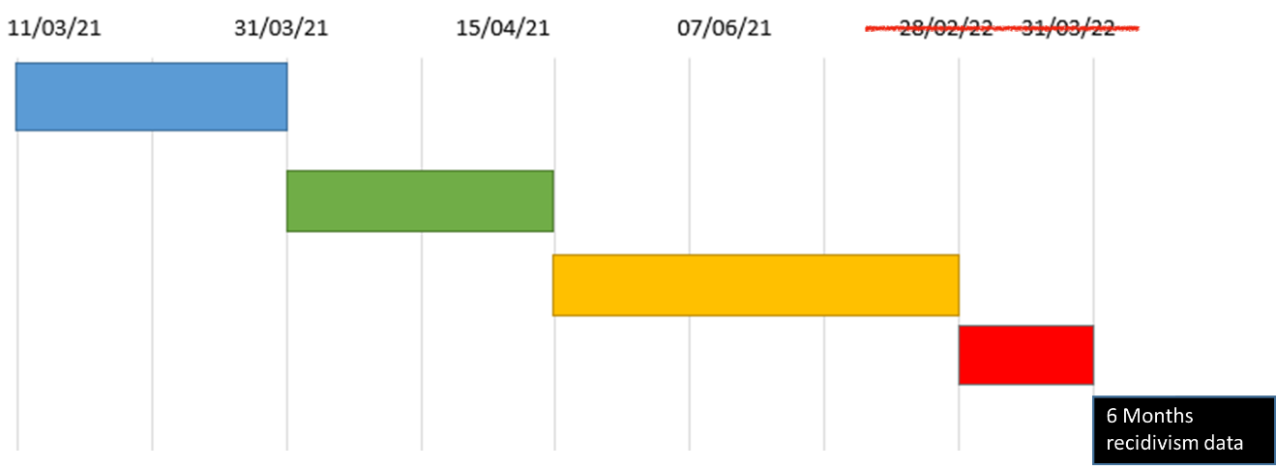

1. Scoping Phase
- Initial meeting with project team 11/03
- Scope Participants/cohort
- Work with psychologist to confirm Behavioural Insights to be measured.
- Second project team meeting 24/03
- Submit Scoping report 31/03
2. Discovery Phase
- Kick off meeting.
- Terms of Reference established.
- Schedule of monthly meetings set.
- Intervention Development
- Info sharing platforms firmly established
- Additional stakeholders identified/invited
3. Implementation Phase
- Stakeholder workshop
- Presentation of final programme
- Training for facilitators
- Launch (07/06)
- Implementation extended.
4. Evaluation Phase
- Data collection
- Stakeholder feedback meeting
- Data Analysis
- Submission of provisional report
- Final Report 31/03/22 - amended to 31/01/2023

OUTCOMES | Motivation levels of perpetrators of hate crime/ hate incidents | Reduction in hate crime and hate incidents within the target areas | Increase reporting of hate crime | Victims have confidence to report hate crime
METRICS | Baseline and follow up feedback from trial participants | Data on reported crime and actual crime figures | Reporting data | Feedback from victims
TIMESCALES | Before and after each participant completes the course | Tracked outcomes for each participants, 6 months after trial participation | Comparing data from comparative period last year | Until December 2022
Evaluation approach
An ambitious approach to evaluation was proposed at the outset of the project, incorporating four separate areas of enquiry, as follows:

Psychometrics
Age-appropriate pre and post psychometrics, or questionnaires, will be used to evaluate the effectiveness of the intervention. These questionnaires will aim to target specific learning outcomes pertaining to the chapters in the programme.
There is no specific, standardised assessment measure for factors associated with hate crime offending. The only existing tool referring to hate crime offending is the Hate Crime Beliefs Scale (Bacon, 2016; Bacon, May & Charlesford, 2021) which assesses beliefs about hate crime offences in the general population, not factors specific to offending that could reliably assess change.
The following measures will be considered to assess Behavioural Insights of Motivation and Capacity:
- Brief Self Control Scale (Tangney, Baumeister & Boone, 2004) is a shorter, 13-item, version of the self-control scale that would be relatively simple for offenders to complete and links with theory that perhaps self-control mediates prejudice and offending in an appropriate situational context. This scale has shown validity in offender populations for predicting recidivism (Malouf et al., 2014)
- The Clinical Anger Scale (Snell et al., 1995 and Snell, 2002) is a brief self-report measure that can be used to assess for levels of anger and response to anger. Anger is likely a key emotion in hate crime offences, as it is in other offender populations and such expressions of anger towards others could manifest as Hate Crime offences (specifically links to modules 2 and 4)
- Other measures considered in this process were; a measure of pro-diverse beliefs (e.g. Pro-Diversity Beliefs Scale; Kauff et al., 2018), the STAXI and Novaco Anger Scale. These were not utilised due to copyright and/or associated fees/limitations for use.
A set number of questions are taken from the goals-based outcomes as a means of fitting with the intervention portal that will be automatically processed as outcome metrics. Each item is given a score based on the extent they agree or disagree with set statements; the scoring is measured pre and post to assess any changes.
Qualitative data
- Ratings of goals-based outcomes will provide individualised indicators of meaningful change (e.g. Kirusek and Sherman, 1968). This will be utilised to as a meaningful comparison for participants whereby qualitative and quantitative responses can be used to enable to participants reflection on change.
- Facilitator Blogs. All professionals involved in the Hate Crime Project were asked to write a blog to share experiences of facilitating, and being involved, in the design and setting up of the trial and intervention. This will help to inform information around the feasibility and acceptability of the trial and any challenges with implementation and engagement. These will also provide an additional perspective to that of the perpetrators in terms of what the facilitators noticed about key learning points across participants.
- Comments, reflection, and pro-active approach to gain feedback during the process of the programme. Facilitators will look to see what qualitative response the perpetrator inputted and check to see if it correlates to the Perpetrators quantitative (Psychometrics) score and the participant answers as outlined in the Post Programme Report. This allows for a full assessment where anomalies can be explored and addressed. This not only enables us to respond to inconsistencies through discounting any false negatives/false positives, but it means facilitators can explore with perpetrators why they may not have engaged. This more in-depth feedback will be used to inform the development of the trial.
- Participant feedback following completion of the programme. At the end of every session the participant is required to enter reflections. The end of session reflections, and overall feedback which is required at the end of the intervention will be accessed for evaluation purposes. This information will also be contained within the Post Programme Report.

Programme design
Programme content - summary
The trial was designed to incorporate two treatments to be tested within the trial, to be evaluated against a control group. This was intended to establish if there is any difference in efficacy between the two treatments in relation to outcomes, and whether any difference is statistically significant and therefore can inform best practice and similar future projects.
Proposed Delivery Methodologies
Treatment 1:
- Up to 90 Perpetrators will be referred to an experienced programme facilitator to undertake the Hate Crime Behavioural Insights Intervention with practitioner guidance at key stages. Each individual will be required to complete 10 sessions (totalling 5 hours each) to complete the intervention, but will have 1.5 hours input (3 x 30 min at the start, middle and end of the intervention). The facilitator is allocated 2 hours per perpetrator which includes administration time.
- Up to 24 additional practitioners can be fully trained in intervention support, this is based on 2 x virtual training sessions with 12 delegates in each group. As an example, if RSMS train 12 delegates in total and each delegate is able to commit 10 hours of delivery over the course of the trial, they will each support 5 Perpetrators to complete the programme. This will result in an additional 60 practitioner guided SU completions.
- There will be a target of 100 practitioner guided completions.
Treatment 2:
- Between 100 to 200 individuals will be referred to complete the online digital intervention without any practitioner guidance. This group will have access to I.T support (via email/phone) if required for technical queries or difficulties.
Control group:
- Between 100 to 200 individuals will form part of a control group and whilst assessed as suitable for the intervention, they will have no intervention.
The above figures are based on the number of suspects (633) within the target cohort, factoring in suitability criteria for the intervention (e.g. that they admit the offence). The practitioner supported sample size will also be informed by availability of resources and consideration to ensure a large enough sample to indicate clear outcomes upon evaluation. This was the proposed plan based on having sufficient numbers to constitute a comparison for all groups.

The list of modules within the online intervention are as follows:
- Module 1 - Exploring different motivations for why people may commit Hate Crimes, can you remember what yours was?
- Module 2 - The impact of Hate Crimes on "victims" and the wider community. Can you recall what impact your actions may have had on the victim? Can you think about how this may impact the wider community?
- Module 3 - The role of thinking traps, or biases and learning to increase perspective taking.
- Module 4 - Identifying the signs of anger, triggers, and how it makes you want to act.
- Module 5 - Identifying other important emotions that may be involved in an anger spiral or be changed to anger towards others.
- Module 6 - Learning to manage responses to emotions by reducing the emotional temperature.
- Module 7 - Learning to take time to explore the pros of cons acting in response to emotions.
- Module 8 - Dealing with people and responding to peer pressure and/or conflict in a way that helps you to stay on track.
- Module 9 - The influence of the media in inflating threat, bias, and distorting facts, and the positive sides of the media and others.
Theory / Practice kit – summary
Principle/ Element | Summary/  Description | How this is reflected in key elements of the programme | Literature
Offender Typologies | Four main typologies of Hate Crime perpetrators; Thrill (66%), Defensive (25%), Retaliatory (8%), Mission (1%). Originated in US. | Thrill - Peer pressure, influence of alcohol, managing emotion, behaviour  Defensive and Retaliatory - thinking patterns and types of perceived threat, managing conflict, managing emotions and behaviours the influence of the media  Mission - prejudice-specific modules | McDevitt (2002).
Racial/ Religiously motivated crimes | Tend to be in response to conflict in day to day situations as opposed to high prejudicial views. Intersectionality and offending. | Managing conflict, factors common to all offender programmes needed, the value of difference and common human values (e.g. role models and famous figures), the influence of the media in perceptions of threat, thinking biases associated with perceived threats towards other groups. | Walters (2016), McBride (2016)
Strengths-based | Fostering acceptance or trust, not blaming/condemning offenders. | A lot of this is reflected in the advice/training given to facilitators in terms of empathy and adopting a non-judgemental attitude. Victim empathy module reinforces the harm actions have caused but in a reflective way and non-judgemental stance by facilitators. Focus on strengths and contacts in the first unit. | Good Lives Model (Ward, 2002)
Common factors across programmes (e.g. ADAPT) | Awareness of prejudice, bias and perceptions of threat linked to diversity, value of difference, managing conflict, anger management (and other emotions), self-control, identity, broadly CBT | Reflected in module about the media, famous figures and role models, and values that they have brought or that is admired, values of difference. Football as a common ground/interest that may override other perceived differences. | Iganski et al. (2005; 2015), Dixon (2002), Hamad (2017), Stephan & Stephan (2000), Walters (2011), Gottfredson & Hirschi (1990)

Module 1: Offender Motivations
Offender motivations is part of Session 1 and includes:
- Reflection on proposed typology as a means of encouraging the offender to reflect on what have motivated them to commit the offence.
- This is also intended to facilitate early reflection on elements of the programme that may be most relevant, description and definition of hate crime, helping the offender to perceive that their actions constitute a hate crime as often recognition of this was difficult to facilitate.
Content of Offender Motivations in the intervention:
“Now let's talk about why some people may commit Hate Crimes:
Thrill - people are driven excitement of committing the crime or targeting others.
Defensive - people target others because they feel they are protecting their territory in some way.
Mission - a strong cultural belief or ideology, tied to the person’s identity, that they have a responsibility to rid society of particular person(s)/groups.
Retaliatory - in response to conflict or feeling of being provoked by someone, but this can also be triggered by the media and key events that are broadcast in the media (e.g. coverage of terrorist attacks).”
Module 2: Victim Impact
Victim Impact is in Session 2 and includes:
- Questions about how this affects the victim, and information and quotes from victims about PTSD and impact on life.
- This also incorporates aspects of the "ripple effect” () helping the perpetrator to understand the impact hate crimes can have on others and the wider community, beyond the scope of the victim.
- Use of famous people that perpetrators may connect to, hoping to facilitate reflection on what constitutes a hate crime and how this has changed their perspective (see example next page).
Content & Wording used to illustrate the victim impact in the intervention:
“Here are just a few ways victims can be impacted by Hate Crime:
"I was so shocked, I feel completely powerless and I still don't understand why it happened. I am scared it will happen again and I won't be able to do anything about it”.
“I get anxious and stressed at the thought of leaving the house, I relive the incident all the time over and over in my head and I don't like being around people I don't know. I feel like I can't trust anyone and I avoid social situations since it happened, my anxiety is even effecting the kids”.
“After the incident I struggled with my routine, it happened on my way home from work and now that's what I associate it with. I called in sick too many times as just couldn't face it, and now I am close to losing my job. I've started drinking more heavily to cope with it all and I still find it difficult to talk about the incident as I don't think people will understand”.
Hate Crime can have a huge, and devastating effect on others feelings of safety and their beliefs about themselves, other people, and the world, increasing the chance that they may develop a mental health condition called PTSD (Post-traumatic Stress Disorder).
This can include some very severe and distressing symptoms such as intense anxiety and threat. It can very much feel as if the person is reliving that worst moment over and over again as the stress caused by it means the memory is not stored in a way that memories would usually be stored. It can lead to avoidance of situations that remind them of the incident and this can have a massive
impact on the persons quality of life. People can feel like they don't want to be around others, and can't trust others, this can require professional support through Mental Health Services.
If people do not seek support when needed, it can impact on that person's quality of life and ability to get better. Even if people do not develop PTSD they can experience significant psychological scars, or injury as a result of this and are likely to have problems with family or relationships, could lose their job, relocate repeatedly to avoid the sense of ongoing fear, use substances such as alcohol and other drugs to cope with the psychological symptoms, or pain, if physical injury was sustained.
Victims of Hate Crime can develop a shared negative view of all people belonging to the age or cultural category of the perpetrator (e.g. perhaps everyone like that thinks that of me, and wants to hurt me) which means they are less likely to react positively to such people in the future and may even avoid associating with certain members of society.”
Examples of famous people
Another core part of the module is using examples of famous people that perpetrators may relate to, with the hope to facilitate reflection on what constitutes a hate crime and that this is unjust.
Evidence has suggested that forming opinions around other shared interests, such as football, given the demographics of the target group, can help to overcome other elements of difference.
This also shaped a large part of session 9 when approaching difference, diversity and shared values.
Content & Wording used to illustrate examples of HC with famous people in the intervention:
Marcus Rashford is a famous footballer you have probably heard of him. He plays for Manchester United. He recently received over 70 racially abusive messages after his team lost to Villarreal, and experienced further messages during the Euros. One of these messages was allegedly from a Maths Teacher. This shows that under certain circumstances, a lot of people with different and sometimes surprising backgrounds can be incited to commit Hate Crime.
Sometimes hiding behind a computer, or being among a group of friends, can make us feel like we are less responsible in that moment. It is very important to remember we are always responsible, and it is your life that will change, and you will face consequences, as well as the victim. Please take a look at the following blogs to gain an idea of how this may translate into individual cases and stories: (NB Warning. these stories contain strong and offensive language)
Module 3: Thinking Traps and Biases
This module is in Session 3 and includes:
- Information on some general thinking traps/biases that may influence offending (e.g. generalisation, emotional reasoning).
- Specific definitions around prejudice and social psychological theory around in-group/out-group, again utilising the example of football that offenders can relate to, and how this can affect perceptions of difference.
- Identifying thinking related to “real” and “symbolic” threats associated with threat-related theories linked to hate crime offending.
- Practice with perspective-taking/generating alternatives
Content & Wording of Module 3:
“The problem with the thinking traps, or biases mentioned in the previous session, is that they are based on sasumptions rather than fact, or rather, opinions. These opinions, or assumptions, tend to come from what we have heard and our life experiences.
Prejudice, or holding views that are prejudiced can be considered one step further towards the risk of committing Hate Crime as this involves the presence of negative feelings, or emotions, towards a person/ group of people.
Similar to these traps or biases, prejudice is something we may not have been aware or challenged in any way, as they could have been around for a long time. Prejudiced beliefs are also full of thinking traps and biases, they are oversimplified, and generalised, not based on fact, and act to devalue that person or persons. We tend to be more likely to hold prejudice about others that are viewed as different to us. Social psychologists have called the “out group”, people we see as being outside of our usual ways of being and values, and the “in group” as people we see as similar to us.
We tend to have positive bias towards those in our “in group”, and want to favours or protect it, which can include those we see as being similar in terms of culture, a shared interest, friends, or family.
For example, if you have been to, or seen, a football match, it is likely you view supporters of the opposing team as the “out group” and fellow fans of “your” team as the “in group”. This divide and opinion of difference can inspire aggression at football matches towards the out group as we see those as being a threat to us or our team. This is why it is felt the fans need to be separated from each other but this still does not stop the hostility and aggression some people feel, and act on.
In reality, those we see as being inn the out group are probably no different to us, they enjoy football and are not defined by the team they support.

Module 4: Identifying Anger
This module is in Session 4 and includes:
- Using the emotional thermometer to identify anger intensity and potential signs anger is building
- Making an individualised thermometer/gage in terms of noting common behaviours and signs
- Keeping a diary/record of triggers for anger
Content & wording for the module 4:
Would you say anger is an emotion you generally experience? Please indicate how common this experience is for you:
Options: Not at all / Less than once a week / Often (1-3 times per week) / A lot (over 3 times per week)
Anger can come in different strengths or “intensity”. If you think of a thermometer, this can be a useful way of imagining different intensities of emotions, or feelings.
Look at the image below that shows red is too hot and indicate very intense or strong emotions, and green the good or what we call “optimum” zone where emotions are not intense. There can also be blue, or minus figures being too cold, disconnected or shut off from emotions. We need to aim to be in the green areas to plan actions and not allow emotions to drive behaviour which will be introduced in module 6. 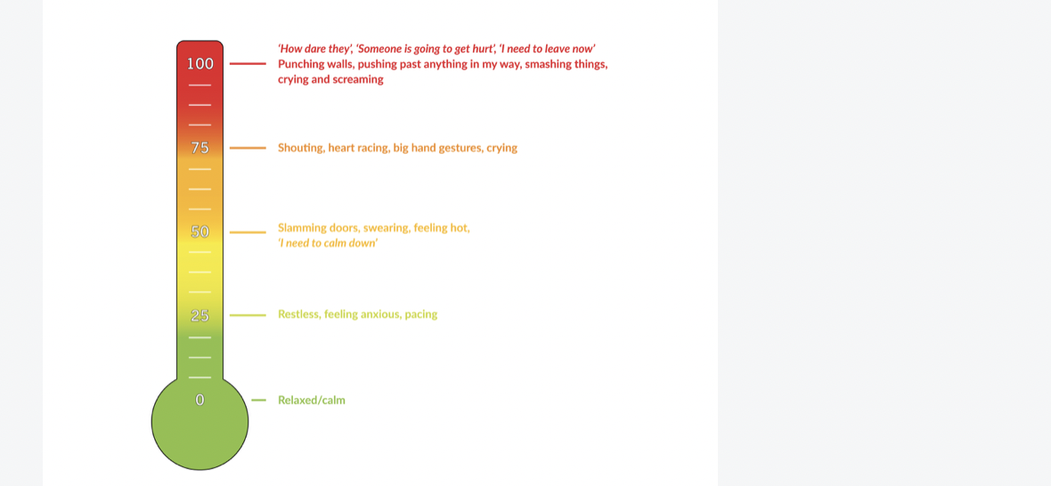
Module 5: Identifying Other Key Emotions
This module informs Session 5 and includes:
- Learning more about shame (video)
- Reminder of signposting to further support and helplines in case this section can be triggering.
- Using the emotion circumplex (pizza tool) to categorise and identify different emotional experiences and recognise which are key emotions the perpetrator experiences
Content & wording on module 5:
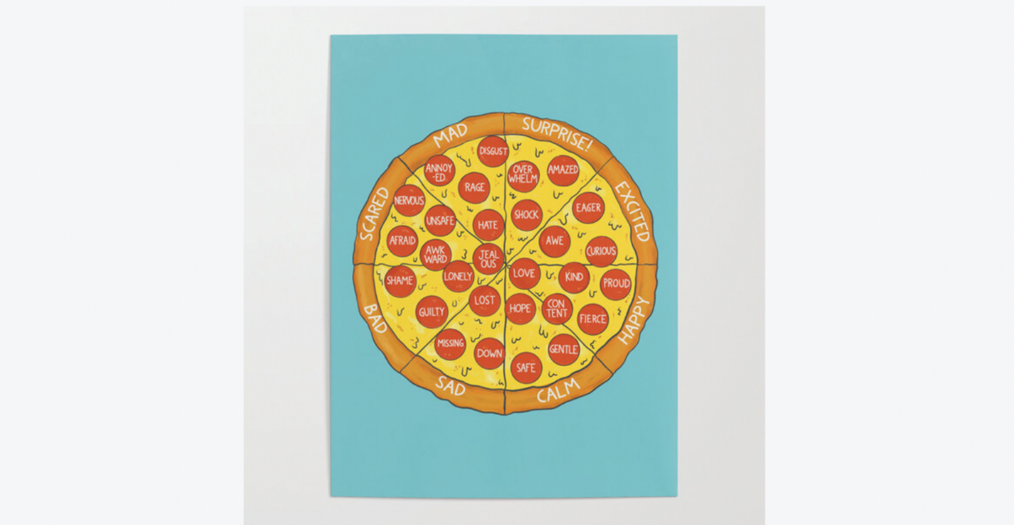
Threat/Fear or Being Afraid – is something spoken about in module 3 when referring to perceived threats. A key emotion linked to threat is anxiety, or fear, which can be transformed into anger towards the person we believe to be causing the threat, for example the view that ‘the UK is changing because of all these foreigners. I need to stop them taking over’ (there may be anxiety around things change and uncertainty of this).
Envy or Jealousy – is a social emotion, this means it is an emotion that involves others, we feel envy or jealousy about what we think others have, that we see as valuable and perhaps compare this to what we don’t have. This could also be linked to those threats mentioned as the envy could be around something material (like a job or house) or symbolic. This can grow into anger and resentment if we feel this is an injustice, or unfair, and could lead us to attack the person who possesses the thing we want. For example, the thought that ‘That person has a nice car, how do they have a car like that, why shouldn’t I have a car like that, I have lived in this country all my life’.
Disgust – towards a person, or culture’s traditions can also affect the way we respond to others. For example, the view ‘That looks stupid, why would they want to look like that, or dress like, it is appalling’.
Note use of the word ‘they’ in these examples. Think back to the information about thinking traps and biases and prejudice contains lots of these. Use of the word ‘they’ is key indicator of over-generalisation, or stereotyping, e.g., tarring everyone from a certain group with the same brush.”
Module 6: Managing Your Reaction
This module informs Session 6, aimed at learning emotional regulation skills, or ways to manage emotional experience. This includes:
- Understanding the window of tolerance and the rationale for being in this, pertaining to offending
- Developing coping strategies to help the person get back in their window, and/or stay regulated, within their window.
- Strategies include surfing the wave of emotions, the STOP technique, building on ways of instilling calming emotions
- Mid-Intervention Recap
Content & wording module 6:
“When we are in our ‘Window of Tolerance’ we are in that green zone on the thermometer. Remember there are 3 zones. These are:

The Green Zone – means you are aware of what you are feeling and thinking, but it is not so strong or intense that it overwhelms you. In this zone, you should feel calm and relaxed enough to be able to think, pause, and consider the consequence of your actions, which will be explored more in the next session.
The Red Zone – tends to be when we experience really strong emotions and get those physical sensations we may have identified in response to anger (e.g. clenching fists, racing heart, urge to attack); we are feeling too much.

The Blue Zone – This where people will feel disconnected, zoned out, or cut off from emotions and feelings, we are feeling too little. Sometimes this can happen to some people when they feel emotions intensely, as it can be a defence, or way of coping with intense feelings.

Being in either the red or the blue zone does not allow us to apply the skills that you are going to introduced to in this session, or in previous and future sessions. We need to be able to think, and when we are too hot, or intense, or too cold and disconnected, our thinking brain is not available.”
Module 7: Actions and Behaviour
This module constitutes Session 7, which includes:
- Reconnecting with people’s values and strengths identified in session 1
- Considering the pros and cons of actions with the long-term and valued actions in mind rather than short-term
- Using an example and completing this with own examples
- This also forms part of emotion regulation, where once someone is back in their window of tolerance, this can be a helpful tool or something to do in advance to prepare for situations where someone may be tempted to act on short-term impulses versus long-term interests
Content screenshot:
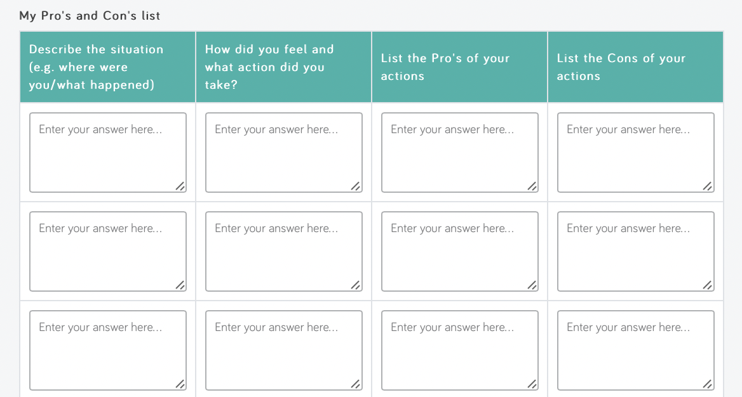
Module 8: Peer Influence and Belonging
This module is in Session 8, which includes:
- Video to introduce the concept of GroupThink
- Considering goals that link with values in peer relationships, and what skills may need to be required or what the person may need to do to achieve that goal
- Learning more about an interpersonal style or tendency (e.g. passive versus aggressive) and how to be assertive in order to meet needs and not be led by peers. Applying this to a situation that could be useful (e.g. planning ahead)
Content & wording for module 8:
Generally, when we respond to others, we have a behaviour style that is more or less like one of these three: Passive, Assertive or Aggressive. If being assertive was described as a good, reasonable reaction, you could think of aggression as over-reacting and being passive as under-reacting. Being assertive is what we all try to achieve, but sometimes it can be difficult, for example, when we feel very strongly about something.
Question 1: What is your usual style, Passive, Aggressive or Assertive, and what things do you do that match that style?
Question 2: How might that style affect how others respond to you?
Question 3: What can you do to ensure you are being assertive but NOT aggressive or too passive? Make a note of how you will change your behaviour to move towards assertiveness when needed…
Module 9: The Role of the Media
This module forms Session 9 and includes:
- Identifying extremist views and fake news, using live examples
- Signposting to PREVENT to raise concerns around radicalisation
- Identifying how thinking biases may apply to the media and providing facts around terrorism (reduction)
- Examples of famous people, introducing people to acknowledging strengths and values in others and in difference
- Explicit reflection on what any of these famous people have contributed to them and/or society
Content & wording on module 9:
Question 1: Who in the media do you admire, and what is it you admire about them?
Question 2: If you have not done so already, write what is it you admire about this person’s personality and values, rather than physical looks or attributes:
There are lots of examples of people that have contributed to our life and our hobbies in many ways. Consider some of these famous actors, sports people and other personalities that a lot of people may have admired or continue to admire.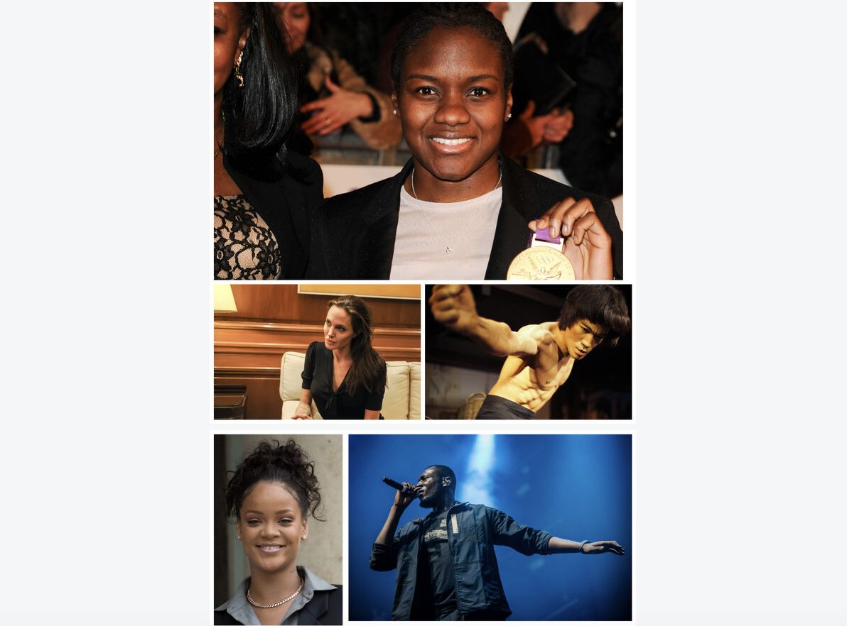

Module 10: Pulling it all Together
The final session, Session 10, focuses on synthesis and relapse prevention/planning work, including:
- Asking for what the person would say to the victim, knowing what they know now (including information about restorative justice)
- Using the decision tree to summarise, and plan actions, based on the main content and strategies recommended in the programme.
- Re-evaluation of programme goals and metrics
- Feedback on the programme and difficulty level
Content screenshot:
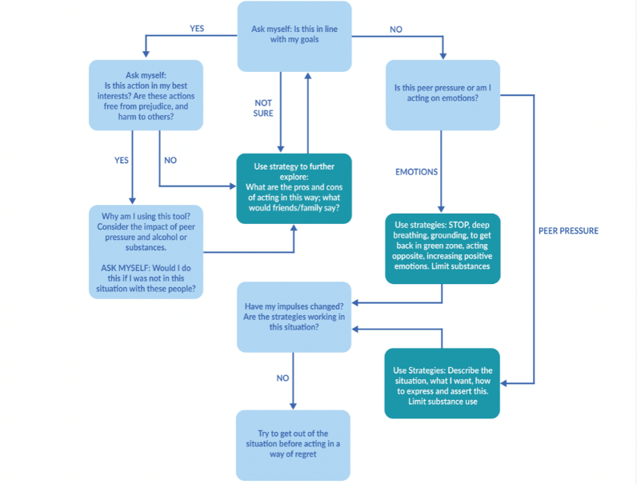
Accessibility and Learning Styles
Allowing for differences in learning styles, there is an optional video that relays a lot of the content where this may be in more of a written format.
Content screenshot:
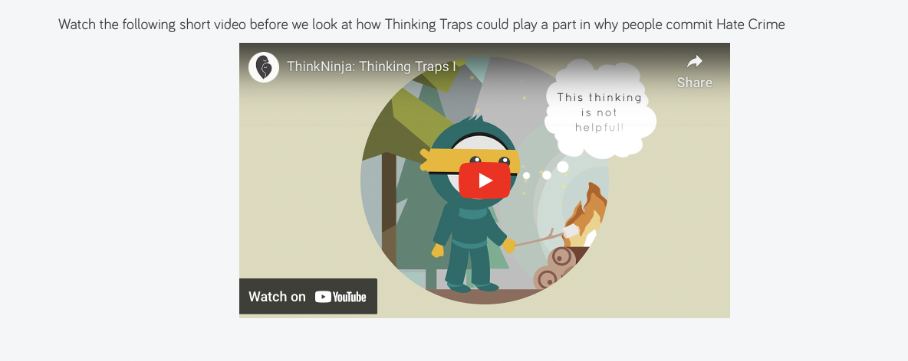
There were also adapted materials for younger participants, or those that may struggle with some of the more complex information (e.g. two videos were produced around the emotion shame and two decision trees).
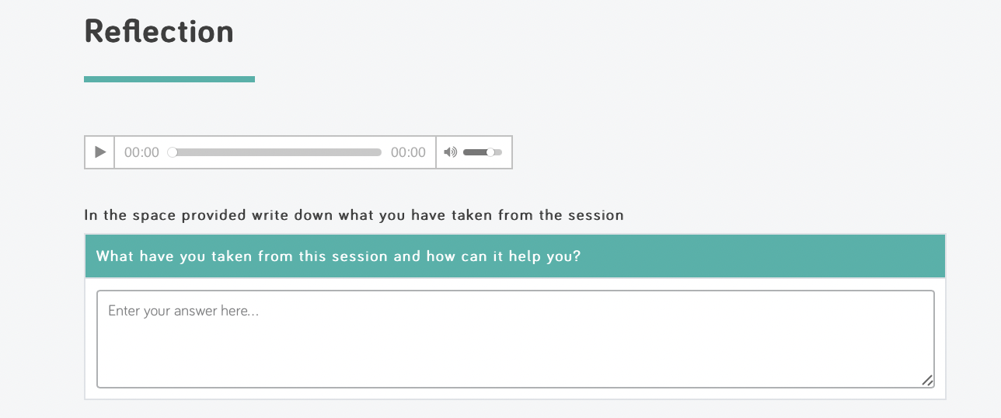
At the end of each session there is space for reflection in which the participant is required to enter information around what they have learned from the content of the session.

Results

Sample Size
Overall, total number of referrals was lower than the target number for the trial. A total of 31 referrals were made to the Hate Crime Programme, 3 were non-compliant or failed to attend, so these individuals were referred back to the police force and 1 person was deemed unsuitable. All trial participants completed the trial with support (OPTION 2), as there was an insufficient number of referrals to justify two treatment groups.
There were two people that completed the programme where the crime was motivated by homophobic prejudice, rather than race/religiously motivated hate crime.
This left a total sample of 25 where pre- and post- outcome data could be meaningfully analysed.
Actual Outcome Measurement approach
Standardised psychometrics were not utilised as there appeared to be difficulties incorporating this onto the existing online portal. Therefore, pre and post goals-based outcomes became the intended primary measure.
- The primary outcome measurement was a Likert scale (1 being strongly disagree to 4 strongly agree) covering 5 statements that link with the main goals-based outcome areas and programme modules.
- Motivation was captured on a categorical scale, coded as a score of 1-4 (low to high motivation) to allow for increased statistics analysis.
Initial Questionnaire:
- (In reference to Hate Crime Incident): My actions had little or no impact on the victim: Rating of 1 to 4
- I struggle to know how I am feeling and have difficulty managing my emotions: Rating of 1 to 4
- I have very strong opinions and often act on these without questioning them: Rating of 1 to 4
- I don’t deal with conflict very well: Rating of 1 to 4
- I am influenced by negative stories and views in the media, especially when it comes to subjects like Race and Religion: Rating of 1 to 4
- Please select the statement which best represents you:
- I am fully motivated and am already taking practical steps to change.
- I am motivated and want to start working on my goals as soon as possible.
- I can see the benefits of addressing my behaviour but don’t feel ready or able to make changes right now.
- I don’t want to set goals or change my behaviour as things are fine the way they are.
Assessment of goals was included, but this was based on qualitative information, rather than a metric that would evidence progression towards goals compatible with quantitative data analysis.
This method still enabled facilitators to gain an indication of areas of the intervention from which each participant could benefit from. This approach also supported qualitative comparison of pre- and post- goals, discussed with the offender to facilitate their reflection on their motivations and any change in their understanding of themselves.
Content and wording for measurement approach screenshot:
This programme consists of 10 sessions. There are specific learning objectives associate with each session. To get an idea of your understanding of each of the areas before and after the programme, please answer the following questions: (please note, if you can’t think of more than one answer put ‘N/A’ or ‘none’ in the box in order to move on).
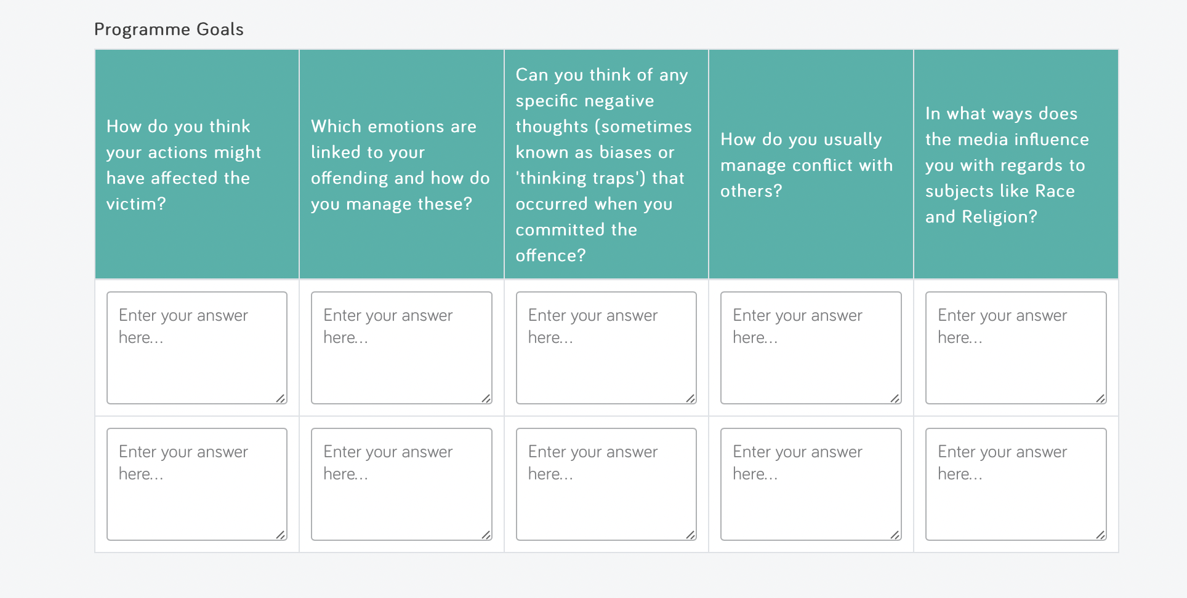
Demographics Overview
The sample that completed the programme consisted of:
- 25 white males between the ages of 13 and 45 with a mean age of 23.4 years
- 56% of the sample were under the age of 18
Outcomes
- 56% had a positive outcome from the programme based on the questions designed to assess psychological capability
- 35% had a positive outcome in terms of questions assessing motivation for change in the programme, or for 75% motivation had either improved or remained the same.
Participation timescales
The average time taken for participants to complete the programme was 23.9 days although there were a couple of outliers that may have inflated this (e.g. one person took 113 days). The most common duration for completion was 20 days (N=5).
Sample Typologies
Most were able to self-identify the typology most relevant to them -13 were able to classify themselves in terms of typology. Where there was insufficient information, the most likely typology was selected - 6 were unable to classify themselves, but the typology could be hypothesised from the information provided about the offence. However 7 were unable to be classified, or information was missing.
The list of participants by typology is as follows:
Typology | Number (/23) | Percentage of Sample | Percentage Suggested by Literature
Thrill | 9 | 39,13 % | 66 %
Retaliatory | 9 | 39,13 % | 8 %
Defensive | 2 | 8,70 % | 25 %
Mission | 0 | 0 % | 1 %
Unable to determine | 3 | 13,04 % | N/A

Typology Findings
- The most common by typology by age group was THRILL, for those under 18, specifically. Thrill was less common in the older age group.
- Of the 14, 75% (9/14) were deemed thrill offenders; the remaining 5 constituted 2 unknown, 2 retaliatory and 1 defensive).
- There was no age recorded for one of the retaliatory offenders.
- This means that the under 18 age group accounted for ALL of the THRILL offenders in the current sample.
- The most common in the over 18’s age group age group was retaliatory, at 54.55% (6/11).
Changes in Motivation
Out of the 20 for which the motivation data was available 7 had a positive change, 8 stayed the same and 5 saw a reduction in motivation.
- One of the people who had a large positive change in the outcome scores, also had quite a large change in motivation (from 2 to 4)
- 4 of those that had a positive change in motivation also had a positive change in outcome
- 3 had a positive change in motivation and a negative change in outcome. This may indicate benefits not reflected on the outcome assessments.
- For 3/7 people with positive changes in motivation, it appears there was a negative change in the questions intended to assess aspects of psychological capability. This would still indicate a positive change given that the intervention was intended to target motivation and psychological capability.
For all of those that had a negative outcome in terms of rated motivation to change, their scores stayed the same on the outcome measures.
Psychological Capability - Descriptive Statistics
Variable | Mean | Standard Deviation | Minimum Value | Maximum Value
Pre-questions score  (N=25)* | 11,7 | 2,79 | 5 | 17
Post-questions score  (N=25)* | 11,6 | 2,55 | 8 | 17
Rating of Difficulty  (N=19)** | 5 | 1,83 | 2 | 8
Pre anger/anxiety  (N=17)*** | 5,82 | 2,51 | 1 | 10
Post anger/anxiety  (N=17)*** | 2,97 | 1,74 | 1 | 6

Psychological Capability - Inferential Statistics
No statistically significant difference between pre- and post- outcome measures.
Effect size very small - 0.04.
Study is underpowered statistically. The estimated number of participants in order for a statistically significant difference to be found in an effect size of 0.04, with high Power (0.8), would be 4,908.
Variable | t(df) | p
Pre- and post- outcome measures | 0.168 (24) | 0,868
Pre and post anxiety/anger measures | 6.184 (16) | <0.001

The difference between pre- and post- anger and anxiety ratings was highly statically significant
Effect Size was very high - 1.32, meaning only a sample of 7 would be required to detect a significant difference if there was one present.
Psychological Capability - Individual Ratings
Variable | Pre-Rating | Post-Rating | t(19) | p value | Effect Size
 | Mean (SD) | Mean (SD)
Q1 - Victim Impact | 2.5 (1.147) | 2.10 (0.852) | 1,221 | 0,237 | 0,2730
Q2 - Managing Emotions | 2.40 (1.046) | 2.55 (0.887) | -0,429 | 0,673 | -0,0958
Q3 - Questioning Opinions | 2.40 (1.095) | 2.70 (1.031) | -1,301 | 0,209 | -0,2910
Q4 - Dealing with Conflict | 2.90 (0.852) | 2.85 (0.933) | 0,237 | 0,815 | 0,0529
Q5 - Media Influence (Race/Religion) | 1.70 (0.801) | 1.65 (1.040) | 0,271 | 0,789 | 0,0606

Reoffending data
Reoffending data on trial participants suggests that participation in the trial may have had a positive impact on deterring reoffending in this area:
- 0 of the 64 trial participants reoffended in a similar offence within a 6-month period
- 1 of 64 perpetrators involved in the trial reoffended in a similar offence within a 12-month period
However, tracking of outcomes over a longer period of time would be useful.

Analysis

Findings
Key findings were as follows:
- The majority of offences committed by trial participant appeared to be verbal in nature, as opposed to physical or violent. This differs from national trends quoted in a survey in England and Wales that suggested 24% of religiously motivated hate crimes and 27% of racially motivated hate crimes involved physical violence.
- THRILL offenders accounted for a high proportion of the sample, but this was almost entirely retracted to the under 18 age group.
- Over 18’s tended to consist of DEFENSIVE and RETALIATORY offenders. It could be this is a cohort effect, or could be indicative of an interaction between typologies and age.
- There could be a role for different versions of the programme that could be more suited to the different typologies and age groups.

Typologies
There was an age-specific finding associated with typology in the current sample. It must be considered that determination of typology may not have been the most reliable method, as it tended to rely on either the participant classifying themselves, or the professional determining this from the limited data available on the criminal offence.
Four typologies:
- Thrill – people are driven by the excitement of committing the crime or targeting others.
- Defensive – people target others because they feel they are protecting their territory in some way.
- Mission – a strong cultural belief, or ideology, tied to the person’s identity that they have a responsibility to rid society of particular person(s)/groups.
- Retaliatory – in response to conflict or feeling of being provoked by someone, but this can also be triggered by the media and key events that are broadcast in the media (e.g. coverage of terrorist attacks).
It was difficult at times to differentiate retaliatory and defensive, which could have been confused by the participants and/or facilitators. This overlap, and potentially a cycle of defensive leading onto retaliatory offences, is something that has been acknowledged by the literature, so these categories may not always be mutually exclusive (Equality and Diversity Commission, 2016). For example, one offender had said something racist in response to a victim asking defendant to sort girlfriend out, and classed this as defensive; the person was “defending his turf” or with regards to his girlfriend (defensive), but was also responding to being provoked, so likely believed he had his “just desserts” for doing so (retaliatory).
This analysis is consistent with other theories pertaining to offending behaviour, such as Finkelhor’s (2009) model of sexual offending, whereby situational factors lends themselves to justify offending and overcome barriers rather than this being a static process.
Outcome Scores
There was no statistically significant difference between pre- and post- outcome measures:
- When accounting for pre and post anxiety and/or anger ratings that were collected during the programme, this was indicative of some change:
- For all pre and post emotion ratings could be obtained, there was a reduction in these scores (of anger/anxiety) after completion of the programme for all but 2.
- There was a highly statistically significant difference between pre and post anxiety/anger scores.
- This is suggestive of some change, perhaps not captured by outcome assessments, supported by very little difference between means in outcome ratings, meaning an extremely high number of participants would need to be assessed in order for any difference to be found.
- The outcome assessments themselves were not standardised, which means they may have lacked construct validity.
- It was unclear what anger/anxiety ratings tapped into, was not intended to be used as outcome assessment, but these could be indicative of a felt sense of change/emotional change.
Anxiety and Anger Ratings
- Changes appeared to be mostly related to anxiety, although some specified anger, specifically.
- Likely general therapeutic techniques would have impacted this - participants entered the process with high shame and anxiety, expecting to be told off, so to speak.
- Some of the general therapeutic strategies (as per the Good Lives Model) adopted by facilitators were likely helpful in facilitating emotional change.
- A reduction in emotional state that was highly significant, even if not directly related to the content of the programme and learning during the programme (e.g. increased emotion regulation strategies), shows the programme was acceptable, safe, and likely therapeutic for the participants. It is also positive that a reduced overall rating of state anger and anxiety, which can be key emotions in offending, could also indirectly have an effect on recidivism.
Individual Outcome Items
For Question 1, this indicated the largest possible effect size and/or closest to significance:
Q1 - My actions had little or no impact on the victim (in reference to the Hate Crime Incident)
This would perhaps indicate that it may be something about the metrics and the participant’s ability access the information, and have sufficient insight, to be able to rate these accordingly and accurately. Whereas, for the above, this is likely to be an area that should be easier to assess by such measures. It is less likely affected by individual insight and more likely to be attributed to changes that have been made in the programme, perhaps having increased construct validity compared to the other items.
For Questions 3 and 4, there was actually a slightly higher mean score for the post, compared the pre, assessment.
Q3 - I struggle to know how I am feeling and have difficulty managing my emotions.
It could be that participants did not know that they had difficulty in this area, and the completing the programme highlighted discrepancies between what they thought and what they now know. For example, someone who has difficulty identifying emotions will not be able to accurately rate or endorse this item. Therefore, this could show a positive change in terms of insight and understanding, which can then infirm signposting for further support with this.
Q4 - I have very strong opinions and often act on these without questioning them.
Again, it is likely that some people may not understand the difficulties they have in this area, and that actually by completing the course and understanding how their thoughts and impulses may be related, the could have resulted in increased insight into this area of difficulty.
Both of the above could reduce recidivism and suggest avenues for further support which is the main purpose of the intervention.
Difficulty Level Rating
There was a large range in terms of difficulty rating which could have affected success on the programme (highest being 8, lowest 2, and average 5). Difficulty level could be a factor affecting outcomes/change particularly given the large age range and high number of the sample that were under 18…
When rating difficulty, of the programme, some of the comments obtained, included:
- “I thought most of it was relatable - spot on to be honest.” But there was also a note to indicate feedback from Mum, for the same participant who commented “Some of the questions were difficult for him to understand.”
- Another participant that rated the programme as 5/10 in difficulty said “Some of the questions were hard but I am thinking about them.” However, this same person did seem to take some meaningful learning from what could be considered complex topics, indicative of an ability to still engage with the material; “If we fail we can feel ashamed. If I fail at anything it makes me want to try harder and carry on. When I had my accident I couldn’t walk for months but I kept going. If I fail my exams I will just have to try harder when I get to college. I feel determined, I wont give up.”
Participant comments
Reflection on content for a positive outcome
One participant that evidenced quite a substantial positive change in outcome scores, did appear to have gained valuable learning that led to change on the metrics. When starting to work through some of the identification and management of emotions sessions, the client appeared to feel they lacked control over their actions:
“Nothing I can do I can’t do nothing when I’m angry I’m angry now and I can’t change that no matter how much stuff I read on here it don’t work it’s not as easy as that.”
This changed towards the end of the programme when asked to provide feedback:
“It’s changed , I was angry at the time all I could see was red what I said wasn’t true anyways I said it out of anger my opinion is still the same everybody’s equal and we should all have equal rights just because of there skin tone doesn’t make it any difference we all have the same hearts emotions and feelings underneath it all.”
Motivation also changed from “I can see the benefits of addressing my behaviour but don’t feel ready or able to make changes right now,” to “I am fully motivated and am already taking practical steps to change.”
Another person, whose score changed from 16 (pre) to 8 post programme made similar indications.
Reflection on content for a negative outcome
One participant that evidenced quite a substantial negative effect (i.e. an increase from 5 to 11 in scores pre to post that would indicate a deterioration in the areas covered in the programme), seems to have found some of the content challenging and perhaps had limited engagement with certain aspects of the course.
For example, they may have taken limited responsibility or had some distortions in self-view:
"The shame and jealousy are what I think other people feel about me - because I have a nice car.”
Related to this, it is possible this affected the person from engaging fully with the victim impact section, and stated “no” when asked to reflect on impact on the person and wider community, this is also seraphs supported by an increase ins score for this question from a 1 to a 3.
However, they did evidence some important learning/insights, which may not have been reflected in the outcome assessment ratings, for example, they stated:
“Whatever is happening, try to be calm, also control your self, and situations try to convert, to other happy way - if it’s possible.” “Just take my time and go away from the situation, that helps me. People can be like matches. I tell myself, calm down calm down, calm down.”
It is possible that some of the language used by participants in the answers may not have captured other parts of learning/insight, for example very strong opinions and acting without questioning could be reflection of increased insight as a result of completing the programme as this increased from 1 to 3.
Participant feedback
Within this section, specific participant feedback from 3 participants will be detailed, using anonymised details:
Sam
Sam is learning to take a calmer approach and take more responsibility for his actions after completing the Hate Crime programme. His key learning from the programme was the salience of alcohol as a trigger for his offending behaviour and his tendency to assume aggressive behaviour was directed towards him.
- “At the time I wasn’t thinking about the things I was saying. I thought the victim was being very rude, but again, there are ways of speaking to people and two wrongs don’t make a right. In future I will be careful with my choice of words and not react that way.”
- “Anger gets you nowhere and it doesn’t help the situation at all.. It’s best to be calm otherwise bad things can happen.’
- “From the sessions I have done, it does show you how to be calmer. I used to think ‘I’ll treat people how they treat me’ but I want to change that so I remain calmer in situations. I have definitely learnt from this course.”
Max
Max was able to identify that his emotions, when paired with pressure from others contributed to his behaviour. He recognised that he tends to show, or express, anger, when he is actually feeling something else.
- “I have learned that my anger will pass, but the hurt and damage that I may cause when I am angry will last a lot longer, from this session I have learned different methods to help me calm down when I am angry.”
- “Our differences do not define us and being different can be a good thing.”
Ben
During the programme, Ben shared some of the relationship struggles that acted as triggers for his anger. He recognised he felt stressed by similar events during the time of the offence and that this likely impacted his behaviour at the time.
- “I have apologised to the victim and could see how she may have felt 'categorised and sad."
- “It is important to change your mind set to be able to deal with situations better. I have learnt to walk away from conflict situations and I have met with the her since the offence and we have resolved things.”
- “I found the programme helpful and appreciated the persistence in helping me complete the programme.”
Facilitator Reflections on Delivery
- Sam was remorseful about his behaviour and engaged with the programme.
- Max engaged with the hate crime programme well and shared difficulties around managing emotions.
- Ben initially presented as agitated over the telephone, but this appeared to relate to a recent stressor when he was last contacted on a withheld number. He presented a number of barriers and obstacles, stating he was unable to attend the online sessions. However, when this was facilitated, Ben was found to engage with the content well during session 1, and evidenced a good degree of reflection. There were a few problems with timely completion of the programme due to technical issues and other difficulties, but Ben managed to complete the programme. The police were supportive despite the deadline having passed.

Lessons learned

Summary of Key Findings
- The intervention appeared to be not only acceptable, but therapeutic for offenders. This was evidenced by participant feedback and highly significant changes to pre- and post- anger and/or anxiety ratings. The time taken to complete the programme was reasonable, for most, with the most common duration being 20 days.
- There was a positive change to psychological capability for 56% of the sample and 35% showed changes to motivation. This is significant, despite the fact that there was no significant change between pre and post outcome assessment.
- There is evidence to suggest insight into personal motivations had improved. For example, consulting individual feedback from those that had a “negative” outcome it was possible to see gains in insight and understanding, of which the measures may not have captured for the remaining 44% and 65% of the sample.
- An additional impacting factor could have been tailoring of the content appropriately to age group given the majority were under 18 years old. Analysis of typologies indicated there could be different motivations for the under 18’s age group, as the “THRILL” typology appeared to be restricted to this group.
- Redesign – the branding of the intervention as being too aligned with ‘racism’ and stigmatising language, suggested the need for re-labelling of the intervention if deployed. Moreover, the length of the intervention was an element that police officers suggested could be considered for review, as the idea of being required to complete 10 modules was viewed as a deterrent to participant engagement.
- Alternative uses – officers suggested that the intervention could have value in other contexts, including anti-social behaviour and upstream deployment in schools as part of PSHE provision.
Main Limitations of Trial
- Recruitment of participants was reliant on several factors which all carried risk of drop off: 1) awareness of the trial as an out of court disposal method, 2) motivation of officers to recruit participants to the trial – challenges of workload and the ease of taking no further action on relevant cases, 3) admission of bias/ prejudice by suspected perpetrators in order to qualify for the out of court disposal offer.
- Changes within Cambridgeshire Constabulary with a knock-on impact on the trial: change of responsibility for hate crimes to Neighbourhood officers after the start of the trial and hate crime losing the status of a force priority before the trial which affected prioritisation of this issue.
- Small sample, effect size and number of referrals onto the programme. This is a reflection of police confidence and difficulties prosecuting hate crime offences but also would have been good to have broadened sample.
- The recommended psychometric measures to assess change/outcome were not utilised. In the absence of a developed standardised assessment of hate crime, other standardised measures tapping into the main aims of the sessions/modules were selected. Feedback was around limits with regards to what could be adapted and recorded on the online portal. This likely had a major impact on statistical significance and assessment of change or outcome, rather than there being no change or outcome.
- The intervention did not offer adapted materials for under 18’s and those who may struggle with the proposed content. This could have helped reduce overall difficulty ratings, whereby difficulty understanding some of the content could have been a factor for the under 18’s which constituted over half of the sample.
Summary of Lessons Learned
- Lesson 1 - Improving Prosecution of Hate Crime: Difficulties with prosecution, pertaining to difficulties defining and identifying a hate crime, obtaining admission of guilt and police confidence in prosecution likely impacted on sample size and value of the intervention in general if this is not available to all that would benefit from it.
- Lesson 2 - Improving Understanding of Motivating Factors (e.g. Offender Typologies): There appeared to be differences in motivating factors across areas and the typologies could be outdated. This may have affected the effectiveness of the intervention.
- Lesson 3 - Age-Appropriate Adaptation: Recommended adaptations were not implemented within the trail and this could have affected understanding of some of the participants.
- Lesson 4 - Validity of Outcome Assessment: Lack of standardised measures means changes may not have been adequately detected and picked up, when there may have been benefit from the programme.
- Lesson 5 - Participant Engagement with Online Interface: Especially if considering independent completion.
Detailed Lessons Learned
1 - Improving Prosecution of Hate Crime
Defining, and prosecuting hate crime offences is challenging.
Considering many in the current sample were motivated by retaliation, or defensiveness, this may make it more difficult to detect hate as a motivator (e.g. getting behind the conflict). The problem is, victims may be unwilling, or unable, to recognise this and perpetrators are ambivalent about acknowledging the presence of any prejudicial actions motivating their offences.
Even when the victim may acknowledge the presence of a hate crime, a study that explored prosecution of hate crimes in the UK and Canada and found that any intervention will remain largely a “tick box” exercise unless a culture change takes place within the police force (Bryan & Trickett, 2021). For example, police (re)interpretation of hate crimes can trump victim accounts.
2 - Improving Understanding of Motivating Factors
The only proposed typologies, which appear to underlie a lot of the evidence base for the programmes, were formulated in the US, in 2002 (McDevitt et al., 2002).
Current findings appear to suggest much higher rates of Retaliatory and Defensive motivations, and that Thrill, although common in the sample, may be more restricted to a younger age group (under 18’s)
Overlap between defensive and retaliatory typologies, and in general, none are mutually exclusive, pertaining to the concept of intersectionality and overlap with general offending characteristics (e.g. Diaz-Faes & Pereda, 2022; Walters et al., 2016).
Although the programme incorporated aspects intended to target all typologies, it is difficult to do this equally and this could dilute being able to focus on one or two particular areas that could be of value.
Given thrill offending was associated with the younger age group, it could be that a separate programme is devised for under 18’s with adapted material and heavier emphasis on those elements associated with thrill motivators: “Thrill Seekers commit assaults to alleviate boredom, to have fun and excitement, and to feel strong. Peer Dynamics assailants commit assaults in order to prove their toughness and heterosexuality to friends” (Franklin, 2000). Moreover, thrill offending also tends to be associated with young men in small groups linked to alcohol (Byers et al., 1999; Franklin, 2000).
Intersectionality is also relevant (Walters 2014), as perpetrators of racial or religiously motivated hate crime are likely also to offend in other manners, they are characterised by a more generalised bias or prejudice linked to offending.
Considering the above it may be that different elements needs to have a higher prominence for different age groups to effectively target specific motivating factors.
3 - Age-Appropriate Adaptation
A way of managing this difference in typologies across age groups and also noting that a lot of the referrals were for under 18’s it would make sense to have two programmes
- Under 18’s that can more appropriately target “THRILL” motivators and have more age -appropriate examples
- Over 18’s more related perhaps to conflict resolution and use of more “adult” examples
Initially the programme had adapted materials for under 18’s and those that may struggle with some the main content. However, the number of under 18’ participants was a lot higher than anticipated.
4 - Validity of Outcome Assessment
There is lack of a measure that has been standardised for use of evaluating such programmes, or that can determine change pertaining to hate crime offending.
Initial recommendations were to utilise standardised measures, but these did not fit with system requirements and/or there were issues determining copyright/use. This included goals-based outcomes directly linking to the module content were favoured and RSMS translated these into some outcome measures/assessment which were used as the main indicators for change. These assessments were potentially problematic in terms of not assessing insight, as people would end up with a nature outcome from gaining insight, e.g.
“I don’t deal with conflict well” - prior to completing the programme someone underestimate the degree to which they have problems in this area, and the programme could bring awareness to there being difficulties in this area.
5 - Engagement with online interface
Participants appeared to vary in terms of the effort and level of engagement in response. This would certainly need to be considered if future iterations involve a model of independent access to the intervention without support from course facilitators.
Lack of proactive engagement is partially mitigated by the fact that the platform requires entry of answers into each field. However, it is feasible that participants enter meaningless answers in order to progress through the engagement and avoid having to participate. Within the trial some participants avoided answering certain questions- particularly with certain exercises, that requested potentially excessive information in the response. For example, certain items such as exploring the pros and cons of behaviour requires participants to give a mandatory response with 4 different examples and cannot progress unless a response is entered into every box.
This level of information being requested for a single question, may promote disengagement as it looks very demanding. An alternative could be to have 1-2 essential examples that the person has to provide but the option to add another row. This could be encouraged by the facilitator, but not made mandatory.
Suggestions from facilitator feedback around engagement include making adaptations to the digital learning environment in order to fit with the person’s needs, such as the first referral that Emma Hands wrote about in her blog. Offering telephone contact and attempting to strike rapport, reduces the sense of threat associated with completing the programme. Moreover, there are significant gains from interacting with a facilitator from the offset, that interacts with participants with a non-judgement attitude, whilst reinforcing clear boundaries - as reflected by Carianne Burr.

Research directions
Future Research
Policing culture and tackling hate crime
Participation within the Constabulary was a challenge and barrier to referrals and therefore there would be value in additional research into behaviour change around hate crime response, investigation and prosecution.
Updating typologies.
The current trial has perhaps demonstrated that the typologies may be out of date, or may not account for offending across different age groups. In addition to this, it must be considered that the typologies were proposed in the US, which has a different population, different incidence rates of hate crime and different characteristics to the UK. These typologies are unlikely to account for changes in technology and methods by which to commit hate crimes, as evidenced by a paper that explored typologies of online offenders (Jack & Adler, 2015), which could have constituted a proportion of this sample.
Use of social media platforms to deter hate related speech and also collect data on hate crimes.
HateMotivCorpus has been trialled as a means of gaining information about hate speech on Twitter (Alnazzawi, 2022). In addition, there has been suggestions and recommendations for practice that the most effective form of retribution for hate related speech is to remove the audience/platform, with the suggestion that there could be a larger role for social media in policing this, for online crimes (Diaz-Faes & Pereda, 2022). The increase in online hate crime has led to the proposal of typologies of online offender (Jacks & Adler, 2015), which require further exploration, and may need to consider alternative/additional intervention to target these.
Research exploring implementation of ‘victim-centred’ recording practices. Such practices were implemented following the MacPherson inquiry into the racist murder of Stephen Lawrence. The hope of such practices are to reduce interpretation placed by parties involved in the process of interpreting victim reports, investigating crimes and enforcement, such as the police force, with the aim being to pick up more readily on prejudicial motivators that could be indicative that a hate crime has occurred. As this type of practice centres on detection by the victim, and the victim’s perspective – including their account of how they were made to feel, this would be step towards removing some of the judgement from the police force. This could be valuable as the current trial indicated that confidence is perhaps low.
Understanding of factors specific to other groups such as female offenders, or from minority, towards majority, groups
Existing research covering the period of 2010-2016 has indicated that women are; less likely to be involved in hate crime offences than men, but more likely to be involved in racially motivated violence compared to other forms of hate crime offences and especially unlikely to be involved in offences motivated by sexual orientation.
The evidence indicates the possible value of different interventions for male versus female offenders and hate crime targeting different protected characteristics. There is little evidence around non-white male perpetrators. A recent critical review of existing hate crime literature suggesting that gender-specific differences, victim-offender overlap and issues pertaining to intersectionality need further, individual exploration. The outcome of which, should inform hate crime policy (Diaz-Faes & Pereda, 2022).

Appendix 1: References and sources
Alnazzawi, N (2022). Using Twitter to Detect Hate Crimes and Their Motivations: The HateMotiv Corpus. MPDI, 7(69). https:// doi.org/10.3390/data7060069
Bacon, 2016;
Bacon, A.M., May, J., & Charlesford, J.J. (2021). Understanding Public Attitudes to Hate: Developing and Testing a U.K. Version of the Hate Crime Beliefs Scale. Interpers Violence, 36(23-24):NP13365-NP13390. doi: 10.1177/0886260520906188. Epub 2020 Feb 18.
Bryan, T. and Trickett, L., 2021. “It’s not Really Hate Crime” – “Reframing Hate Crime as not Police Business” – Police Narratives of Resistance and Denial. Journal of Hate Studies, 17(1), pp.74–84. DOI: http://doi.org/10.33972/jhs.206
Chiles, J.A., Von Cleve, E., Jemelka, R.P., & Trupin, E.W. (1990). Substance abuse and psychiatric disorders in prison inmates. Psychiatr Serv, 41, 1132-1134
Diaz-Faes & Pereda (2022).
Felsinger, J., Fyfe, C. M., & Smith, D. (2017). Working with hate crime offenders: The ADAPT programme. Probation Journal, 64(4), 413-421.
Finkelhor, D. (2009). The Prevention of Childhood Sexual Abuse. 169-194.
GREC (Grampian Regional Equality Council) (2013). ADAPT: Anti-Discriminatory Awareness Practice Training. Aberdeen: GREC.
Ramírez, Chiclana, Méndez & Ana Suárez, (2022). Sociodemographic and psycho social Differences Between Hate Crime Offenders and Other Non-Bias-Motivated Criminals: Implications for Prison Rehabilitation Programs. International Journal of Offender Therapy and Comparative Criminology. https://doi.org/10.1177/0306624X221132
Senior, J., Birmingham, L., Harty, M.A., Hassan, L., Hayes, A.J., Kendall, K., …. & Shaw, J. (2013). Identification and management of prisoners with severe psychiatric illness by specialist mental health services. Psychol Med, 43, 1511-1520.
Walters, M. A. (2011). A general theories of hate crime? Strain, doing difference and self control. Critical Criminology, 19(4), 313-330.
Walters, M.A., Brown, R., & Wiedlitzka, S. (2016). Causes and motivations of hate crime. Equality and Human Rights Commission (Research report 102); UK.
Ward, T. (2002). Good lives and the rehabilitation of offenders: Promises and problems. Aggression and Violent Behaviour, 7, 513-528. doi:10.1016/S1359-1789(01)00076-3.
Williams, M. (2021). The Science of Hate: How prejudice becomes hate and what we can do to stop it. Faber: UK.

Appendix 2: Information sharing methods

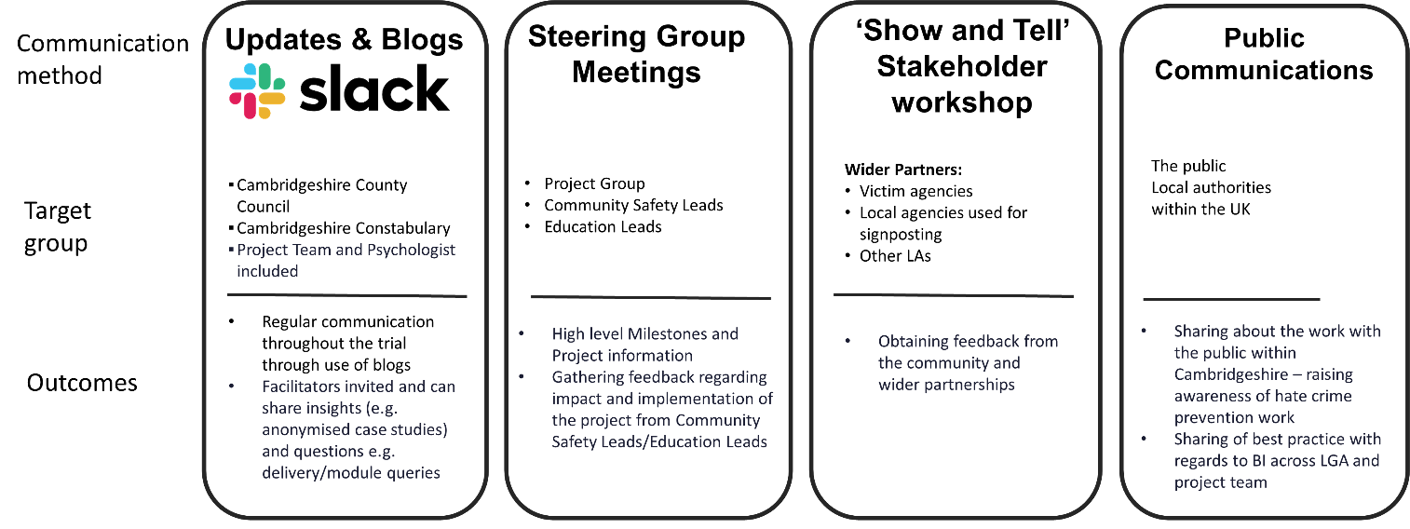
Appendix 3: Facilitator blogs
Facilitator Blog 1 - Carianne Burr, ‘Building Relationships Virtually’
Being confronted with challenging behaviour is difficult at the best of times. When all contact is virtual, it becomes even more problematic. Where I have been able to use my body language, facial expressions, eye contact or gestures to be able to manage difficult situations in the past, I am resigned to words alone. The importance of building rapport and meaningful relationships is central to all the work I have ever carried out; without which growth is compromised. So, I am rising to the challenge of cultivating relationships virtually in our new-world existence.
Initial phone calls to introduce myself have become pivotal opportunities with first impressions counting more than ever. I am dedicating more time to asking how my clients are, sharing a bit about myself, using appropriate humour wherever possible and demonstrating empathy wherever I can from the outset. I am being flexible beyond the usual, offering extra support wherever needed. I am sharing my core belief, at the first given opportunity, that we are, as humans, flawed and that this is ok; it is not the regretful acts that define us but how we grow and learn from them that determines our true worth.
With all this in mind, I have still encountered challenges; resistance, abuse, reluctance, non-engagement. It is in these moments I remind myself just how difficult it must be to acknowledge self-made behaviours that have resulted in police involvement. For most, this is their first encounter with the criminal justice system and all the shock, and shame, that comes with it. For some, this extends to the realisation that their actions are indeed illegal and consequential. I am also acutely aware that we all come with our own ‘dirty laundry’, but that most of us are not asked to air it with someone we don’t know, let alone will never meet in person.
These are the challenges for those we are working with. Our challenge is to navigate our way through, while attempting a unity with the client so we face and overcome each challenge, collaboratively. I am aware this all sounds rather ideological and of course, these are all examples of when challenging situations are dealt with successfully. It doesn’t always work out this way and so when it doesn’t, relational bond and engagement are affected. When the client takes two steps back, we find ourselves pushed further and further away, compromising our ability to support change.
I have experienced this first hand with a client who refused to answer my phone calls from a withheld number. When he did answer, I was met with what can only be described as rage. It took perseverance from me (and a reminder to myself that I don’t know everything that is going on for the client) to establish that he had received threatening calls from withheld numbers before and his rage was in actual fact, fear. My initial assumption that he was simply being resistant, difficult or avoiding having to engage with the programme had ignited a sizable rift in our rapport, from the outset. My bad and I own it. But, I did persevere and, when I could get him on the phone again, asked him what was going on for him, and guess what, he opened up. Just that attempt to try to scratch beneath the surface and hear what he had to say helped us to mend the very obvious rupture. Every obstacle he raised, we explored and alternatives were sought, together as a collective. We had managed to re-establish relational alignment in order to work together. Since then, he has confided in me his difficulties, shared his feelings and fears like no other client has.
I suppose in summary, building relationships in a limited time frame is challenging; building relationships in a limited time frame without ever meeting in person is even more so. We need to draw on core relational skill sets in order to fast track rapport building if we are to meaningfully support our clients in their journeys.
My first experience working with children in the Criminal Justice System whilst working as a probation officer in Bermuda for three years where Probation Service manages the risk of convicted individuals aged eleven to ninety-nine!
I must admit, when I arrived for my first day at work in Bermuda, I was not looking forward to working with children. I had memories of horror stories told by friends who had worked in residential children’s homes in the UK and to be quite honest; I was scared. However, my experience challenged my unconscious bias about children who offend, and I became keenly aware of how vulnerable, impressionable some children are and learned how to adapt to situations with Safeguarding and welfare of children clearly now at the forefront of my mind. Also, I found the skills I gained as a probation officer and my knowledge and training around trauma informed practice helped me remember how important it is to take the time to firstly listen carefully to hear and respond to the underlying needs that may be driving the behaviour. Once the needs have been explored, communication around meeting needs with pro social behaviour can start.
After my return to the UK, I was the liaison probation officer for the Youth Offending Service and NPS. Cases involving young people can be challenging, sad, and frustrating at times but it can also be enlightening and rewarding. I enjoy hearing the different perspectives young people have on society, hearing their thoughts on why they are friends with certain people, why they like certain things, what their goals are and exploring their emotions and feelings can lead to some interesting and hilarious conversations.
In 2022, I have begun supporting young people with completing a Hate Crime intervention with Redsnapper. The cases are so varied and concern speech and behaviour that can be highly sensitive, embarrassing and confronting for the young person involved. However, the workbook materials are not punitive or judgmental and instead allow for a strength-based guided educational approach that develops thinking around the damaging effect on victims and how to make positive changes.
Facilitator Blog 2 - Emma Hands, ‘Challenging First Referral’
I was very uncertain on what to expect for my first referral. Now reflecting on the process thus far, I would say the client was somewhat more challenging for my first referral than others. Challenges that arose throughout this case included:
- Difficulty getting in touch with the client
- Attendance to sessions
- Lack of willing attitude
- The setting in which the client carried out the sessions
- Learning ability of the client
After the initial call with the client’s guardian, it become clear that there would be some challenges with this particular referral. I wanted to ensure that the challenges were minimised as much as possible for both myself and the client to make the process as fulfilling and beneficial as possible. In order to overcome these challenges, I felt it was important to offer as much support as possible to the client and to be flexible to accommodate their needs.
To help overcome the learning challenges, the use of examples and rephrasing questions was really important, to ensure the client understood what was being asked and to help them feel supported and comfortable within the session. By ensuring the client feels supported throughout the process allows you to build a better rapport and generates a safe environment. This allows the client to feel able to air their concerns and struggles throughout the sessions and vocalise if they are finding there to be any challenges. I used examples in correlation with my own situation and then would reflect using the situations of the client, this helped to put the questions into perspective for the client and allow them to think about what is being asked in terms of their own life.
The client also struggled to hold their attention.
The setting in which the client sat to take the meeting was not ideal for maintaining concentration. There were many others in the room, it was loud and chaotic; there were a lot of distractions. I used a combination of open and closed questions to keep the exchange going and to keep the client focused on the task at hand.
The client also has ADHD, which played a factor in how focused they could remain on a task. To help overcome this issue, for the second session it was agreed that we would break the session into two thirty-minute sessions rather than one, one hour session. The purpose of doing this, was to relieve the pressure of the client having to concentrate for a long period of time and hopefully promote positive engagement within the shorter sessions.
Based upon this referral I have learnt that it is best to accommodate the needs of the client to get the most out of the sessions rather than following standard guidance, and switching these into shorter sessions to meet the needs of the client.
Facilitator Blog 3 - ‘Working with Children in the Criminal Justice System’
I stumbled into working for London Probation Area, (as it was then called) in 2002. I studied law at university but had always been interested in what motivates people and psychology. I saw the Probation Service as an interesting combination of criminal law and human behaviour. Since then, I have managed a caseload, presented breaches in court, and co-facilitated accredited programs with adult individuals on licence or serving a sentence in the community.
My first experience working with children in the Criminal Justice System whilst working as a probation officer in Bermuda for three years where Probation Service manages the risk of convicted individuals aged eleven to ninety-nine!
I must admit, when I arrived for my first day at work in Bermuda, I was not looking forward to working with children. I had memories of horror stories told by friends who had worked in residential children’s homes in the UK and to be quite honest; I was scared. However, my experience challenged my unconscious bias about children who offend, and I became keenly aware of how vulnerable, impressionable some children are and learned how to adapt to situations with Safeguarding and welfare of children clearly now at the forefront of my mind. Also, I found the skills I gained as a probation officer and my knowledge and training around trauma informed practice helped me remember how important it is to take the time to firstly listen carefully to hear and respond to the underlying needs that may be driving the behaviour. Once the needs have been explored, communication around meeting needs with pro social behaviour can start.
After my return to the UK, I was the liaison probation officer for the Youth Offending Service and NPS. Cases involving young people can be challenging, sad, and frustrating at times but it can also be enlightening and rewarding. I enjoy hearing the different perspectives young people have on society, hearing their thoughts on why they are friends with certain people, why they like certain things, what their goals are and exploring their emotions and feelings can lead to some interesting and hilarious conversations.
In 2022, I have begun supporting young people with completing a Hate Crime intervention with Redsnapper. The cases are so varied and concern speech and behaviour that can be highly sensitive, embarrassing and confronting for the young person involved. However, the workbook materials are not punitive or judgmental and instead allow for a strength-based guided educational approach that develops thinking around the damaging effect on victims and how to make positive changes.

Appendix 4: Raw reoffending data (anonymised)

Case/Crime Number | Offence Type | Complied | Completion Date | New offence 3mnths | New offences 6mnths | New offence 12mnths | Offender typology
2021
35/60985/21 | S.4A POA | Y | 02/12/2021 | None | None | None | Retaliatory
35/62675/21 | Rac Agg. S.4A POA | N | N/A |  |  | 1x Common assault NFA, 1x S.4A POA NFA, 1x Rac Agg. S.4A POA Charge | Thrill
35/74954/21 | Rac Agg. Criminal Damage | N | N/A | None | 1x ABH NFA | None | Thrill
35/NT/18201/21 | Rac Agg. ABH | Y | 10/01/2022 | None | None | None | Defensive
35/NT/17004/21 | DV ABH | Y | 05/03/2022 | None | 1x DV ABH NFA | None | Unable to determine
35/NT/18008/21 | Affray | Y | 09/02/2022 | None | None | None | Thrill
35/NT/18100/21 | Rac Agg. S.4A POA | Y | 11/01/2022 | None | None | None | Defensive
35/70892/21 | Rac Agg. S.4A POA | Y | 16/02/2022 | None | None | None | Unable to determine
35/79469/21 | S.4A POA (Hate) | Y | 22/12/2022 | None | None | None | Thrill
35/NT/19557/21 | Rac Agg. S.5 POA | Y | 18/02/2022 | None | None | None | Defensive
35/76293/21 | Rac Agg. S.4A POA | N | N/A | None | None | 1x Burglary NFA, 1x PWITS Class A under investigation, 1x Theft of motor vehicle NFA, 1 PWITS Class B charge | Thrill
35/73012/21 | Rac Agg. S.4A POA | Y | 08/02/2022 | None | None | None | Thrill
35/1607/22 | Rac Agg. Common Assault | Y | 10/02/2022 | None | None | None | Retaliatory
35/NT/11140/22 | Rac Agg. S.4A POA | Y | 04/03/2022 | None | None | None | Thrill
35/NT/19674/21 | Rac Agg. S.4A POA | Y | 09/03/2022 | None | None | None | Thrill
2022
35/86705/21 | Rac Agg. Criminal Damage | Y | 11/03/2022 | None | None | 1x Assault police CR | Thrill
35/86705/21 | Rac Agg. Criminal Damage | Y | 23/03/2022 | None | 1x ABH outcome 22 | 1x Assault police CR | Thrill
35/14983/22 | Mal Comms (Racial/Hate) | Y | 29/03/2022 | None | None | None | Thrill
35/NT/11411/22 | Rac Agg. S.5 POA | N | N/A | None | 1x DA Mal Comms NFA | None | Unable to determine
35/14983/22 | Mal Comms (Racial/Hate) | Y | 12/04/2022 | None | None | None | Thrill
35/7951/22 | Arson (Hate) | Y | 05/04/2022 | None | None | None | Thrill
35/7951/22 | Arson (Hate) | N | N/A | None | None | None | Thrill
35/9237/22 | Mal Comms (Racial/Hate) | Y | 27/04/2022 | 1x ABH crime NFA | 1x Take/make/distribute indecent images NFA, 1x Theft from shop CR, 1x Common assault NFA | 1x Theft from shop NFA, 1x ABH awaiting YOS outcome, 1x ABH NFA, 1x Common Assault NFA | Thrill
35/NT/10534/21 | Rac Agg. ABH | Y | 12/04/2022 | None | None | 1x Rape NFA | Retaliatory
35/13455/22 | Mal Comms (Racial/Hate) | Y | 06/04/2022 | None | None | 1x Theft from shop CR | Thrill
35/NT/12190/22 | Rac Agg. ABH | Y | 05/05/2022 | None | None | None | Retaliatory
35/NT/10804/22 | Rac Agg. S.4A POA | N | N/A | None | 1x DV C&C NFA | None | Retaliatory
35/5829/22 | Rac Agg. Harassment | Y | 05/05/2022 | None | None | None | Thrill
35/5829/22 | Rac Agg. Harassment | Y | 05/05/2022 | None | None | None | Thrill
35/NT/13210/22 | Mal Comms (Racial/Hate) | Y | 28/04/2022 | 1x Mal comms NFA, 2x Harassment NFA | None | None | Defensive
35/NT/13290/22 | Rac Agg. Harassment | Y | 24/05/2022 | None | None | None | Unable to determine
35/20517/22 | Rac Agg. Common Assault | Y | 17/08/2022 | None | None | None | Defensive
35/19917/22 | Rac Agg. Common Assault | Y | 09/06/2022 | 1x DA Criminal damage NFA | None | None | Thrill
35/15231/22 | S.4A POA (Hate) | Y | 19/06/2022 | None | 1x S.4A POA charge | None | Defensive
35/NT/14111/22 | Rac Agg. S.4A POA | Y | 23/06/2022 | None | None | None | Retaliatory
35/27662/22 | Rac Agg. Harassment | Y | 27/06/2022 | None | None | None | Thrill
35/6036/22 | Harassment (Hate) | Y | 28/06/2022 | None | None | None | Defensive
35/29014/22 | Act to Stir up Sexual Hatred | Y | 13/07/2022 | None | None | None | Thrill
 | Rac Agg. Common Assault | Y | 24/06/2022 | None | None | None | Thrill
35/36623/22 | Rac Agg. Common Assault | Y | 30/06/2022 | None | None | None | Thrill
35/36623/22 | Rac Agg. Common Assault | Y | 22/06/2022 | None | None | None | Thrill
35/40816/22 | ABH (Hate) | Y | 31/10/2022 | None | None | None | Retaliatory
35/25143/22 | Mal Comms (Racial/Hate) | Y | 09/11/2022 | 1x ABH crime NFA, 1x Theft NFA | 1x Common assault/Criminal damage/Sexual assault NFA | 1x Possession Class B - Cannabis awaiting YOS outcome | Retaliatory
35/41754/22 | Rac Agg. S.5 POA | Y | 19/07/2022 | 1x S.4A POA NFA | None | None | Defensive
35/16788/22 | Rac Agg. S.4A POA | Y | 26/07/2022 | None | None | None | Defensive
35/NT/15276/22 | Rac Agg. Criminal Damage | Y | 15/08/2022 | None | None | None | Thrill
35/35894/22 | Rac Agg. S.4A POA | Y | 19/08/2022 | None | None | None | Defensive
35/NT/15823/22 | Rac Agg. S.4A POA | Y | 25/08/2022 | None | None | None | Retaliatory
35/30109/22 | Mal Comms (Racial/Hate) | Y | 26/11/2022 | 1x Common assault NFA | None | None | Thrill
35/37255/22 | Rac Agg. S.4A POA | Y | 24/08/2022 | None | None | None | Thrill
35/37798/22 | S.4A POA (Hate) | N | N/A | None | None | None | Thrill
35/NT/15786/22 | Harassment (Hate) | Y | 24/08/2022 | None | None | None | Defensive
35/55920/22 | Rac Agg. Harassment | Y | 07/09/2022 | None | None | None | Unable to determine
35/44341/22 | S.5 POA (Hate) | Y | 14/09/2022 | None | None | None | Unable to determine
35/48194/22 | ABH (Hate) | Y | 28/09/2022 | None | None | None | Thrill
35/29757/22 | S.4A POA (Hate) | Y | 28/09/2022 | None | None | None | Retaliatory
35/50204/22 | Criminal Damage | Y | 26/10/2022 | None | None | None | Thrill
35/41156/22 | Rac Agg. S.4 POA | Y | 07/10/2022 | None | None | None | Retaliatory
35/NT/17270/22 | Harsssment | Y | 24/10/2022 | None | None | None | Retaliatory
35/NT/17981/22 | Rac Agg. S.5 POA | Y | 10/11/2022 | None | None | None | Thrill
35/73676/22 | Rac Agg. S.4A POA | Y | 09/11/2022 | None | None | None | Thrill
35/51967/22 | Mal Comms (Racial/Hate) | Y | 05/12/2022 | None | None | None | Thrill
35/73163/22 | Mal Comms (Racial/Hate) | N | Unsuitable diversion due to suspect not speaking English | None | None | None | Defensive

