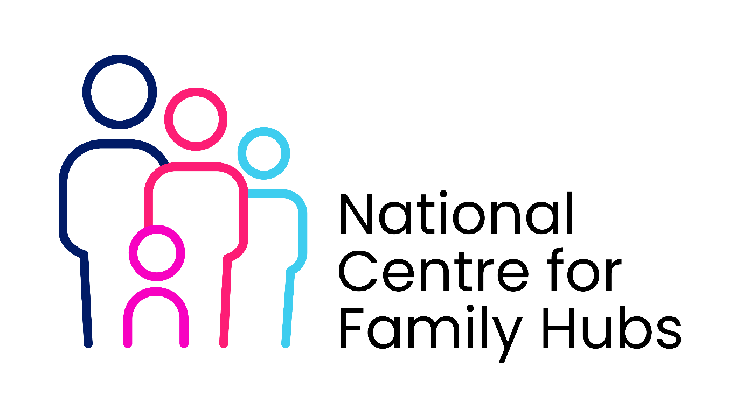
Memorandum of Understanding (MoU)
Between [School Name] and [Family Hub Name]
1. Purpose
This Memorandum of Understanding (MoU) sets out the shared commitment between [School Name] and [Family Hub Name] to work collaboratively to improve outcomes for children, young people, and their families.
The partnership aims to ensure early identification of need, coordinated support, and improved access to services through a whole-family approach.

2. Shared Principles
Both parties agree to:
- Put children and families at the centre of all decision-making
- Promote early help and prevent escalation of need
- Work in a strengths-based and inclusive way
- Share information appropriately to safeguard children and support families
- Respect each organisation’s roles and professional expertise
- Promote equality, diversity, and inclusion

3. Objectives of the Partnership
- Improve children’s attendance, attainment, and wellbeing
- Strengthen parental engagement with education and support services
- Provide holistic, coordinated support to families
- Identify needs early and respond effectively
- Reduce duplication and improve service efficiency

4. Roles and Responsibilities
The School will:
- Act as a key point of contact for identifying children and families who may need support
- Refer families to the Family Hub using agreed processes
- Share relevant information (with consent where appropriate)
- Provide space for outreach, drop-ins, or joint activities where possible
- Engage with multi-agency meetings (e.g. Team Around the Family)
- Promote Family Hub services to families
The Family Hub will:
- Provide early help and family support services
- Offer advice, guidance, and direct support for families
- Respond to referrals in a timely manner
- Provide feedback on outcomes (within information-sharing agreements)
- Attend school-based meetings where appropriate
- Deliver outreach support, workshops, or drop-in sessions

5. Information Sharing
Both parties agree to:
- Share information in accordance with GDPR, data protection legislation, and safeguarding requirements
- Obtain consent where appropriate, unless there are safeguarding concerns
- Use secure methods for communication
- Have a clear information-sharing agreement in place

6. Safeguarding
- Safeguarding remains the responsibility of all professionals
- Concerns about a child’s safety will be reported immediately in line with local safeguarding procedures
- The school’s Designated Safeguarding Lead (DSL) and the Family Hub safeguarding lead will maintain regular communication
- Escalation processes will be followed where necessary
7. Referral Processes
- A clear referral pathway will be agreed and documented
- Thresholds for support will be understood by both partners
- Referrals will be acknowledged within [insert timeframe, e.g. 5 working days]
- Feedback will be provided where appropriate

8. Communication and Meetings
- Named link contacts will be identified for both organisations:
  - School: [Name/Role]
  - Family Hub: [Name/Role]
- Regular meetings will take place (e.g. monthly/termly)
- Joint planning and review meetings will support continuous improvement

9. Monitoring and Review
- The effectiveness of the partnership will be reviewed regularly
- Success measures may include:
  - Attendance improvements
  - Increased parental engagement
  - Reduction in referrals to statutory services
  - Positive feedback from families
- This MoU will be formally reviewed every [12 months]

10. Dispute Resolution
Any disagreements will be addressed through:
- Initial discussion between named contacts
- Escalation to senior leaders if required
- Reference to local partnership governance arrangements

11. Duration of Agreement
This MoU will commence on [date] and remain in place until [date], unless reviewed or terminated by either party with [e.g. 3 months'] notice.

12. Signatories
Signed on behalf of [School Name]
Name: ________________________
Role: _________________________
Signature: ____________________
Date: _________________________
Signed on behalf of [Family Hub Name]
Name: ________________________
Role: _________________________
Signature: ____________________
Date: _________________________

