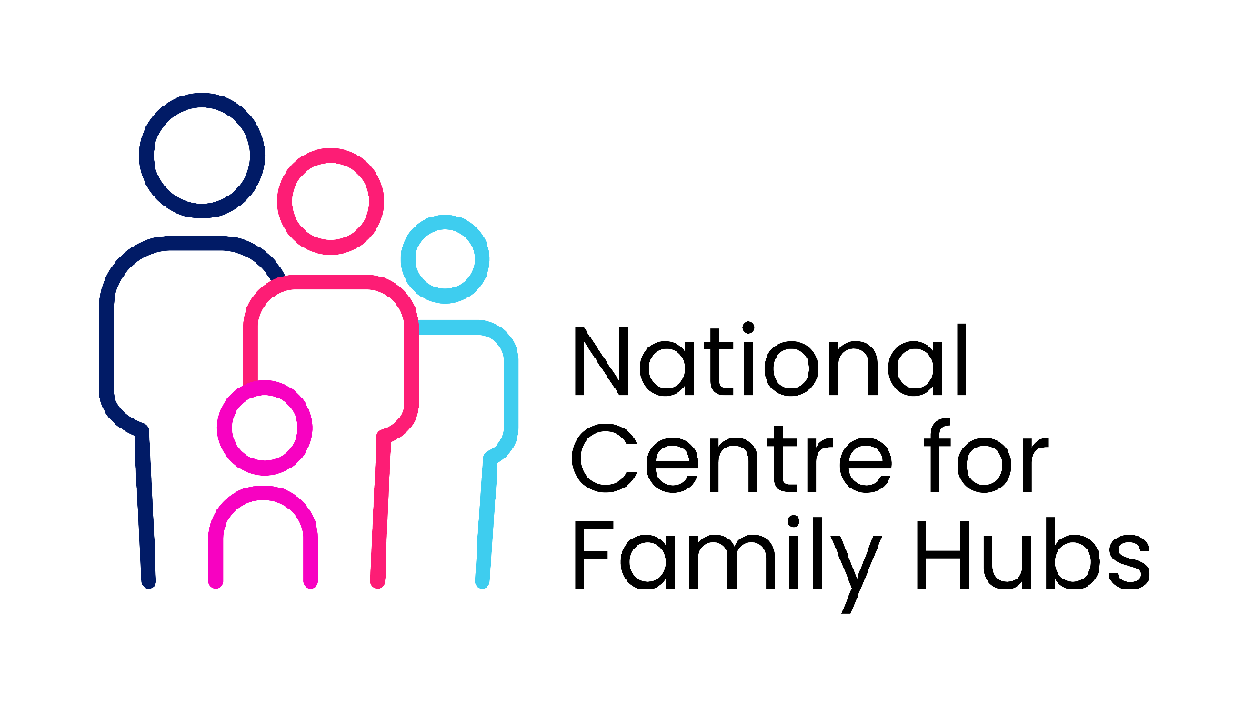
Monitoring and Evaluation Frameworks
Logic Model Framework
To build an effective Monitoring and Evaluation (M&E) framework, you must first map the structural logic of the partnership.
+---------------------------------------------------------------------------------------+

| INPUTS --> ACTIVITIES --> OUTPUTS --> OUTCOMES --> IMPACT |
| Staff, Space, Co-located Sessions Increased Improved |
| Funding, Books Services Delivered Literacy Life |
+---------------------------------------------------------------------------------------+
- Inputs: Shared staff, library space, integrated funding, books, and digital resources.
- Activities: Co-located health clinics, early years rhyme times, and parent support groups.
- Outputs: Number of integrated sessions delivered and total joint registrations completed.
- Outcomes: Increased early literacy, improved parental confidence, and faster access to targeted support.
- Impact: Improved child development outcomes and reduced health inequalities in the community.
Key Performance Indicators (KPIs)
Track performance across four distinct areas to measure the health and reach of the hub.
1. Reach and Engagement
- Total number of families registering for joint Family Hub and library memberships.
- Percentage of registrations originating from targeted or deprived postcodes.
- Monthly footfall breakdown comparing standard library users to Family Hub service users.
2. Service Integration
- Number of external health or social care practitioners co-locating sessions within the library.
- Multi-agency referral completion rates between library staff and family support workers.
- Volume of joint events delivered by library and early years staff per quarter.
3. Family and Child Outcomes
- Percentage of parents reporting increased confidence in supporting their child's early literacy.
- Proportion of children tracking at or above age-related expectations in communication at age two.
- Percentage of families reporting improved mental well-being after attending hub sessions.
4. Operational Efficiency
- Cost per family engaged across the integrated service model.
- Staff satisfaction scores regarding cross-agency communication and training.
- Library space utilisation rates during designated Family Hub operating hours.
Data Collection Matrix
Utilise a mix of continuous and periodic collection methods to gather your data.
- Quantitative Data: Track system metrics continuously using electronic library management systems and Family Hub case management databases.
- Qualitative Data: Collect parental feedback through quarterly focus groups and post-intervention surveys.
- Staff Feedback: Conduct bi-annual reflective workshops and annual workforce surveys to assess partnership friction.
- Observational Data: Use validated early years tools during rhyme time sessions to measure child engagement levels.
Evaluation Timeline and Reporting
Establish regular milestones to review performance data and adjust service delivery.
- Baseline: Establish current library usage statistics and local early years readiness data at launch.
- Quarterly Monitoring: Review reach KPIs and operational efficiency metrics to troubleshoot delivery issues.
- Mid-Term Evaluation (Month 6): Assess the strength of service integration and staff partnership dynamics.
- Annual Impact Review: Analyse child development outcomes and parental confidence metrics against the baseline.

