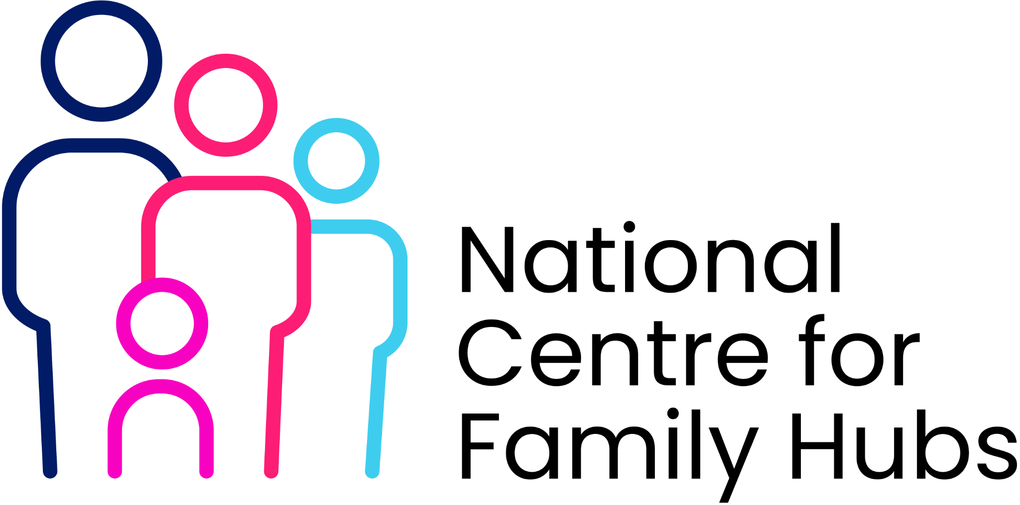
Family Hub and Network Asset Mapping Template
Best Start Network Sites
Purpose: Support Local Authorities to identify, map and assess assets across their Family Hub and Best Start Network. Example entries are included in each section and can be replaced with local information.

1. Area Profile
Information | Detail
Local Authority | Example Council
Assessment Date | July 2026
Lead Officer | Jane Smith
Family Hub Lead | John Brown

2. Priority Communities
Community/Ward | Reason for Priority Status | Evidence Source
Green Estate | High deprivation and low Family Hub engagement | IMD and attendance data
Riverside | Population growth | Birth and housing data

3. Key Population Groups
Population Group | Estimated Numbers | Current Challenges
Children with SEND | 1250 | Access to specialist support
Young Parents | 420 | Low engagement with services

4. Current Family Hub Sites
Site Name | Location | Lead Organisation | Services Delivered | Catchment Area
Central Family Hub | Town Centre | Local Authority | Parenting, HV, SEND | Central Ward

5. Current Network Sites
Site Name | Venue Type | Location | Existing Activities | Attendance
Green Estate Library | Library | Green Estate | Story Time, information sessions | High

6. Physical Assets
Asset | Location | Existing Family Use | Potential
Community Centre | Green Estate | Family events | Excellent
Church Hall | South Ward | Toddler groups | Good

7. Community Assets
Asset | Current Activity | Reach | Opportunities
Parent Champions | Promote services | High | Outreach
Peer Support Group | Weekly support | Medium | Family engagement

8. Existing Partners
Organisation | Sector | Current Involvement | Future Opportunities
ICB | Health | Health visiting | Joint outreach
Local Nursery Group | Early Years | Information sharing | Parenting sessions

9. Accessibility Assessment
Area | Current Position | Assessment
Public Transport | Good | Green
Rural Reach | Limited | Red

10. Gap Analysis
Theme | Existing Provision | Gap Identified | Priority
Parenting Support | Hub Based | Limited rural access | High

11. Potential New Network Sites
Venue | Community Need | Benefits | Priority
North Library | Growing family population | Trusted venue | High

12. Co-location Opportunities
Opportunity | Partners Involved | Benefit
Family Hub in GP Practice | ICB and Council | Improved access

13. Asset Prioritisation Matrix
Asset | Accessibility | Community Trust | Partnership Potential | Sustainability | Total
Community Centre | 5 | 5 | 4 | 4 | 18

14. Short-Term Action Plan
Action | Lead | Timescale
Engage library service | Family Hub Lead | 3 months

15. Medium-Term Action Plan
Action | Lead | Timescale
Develop outreach programme | Best Start Lead | 6-12 months

16. Long-Term Action Plan
Action | Lead | Timescale
Establish additional network site | Partnership Board | 12+ months

Family Feedback

What families tell us works well: ______________________________

What families tell us needs improvement: _______________________

Communities currently underrepresented: _______________________

