Nudge Summary - Using behavioural insights to encourage energy efficiency
Image 1
Image 1 shows one intervention variant from our first intervention approach. It emphasises the loss of heat through roofs due to poor insulation. It features an image of a red-tiled roof with the slogan “Are you losing heat through your roof?”. The caption posted alongside the image highlighted social norms by stating that 4 out of 5 homes in Devon do not have sufficient loft isolation.
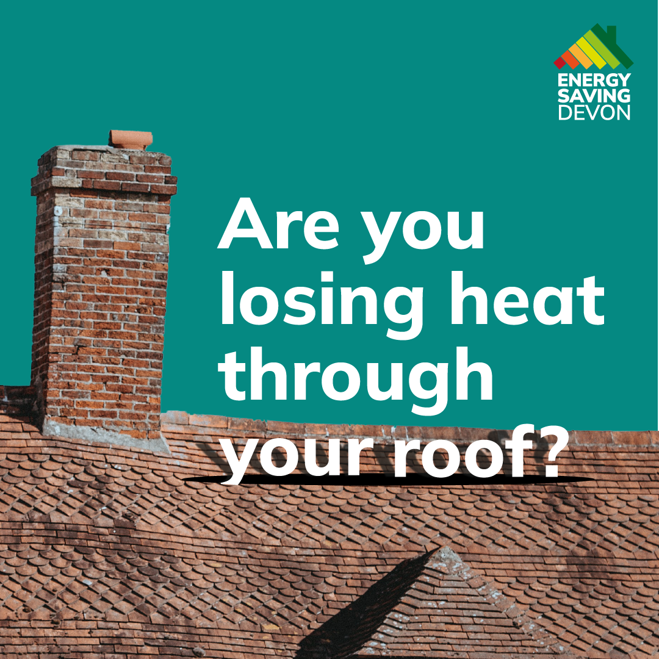

Image 2
Image 2 shows the second intervention variant from our first intervention approach. This ad highlights the loss of money as a result of poor loft insulation. It features an image of a red-tiled roof with the slogan “Energy bills going through the roof?” The caption posted alongside the image appealed to a sense of loss aversion by pointing out that residents may be losing money due to insufficient insulation.

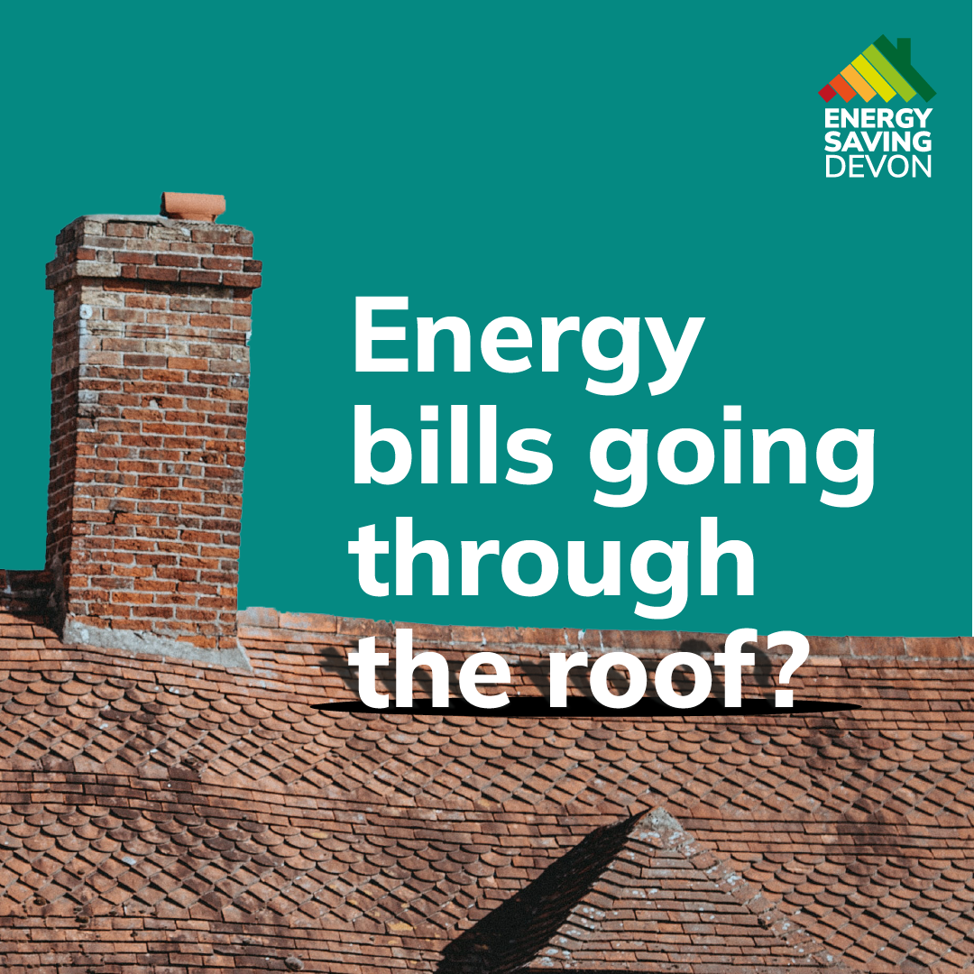

Image 3
Image 3 shows the ad developed for our second intervention approach which compared the recommended depth of insulation required in lofts with locally identifiable objects, in this case a mackerel, for increased salience. It features an image of a mackerel with the message “Thick as your average mackerel”.
This ad was tested with two different captions alongside it, one emphasising a social norm and one highlighting financial loss due to insufficient insulation.
