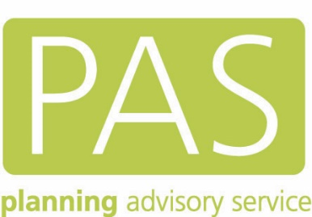

Guide to making an Infrastructure Funding Statement

Part 1 – A handbook to managing developer contributions
Part 2 – A step-by-step guide to publishing data

Published separately: A sample IFS with detailed notes

First published December 2020

Contents

Contents 2
This guide 5
What is an Infrastructure Funding Statement (IFS)? Do I have to make one? 5
What goes into an IFS? 6
Types of IFS 7
The wider role of IFS 7
IFS reporting is a snapshot 8
IFS and statements about the future 9
Pulling together to make an IFS 10
Publishing your IFS 11
Examples of IFS we like 12
Enfield 12
Stratford-on-Avon 12
Blackburn with Darwen 12
Overview of the Government’s recommended process for preparing and publishing underlying data on developer contributions 14
Gathering information 14
Publishing your raw data 15
Definitions for recording the intended purpose of developer contributions 16
Section 106 17
CIL 19
Community Infrastructure Levy 19
Neighbourhood CIL 19
Mayoral CIL 19
Community Infrastructure Levy administration costs 19
Reporting on in-kind contributions 19
Recording instalment payments and surcharges 20
REPORTING ON SECTION 106 PLANNING OBLIGATIONS 21
Introduction – how to treat data on s106 planning obligations in the Infrastructure Funding Statement (legislative requirements) 21
CSV1 – developer agreements 24
CSV2 - Developer agreement contributions 26
CSV3 - Developer agreement transactions 27
Worked example 1 – section 106 29
Worked example 2. Section 106 where the agreement is varied 32
Community infrastructure levy 34
Introduction 34
CSV1 – developer agreements 37
Worked example 3 – CIL 39
ANNEX 1 – opening, formatting, infilling, saving and publishing the csv files (using Excel) 42
Introduction 42
Accessing the spreadsheets 42
Create your CSV files 42
Formatting the spreadsheets 43
Setting column width 43
Formatting the date columns to record dates in the recommended format 44
Update your developer contributions web page 46
Licensing 47
Annex 2 – A table of contents for the IFS 48

PART 1 – Handbook

A guide to managing developer contributions in a local authority

This guide
This guide has been written to assist local planning authorities publish an Infrastructure Funding Statement (IFS). It was produced with the help of colleagues from the Ministry of Housing Communities and Local Government (MHCLG), and was informed by a series of workshops with practitioners who asked helpful questions. Our thanks to all of you.
It is clear to us that the first round of statements are going to flush out a series of implementation and specification issues. This is a complicated and messy “real world” topic with lots of different authorities and agencies involved. We are expecting to issue updates to this guide as we collectively learn more – or indeed to replace it with new guidance reflecting some of the changes to a national infrastructure levy laid out in the planning white paper ‘Planning for the Future’. Whatever happens next, we are confident that the principles of transparency and accountability around the collection and spending of developer contributions are here to stay.

What is an Infrastructure Funding Statement (IFS)? Do I have to make one?
An IFS is a document that must be published each year by a “contribution receiving authority”. A contribution receiving authority is any authority which issues a Community Infrastructure Levy (CIL) liability notice or receives money or in-kind works from a Section 106 agreement. This means almost all local planning authorities will need to produce one, including county councils. Where parishes receive a proportion of CIL they will need to produce a report for each financial year in which they receive CIL receipts too.
Authorities that charge CIL have had to produce a report on receipts and expenditure since the regulations were introduced in 2010, but there has not been a requirement to report on section 106 in this way before now. The first “combined” IFS covering both CIL and section 106 contributions are to be published by the 31st December 2020 for the period 1st April 2019 to 31st March 2020. The information to be provided relates to all the new activity in the year as well as all unspent money from previous years. Some councils will therefore have to perform a one-off “stock take” of obligations from lots of old agreements to establish whether they relate to unspent funds that need to be reported.

What goes into an IFS?

There are three components to an IFS. The first is a mandatory requirement as set out in the CIL Regulations 2010 (as amended). Regulation 121A and Schedule 2 require the contribution receiving authority to publish an IFS which includes
- The infrastructure projects or types the authority intends to be funded at least in part by CIL
- A CIL report
- A section 106 report
The second part is non-mandatory but is set out in planning practice guidance. It recommends publishing more detailed developer contributions data in a set of tables at a level of individual transactions. This provides for transparency and accountability at the level of individual obligations. Some software systems offer the facility to export compliant tables very simply. Councils without these systems – e.g. those using a simple spreadsheet or home-made database – are encouraged to translate their data into the standard format recommended by MHCLG. The second part of this guide provides a step-by-step approach to populating the tables.
Lastly there is an opportunity to use the IFS to showcase how the council is developing and delivering an infrastructure strategy. Telling the whole story might mean that some projects from a different regulatory regime (e.g. Highways schemes delivered via a section 278 agreement) should also be included.

Types of IFS
It would be easy to see IFS reporting as a burden and just another regulatory requirement. We think they are an excellent way to demonstrate capable governance and effective delivery. For some councils (those who do not charge a CIL) this might be the first public statement on infrastructure delivery via developer contributions. An early decision for authorities approaching an IFS is what sort of job they want the IFS to do, and in part that turns on how much time and effort they want to spend:
- A “bare bones” but compliant IFS might be 2 or 3 pages long and provide totals and high-level themes and categories in an infrastructure plan (although authorities are encouraged to do more);
- A basic IFS might be broken out by ward and detail schemes already underway in an accessible way. It will contain a narrative to explain the numbers;
- A “full” IFS will have photographs and details relevant to businesses and communities showcasing what developer contributions have helped to deliver. It will set out existing infrastructure priorities and give details of how new schemes and ideas will be considered. It will contain messages from councillors who set the vision and make choices on projects suggested by parishes and communities.
As with all council documents it is for them to decide an appropriate level of “sign off” before publication. We have heard a wide variety of approaches – everything from no process at all right up to full council or even Mayor. For some councils section 106 agreements have been very much a technical and legalistic subject dealt with in the planning department. The direction of travel is to continue to strengthen councils’ roles as infrastructure providers and make infrastructure planning much more transparent. This inevitably means more corporate and political responsibility and ownership to ensure successful delivery of projects.

The wider role of IFS
The thinking and organisation required to make a good IFS serves a broader benefit. One of the biggest risks for councils taking developer contributions is that they are seen to just “sit” on them, leaving them unspent even after many years. This begs the question of whether the contributions are genuinely needed, and creates doubt that councils are reliable custodians of the money. In turn, this places a burden on councils who receive many Freedom of Information requests. This unhelpful loop is avoided by establishing some clear processes and principles that explain how an infrastructure strategy leads to allocation and delivery on projects with genuine community benefit.
Earlier in 2020 PAS published a guide for senior leaders called “Start with the spend in mind”. It sets out in a series of fact sheets on the choices facing senior officers and councillors and how the various parts of the planning system reinforce each other when used well.
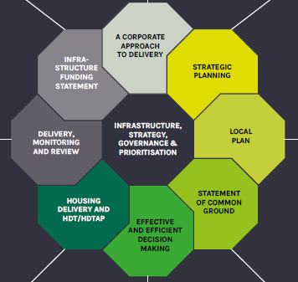
Figure 1 Image from "start with the spend in mind"

Both our document and the planning guidance encourage councils to use the IFS as a form of promotion. In part this flows from a study commissioned by MHCLG that found that the public had not made a link between developer contributions and the delivery of affordable housing, community facilities and the like. Improving the communication may help influence the public’s attitude towards development. Set against that is the need to manage expectations – many councils have quite large sums of money in their IFS but they are already allocated to large and long-term infrastructure projects like roads and schools. The funds are not being “sat on” but instead accrued for large scale expensive projects and they are not therefore available to other bids.

IFS reporting is a snapshot
An annual publication, especially if including the transaction level detail, is going to be a snapshot of a moment in time. Care should be taken to describe infrastructure priorities in such a way that does not close down opportunities or make everything seem locked and unable to change.
We heard from officers at our events that there was a worry that the document (especially in the first year) would not be complete with every detail, and indeed it is the nature of some obligations that they take time to resolve into an agreed figure. In almost every case the correct course of action was to take the opportunity to use the IFS to explain the context and the intention, and to accept that it is in the nature of infrastructure planning that things change. This is most obvious when councils consult and engage their communities on their priorities.
There is also good practice starting to emerge in two areas crucial to the long-term success of good infrastructure planning:
- Engagement across local government boundaries- we saw some excellent practice where county and district councils were spending time keeping each other informed on both emerging priorities but also the delivery of schemes where money was being passed to counties as a delivery partner.
- Finding a political route – in the past some planners have been wary of letting councillors make decisions on infrastructure schemes for fear that they could favour their own ward or try to generate some kind of electoral advantage. We heard from Sevenoaks who have introduced a member-led panel who allocate CIL and have a structured bidding process. They also have a dashboard so communities can self-serve details on which applications have generated payments and how much is available for them to spend.
We spent some time considering the proposals for a new infrastructure levy as part of the “Planning for the Future” White Paper proposals and how that might change things in councils. Our conclusion was that the outlook seemed to increase the importance of proper and transparent infrastructure planning and delivery, so time spent getting the principles right would not be wasted.

IFS and statements about the future
Several people at our events were clear that there was a sharp difference between the “reporting the facts” part of an IFS (e.g. balances received) and making statements about likely future receipts and infrastructure priorities. In our view this distinction is not helpful.
The government’s guidance on CIL suggests a narrative that sets out how developer contributions will be used to deliver plan policies, including projects or types of infrastructure. This recognises the statement’s opportunity to communicate and reinforce a model of delivery rather than a new and binding commitment. Where there is a degree of confidence about future income that can be shared too.

Pulling together to make an IFS
The production of an accurate IFS requires coordination between many different authorities and agencies. Some, like districts and parishes, will have inherited a variety of work practices. Others, like the NHS and the police are not used to “reporting back” and explaining what has happened to the infrastructure funds.
It is probable that many statements will have some estimates and best guesses, and this will continue until the planning system updates its underpinning processes with automation and digital standards. Until that glorious day it might be prudent to agree a condition with delivery partners that project funding is accompanied by a requirement to report back on progress towards delivery.
Each collecting authority will have its own context and partners, but we have put together the following checklist:
Partner | Information to consider / role in developing IFS
Infrastructure providers | - How are they involved in feeding demands in to the prioritisation of projects?  - How do they feedback to you on spend of developer contributions and delivery of projects?
Leadership team (Officers and Members) | - Who identifies which projects are funded and how do they prioritise what the funds might be spent on in the future?  - Is it clear enough that you can record this in the IFS?  - How will a decision be made for inclusion of priorities in the IFS? Delegated / committee / Exec Member?
Planning | - Are you using the IDP and the Local Plan to inform the strategy for prioritisation and spend of funds?  - Are you using intelligence from strategic sites to feed in to the strategy for prioritisation?
Spending departments | - Is there a clear audit train of what has been “allocated” and what has been “spent” by spending departments? Are departments holding unspent and unallocated monies? How do they report to you?
Partner authorities e.g. County, GLA | - Do you have a feedback loop to record where funds have been transferred and infrastructure delivered by a partner organisation?  - Are you clear on how one another will report on this?
Local councils including Parish and Town Councils | - Do they know about the requirement to publish an IFS?  - Are they able to publish their own reports on their own website or does the Council need to do it for them?

Publishing your IFS
Each council will have a website structure and pre-existing network of corporate reports and publications. MHCLG would like you to send the web address of your IFS to them at CIL@communities.gov.uk. There is separate guidance later in this document on how to publish the accompanying data tables.
In this first year of reporting some councils are behind – partly because of the pandemic and the amount of work getting the data shipshape. The deadline for publication remains the 31st December 2020 and there is no extension. Some councils will not be able to get their IFS through appropriate signoff (e.g. full council) and so should publish a summary explaining the issue and when they expect it to be resolved.

Examples of IFS we like

The guidance from MHCLG is mostly concerned with the data specifications, not what the document should look like. It is for each collection authority to decide, and this should be based on a common-sense assessment of the work required, value to the reader and corporate brand.
It is early days for IFS, but a quick trawl through some websites yielded the following early examples:

Enfield
We like the way that Enfield’s IFS starts with some key headlines, but also goes into more detail on individual projects. It shows the sites that created the contribution in the first place – reinforcing the connection between development and the delivery of infrastructure. It has a strong narrative and the scale of development in Enfield means they have some exciting and easy to explain projects underway. It also explains the governance arrangements and links to related delivery and corporate plans.

Stratford-on-Avon
Stratford’s IFS is for the previous year but is still a good example. It is honest about some gaps in the information available. It explains the six criteria used for assessing projects before they can be placed on the infrastructure list, and the process of monitoring and spending overseen by cabinet. Importantly it also includes the appendices used to submit bids and a template that parish councils can use to produce a report which is compliant with regulation 121B.

Blackburn with Darwen
This might be our favourite s106 statement, despite not having page numbers. It explains context very well and has a comprehensive list making an explicit link between individual developments and cumulative spend on infrastructure. The council has chosen to report on s278 agreements alongside s106. They have used photos throughout and are careful to manage expectations. They also take the opportunity to explain the monitoring fee structure.

PART 2 – Technical Guide

A step-by-step guide to publishing IFS data.

Remember that there is also a video and separate appendix that also sets out some helpful reminders about what and how to publish on the PAS website.

Overview of the Government’s recommended process for preparing and publishing underlying data on developer contributions

The following section provides guidance on the Government’s recommended approach to preparing and publishing the underlying data that informs the infrastructure funding statement. It builds on the Government’s guidance ‘Publish your developer contributions data’ . The use of this approach is not mandatory, but you might find it helpful, particularly if you do not have an automated system to record your data or you do not use a third party provider which is able to prepare your data in a suitable format.
Advice on the legislative requirements for producing your infrastructure funding statement is at section 3 below.
Figure 2. Overview of the steps to prepare and publish an infrastructure funding statement
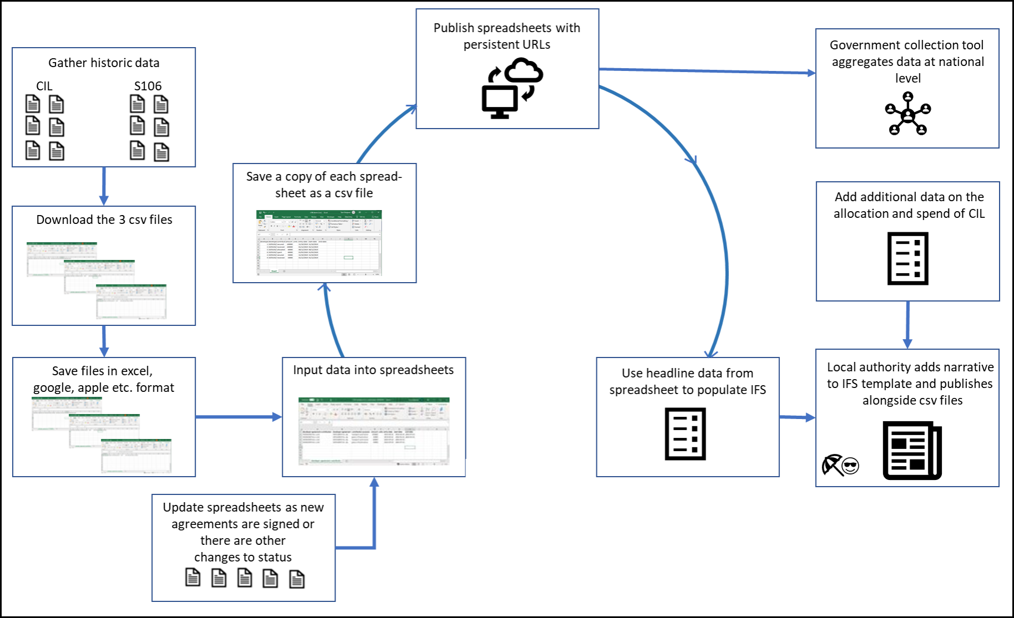

Gathering information
The first step is to gather the relevant information on section 106 agreements and CIL demand notices and receipts. Relevant information from these records can be input into three spreadsheets which can be downloaded from the gov.uk website. You do not need to record section 106 agreements where the proceeds have been ‘spent’ in previous years. However, including this data in the spreadsheets can help you provide a more thorough picture of the benefits of developer contributions. However, you should record historic agreements where sums have been paid by developers in previous years where those sums have not yet been spent.
Recording the data on spreadsheets
The three spreadsheet (CSV) files for recording the data can be downloaded via the following links:
Csv1 Developer agreements
Csv2 Developer agreements contributions
Csv3. Developer agreement transactions
A CSV file (or comma separated value file) is a universally recognised file format for storing tabular data in plain text. CSV files can easily be created from an excel file (or google sheet, apple numbers etc.). This guidance will show you how. Storing the data in 3 separate files rather than 1 file reduces duplication and makes the data easier to use and maintain.
As csv files do not retain any formatting when saved, it is recommended that the spreadsheets are saved in the format of the software package you are using (e.g. excel, google sheets or apple numbers).
This will enable the spreadsheets you are working on to be formatted (e.g. increasing column widths) to make it easier to see and review inputted data without having to reformat each time the files are opened.
In authorities where the CIL and planning obligation teams are separate, it may be easier for each team to input their data into separate versions of the spreadsheets. The data should then be combined to form master sheets and converted to CSV format when you are ready to publish.
The data should be recorded in the spreadsheets using the recommended Government format. The details of this are explained later in the guidance.
It is important that the CSV files:
- Are named using the convention specified in each section below;
- The column headers are written exactly as shown, in lowercase;
- Include 1 row of data for each agreement, contribution or transaction (as relevant)
- Only contain entries that conform to the constraints described below

Publishing your raw data
It is recommended that you upload your CSV files to your authority's website at the same time as you publish your infrastructure funding statement. The three CSV files should be given a persistent web address (Uniform Resource Locator or URL). These web addresses should then be emailed to DigitalLand@communities.gov.uk who will add them to the national register
As an example, (fictitious) Midwich local planning authority might use the following persistent addresses (note that these are fictitious):
- https://www.midwich.gov.uk/developer-agreement
- https://www.midwich.gov.uk/developer-agreement-contribution
- https://www.midwich.gov.uk/developer-agreement-transaction
You must state on your web page that the data is provided under the Open Government Licence.
It is recognised that the first year (2019/20) will be the most difficult because of the amount of information you may need to collect and record, although CIL authorities will already have been doing this for CIL receipts and spend. Going forward, regular recording of data will make reporting in future much easier.

Definitions for recording the intended purpose of developer contributions
Paragraph 179 of the Planning Practice Guidance on CIL provides a breakdown of infrastructure categories/purposes that should be used in the spreadsheets. These will be reviewed over time to see if they are appropriate and cover the main types of infrastructure delivered through developer contributions. Local authorities should decide for themselves which category to use to record an item of infrastructure. Definitions have been provided below for guidance.
It is recognised that there is overlap between some of the categories. For example, a sum might be used to extend an area of open space to enable it to be used for sport. As open land, it could contribute towards flood management and may, through (for example) tree planting at the edges provide additional green infrastructure. For the purpose of recording the intended purpose of the contribution, it should be recorded under the main intended purpose. In this example, it is likely to be recorded under ‘Open space and leisure’.
The regulations require the infrastructure funding statement to include a summary of the individual items of infrastructure that are provided through developer contributions and the amount spent on each. The categories below should be used in the developer-agreement-contributions spreadsheet (CSV2) for section 106 planning obligations and will provide a broad breakdown of infrastructure types. However, you might want to be more explicit in your infrastructure funding statement. For example, if a section 106 payment is used to fund a roundabout, you will probably want to record it as a roundabout in your infrastructure funding statement rather than under the generic term ‘transport and travel’. As infrastructure funded through CIL comes from the central pot rather than agreements attached to specific planning permissions, the infrastructure provided will need to be recorded separately (i.e. not in the CSV files) and itemised in the infrastructure funding statement. However, you can record Cil which is to be used for administration purposes, to be spent in neighbourhoods, and for London Boroughs, CIL collected on behalf of the Mayor in in the column contribution-purpose in CSV2 where this can be attributed to particular chargeable developments.

Section 106
For section 106 planning obligations, the intended purpose of the contribution should be identified in the spreadsheet CSV 2 using the following categories. Brief definitions are provided below, but local authorities are best placed to decide which category to use and to use the infrastructure funding statement to provide more detail.
Category | Definition
Affordable housing | Affordable housing is defined in the glossary of the NPPF as: housing for sale or rent, for those whose needs are not met by the market (including housing that provides a subsidised route to home ownership and/or is for essential local workers). It includes: Affordable housing for rent; Discounted market sales housing; and other affordable routes to home ownership. Qualifying conditions for each of these routes is set out in the NPPF’s glossary. Record the count of units not value.
Bonds (held or repaid to developers) | These include financial securities which will need to be paid at certain trigger points during the development.
Community facilities | Community facilities can include the provision of buildings and spaces such as village halls, community centres, places of worship, meeting places and libraries. To avoid double counting, health and educational facilities should be recorded under their main categories.
Digital infrastructure | This includes electronic communications networks, such as next generation mobile technology (such as 5G) and full fibre broadband connections. It also includes radio and electronic communications masts, and the sites for such installations.
Education | This should include all school phases aged 0-19 years, special educational needs (which could involve greater travel distances), and both temporary and permanent needs where relevant.  For the purpose of reporting the provision of additional school places, the data on school places should be split in the spreadsheet (csv 2) into the following age groups: Primary; Secondary; Post-16; Other.
Flood and water management | This includes infrastructure with the purpose of managing the risk of flood and coastal erosion. This can include structural measures to reduce the likelihood and impact of floods, such as hard defences and flood relief works. It can also include soft defences such as green infrastructure (e.g. natural flood management and sustainable drainage systems).
Green infrastructure | Green infrastructure is defined in the NPPF as “a network of multi-functional green space, urban and rural, which is capable of delivering a wide range of environmental and quality of life benefits for local communities”.  Green infrastructure can embrace a range of spaces and assets that provide environmental and wider benefits. It can, for example, include parks, playing fields, other areas of open space, woodland, allotments, private gardens, sustainable drainage features, green roofs and walls, street trees and ‘blue infrastructure’ such as streams, ponds, canals and other water bodies. It includes the provision of Suitable Alternative Natural Greenspace (SANG) which is provided to avoid or mitigate the impact of increased human activity on certain habitats and species in protected areas.
Health | This includes facilities needed for primary, secondary and tertiary care.
Highways | This relates to agreements entered into under section 278 of the Highways Act 1980.
Land | This includes land which is provided instead of money.
Open space and leisure | Open space is defined in the NPPF as “All open space of public value, including not just land, but also areas of water (such as rivers, canals, lakes and reservoirs) which offer important opportunities for sport and recreation and can act as a visual amenity”. This category can also include formal sports pitches, open areas within a development, linear corridors and country parks.
Section 106 monitoring charges | Authorities can charge a monitoring fee through section 106 planning obligations, to cover the cost of monitoring and reporting on the delivery of that section 106 obligation. Monitoring fees can be used to monitor and report on any type of planning obligation, for the lifetime of that obligation. Monitoring fees should not be sought retrospectively for historic agreements. They must be reported in the infrastructure funding statement.
Transport and travel | This includes measures to improve accessibility and safety for all modes of travel, particularly for alternatives to the car such as walking, cycling and public transport, and measures that deal with the anticipated transport impacts of the development such as new access roads, and roundabouts.
Other | Any infrastructure which doesn’t fit in the categories above. You will be able to describe these in your infrastructure funding statement. MHCLG will review infrastructure types recorded under the ‘other’ category and may in the future expand this list of categories.

CIL
The regulations require that the infrastructure funding statement should include summary details of the amount of CIL spent on administrative expenses (under regulation 61); the amount of CIL passed to parish councils (under regulation 59A) and summary details of the receipt and expenditure of CIL used in neighbourhoods in unparished areas (regulation 59F). You can record these figures in the CSV files (CSV 2) where it is possible to link payments to individual CIL receipts. However, as expenditure on CIL administration costs and the amount passed to parish councils is capped this might not be possible. Similarly, while local authorities should not report on CIL collected on behalf of another authority (e.g. the Mayor of London), the amount of CIL collected for this purpose can be recorded in column C of the developer-agreements-contributions spreadsheet (CSV2). The following categories are therefore identified:

Community Infrastructure Levy
This is the default category. If you have separately recorded payments going to neighbourhoods and to be used to cover administration costs, these should be deducted from the total received. This will avoid double counting. If you cannot split the payment you can enter one line for the total CIL amount.

Neighbourhood CIL
This includes sums passed to parish councils under regulation 59A and sums spent by the authority on infrastructure in areas where there is no parish council (regulation 59F).

Mayoral CIL
London boroughs that collect CIL on behalf of the Mayor of London should identify these sums separately in the spreadsheets. The administrative cost of collecting CIL on behalf of the Mayor (4% of the total) should be included in figure and not identified separately.

Community Infrastructure Levy administration costs
Where a portion of CIL collected is to cover administration costs, this should be identified separately where possible.

Reporting on in-kind contributions
For section 106 planning obligations you should report on the number of units to be provided as ‘in-kind contributions’ (e.g. number of school places, number of units of affordable housing). You can record the number of units agreed in the developer-agreement-contributions spreadsheet (column E in CSV2). The developer-agreement-transaction (CSV3) spreadsheet allows you to record when these agreements are met either wholly or in part. If the in-kind contribution includes items such as land, you should record this as the equivalent land value rather than the number of units.
For CIL, the value of any acquired land or infrastructure payment should be recorded in the developer-agreement-contributions spreadsheet (CSV2) in column D (amount) as the equivalent cash value as stated in the agreement made for that land or in respect of the infrastructure. The developer-agreement-transaction (CSV3) spreadsheet allows you to record when these contributions are met either wholly or in part.
You have the opportunity to explain in more detail in the free text in your infrastructure funding statement.

Recording instalment payments and surcharges
You should record what money you have received and when. Instalment payments should therefore be recorded as each instalment is received. Similarly, any surcharges should be included within the total sum for the agreement.

REPORTING ON SECTION 106 PLANNING OBLIGATIONS

Introduction – how to treat data on s106 planning obligations in the Infrastructure Funding Statement (legislative requirements)
Planning obligations have to be linked to the particular development they relate to. It should therefore be possible to monitor and report the individual stages in the process from signing a planning agreement, through receiving contributions, allocating to a specific obligation for delivery and when monies are spent.
The infrastructure funding statement must set out the amount of future planning obligation expenditure where funds have been allocated. ‘Allocated’ can mean either (i) a decision has been made by the local authority to commit funds to a particular item of infrastructure or project and/or (ii) the funds have been passed to a team within the authority spend. The regulations require you to provide summary details of the items of infrastructure on which the money has been allocated, and the amount allocated to each item. It is recommended that you explain the exact status of sums that have been allocated but not spent in your infrastructure funding statement.
Figure 3 provides a breakdown of the information on section 106 planning obligations which must be included in your infrastructure funding statement as set out in Schedule 2 to the Regulations. Figure 4 provides a more diagrammatic representation of the information requirements
The three spreadsheets can be downloaded from the gov.uk website as explained in a previous section.
Figure 5 illustrates the information which should be recorded in each of the three spreadsheets.
The main focus of the infrastructure funding statement is what has happened in the reported year. There are four main categories of data:
- Obligations that have been entered into in the reported year;
- Money that has been received in any year but not spent;
- Monies that have been allocated but not spent during the reported year;
- Money that has been spent during the reported year.
Note that historic planning obligations only need to be reported where money has been received in the reported or in previous years but has not yet been spent.
The section 106 report can also include summary details of any funding or provision of infrastructure which is to be provided through a highway agreement under section 278 of the Highways Act 1980 which was entered into during the reported year (see paragraph 4 of Schedule 2 to the Regulations).

Figure 3. Data reporting requirements for section 106 planning obligations. The letters within each box refer to the subparagraphs within paragraph 3 of Schedule 2.

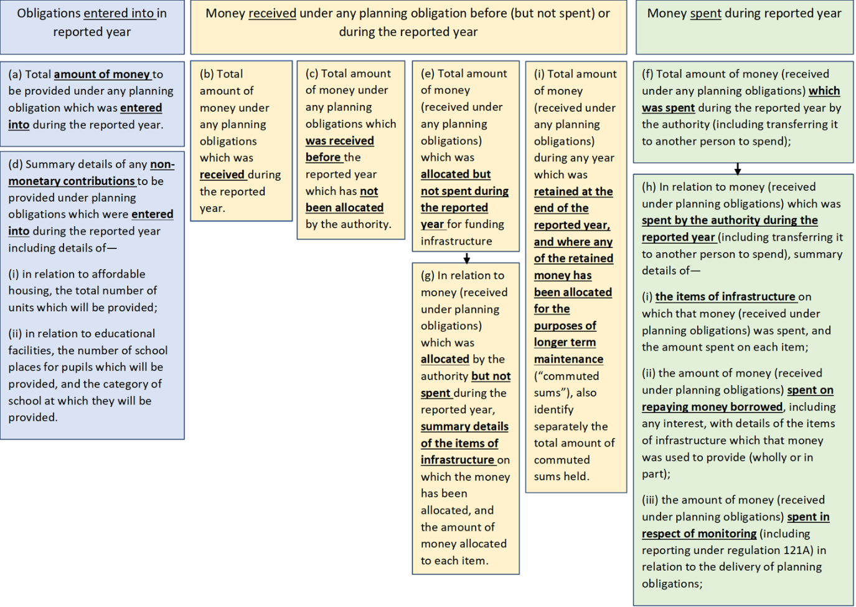
Figure 4. Diagrammatic representation of the reporting requirements for section 106 planning obligations
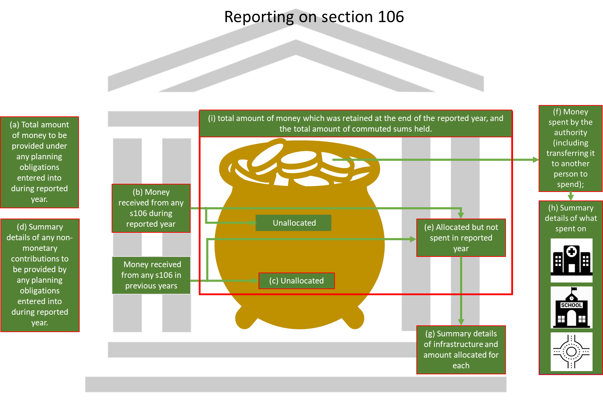
Figure 5. How to use CSV files to generate the data to the Government’s recommended data standard

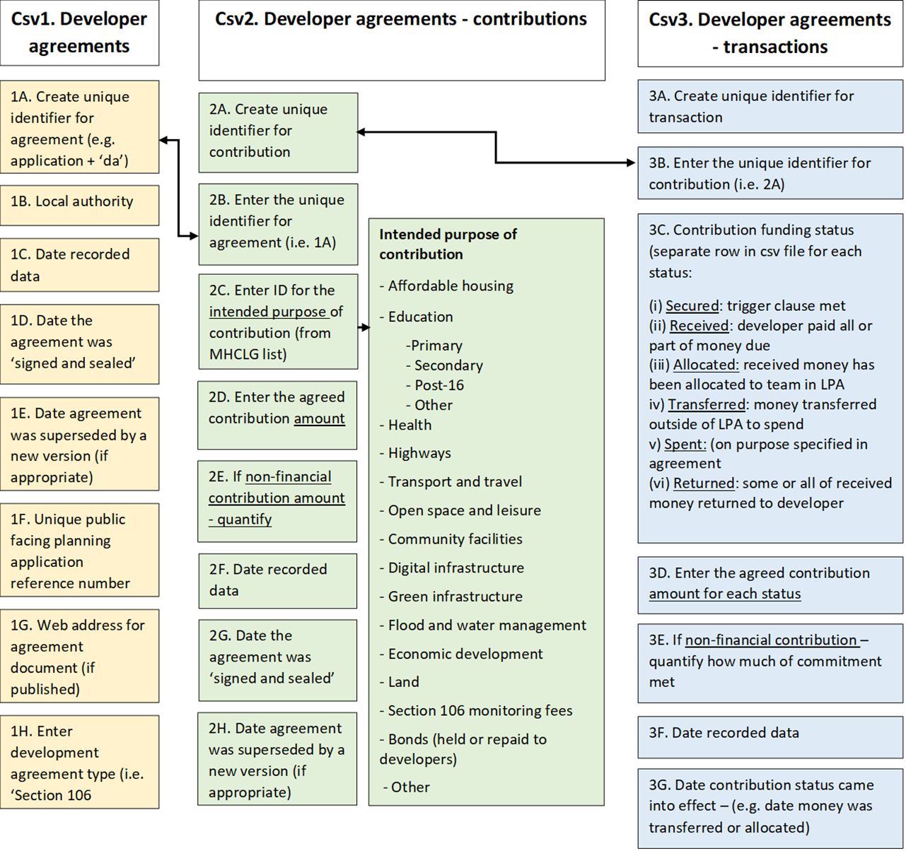
The contents of each spreadsheet are explained in more detail below together with illustrations of how data should be recorded. It is important that the correct format is used.
CSV1 – developer agreements
A developer agreement, for the purpose of recording information in the csv file, is any legal document that secures contributions from a development for infrastructure or affordable housing (including section 106 planning obligations and section 278. agreements). It also includes demand notices for CIL which are considered later.
Developer agreements must be listed in a CSV file named exactly as follows, but with the actual date you created the file instead of YYYYMMDD: developer-agreement_YYYYMMDD.csv (for example, developer-agreement_20200601.csv).
Do not delete or overwrite old or superseded agreements.

Column | Column heading | Guidance
A. | developer-agreement | Create a unique identifier for the agreement. By ‘unique’ this means it should not be used for anything else in your organisation. You could, for example, use the relevant planning application number appended with a suffix such as ‘-da’.
B. | organisation | Find your organisation in this list (in most cases this will be a local planning authority). Text must follow the same letter casing, with no spaces. Norfolk’s local planning authority, for example, would be: local-authority-eng:NFK
C | entry-date | Enter the date that you record this, in the format YYYY-MM-DD. For 1 February 2019, for example, you should enter 2019-02-01
D | start-date | For section 106 planning obligations, enter the date the agreement was ‘signed and sealed’.  If the original section 106 agreement is superseded by a new version (for example a deed of variation), enter the date on which the new version was agreed.
E. | end-date | Leave this blank if this version of the section 106 agreement has not been superseded by a new one. If it has, enter the last day this version was in effect, in the same format as the entry-date column.
F | planning-application | Enter the unique, public facing reference number for the planning application.
G. | document-url | Enter the web address that links directly to the actual agreement document.
H. | developer-agreement-type | This should be ‘S106’ for section 106 planning obligations.

Figure 6. Example of a developer-agreement file (CSV1) – illustrating the recording of the initial agreement and a subsequent variation
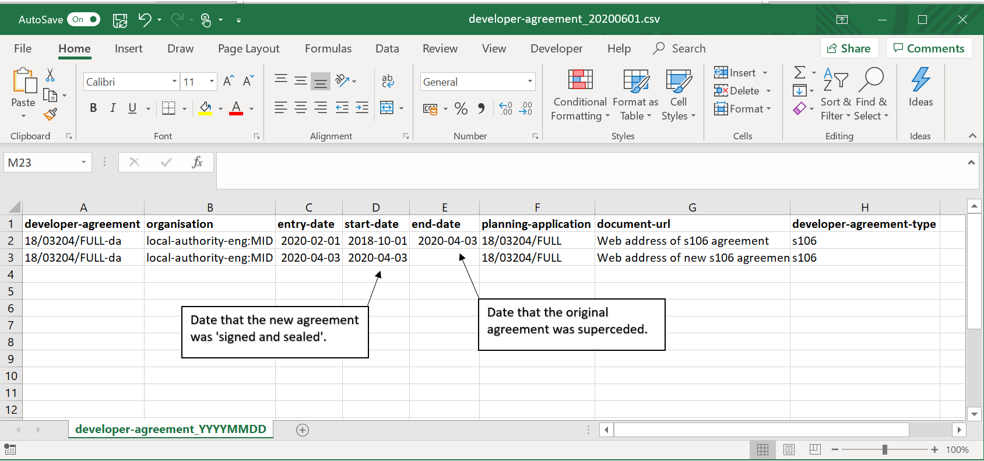

CSV2 - Developer agreement contributions
Developer agreement contributions are the individual obligations or sums within an agreement, assigned to particular purposes such as affordable housing.
Developer agreement contributions must be listed exactly as follows, but with the actual date you created the file instead of YYYYMMDD: developer-agreement-contribution_YYYYMMDD.csv (for example, developer-agreement-contribution_20200601.csv).
Where there is uncertainty about what will ultimately be delivered, it is recommended that the most likely outcome is recorded. This can be amended in future years, and if significant, explained in the free text sections of your infrastructure funding statement.
Column | Column heading | Guidance
A. | developer-agreement-contribution | Create a unique identifier for the contribution.
B. | developer-agreement | Enter the unique identifier you’ve created for the agreement (as set out in column A of CSV1).
C | contribution-purpose | Enter the ID for the intended purpose of the developer contribution. This is found in the first column of the developer-contribution-purpose.csv file (for example, the ID for transport and travel is transport-and-travel).
D | amount | Enter the agreed, secured contribution amount, in pounds and pence but without a currency symbol or commas (for example 100000.00)
E. | units | If the developer has agreed a non-financial contribution you should quantify that here (for example enter 100 if that many affordable housing units have been promised or enter 2 for 2 public playgrounds).
F | entry-date | Enter the date that you record this data (for example, today’s date), in the format YYYY-MM-DD. For 1 February 2019, for example, you would enter 2019-02-01
G. | start-date | Enter the date the agreement was ‘signed and sealed’.  If the original section 106 agreement is superseded by a new version (for example a deed of variation), enter the date on which the new version was agreed.
H. | end-date | Leave this blank if this version of the section 106 agreement has not been superseded by a new one. If it has, enter the last day this version was in effect, in the same format as the entry-date column.

Figure 7. Example of a developer-agreement-contribution file illustrating the recording of a single agreement providing two items of infrastructure
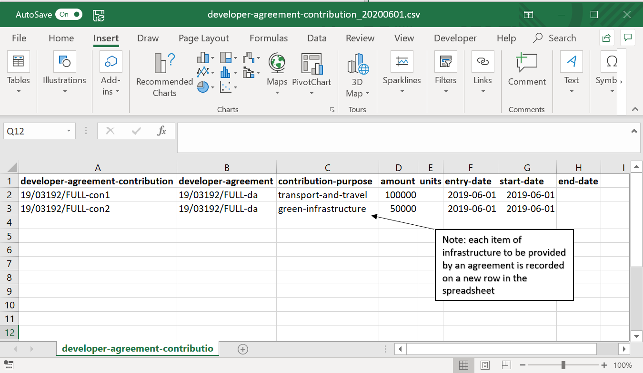
CSV3 - Developer agreement transactions
Developer agreement transactions relate to the stage the funding for the contribution is currently at. The stages are: ‘secured’; ‘received’; ‘allocated’ or ‘transferred’ (depending on whether the received money has been allocated to a team within the authority or transferred externally); ‘spent’; and ‘returned’. While more than one of these stages may have been reached for a particular agreement within a reported year, by recording each stage individually, digital tools should be able to identify the most up to date position at the end of the reported year.
Developer agreement transactions must be listed in a CSV file exactly as follows, but with the actual date you created the file instead of YYYYMMDD: developer-agreement-transaction_YYYYMMDD.csv (for example, developer-agreement-transaction_20200601.csv).

Column | Column heading | Guidance
A. | developer-agreement-transaction | Create a unique identifier for the transaction.
B. | developer-agreement-contribution | Enter the unique identifier you’ve created for the contribution (as set out in column A of CSV2).
C | contribution-funding-status | Enter one of the following to indicate what stage the funding for the contribution is currently in:  - ‘secured’: the trigger clauses associated with the contribution have been met, meaning the developer is now required to pay all or part of the contribution.  - ‘received’: the developer has paid all or part of the money due to the local planning authority  - ‘allocated’: the received money has been allocated to a team within the local planning authority, who will spend the money  - ‘transferred’: the received money has been transferred to an organisation outside the planning authority (for example another local authority or Transport for London), who will spend the money  - ‘spent’: the received money has been spent on the purpose specified in the section 106 agreement  - ‘returned’: the received money (or a portion of it) has been returned to the developer  If more than one stage applies (for example if some money was spent and some returned), please create a separate row for each status. Fill in each row with all other fields.
D | amount | Enter the amount of money for each funding stage.  Enter the amount as a numeric value. For example, £10,000 would be entered as 10000.00
E. | units | If the developer has agreed a non-financial contribution you should quantify how much of that commitment has been met for this transaction if you can (for example enter 50 if 100 affordable housing units were committed and 50 have been delivered).
F | entry-date | Enter the date that you record this data (for example today’s date), in the format YYYY-MM-DD. For 1 February 2019, for example, you should enter 2019-02-01
G. | start-date | Enter the date on which this contribution stage came into effect (for example the date that money was transferred or allocated).
H. | end-date | Leave this blank if this version of the section 106 agreement or CIL demand notice has not been superseded by a new one. If it has, enter the last day this version was in effect.

Figure 8: Example of a developer-agreement-transaction file illustrating how each stage reached is recorded on a new row
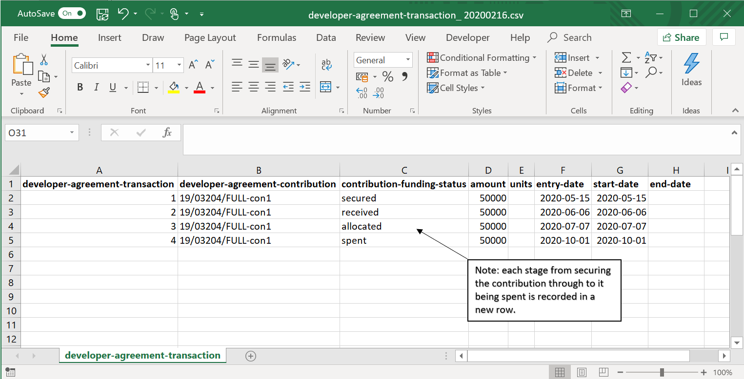

Worked example 1 – section 106
Fictitious Midwich Borough Council granted planning permission (19/03192/FULL) for a residential development on 1 June 2019. A section 106 planning obligation was agreed on the same day, which will provide £100,000 towards a transport scheme and £50,000 towards the provision of green infrastructure.
The trigger clauses associated with the contribution were met on 31 October 2019 and the developer was required to pay (in this case) all of the contribution.
The Council received the full £150,000 from the developer on 1 December 2019. They passed (allocated) £60,000 to the authority’s transport team on 8 December, who spent the £60,000 on 1 March 2020. The remainder of the money (£90,000) remains unallocated at the end of the reported year (31 March 2020).
This information would be recorded in the csv spreadsheets as below.
CSV1 – developer_agreements
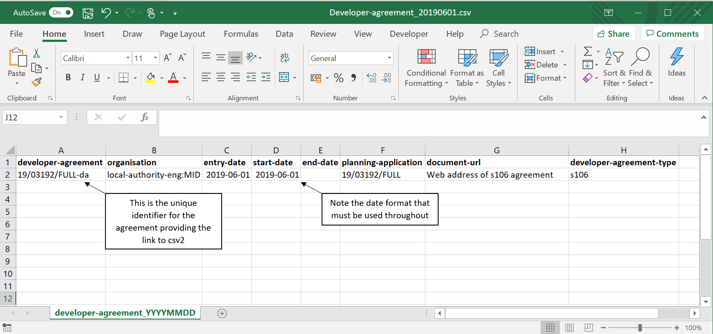

CSV2 – developer_agreements_contributions
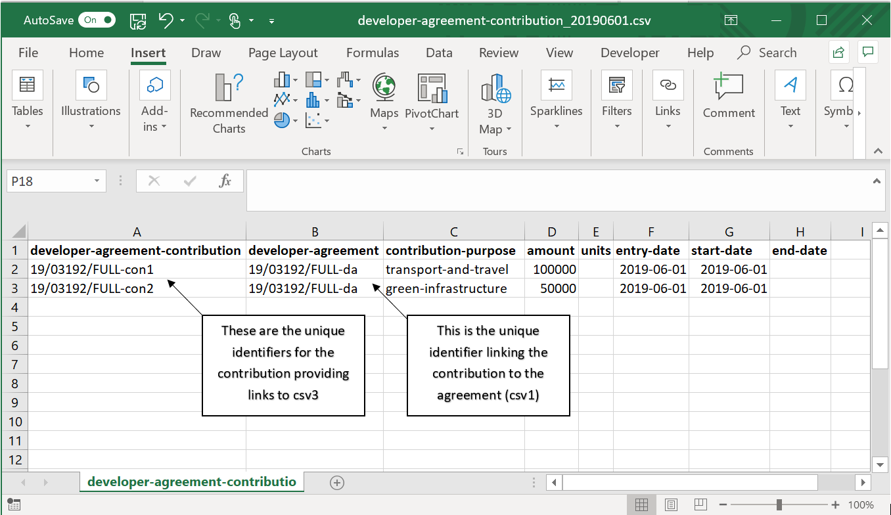

CSV3 – developer_agreements_transactions
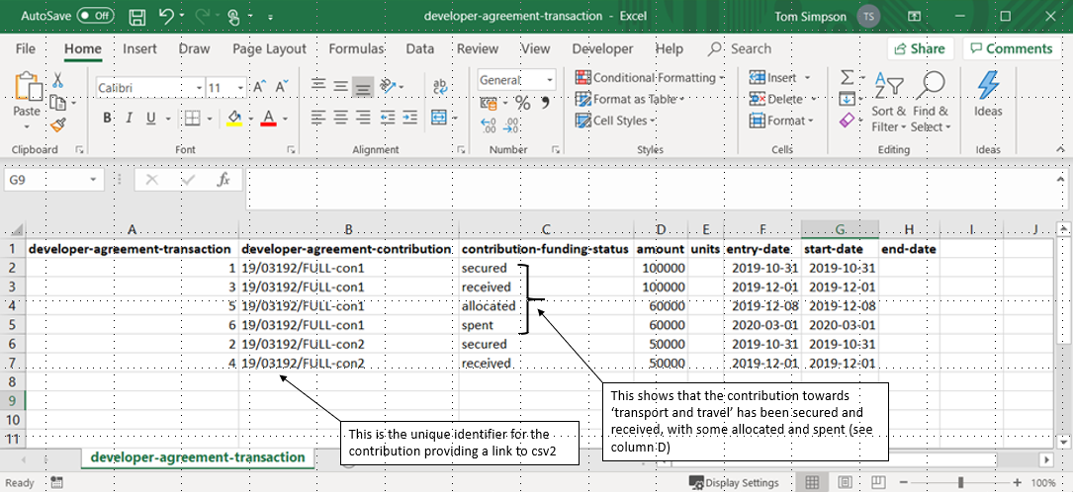

Worked example 2. Section 106 where the agreement is varied
Midwich Borough Council granted planning permission (18/03204/FULL) for a residential development on 1 October 2018. A section 106 planning obligation was signed on the same day, which would provide £60,000 towards the provision of green infrastructure.
For a number of reasons, the developer sought to reduce the amount of money they should pay. Negotiations on a new agreement were concluded on 3 April 2020, which meant that the developer would now only contribute £50,000 towards green infrastructure.
The trigger clauses associated with the varied contribution were met on 15 May 2020 and the developer was required to pay (in this case) all of the contribution.
The Council received the full £50,000 from the developer on 6 June 2020.
They passed (allocated) the £50,000 to the parks team on 7 July 2020, which spent the full sum on 1 October 2020.
This information would be recorded in the CSV spreadsheets as below.

CSV1 – developer_agreements
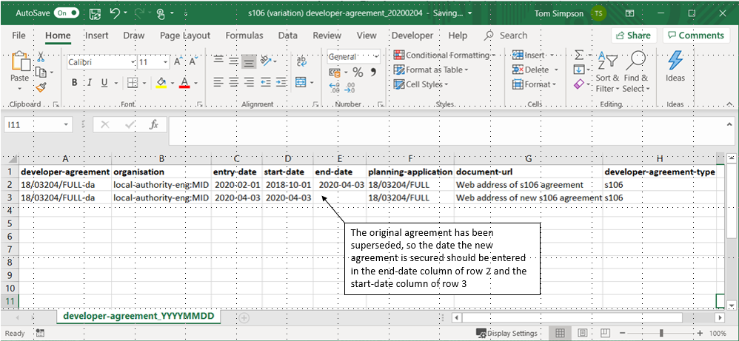

CSV2 – developer_agreements_contributions
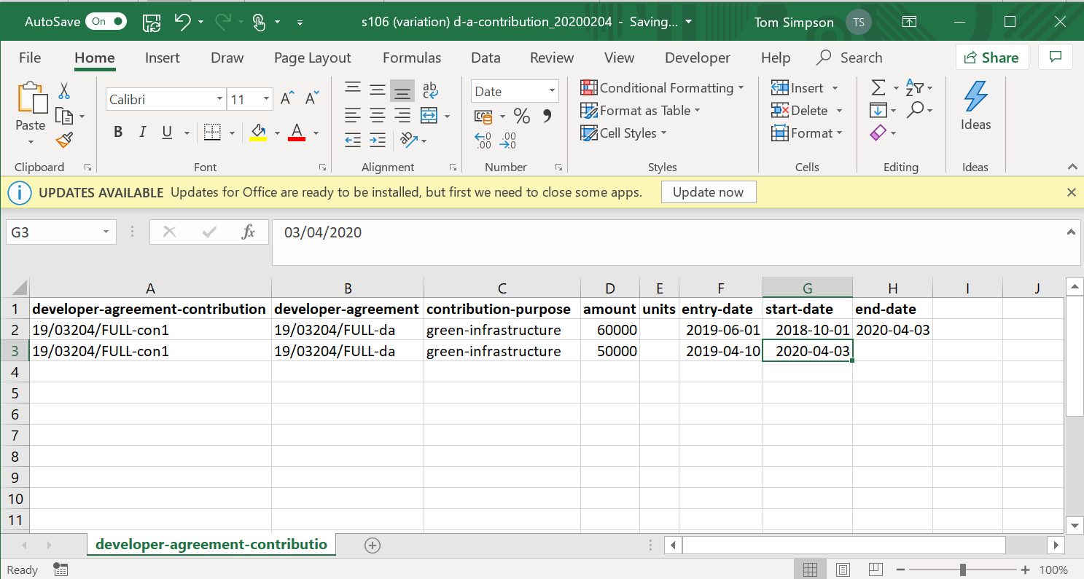

CSV3 – developer_agreements_transactions
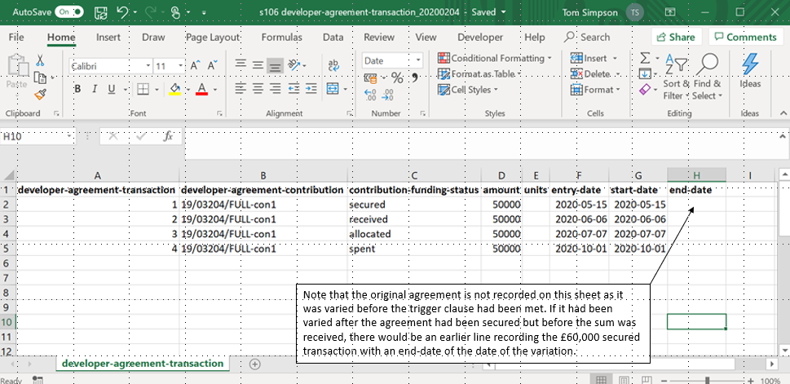

Community infrastructure levy

Introduction
For CIL, the money received goes into a central ‘pot’, and monies from this pot are then allocated and spent on infrastructure. The allocation and spend is not normally attributable to particular planning permissions. Therefore, when inputting data on CIL into the CSV files, the only specified input requirements in the status column of the developer-agreement-contributions spreadsheet (CSV2) are neighbourhood CIL, mayoral CIL and CIL administration costs (where possible – see page 8 above). Similarly, in the developer-agreement-transaction spreadsheet (CSV3), the only data to record in the status column (column C) relates to when a demand notice has been issued and when money has been received. This is explained further below. Local authorities will need to keep a separate record of the allocation of CIL receipts, when they are spent and what they are spent on.
The figure below illustrates the information on the Community Infrastructure Levy which should be included in your infrastructure funding statement.
The main focus is on what has happened in the reported year. There are five main categories of data to include in your infrastructure funding statement are:
- The total value of demand notices issued during the reported year;
- Money collected during the reported and earlier years which has not been spent;
- Money spent during the reported year and what it was spent on;
- Retained CIL receipts
- Money passed to parish councils and other persons.
Figure 9. Data reporting requirements for CIL. The letters refer to the subparagraphs within paragraph 1 of Schedule 2.
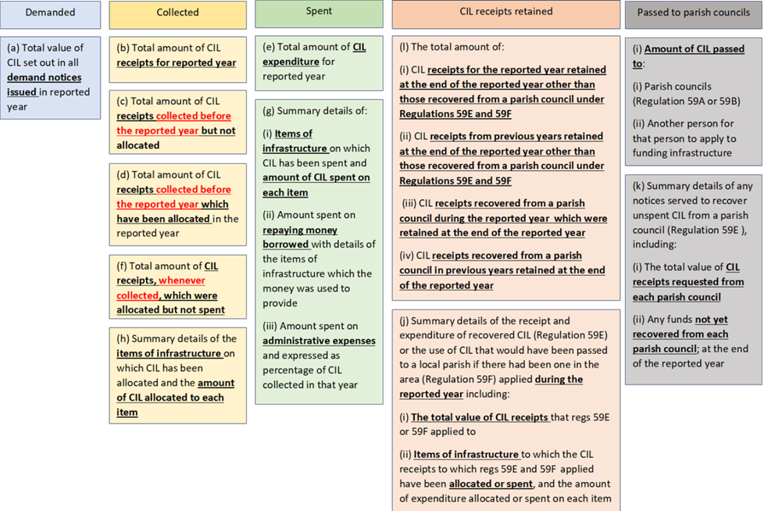
Figure 10. Diagram of the CIL reporting requirements illustrating contributions demanded, collected, retained and spent and distinguishing between pre and post 2019 reporting.
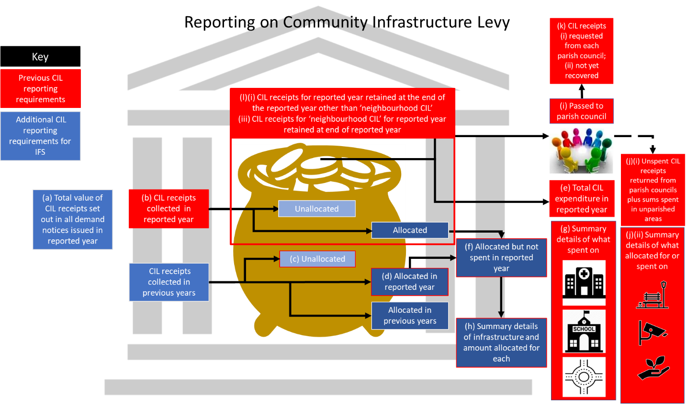

Figure 11. Recommended data standard for csv files

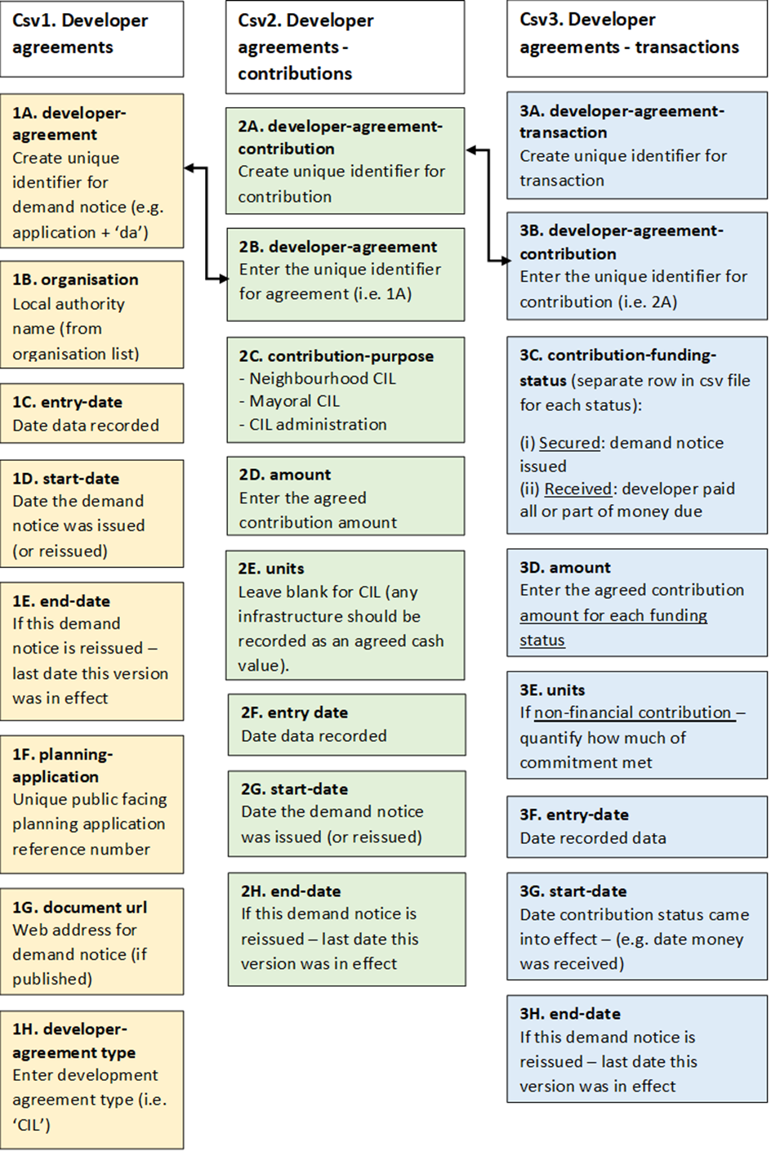
The contents of each spreadsheet are explained in more detail below together with illustrations of how data should be recorded. It is important that the correct format is used.

CSV1 – developer agreements
For CIL, the developer agreement is any demand notice for CIL.
Developer agreements must be listed in a CSV file named exactly as follows, but with the actual date you created the file instead of YYYYMMDD: developer-agreement_YYYYMMDD.csv
Do not delete or overwrite old or superseded agreements.
Column | Column heading | Guidance
A. | developer-agreement | Create a unique identifier for the agreement. By ‘unique’ this means it should not be used for anything else in your organisation. (You could, for example, use the relevant planning application number appended with a suffix such as ‘-da’.)
B. | organisation | Find your organisation in this list (in most cases this will be a local planning authority). Text must follow the same letter casing, with no spaces. Norfolk’s local planning authority, for example, would be: local-authority-eng:NFK
C | entry-date | Enter the date that you record this data (for example today’s date), in the format YYYY-MM-DD. For 1 February 2019, for example, you should enter 2019-02-01
D | start-date | Enter the date the demand notice was issued.  If the CIL demand notice is superseded by a new version, enter the date on which the new version was agreed.
E. | end-date | Leave this blank if this version of the CIL demand notice has not been superseded by a new one. If it has, enter the last day this version was in effect, in the same format as the entry-date column.
F | planning-application | Enter the unique, public facing reference number for the planning application.
G. | document-url | Enter the web address that links directly to the CIL demand notice. If your CIL demand notices are not published, leave this blank.
H. | developer-agreement-type | Enter ‘CIL’

CSV2 - Developer agreement contributions
For CIL, the total sum should be split into separate developer agreement contributions with the contribution-purpose as either CIL, CIL administration, Neighbourhood CIL or as Mayoral CIL. If the CIL is being paid by instalments, each instalment should be recorded separately.
Developer agreement contributions must be listed exactly as follows, but with the actual date you created the file instead of YYYYMMDD: developer-agreement-contribution_YYYYMMDD.csv

Column | Column heading | Guidance
A. | developer-agreement-contribution | Create a unique identifier for the contribution.
B. | developer-agreement | Enter the unique identifier you’ve created for the agreement.
C | contribution-purpose | Enter the ID for the intended purpose of the developer contribution. This is found in the first column of the developer-contribution-purpose.csv file (for example, the ID for CIL administration costs is cil-administration-costs).
D | amount | Enter the agreed, secured contribution amount, in pounds and pence but without a currency symbol or commas (for example 100000.00)
E. | units | N/A
F | entry-date | Enter the date that you record this data (for example today’s date), in the format YYYY-MM-DD. For 1 February 2019, for example, you should enter 2019-02-01
G. | start-date | Enter the date the demand notice was issued.  If the original demand notice is superseded by a new version (for example a deed of variation), enter the date on which the new version was agreed.
H. | end-date | Leave this blank if this version of the demand notice has not been superseded by a new one. If it has, enter the last day this version was in effect, in the same format as the entry-date column.

CSV3 - Developer agreement transactions
Developer agreement transactions must be listed in a CSV file exactly as follows, but with the actual date you created the file instead of YYYYMMDD: developer-agreement-transaction_YYYYMMDD.csv

Column | Column heading | Guidance
A. | developer-agreement-transaction | Create a unique identifier for the transaction.
B. | developer-agreement-contribution | Enter the unique identifier you’ve created for the contribution.
C | contribution-funding-status | Enter one of the following to indicate what stage the funding for the contribution is currently in:  - ‘secured’: the demand notice has been issued and the developer is now required to pay all or part of their CIL liability  - ‘received’: the developer has paid all or part of the money due to the local planning authority  If more than one status applies (for example if some money was secured and received), please create a separate row for each status. Fill in each row with all other fields.
D | amount | Enter the amount of money for each funding status.  Enter the amount as a numeric value for example £10,000 would be entered as 10000.00
E. | units | N/A
F | entry-date | Enter the date that you record this data (for example today’s date), in the format YYYY-MM-DD. For 1 February 2019, for example, you should enter 2019-02-01
G. | start-date | Enter the date on which this contribution status came into effect (for example the date that money was received).
H. | end-date | Leave this blank if this version of the demand notice has not been superseded by a new one. If it has, enter the last day this version was in effect.

Worked example 3 – CIL
Midwich Borough Council granted planning permission (18/00599/FULL) for a residential development on 23 March 2018. The local authority issued a demand notice for £15,600 on 4 January 2020 following receipt of a Commencement Notice, and the developer paid in full on 15 March 2020.
This information would be recorded in the csv spreadsheets as below.
CSV1 – developer_agreements
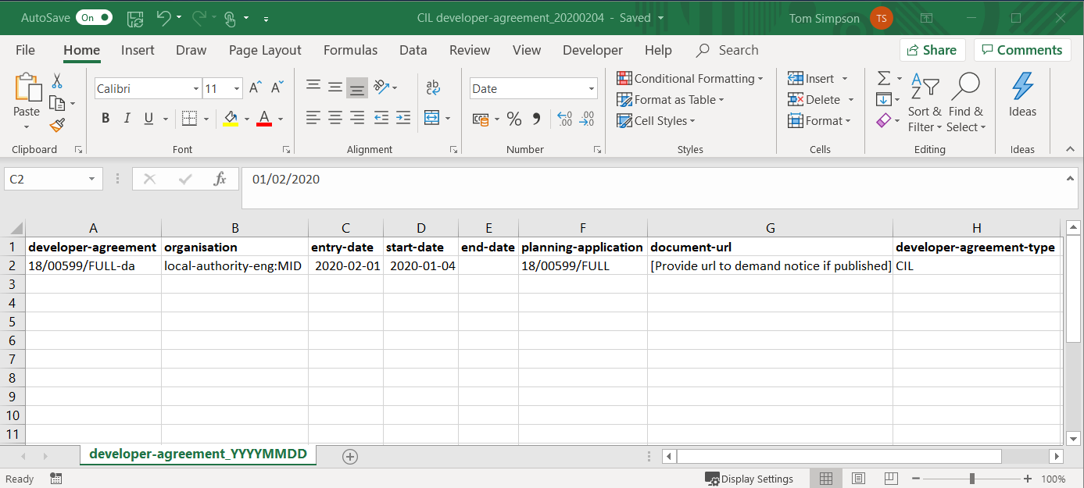

CSV2 – developer_agreements_contributions
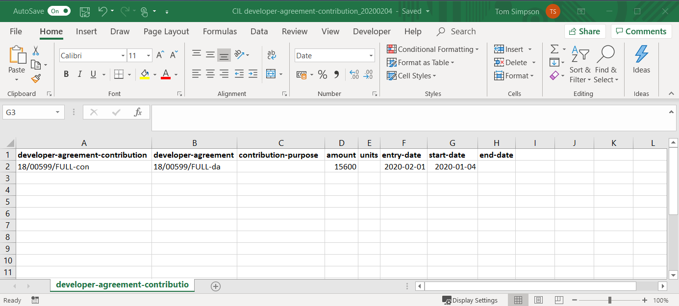
CSV3 – developer_agreements_transactions
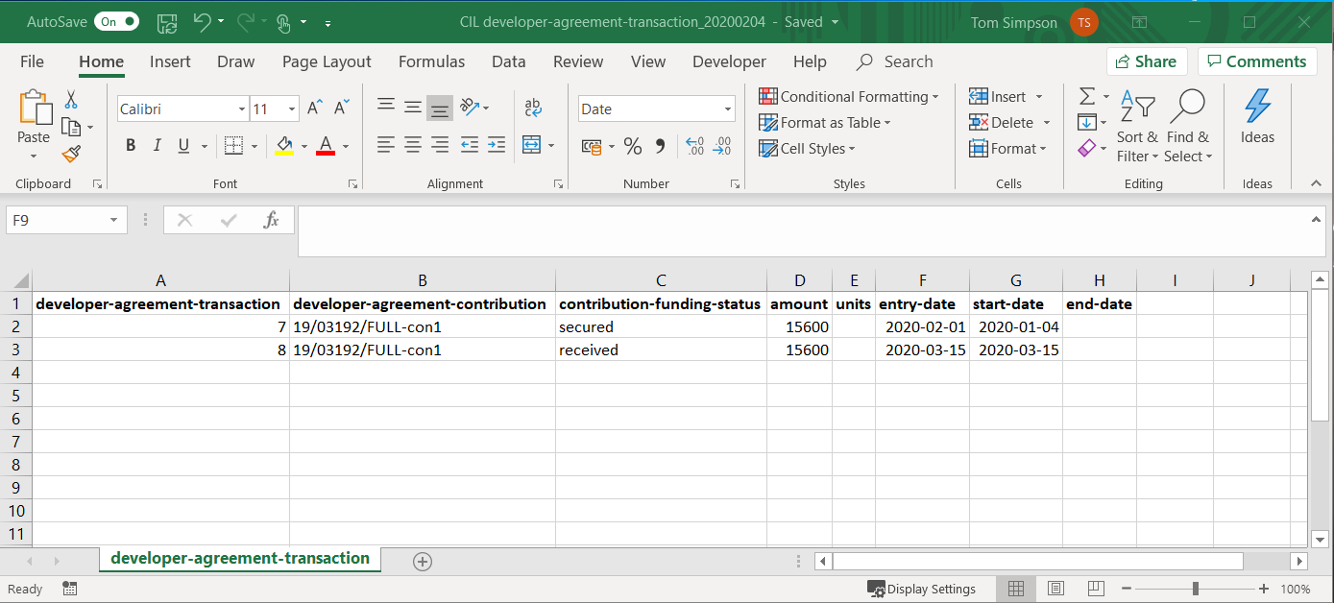

ANNEX 1 – opening, formatting, infilling, saving and publishing the csv files (using Excel)

This section was explained in a short video available on the PAS website.

Introduction
Data should be published in a format that is readable without the use of proprietary software. For example, data published within a .csv table can be used freely, regardless of the user’s choice of development tools. On the other hand, data published in excel (e.g. .xls) or Adobe (.pdf) is locked to a particular vendor.

Accessing the spreadsheets
Click the link to download the relevant csv files found in the Publish your developer contributions data guidance.

Create your CSV files
Developer contributions data must be entered in the 3 separate CSV files. A CSV file (or comma separated value file) is a universally recognised file format for storing tabular data in plain text. Storing the data in 3 separate files rather than 1 file reduces duplication and makes the data easier to use and maintain. The 3 files will be linked together using unique identifiers (see below). The first .csv spreadsheet will contain the list of all agreements. The second .csv spreadsheet will list all the contributions, linked back to the agreement they came from. The third .csv spreadsheet will list all the transactions linked back to the contributions that pay for them.
developer agreements
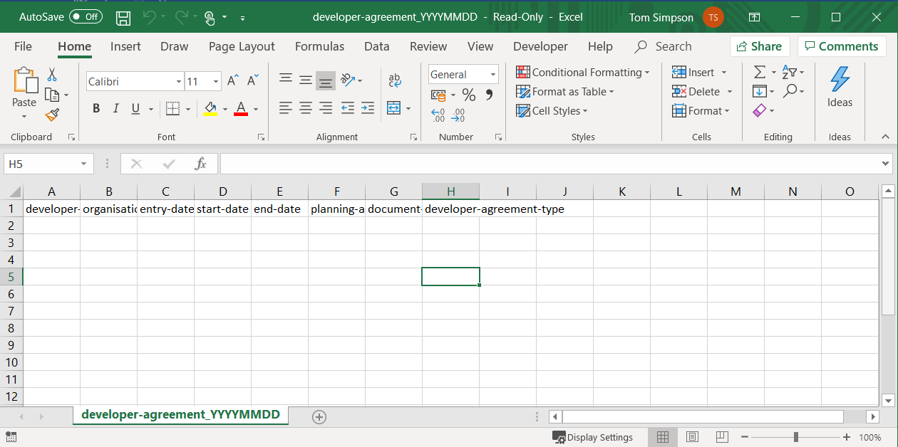

developer agreement contributions
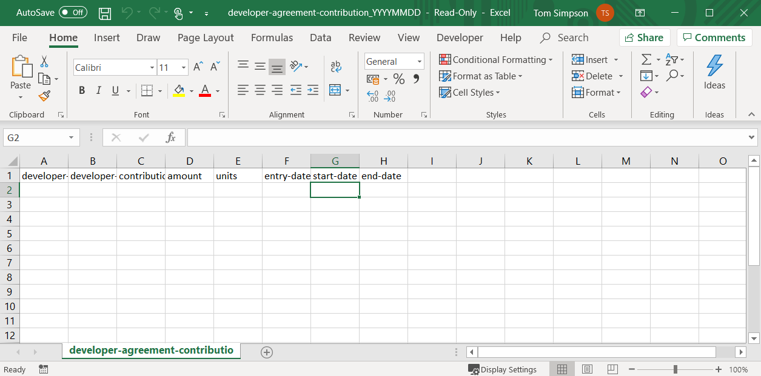
developer agreement transactions
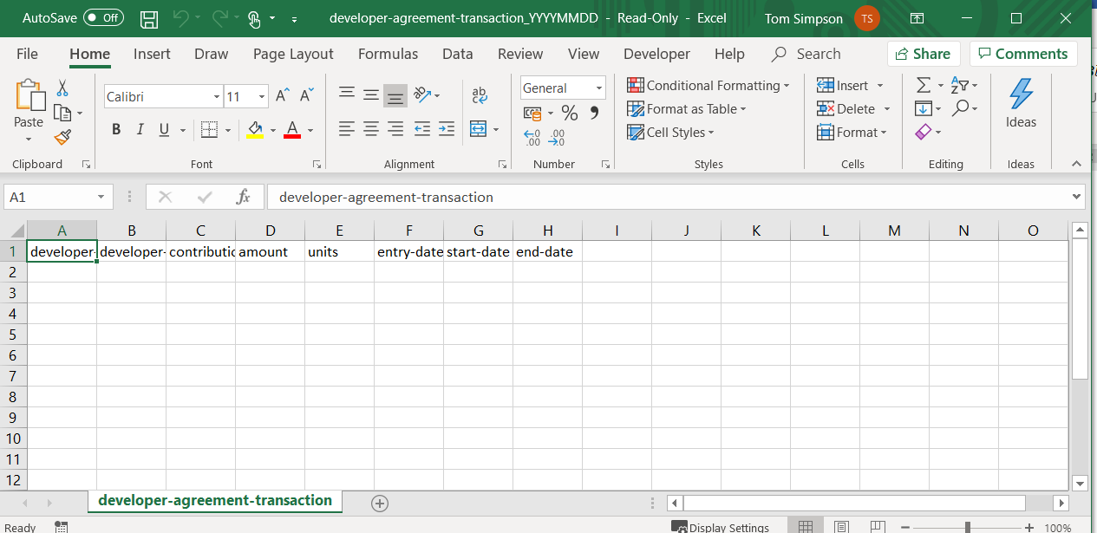

Formatting the spreadsheets
It is recommended that when recording your data, you format the spreadsheets so you can easily read the data and save it in an appropriate file format (for example, excel, google sheets or apple numbers). They can then be saved as csv files (which will result in the loss of all the formatting) for uploading to your website.

Setting column width
Set column width of the active columns by highlighting the column letters (A-H below) and under the ‘Format’ tab click ‘Autofit column width’ (see below). You might want to repeat this step if any of the entries in a particular cell or column are wider than the initial formatting.
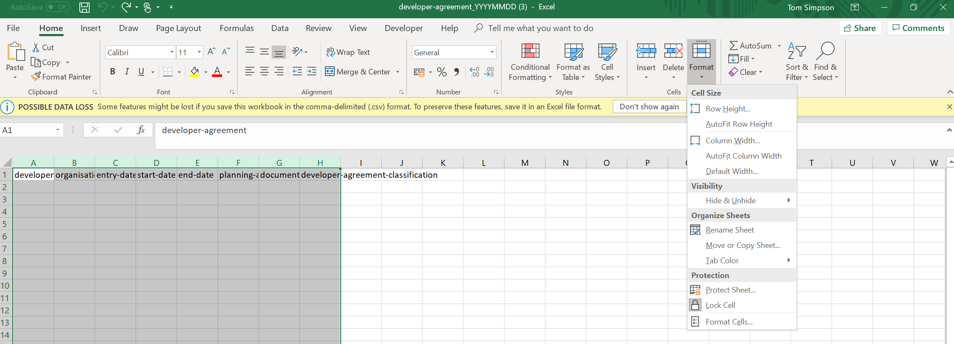

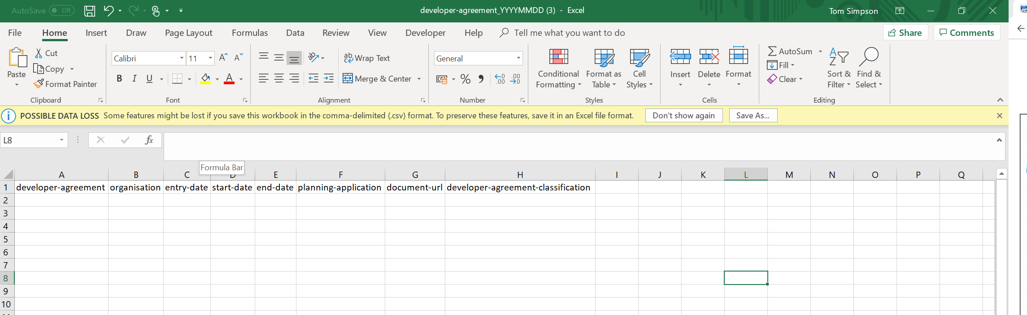

Formatting the date columns to record dates in the recommended format
The digital guidance recommends formatting dates as YYYYMMDD. You can format the date columns by:
(i) highlighting the relevant columns;
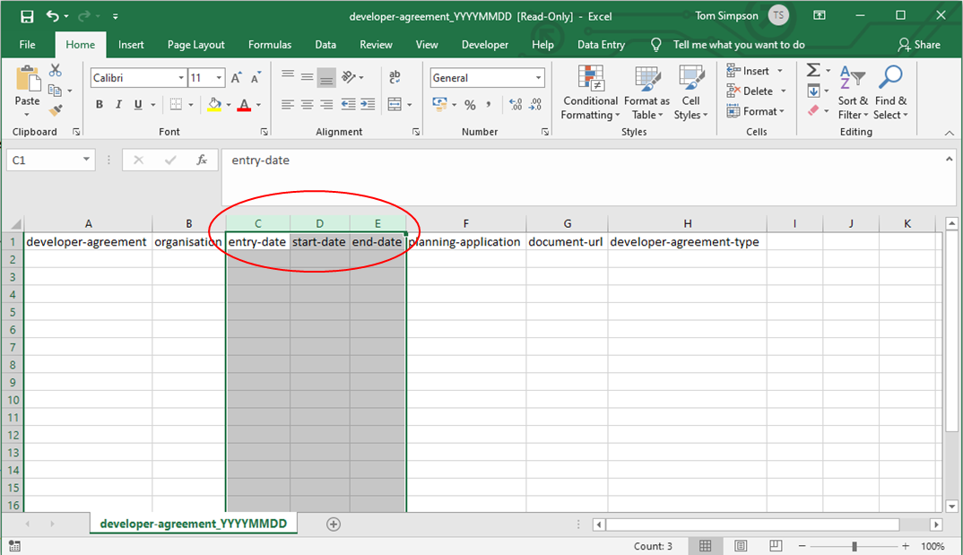
(ii) clicking the format button at the top; and selecting format cells;
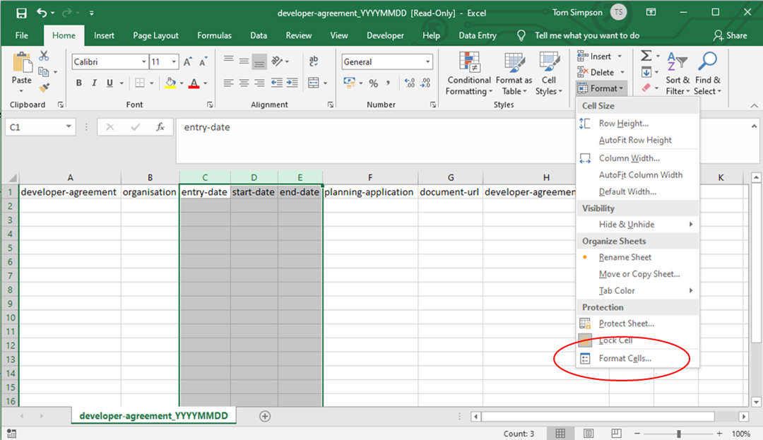

(iii) selecting ‘date’; and then format with sample ‘2012-03-14’
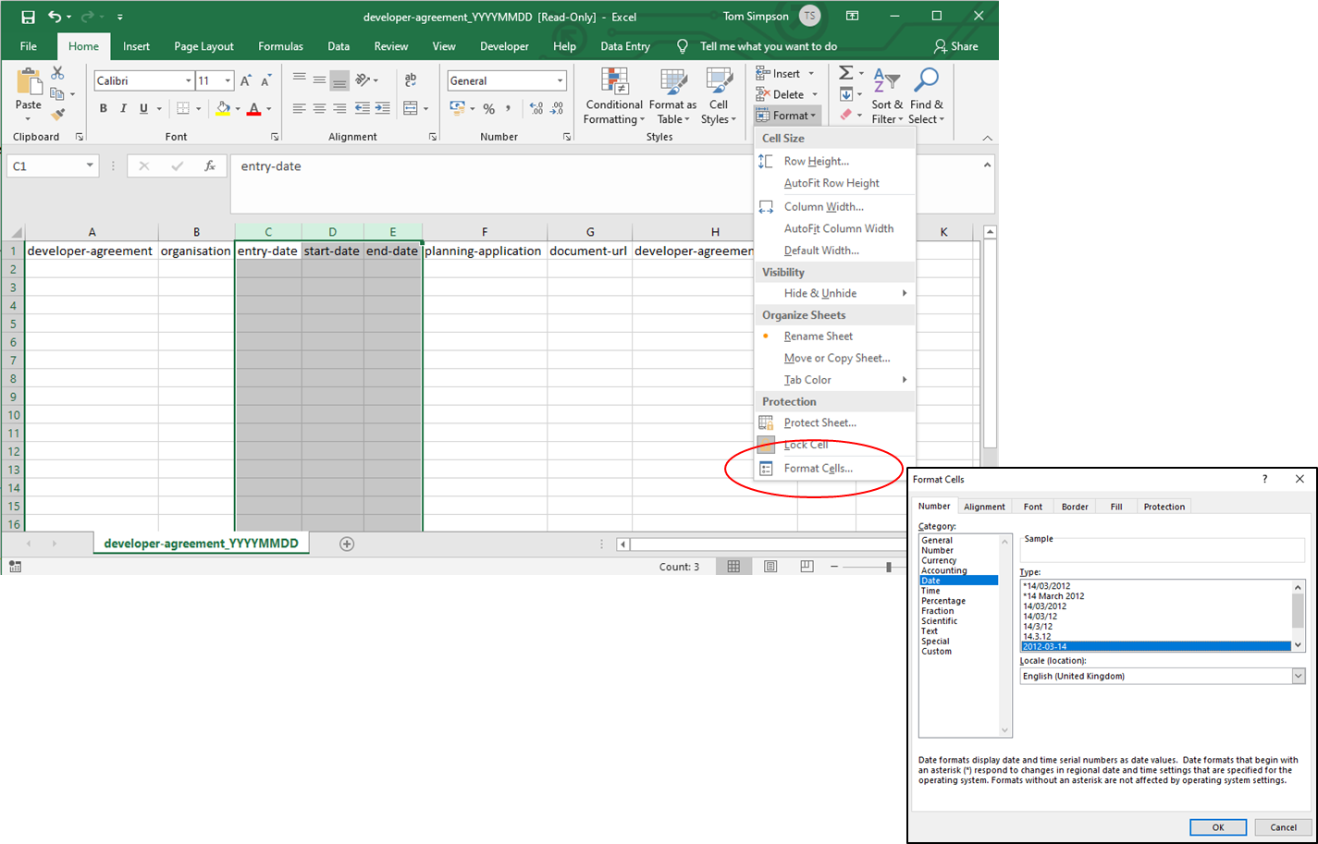

Update your developer contributions web page
You must be able to upload the files created above to your local planning authority’s website and edit (or create) your developer contributions web page. If you aren’t able or authorised to do this, speak to someone who is (this might be the person who updates your local planning authority’s brownfield site register or planning application web pages).
Upload each CSV file to your local planning authority’s website. Make sure the URL for each CSV file is persistent (a web address that will not change over time). As an example, Norfolk’s local planning authority might use the following persistent addresses (note that these are examples, not live data):
https://www.norfolk.gov.uk/developer-agreement/developer-agreement_20190101.csv
https://www.norfolk.gov.uk/developer-agreement-contribution/developer-agreement-contribution_20190101.csv
https://www.norfolk.gov.uk/developer-agreement-transaction/developer-agreement-transaction_20190101.csv
https://www.norfolk.gov.uk/developer-agreement-transaction/latest
When you upload the files you should:
- keep your older files online – it’s important to retain a history of all developer contribution files
- make a copy of the new files, rename the copies exactly the same except with ‘latest’ in place of the date, then upload both sets of files
You should then update your local planning authority’s developer contributions web page to make the CSV files publicly available. If your website does not have a page on developer contributions, you or someone in the web team will need to create one. We recommend publishing your developer contributions on the same web page as your authority’s infrastructure funding statement.
The page must list the persistent URLs as defined above. The URLs must be written out in full. (The URL should not change. However, if it ever does change, you should tell MHCLG (DigitalLand@communities.gov.uk).

Licensing
You must state on your web page that the data is provided under the Open Government Licence.
Email the URLs to MHCLG (DigitalLand@communities.gov.uk) who will add them to the national register of developer contributions

Annex 2 – A table of contents for the IFS

The tables are in two parts – those matters that “must” be in the report because they are required by regulations and others that “should” be in the report in guidance.
Matters that must be included in the CIL report
Total value of CIL in demand notices for the reported year
Total amount of CIL receipts for the reported year
Total amount of CIL receipts collected before the reported year but which have not been allocated
Total amount of CIL receipts allocated in the reported year
Total amount of CIL expenditure for the reported year
In relation to CIL expenditure for the reported year summary details of:
- The items of infrastructure and the amount spent on each item;
- Amount of CIL spent on repaying money borrowed, including any interest, with details of the items of infrastructure the money was used to provide; and
- Amount of CIL spent on administrative expenses and the amount expressed as % of CIL collected in the reported year.
In relation to receipts, whenever collected, which were allocated but not spent in the reported year summary details of the items of infrastructure on which CIL (including land payments) has been allocated and the amount of CIL allocated to each item.
Amount of CIL passed to –
- Any Parish council; and
- Any other person for that person to apply to funding infrastructure.
Total amount of receipts in the reported year of CIL that has been recovered (Reg 59E) or used as the neighbourhood portion in areas without Parish Councils (Reg 59F). Summary details should be provided of the items of infrastructure that these have receipts been allocated to or spent on and the amount on each item.
Summary details of notices served in the recovery of CIL (Reg 59E) including:
- Total value of CIL receipts requested from each parish council; and
- Any funds not yet recovered at the end of the reported year.
Excluding the neighbourhood portion (Reg 59E and 59F) the total amount of:
- CIL receipts for the reported year retained at the end of the reported year;
- CIL receipts from previous years retained at the end of the reported year
For the neighbourhood portion (Reg 59E and 59F) the total amount of:
- CIL receipts for the reported year retained at the end of the reported year;
- CIL receipts from previous years retained at the end of the reported year

Matters that must be included in the Section 106 report
Total amount of money secured through S106 during the reported year
Total amount of money received through S106 during the reported year
Total amount of S106 receipts collected before the reported year but which have not been allocated
Total amount of S106 expenditure for the reported year (including transferring it to another person to spend)
In relation to S106 expenditure for the reported year summary details of:
- The items of infrastructure and the amount spent on each item;
- Amount of S106 spent on repaying money borrowed, including any interest, with details of the items of infrastructure the money was used to provide; and
- Amount of S106 spent in respect of monitoring.
Total amount of S106 receipts which were allocated but not spent in the reported year for funding infrastructure and summary details of the items of infrastructure and the amount of money allocated to each item.
Total amount of S106 received during any year which was retained at the end of the reported year for the purposes of longer term maintenance (commuted sums).
Summary of non-monetary contributions secured during the reported year including:
- The total number of affordable housing units ;
- The number of school places and the category of school.

Matters encouraged to be in the IFS
Report on the delivery and provision of infrastructure
Estimated future income
Infrastructure projects or types of infrastructure that the authority intends to fund, either wholly or partly, by the levy and / or planning S106 obligations
Future spending priorities on infrastructure and affordable housing in line with up-to-date or emerging local plan policies
A written narrative in respect of the above to demonstrate how developer contributions will be used to deliver relevant strategic policies in the local plan, including infrastructure projects or types of infrastructure that will be delivered, when and where
To be used as a wider engagement tool and promotional tool
To be published with updated data and more frequently than the 31st December annual deadline
Matters encouraged to be included in the S106 report
Summary details of any funding or provision of infrastructure to be provided through a S278 highways agreement that has been secured during the reported year
Summary details of any funding or provision of infrastructure to be provided through a S278 highways agreement that has been received during the reported year

Planning Advisory Service
18 Smith Square
London
SW1P 3HZ
Telephone 020 7664 3000
Fax 020 7664 3030
Email pas@local.gov.uk
http://www.local.gov.uk/pas

Some planning authorities collect money for a separate charging authority – e.g. London Boroughs collect for the London Mayor who will produce his own IFS
Counties that enter into a section 106 agreement as a signatory must put the agreement in an IFS. It is also good practice for counties to account in the IFS for funds passed to them by districts.
Appendix 3 is a table that lists out components to the IFS and whether they are a “must include” or “should include”
CIL regulations are updated regularly. If these links become out of date please let us know!
This infrastructure list can exclude the neighbourhood portion
These tables are called CSV files for Comma Separated Variable – they have a file extension of .csv
Publishing sufficient detail in the IFS and supporting tables to avoid the cost of answering individual FOI and EIR is one strong argument for publishing the additional data.
Paragraph: 177 Reference ID: 25-177-20190901
CIL collected includes land payments and infrastructure payments.
Where the amount of money for a Section 106 (S106) planning obligation is not known, an authority must estimate

