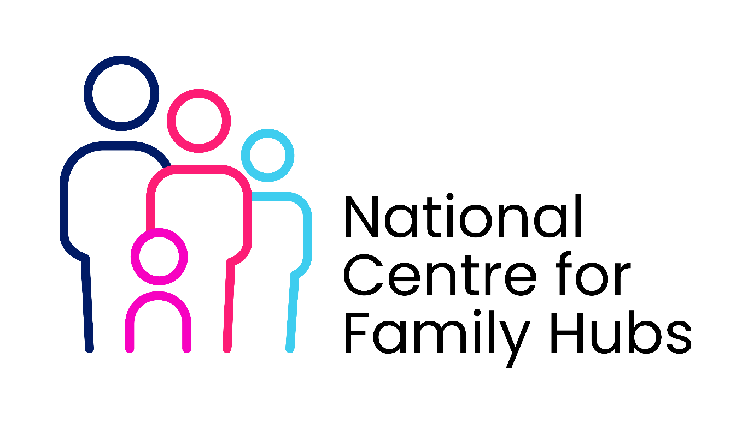

Partnership Agreement
Between [Library Service Name] and [Family Hub / Local Authority Name]

1. Purpose of the Agreement
This agreement sets out the roles, responsibilities, and shared commitments between [Library Service Name] and [Family Hub Name] to deliver integrated services for children, young people, and families through a Family Hub model.
The partnership aims to:
- Improve access to services for families
- Deliver a “no wrong door” approach
- Promote early intervention and prevention
- Use libraries as community-based Family Hub sites and/or network locations

2. Scope of the Partnership
This agreement covers:
- Delivery of Family Hub services from library settings
- Use of libraries as Hub and/or Network Sites
- Joint working on outreach, engagement, and auto-enrolment pathways
- Data sharing and referral processes
- Workforce collaboration and training

3. Shared Principles
Partners agree to:
- Place children, young people, and families at the centre of service design
- Promote equity, inclusion, and accessibility
- Work collaboratively across agencies
- Ensure safeguarding is a shared priority
- Support continuous improvement through data and feedback

4. Roles and Responsibilities
4.1 Library Service Responsibilities
The Library Service will:
- Provide accessible, welcoming spaces for Family Hub delivery
- Host agreed services (e.g. health visiting, parenting groups, early years sessions)
- Act as a trusted universal access point for information and advice
- Promote Family Hub services to library users
- Support digital inclusion and access to online services
- Ensure staff are trained in safeguarding awareness and signposting

4.2 Family Hub Responsibilities
The Family Hub will:
- Coordinate service delivery within library sites
- Provide staff and practitioners for on-site services
- Lead on case management and targeted interventions
- Ensure safeguarding processes are embedded and communicated
- Support library staff with training and guidance
- Provide branding, communications materials, and service information

4.3 Joint Responsibilities
Both parties will:
- Develop and maintain referral and access pathways
- Co-design services based on local need
- Share data appropriately and lawfully
- Participate in partnership meetings and governance structures
- Promote the Family Hub offer across networks

5. Libraries as Hub and Network Sites
- Hub Sites: Where libraries serve as primary delivery locations for multiple integrated services
- Network Sites: Where libraries provide access points for information, outreach, and selected services
Each participating library will be designated as:
- ☐ Hub Site
- ☐ Network Site
Service levels and expectations will be agreed for each site.

6. Access Pathways and Auto-Enrolment
6.1 Access Pathways
- Libraries will provide a first point of contact for families
- Staff will signpost or refer families to appropriate Family Hub services
- Referral pathways will be clearly documented
6.2 Auto-Enrolment
Partners will:
- Explore or implement auto-enrolment into Family Hub services through systems such as birth registrations, health visiting, or library membership
- Ensure compliance with GDPR and data protection legislation
- Provide clear information to families about enrolment and opt-out options
- Align library membership data (where appropriate) with Family Hub systems

7. Data Sharing and Information Governance
- All data sharing will comply with UK GDPR and Data Protection Act requirements
- A separate Data Sharing Agreement (DSA) will be in place
- Data will only be shared where necessary, lawful, and proportionate
- Consent and/or lawful basis for processing will be clearly established

8. Safeguarding
- Both partners will adhere to local safeguarding policies and procedures
- Concerns will be reported through agreed safeguarding pathways
- Staff will receive appropriate safeguarding training

9. Workforce Development
Partners will:
- Provide joint training opportunities (e.g. safeguarding, family support awareness)
- Support library staff to confidently engage and signpost families
- Encourage multi-agency working and shared learning

10. Communications and Engagement
- Joint branding and messaging will be used where appropriate
- Libraries will promote Family Hub services through:
  - In-library displays
  - Digital channels
  - Community outreach
- Partners will collaborate on campaigns to reach underserved communities

11. Monitoring and Evaluation
- Agreed performance measures will include:
  - Footfall and engagement in library-based services
  - Referrals and uptake (including auto-enrolment data)
  - Outcomes for children and families
- Partners will review performance regularly and adapt delivery as needed

12. Funding and Resources
- Funding arrangements will be agreed locally and set out in an appendix
- This may include:
  - Contribution to staffing
  - Use of premises
  - Delivery costs
- Any additional funding bids will be developed collaboratively where appropriate

13. Governance and Review
- The partnership will report into [relevant governance board, e.g. Family Hub Board]
- This agreement will be reviewed annually or as required
- Named leads from each organisation will oversee delivery

14. Duration and Termination
- Start Date: __________________
- Review Date: ________________
Either party may terminate the agreement with [e.g. 3 months’ notice], subject to ensuring continuity of service where possible.

15. Signatories
For [Library Service Name]:
Name: ________________________
Role: _________________________
Signature: ____________________
Date: ________________________
For [Family Hub / Local Authority]:
Name: ________________________
Role: _________________________
Signature: ____________________
Date: ________________________

