Insight report
  - Using behavioural insights to encourage homeowners to make their homes more energy efficient
  - October 2022

Contents
Introduction 2
Summary of findings 2
Literature Review 5
Conclusion 26
Local primary research 27
Conclusions 48
Sample size calculations 49
References 54

About Social Engine
Social Engine was established in 2015 to support organisations to adopt an evidenced-based and insight-led approach. We work with charities, local authorities, social enterprises and other social purpose organisations to overcome organisational challenges through engagement, research and the practical application of evidence into practice.
Our work involves applying behavioural insights to support service improvement across a wide range of policy and service areas in order to improve outcomes for individuals and communities.
www.social-engine.co.uk

Introduction
A key part of the project involved gathering evidence and insight to understand what is known about the influences on people’s decisions to retrofit their homes that could be used to inform our intervention design and plan our trial. The findings from our investigation are set out in this report.
Our evidence and insight gathering drew on a range of sources:
- A review of academic and practitioner research evidence
- Primary research conducted with residents in Devon
- A review of available data and documents provided by Councils participating in the retrofitting consortium
- In addition, we were able to draw on our own knowledge of behavioural insights more broadly.

Summary of findings
- Most people are open to the idea of adopting energy efficiency. In studies around one third of households (35%) had already adapted or were seriously considering adopting retrofitting measures, however within our local research this figure was even higher (61%).
- Understanding of retrofitting, net zero, carbon emissions and decarbonisation is low – only 41% said they know what retrofitting is (and that figure appears to be an overstatement as a number of descriptions indicated misunderstanding).
- Despite the lack of clarity and understanding of retrofitting as a term, improving energy efficiency is something which is on people’s agenda, with 72% currently considering retrofitting.
- There are a number of potential ‘trigger points’ that provide opportunities to encourage the take-up of retrofitting measures.
- Home improvements are one potential trigger point – offering the opportunity to incorporate retrofit measures into already planned renovations. One third of households are planning major home improvements over the next three years.
- The cost-of-living crisis may also create another trigger point which could be used to encourage retrofitting.
- It’s clear that the cost of living is a major feature of people’s lives at present - 93% are worried about inflation and 86% expect their household finances to worsen over the next 12 months
- Although around 40% say they are relatively financially well off and another 40% can cover the essentials, around 1 in 5 (19%) are already struggling financially

Influences and motivations
- Whilst being more environmentally friendly was felt to be a significant motivating factor, financial considerations were reported as being even greater influences by respondents.
- Three of the top five motivations related to financial factors, with 94% of respondents saying reducing the cost of energy bills was likely to influence them.
- Information was also a key consideration, with access to reliable information, knowing how long work would take and how much it would cost and knowing a reliable installer were all frequently perceived as being likely influences on behaviour.

Barriers
- Cost is by far the most common factor – with half the respondents to our survey citing it as a barrier to installing energy efficiency measures.
- Structural factors – such as living in listed buildings or conservation areas were a barrier to installing retrofitting measures.
- Lack of trust towards builders was felt to inhibit take-up of retrofitting – knowing someone reliable, sufficiently knowledgeable and trustworthy was an important consideration.
- Factors relating to people’s lifestyles also served as a barrier to take-up, in particular a lack of time to research different options and find suitable installers caused to limit the take up of retrofitting, even where there was a desire to do so.
- People’s beliefs also created a barrier, for example perceptions of the technology as being in its infancy and therefore unreliable or too expensive, or misconceptions around the efficiency of measures (e.g., wall insulation causing dampness) served to reduce take-up.
- The ‘split incentives’ between tenants and landlords were a factor in rented properties, where the costs and benefits of installing retrofit measures fall between home owners and renters and act as a disincentive for investment.

What works?
- In reviewing 40 interventions and programmes, aimed to promote positive behaviours in relation to energy use, virtually all the interventions employed ‘simplification’.
- Other commonly used levers included social and descriptive norms and the use of feedback mechanisms.
- These interventions make use of behavioural techniques – which address people’s biases, heuristics and other psychological barriers - to drive behaviour change among their target audiences.

Understanding our audience
- Our segmentation analysis produced three distinct segments within our sample: those who had already installed retrofitting measures, those who were seriously considering them and a third group who were not considering installing retrofitting measures (comprised of those who had previously considered doing so and rejected it and those who were not considering them).
- We found that attitude towards retrofitting was closely associated with income, housing tenure and housing type and affluence.

Conclusion
Despite gaps in the research literature surrounding energy efficiency behaviours, rather than curtailment, there is a relatively strong body of evidence to draw on.
Reassuringly, the findings from the local research are consistent with much of the evidence from the literature review. They confirm widespread opportunities for increasing the uptake of retrofitting measures, with a significant proportion of people planning or at least open to the idea of making their homes more energy efficient.
A range of factors act as motivations for installing retrofit measures, including the availability of a range of reliable information and being more environmentally friendly, but the most significant factors are financial. Similarly, cost is the greatest barrier to take up.
Whilst concern about the cost of living crisis, rising prices and anxiety over household finances is almost universal, there are considerable differences in the levels of interest in and attitudes towards retrofitting. The strong correlation between affluence – and a range of associated variables such as housing tenure, employment status and housing type – and retrofitting intentions further underlines the importance of financial factors as an influence on behaviour.
Our segmentation analysis provides clarity on some of the key differences in motivations, trusted sources of information and trigger points that exist among our three segments. This presents opportunities for targeted engagement, framed around simplified messaging tailored to particular audiences.

Literature Review

Introduction
The UK is legally committed to reduce carbon emission by 80% by 2050. Since energy use in homes accounts for just under a third of total energy use in the UK, the role of retrofitting properties is going to be a crucial component of achieving our CO2 targets.
Government policy has traditionally focused primarily on the technoeconomic aspects of achieving energy savings and has tended to ignore the complex emotional, personal and socially-bound contexts of people’s homes, where retrofit decisions are made.
Nonetheless there is a growing body of evidence – from both academic and practitioner research – which seeks to understand environmental attitudes and retrofitting behaviours and the influences on them.

What we did
This document sets out the key findings of our literature review which aims to answer the following research questions:
- What factors - financial, sociodemographic and psychological - influence people’s decisions to retrofit their properties?
- What would encourage homeowners to retrofit their properties?
- What are the barriers that inhibit the take-up of retrofitting?
- What are people’s understanding of and attitudes towards retrofitting?
- What are people’s current attitudes and behaviours towards the environment?
To explore these topics, we reviewed previous academic and practitioner evidence, including attitudinal surveys, psychological experiments, systematic reviews and research reports.

Values and attitudes towards the environment
Before considering the evidence specific to retrofitting, we began our review by looking generally at what is known about people’s attitudes and values in relation to the environment more broadly.
Environmental attitudes are defined as a concern for the environment or caring about environmental issues. They consist of three components:
- Cognitive – knowing or being aware about environmental issues – for example the consequences of climate change
- Affective – having an emotional rection or attachment towards the environment
- Conative – having the intention to act in ways that benefit the environment
Environmental attitudes are important because they often, but not always, determine environmental behaviour, with research showing the relationship between the two being moderate. In studies, the majority of research participants show higher levels of environmental concern which is not reflected in their true behaviour. Therefore, caring about the environment doesn’t always mean behaving in ways that benefit the environment. For example, in a survey, 85% of people stated that climate change is one of the most important issues faced, but only 15% said they have recently adopted energy efficiency measures in their homes.
Research has shown that over recent years people’s environmental attitudes have increased. For instance, environmental concern has risen 25 percent between 2011 and 2020 (see figure 1).
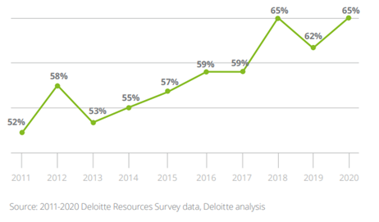

Figure 1

What drives environmental attitudes?
Research suggests that the influence of socio-demographic factors on environmental attitudes is moderate, with an explained variance ranging between 20-30%.

Age
Younger people report higher levels of environmental concern than older people. This can be explained by the ‘era effect’: younger people have stronger environmental attitudes than older people because they grew up in a time where environmental issues have received far greater media attention.
However, when it comes to actual environmental behaviour, some studies indicate that older people actually exhibit more environmentally friendly behaviour.

Gender
Women show greater levels of environmental concern compared to men. However, men tend to have greater environmental knowledge than women. The fact that women exhibit higher levels of environmental concern, relative to men, researchers have suggested, highlights an emotional dimension to environmental attitudes: with women tending to be more emotionally connected to nature than men.

Socioeconomic status
Research suggests that more affluent people hold stronger environmental attitudes than those from more deprived backgrounds, for two reasons. Firstly, wealthier individuals have fewer economic problems to worry about and therefore more available time to focus their attention on environmental problems. Secondly, affluent individuals tend to have greater educational attainment, which is associated with greater environmental knowledge, which is the cognitive component of environmental attitudes.

Urban-Rural Residence
Some differences exist in the level of environmental concern between residents living in cities and those in rural areas, but again the evidence is mixed. Farmers and rural residents, with their need to use environmental resources directly, tend to be hold more anthropocentric views (believe that nature should be preserved as a resource for consumption), whereas city residents tend to be more ecocentric (believe that nature should be preserved for its own sake).

Pro-environmental Behaviours
There are two approaches used to define and study pro-environmental behaviour: one focuses on impact, the other focuses on intention. The dominant approach is the one that focuses on impact, particularly carbon impact. Accordingly, pro-environmental behaviours reflect behaviours which contribute to the sustainability of the natural environment.
When discussing pro-environmental behaviour, it is also useful to differentiate between two types: curtailment and efficiency.
Curtailment behaviours involve changes in routine, such as recycling, regularly changing the thermostat settings and using public transport means instead of driving a car.
Efficiency behaviours refer to one-time actions that result in reduced energy consumption, such as retrofitting, installing extra home insulation, or buying an electric car.
Public policy and behaviour change activities have tended to focus on curtailment behaviours more than on efficiency behaviours. While efficiency behaviours generally occur only once, they offer potentially greater environmental benefits, compared to curtailment behaviours. For example, Figure 2 illustrates the huge potential of retrofitting in reducing CO2, relative to a range of curtailment behaviours.
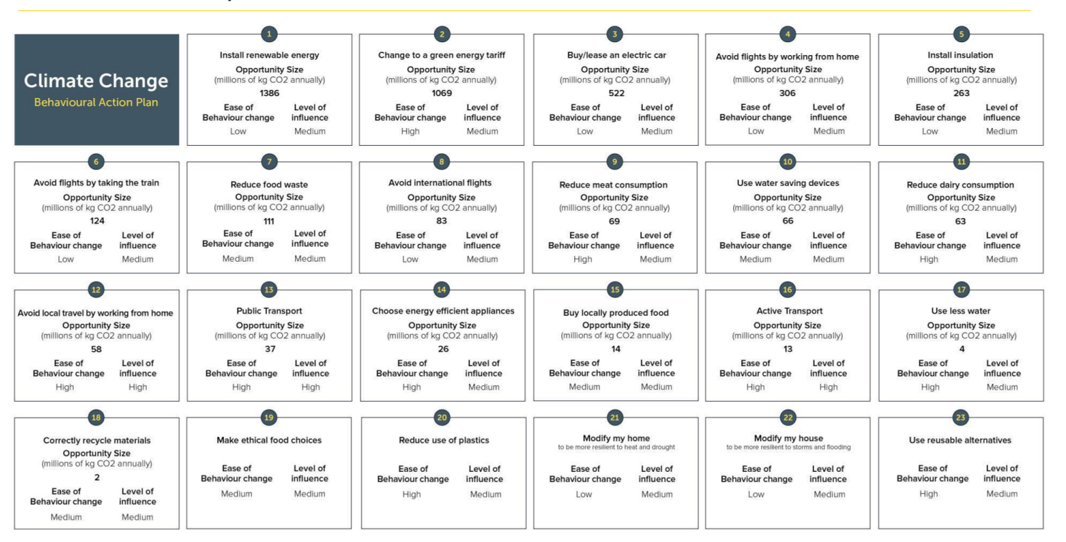

Figure 2

The relationship between attitudes and behaviours
Research suggests that there is a complex relationship between people’s environmental attitudes and their behaviours. Although attitudes provide the basis of environmental behaviours, as previously mentioned, having a positive environmental attitude doesn’t always mean engaging in pro-environmental behaviours.
According to the low-cost hypothesis, environmental attitudes exert greater influence on low-cost or easy behaviours (such as curtailment behaviours, like turning off the lights), rather than on high-cost behaviours (such as efficiency behaviours) which often require money, effort and involve a degree of disruption or discomfort. This doesn’t mean that attitudes are unimportant in relation to high-cost behaviours, but rather it highlights the importance of addressing other structural and psychological barriers too, when trying to promote efficiency behaviours.
There are 6 important conditions which can strengthen the link between attitudes and high-cost behaviours, such as retrofitting:
- knowing about the issues;
- knowing about action strategies;
- having an internal locus of control, which means believing that your own actions will result in certain outcomes;
- stating a verbal commitment to act;
- being concerned about the issues, and;
- feeling personally responsible to act on them.
Frequently, pro-environmental knowledge or attitudes exist without being translated into action because of five important psychological barriers. These are:
- limited cognition (including problems of uncertainty about the problem or the results of action, and a lack of perceived behavioural control);
- comparisons with others (including negative social norms about action);
- sunk costs (including previous financial investments, perceived risks including physical, financial, social, functional, psychological, and temporal risks);
- limited behaviour (including engaging in small token behaviours, such as regularly switching off the lights, and justifying environmentally harmful behaviour by engaging in positive but simple, relatively unimportant pro-environmental behaviours).

Environmental Values
Values reflect what people find important in their lives and provide the basis of pro-environmental behaviour. They are formed relatively early in life, tend to be stable over time and exert a significant influence on our behaviours, as well as how we evaluate those behaviours.
In the environmental domain, four values are important:
- Biospheric values – make people focus on the consequences of their choices on nature and the environment
- Altruistic values – make people focus on ways to benefit others
- Egoistic values – make people focus on how to increase their resources, such as money and status
- Hedonic values – make people focus on what makes them feel good and ways to reduce effort
Biospheric and altruistic values represent self-transcendence and collective interests, whereas egoistic and hedonic values reflect self-interests.
Research has consistently shown that self-transcendence values, especially biospheric values, are strongly correlated with pro-environmental behaviours. The more individuals endorse biospheric values, the more they recycle and drive in an energy-efficient manner engage in environmental activism are willing to reduce their car use, accept policies household CO2 reduction policies and adopt renewable energy systems at home. Biospheric values represent a general, rather than a specific, goal to protect the environment, which explains their association to a variety of pro-environmental behaviours.
Contrary to popular belief that people prioritise egoistic and hedonic values, a study across 23 countries showed that people tend to endorse more strongly biospheric and altruistic values, compared to egoistic and hedonic values, with altruistic values being particularly significant among people in the UK.
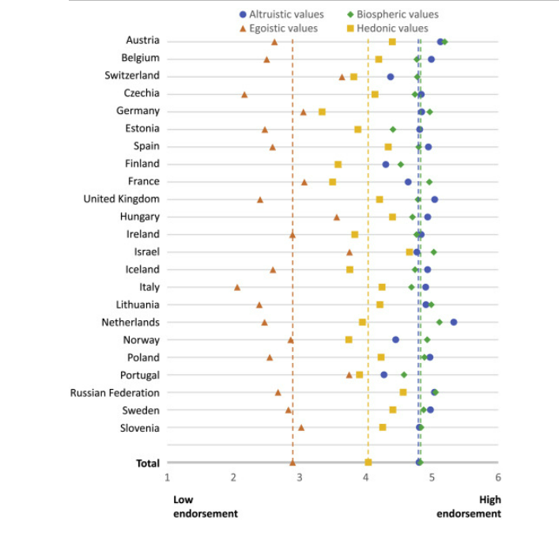

Figure 3

Despite research showing most people have strong biospheric and altruistic values, many still fail to act in pro-environmental ways, that would be consistent with their endorsed values.
There are several reasons which explain this contradiction.
One important factor is the cost, or perceived cost, of behaviour. People are less likely to engage in pro-environmental behaviour when it is associated with high financial costs, significant effort or inconvenience. For example, research participants, who prioritised biospheric values, failed to drive in an energy efficient manner when they were in a hurry or under complex traffic situations. This might mean that people dismiss the idea of retrofitting their properties due to lengthy application processes and perceived 'hassle’. When acting in an environmentally friendly way is perceived as being too costly, changes in costs and benefits of behaviour are essential to motivate people to act in line with the values that are important to them.
The second factor relates to social norms. Our perceptions of what other people value, particularly those close to us such as friends and family, can influence how we behave. When participants perceived members of their social network as people who endorsed biospheric values, they were more likely to engage in pro-environmental behaviour. This effect was more pronounced among those identifying strongly with the group and, perhaps surprisingly, those who were less environmentally motivated. In other experiments, people were more likely to litter in an environment where there was already litter or when buildings were covered with graffiti. In another study, when homeowners were told the amount of energy that other community members consumed on average, they then adapted their consumption to fit the norm. These findings suggest that interventions could motivate people to act pro-environmentally by making them aware of the actual endorsement of biospheric values of their groups, which are often higher than people perceive.
The third factor is environmental self-identity. Values affect pro-environmental behaviours, via self-identity. It is reasonable to assume that individuals who endorse biospheric and altruistic values tend to see themselves as people who care about the environment and the welfare of others. However, this is not always the case. Although values are stable over time, our identities are more dynamic and susceptible to change. For instance, people can strongly value the environment, but if they always go to work by car, instead of using public transport, then they may not see themselves as an environmentally friendly person. In a series of four experiments, it was shown that environmental self-identity can be strengthened by making people’s past behaviour more salient to them.
A number of campaigns and marketing strategies have aimed to promote pro-environmental behaviours by using two strategies: messages which appeal to people’s self-interests or messages that reflect altruistic and biospheric interests. Experimental evidence has failed to show which of the two strategies is superior. Some studies have suggested that self-interest appeals (such as monetary gains) might be more effective, whilst others indicate biospheric appeals are more effective. Other research has found that messaging appeals should be tailored matching people’s values. But there are studies showing that using biospheric appeals have negligible effects when targeting people whose biospheric values are already strong. Similarly, appealing to monetary benefits when targeting people with self-interests, can make people act in even more selfish ways, because they can inadvertently crowd out any intrinsic motives to behave environmentally.
Most of the research to date regarding messaging appeals has focused on low-cost, curtailment behaviours, rather than high-cost efficiency behaviours. Recycling is generally easy and inexpensive for people to do, whilst installing solar panels is generally hard and expensive. In addressing this gap within the literature, an experimental study revealed that messages which combine the use of a social-norm (‘the vast majority of people in your neighbourhood have installed an energy efficient heat pump”) together with both environmental and financial benefits, was effective at increasing people’s intention to buy energy efficient products. However, in the absence of a social norm, highlighting financial benefits, rather than environmental ones, were more effective in encouraging people to buy energy efficiency products.
A different communications approach which may solve the debate regarding which of the two messaging strategies (i.e., appealing to egoistic or biospheric benefits) is more effective, draws on theories of self-identity and competitive altruism. Competitive altruism is defined as: voluntary acts of self-sacrifice and the willingness to incur costs that are associated with status. Since most people care how they are perceived by their close friends and family, presenting yourself as a person who cares for the environment can mean people are afforded social status and acceptance in certain contexts. People can behave pro-environmentally for non-environmental reasons, such as gaining social reputation and status. Moreover, regardless of their values (whether principally biospheric or egoistic), people have an innate desire to be accepted by others.
‘Green’ brands have employed marketing strategies, which take advantage of people’s identities, particularly social identities - how they want to be seen - and social reputation. For example, Tesla has successfully employed this strategy, with a common association of driving a Tesla car with being ‘modern, fun and environmentally friendly’. Similarly, when Toyota Prius owners – one of the first popularly marketed hybrid cars – were asked why they bought their cars, most answered ‘because it makes a statement about me: It shows the world that its owner cares’. Environmental concerns were relatively unimportant when it came to purchasing reasons. In relation to retrofitting, when asked why they installed solar panels, one research participant described it as: ‘like flying a flag saying we’re green’. Earl and Peng (2013) identify ‘enhancing social standing’ as a key motivation for undertaking home improvements.

Attitudes and behaviours towards retrofitting
Nesta conducted survey research exploring people’s attitudes in relation to retrofitting and energy efficiency. One of the key findings reflected the fact that the vast majority of people were open to the idea of adopting energy efficiency measures and 35% had already adapted or were seriously considering adopting these measures. Participants also expressed the view that the responsibility for tacking climate change lies mostly on institutions (such as the government and companies), rather than on individuals. Using technology as a means to address environmental problems was a belief which was mentioned by more than half (64%), yet only 35% have currently adopted, or are planning to adopt, energy efficiency measures.
This study also asked what specific actions or measures were more important for addressing climate change. Although 61% said they thought it was important to heat their properties in ways that are energy efficient, only 1 in 4 were already doing this or consider doing it.
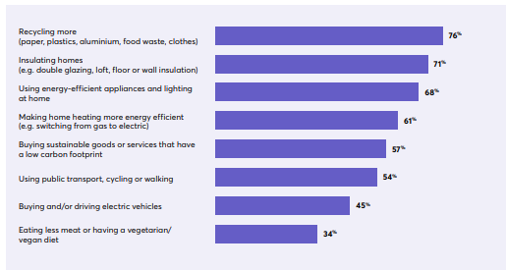

Figure 4

The study also used covariate analysis to group participants into 4 segments based on their intention to adopt energy efficiency measures. The four groups were:
- Not ready (17%)
- They are the least likely group to consider adopting energy efficiency measures
- More likely to be 55+ years of age, white, retired, live in rented flats
- 1 in 3 agree that everyone will need to adopt energy efficiency or green heating at some point in the future
- Only 7% consider adopting green heating measures within the next 3 years
- Unwilling to put time and effort into researching energy efficiency measures and are sceptical about the environmental benefits that such measures would bring

- Getting ready (47%) – they are considering
- More likely to be women, 35-54 years of age and own their homes
- More than half (63%) agree that everyone will need to adopt energy efficiency or green heating at some point in the future
- They consider it hard to find trusted and reliable tradespeople and don’t know where to start looking for energy efficiency measures

- Ready (20%)
- More likely to be 18-34 years old and employed full-time
- Like to keep up with the latest trends when it comes to household technology and décor
- Less likely to regard upfront costs as too expensive

- Action
- More likely to be men and own their homes
- Have made, or are making, energy efficiency improvements
- Want to make their homes as energy efficient as possible, willing to invest time and effort and are competent in DIY
Research conducted by Ipsos MORI, based on a sample of 4,608 people in the UK, revealed the following key findings:
- Only a few people claimed to have a good or fair understanding about terms, such as greenhouse gas emissions, net zero carbon emissions and decarbonization.
- People have a greater understanding when it comes to policies related to electric vehicles, compared to policies related to at-home energy efficiency
- The vast majority of households use gas central heating and awareness of alternatives such as heat pumps is relatively low, though there is strong awareness of electric heating
- Take up is low of a range of energy efficiency measures, such as microgeneration (7%), home insulation (21%) and low carbon heating (4%)
- Intentions to install low carbon home heating measures are generally low (14%) but tend to be relatively strong among younger people, those with higher incomes and those living in houses built in 1990 or later
- Willingness to make home insulation measures is higher (24%), compared to home heating measures (14%) and microgeneration (13%)

Influences on, and barriers to, the take up of retrofitting

Motivations and drivers
Quantitative research has explored the motivations behind people’s decisions to retrofit their properties. In a survey with a sample of 2,023 people, the top drivers for intentions to retrofit were: reduction of costs (46%), availability of financing options, such as grants and subsidies (32%), convincing and credible information that retrofitting measures would result in a warmer home and reduced bills (24%), and information from a trusted source on how to reduce energy use (19%).
In another survey, people’s motivations to retrofit their properties fell into three broad categories: save energy, save money, and save the environment. It also found that the adoption of solar water heating and solar PV was more strongly associated with fuel savings, whereas micro-wind adoption was strongly associated with environmental concerns, such as global warming and reduced emissions.
In contrast to these studies which identified financial factors as being key motivations for home retrofitting, a survey experiment showed environmental concerns to be the only significant driver for people’s willingness to pay for retrofitting measures. They found that individuals with high environmental concerns are more likely to accept energy-saving measures, compared to people who are merely motivated by cost and pricing factors.
Another study, which used a segmentation approach, explored motivations of homeowners who have already installed energy efficiency measures, in particular renewable heating systems, in their properties. Using six key motivations - cost, general attitudes towards retrofitting measures, government grants, environmental protection, comfort and the influence of peers – and their associated demographics, the researchers created three segments of participants who had adopted retrofitting measures in their homes.
- Convenience-oriented
This was the largest segment (54%) of the sample and is characterised by those who want retrofitting measures to fit easily into their daily routine. They were motivated mainly by comfort considerations, as they prefer the overall handling, fuel acquisition and maintenance requirements of the renewable heating system to entail a minimum amount of effort. Moreover, people in this segment tended to be women, own a newly built home, to not have a university degree and to seek advice from an energy consultant.
- Consequences aware
This was the second largest group (32%). Key motivations in this segment reflected cost, including the costs of installing energy efficiency measures, as well as current and anticipated fuel prices. Securing themselves and their households against the risks posed by an energy crisis, as well as protecting the environment, were also significant motives. Therefore, it is important for them to minimise their dependency on fossil fuels. People in this segment were more likely to be men, have a university degree and a higher than average income.
- Multilaterally motivated
This was the smallest group and represented people whose motives included multiple factors, such as cost, government grants and comfort considerations. Moreover, this segment’s decision to retrofit their properties was particularly influenced by their peers, especially their friends. Knowing other people who have already installed retrofitting measures was an important influencing factor, as well as the social validation and positive responses which they anticipated receiving from friends and family. People in this segment were less likely to own a new build home and they also tended to have lower average incomes than the other two groups.
These findings have important implications for the design of policies and campaigns designed to encourage take up of retrofitting. For example, highlighting non-economic aspects (such as comfort considerations and social norms) could be particularly effective when targeting certain groups, whilst addressing economic aspects (such as reduction in energy bills) are likely to resonate with other audiences.
A number of other studies have also sought to create segments based on people’s attitudes and behaviours surrounding retrofitting. For example, a qualitative study, based on user-centred design principles, experts’ opinions and qualitative interviews, created personas based on certain motivations, and demographics. Their personas offer practical insights into different types of potential consumers with an indication of the likely level of interest and what underpins this attitude (their drivers), as well as their expectations of professionals.
It’s worth noting that this study found that:
“A number of the developed personas have little interest in energy saving, and none see this as the primary motivator for renovation.”
However, encouragingly they went on to suggest that the personas instead offered insights into other motivations can potentially be used to encourage the take-up of retrofitting as a ‘by product’ of their wider interest.
The ‘Idealist Restorer’ gets actively involved and wants to have an influence on the details, is very keen on learning and expanding their DIY skills, interested in ‘clever’ energy saving technologies but not at the expense of aesthetics.
The ‘Affluent Service Seeker’ is more passive and hands off, perceives energy efficiency as something difficult and expects reliability and high quality from specialist professionals.
The ‘Property Ladder Climber’ is interested in retrofitting measures if they offer a return in terms of selling and increasing property value and is unlikely to consider technologies with long payback periods.
The ‘Stalled’ is the most difficult to convince and lacks both the time, finances and enthusiasm, therefore is more likely to be show some interest in smaller, rather than larger, projects.
The ‘Pragmatist’ reflects the those who might be most open to the practical opportunities for energy improvements, they value the functional aspects of energy efficiency and express their environmental concerns.
Different customers have different expectations and requirements from builders. A study explored this and recommended different approaches for builders to take depending on a range of customer characteristics (Table 1).
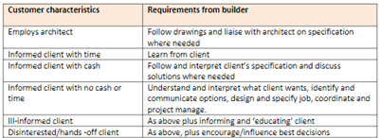

Table 1

Useful findings also come from a qualitative study conducted in the UK. According to qualitative interviews conducted in Manchester and Cardiff, the 3 most common motivations regarding home retrofit decisions included ‘saving money’, reducing C02 emissions and resource efficiency. Other motivations included ‘warmth and comfort’, ‘aesthetics and space’, ‘health and safety’ and ‘time and convenience’. The frequency of each of these motivations given by respondents can be seen in Figure 5.
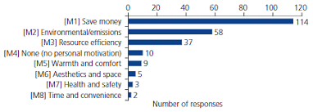

Figure 5

The study sought to link participants’ demographics with their different motivations for installing retrofit measures. Household income, marital status and type of dwelling were all found to correspond with motivations to install retrofitting measures, whilst gender, age and education level were found to be linked with retrofitting motivations.
Household income was strongly associated with the motivations to ‘save money’ and ‘resource efficiency’. Contrary to the authors’ hypothesis, saving money was strongly associated with more affluent households (those with incomes greater than £40,000), whereas the motivation of resource efficiency was strongly associated with household incomes of less than £40,000.
Married interviewees were strongly associated with the motivation to save money, while single people were found to be strongly associated with resource efficiency.
Individuals living in flats were strongly associated with the motivation of resource efficiency, while individuals living in semi-detached or detached houses were strongly associated with the motivation to save money.
Motivated by saving money | Motivated by resource efficiency
Higher household income (over £40,000) | Lower household income (below £40,000)
Married | Single
Detached or semi-detached houses | Flats

Table 2

According to research by Energy Saving Trust, most people are motivated to renovate their properties for reasons which reflect aesthetics and adding space, rather than energy efficiency. Energy efficiency was found to be less important when it comes to home renovations.
However, opportunities to persuade people to adopt retrofitting measures do exist, as 85% of respondents said they would be willing to stretch their budget and pay more to install energy efficiency measures whilst undertaking home renovations.
When asked what would persuade people to pay more for energy efficiency measures, saving on energy bills was the most common answer (68%), followed by making the room warmer (50%), increasing property value (33%) and reducing CO2 emissions (21%).
Based on these findings, Energy Saving Trust created a chart setting out the potential opportunities to encourage additional energy saving action at trigger points across five different household types.
Families with young and or growing children, that are considering undertaking larger renovation projects and a willingness to increase their budget in order to incorporate energy saving measures, represent the household group with the highest potential. Single person households, who have the lowest available budget (in part due to the financial pressure of living alone), is the household type with the lowest potential to reduce emissions.
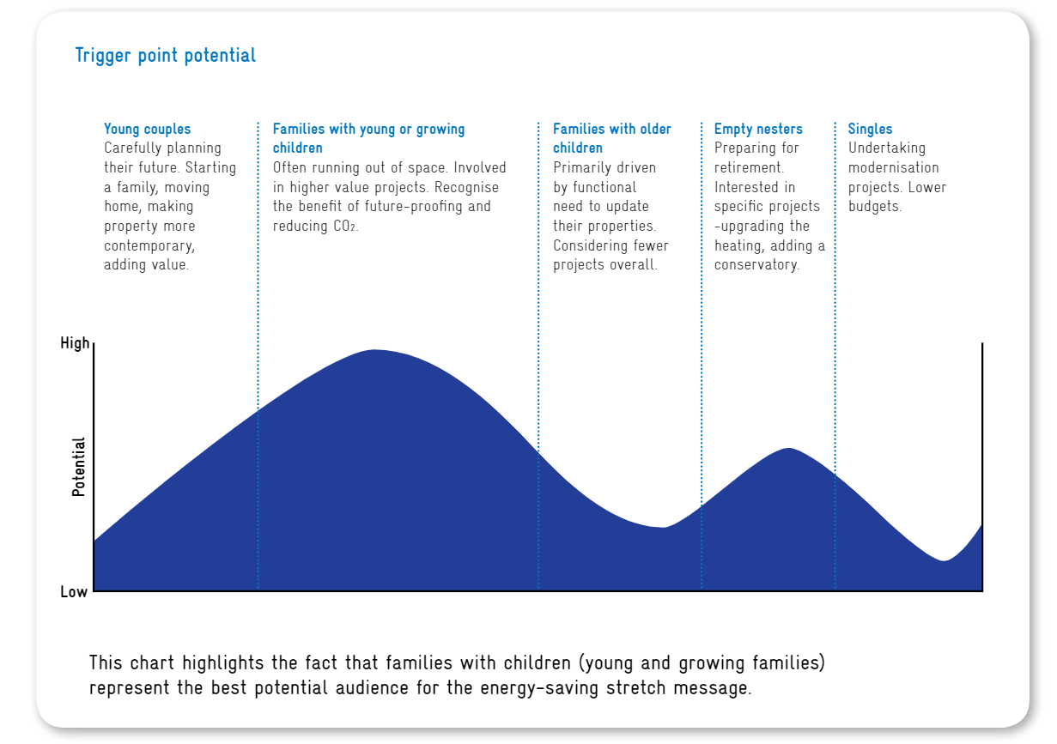

Figure 6

The report also outlined the motivations and attitudes of private landlords who typically take a more functional and economic approach when it comes to renovating their properties. Important reasons for undertaking refurbishments projects among landlords include ensuring that properties are in a good state in order to be rented out, increasing the property value and improving saleability. Moreover, 9 out of 10 landlords expressed their willingness to increase their budgets to add energy efficiency measures and 66% saw the opportunity to introduce insulation as motivating.
Similar to the Energy Saving Trust research report, another study exploring the effectiveness of the UK’s Green Deal suggested a number of critical moments in time where homeowners are likely to be more receptive to energy efficiency measures. As homeowners’ intentions to renovate their homes were strengthened, information regarding efficiency measures became more salient. Homeowners that were close to finalising their renovation plans embraced the idea of energy efficiency measures because they were already preparing for significant disruptions in their home life and were engaging with contractors and experts. Significantly, the authors concluded that energy efficiency measures are likely to appeal to all households considering renovations and that policies and strategies could benefit from framing and presenting energy efficiency measures as an ‘add-on’ or ‘side work’ to renovations.

What are the barriers that inhibit the take up of retrofitting?
A number of studies have been conducted that identify a range of barriers that discourage people from adopting energy efficiency measures. These included financial and psychological barriers, demographic characteristics and differences relating to the type of retrofit measures being installed.
Financial
Financial factors, including cost and a lack of available capital and financing options, have been found to be important factors deterring people from retrofitting their properties. One study, based on a sample of 1,000 people, found that 50% cited the high cost of installation as the single most important obstacle.
Qualitative research has suggested that cost becomes an even more significant factor when the financial returns of energy saving investments are uncertain or unknown. Cost may also lead to people delaying an ongoing retrofitting project or to consider cheaper alternatives that are not energy efficient. Although these studies were undertaken prior to the current cost of living crisis, it is likely that these factors may be even more significant given the rate of inflation and continuing economic uncertainty.
A UK study sought to link demographic variables with barriers for adoption of energy efficiency measures. The qualitative interviews revealed the following barriers:
- Cost (which was the most important factor)
- Beliefs/ information – which reflected a lack of expert knowledge of what to do, unclear or lack of trustworthy information, and mistrust towards energy companies and contractors
- Family/ partner/ housemate – which included subthemes such as disagreement between occupants regarding what measures to install, as well as apathy and disinterest from other family members
- Institutional - the perception that government incentives are incorrectly targeted and energy companies are unwilling to genuinely promote energy efficiency
- Landlord-tenant/ housing associations – the ‘split incentives’ between landlords and tenants. On the one hand, reluctance among landlords to install energy efficiency measures since they don’t benefit from reduced bills, while on the other hand, tenants are unwilling to invest in homes they don’t own
- Personal behaviours and attitudes – which included current lifestyles (e.g., laziness, lack of time, convenience and forgetfulness), and the feeling that people have already ‘done something’ and therefore don’t need to consider doing more
- Property itself – which includes limitations of the structure of the home, such as its age or unsuitable loft space, and ‘conservation and heritage’ (a subtheme where owners were unable to retrofit their properties because of planning issues, such as being listed buildings or in a conservation area).
Researchers also identified statistical associations between certain demographics and barriers to retrofitting:

Gender
Women were associated with the barriers of belief/ information and family/partner/ housewife, whilst men were associated with ‘institutional’ and ‘landlord-tenant’ barriers. The authors argued that women were more concerned with internal barriers, such as beliefs and family relationships, whilst men were more concerned with external barriers, such as institutions and landlords.

Marital status
Married interviewees were associated with the Property barrier, while single people were more likely to be associated with the Landlord-tenant barrier.

Education level
People with university degrees were associated with the following three barriers: Landlord-tenant, Personal behaviour, and Property.

Dwelling
Expectedly, people living in apartments or flats were associated with the Landlord-tenant barrier.

Number of occupants
Households with 3 or more occupants were strongly related with the family/partner/ housemate barrier. For this reason, the authors criticised policies which often treat the household as a single unit and do not focus on inter-occupant relationships which are found to be important.

Housing tenure
Owner occupied homes were strongly associated with the Property barrier, whilst tenants were associated with the split incentive barrier between Landlord-tenant.

Location
Differences were found between residents living in Manchester and those living in Cardiff. For example, Manchester was particularly associated with the barriers of Beliefs/information, Cost, Institutional, and Personal behaviour, whilst Cardiff was associated only with the Property barrier. The authors noted that there was a greater level of institutional trust towards Manchester City Council compared to attitudes towards Cardiff City Council. This result also highlights the importance of councils undertaking their research, as the barriers in different localities can evidently vary significantly.

Another UK study showed that barriers deterring people from installing efficiency measures depend on the type of energy efficiency measure or renewable technology. People rejected loft insulation because of the disruption and inconvenience of having to clear the loft and losing storage space. Those who rejected condensing boilers thought they were expensive, short lived and unreliable. Compact fluorescent lamps were rejected because they were perceived as ‘ugly’, ‘big’ and incompatible with existing fittings. Renewable technologies, such as solar water heating and micro-wind generation, were ruled out due to high capital costs, difficulties finding trustworthy installers and contractors, installation issues, such as finding space, and concerns (especially for micro-wind generation) about noise, vibration and visual intrusion. It should be noted that the study was conducted in 2007 and therefore these barriers (or at least some of them) might no longer be relevant, however even if technological advances have removed or reduced some of these barriers the perceptions may still exist long after the reality has made them redundant.

A more recent study conducted by Ipsos MORI also sought to explore relationships between types of retrofitting measures and their associated barriers.
- Barriers in relation to micro-generation technologies, such as solar PV and micro-wind generation were: cost (64%), no guarantee it will save money (39%), hassle/disruption of installation (24%), lack of trusted installers (20%), ‘owner will not allow’ (13%) and difficulty selling the property in the future (12%).
- Barriers that were associated with home insulation included: high costs (49%), no guarantee it will save money (25%), owner will not allow (21%) and hassle/ disruption of installation (16%).
- In relation to low carbon heating, significant barriers reflected: costs (70%), no guarantee it will save money (37%), hassle/disruption of installation (15%), lack of trust in installers (15%) and concerns in unproven technologies (14%).
As can be seen from the results, although there are differences in the barriers to the adoption of different type of retrofitting measures, there is also a degree of consistency in the prominence of costs and the uncertainty of saving money.

In reviewing the literature, Early and Peng (2011) identify low confidence and anxieties about DIY competence as an important barrier to renovation decisions. Other research shows that people’s own ratings of themselves as renovators predicts the likelihood of undertaking renovation. UK data from the Family Expenditure Survey reveals that less affluent households appear to do less DIY when it comes to home improvements. In another study, it was shown that those from more affluent backgrounds were more likely to outsource boring and routine tasks and they were more likely to undertake DIY activities they enjoyed themselves. It is important to note that DIY knowledge can also influence decisions adversely, making people to choose suboptimal renovation and retrofitting solutions. This is because DIY and possessing specific DIY tools and skills often influences people’s choices of which energy efficiency measures to install, rather than being informed by determining which measures would be more suitable.

Other research identifies ‘DIY renovators’ as having low trust in contractors. Lack of professional trust represents a major obstacle related to retrofitting. In a qualitative study, a participant reports ‘not knowing where to look’ in order to find trustworthy and reliable builders. Homeowners often commission contractors who are not necessarily the most appropriate for the particular task, but are trusted because of past experience or recommendation. Householders may also feel anxious in their discussions with builders and contractors when it comes to rejecting or negotiating offers. There is also some evidence to suggest that women can feel anxious in their interactions with contractors who are predominately men.

A number of studies therefore point to significant differences in the barriers to retrofitting homes that households and people with certain sociodemographic profiles face. To overcome this, clearly requires interventions to be tailored and specific to the particular needs and obstacles faced by different households and groups.
BARRIERS AND MARKET FAILURES | TYPOLOGIES
Economic and financial barriers | - High costs of energy efficiency measures  - Limited access to capital  - Uncertainties linked to property prices  - Hidden and high transaction costs
Institutional and Regulatory barriers | - Problems with legal framework for renovation of residential buildings  - Insufficient enforcement of standards  - Lack of equipment for monitoring
Technological barriers | - Technological difficulties linked to micro generation technologies in buildings  - Scarcity of investment in R&D of energy efficiency enhancement  - Lack of technical or commercial skills and  knowledge
Information barriers | - Lack of awareness and information  - Uncertainties about cost-effectiveness
Organisational barriers | - Ignoring of small energy efficiency improvement options  - Organisational failures
Behavioural barriers | - Resistance to change  - Time constrains, and the ability to use information

Table 3

A taxonomy of barriers
Another study provides a useful and practical taxonomy of barriers. Accordingly, barriers are grouped in 6 main categories: economic and financial, institutional and regulatory, technological, information, organisational and behavioural. Notably, the researchers highlighted that the majority of policies and strategies have neglected addressing the psychological and behavioural barriers.

Psychological and behavioural barriers
Other scholars in the field of behavioural sciences, who study the psychological dimensions of barriers, have attempted to describe biases and heuristics as well as other psychological factors which play a role in the decision-making process in relation to retrofitting.

Temporal discounting: smaller benefits in the present outweigh bigger benefits in the future – so future savings on utility bills resulting from energy efficiency investment are disregarded rather than considering whole-life costings. It has been suggested that consumers should be more immediately rewarded for taking positive actions now that will yield greater benefits (save energy) in the long-term.

Risk aversion: Risk aversion reflects the tendency of people to avoid taking risks, which leads them to inaction. Residents have been found to show a greater degree of risk aversion when considering energy efficient insulation and ventilation systems, compared to traditional products. Similarly, participants were more likely to choose energy efficiency companies, with ‘guaranteed’ savings, indicating their efforts to reduce potential risks. Indeed, many studies have shown that uncertainty around electricity supply and pricing, government policies and long-term financial payoffs make investing in energy-saving products and services feel like a riskier decision for people. Another UK study demonstrated that intentions towards energy efficiency were reduced by uncertainty surrounding future financial benefits.

Sunk costs: People become psychologically invested in costs they have already paid, regardless of the benefits of the new investment. This bias can lead people to avoid investing in new energy efficient measures in favour of repairing existing systems, where they have already spent substantial amounts of money. For example, fixing a less energy efficient boiler because they have spent a considerable amount of money on purchasing it, rather than accepting that money has ‘gone’ and purchasing a new, more energy efficient system.

Availability heuristic: Information that is most recent, extreme and/ or vivid can be more easily recalled and, therefore, influences decisions to a greater extent than information that doesn’t have those features. Research has shown that people are more likely to install energy saving measures which they are familiar with, such as PV panels which have high visual impact (salience) and tend to have more media coverage, rather than roof insulation which might be hidden from sight. Similarly, items that are more vivid and can be more easily imagined have a greater bearing on our decisions. For example, the aesthetical advantages of the refurbishments the architect describes are easier to imagine than the energy efficiency measures’ benefits such as humidity control and thermal comfort. Indeed, research has shown that aesthetics is a greater motivating factor than energy efficiency, in people’s decisions to renovate their homes. A number of studies have shown that energy efficiency is only likely to be considered to the extent that other considerations, particularly aesthetics and comfort, are not compromised.

Endowment effect: people tend to value the things they own more highly, simply because they own them, rather than as a result of their characteristics. This bias might explain why people are resistant to changing old appliances and boilers with energy efficient ones – placing additional and sentimental value on their possessions, rather than looking objectively at their worth.

Status quo bias: Status quo bias is a cognitive bias which reflects a preference for the current state of affairs. If the existing state of the house is perceived as ‘good enough’ then the prospect of undertaking renovation might be discarded. Research shows that people are irrationally reluctant to move from the status quo and more tend to accept the ‘do nothing’ (or default) option. This results in people being more willing to accept interruptions in electricity supply than considering switching electric provider, with evidence suggesting that 50% of respondents who choose to stay with their current deal would have been better off switching. An experimental study found that when renewable electricity suppliers were presented as the default option, consumers were more likely to choose renewable energy sources than those using fossil fuels.

Regret aversion: actions and decisions require greater justification than inaction and this results in a tendency to try to minimise regret. If decisions later prove to be mistakes, the regret that follows is greater than that that caused by failing to act. Consequently, people can choose to do nothing rather than risk taking action which they later come to regret.

Choice overload: When presented with too many choices (for example, a bewildering array of different energy efficiency measures, devices, technologies and contractors to choose) people can be overwhelmed. In this instance, people are likely to avoid making a decision and instead choose to do nothing. One experimental study found that adding more options to a list of energy saving recommendations has a negative impact on the number of recommendations pursued. Simplifying the presentation of options and making the ‘right decision’ clearer increases the likelihood of people taking action.

Hassle factor: The perceived and actual difficulty of a task demotivates people from taking action, even if they are aware that doing so is the right thing. For example, in the context of retrofitting, 15% of people were discouraged by the potential discomfort from having home life disrupted while renovations take place. Results from a trial showed that removing the ‘hassle factor’ - by helping people clearing their lofts -can increase the take-up of loft insulation.

Trials and Interventions
In reviewing the literature, a report identifies 40 interventions, or programmes, aimed to promote positive behaviours in relation to energy use. The discussed interventions make use of behavioural techniques – which address people’s biases, heuristics and other psychological barriers - to drive behaviour change among their target audiences. In terms of frequency and types of behavioural techniques used, the report found that virtually all the interventions employed ‘simplification’. Other commonly used levers included social and descriptive norms and the use of feedback mechanisms.
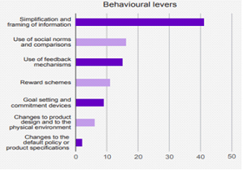

Figure 7

Conclusion

The studies cited in this review were conducted between 2010-2022, and typically used large sample sizes and were transparent in their methodologies. They generally adhered to recognised standards in terms of their research methodology. They included a number of high-quality academic studies, including those that synthesise research evidence and are considered the most robust evidence available.
The first part of the review - which reflected a more general investigation of broad environmental values, attitudes and behaviours - included a mixture of UK and international academic studies that were conducted by established scholars and research teams in the field of psychology and values research and published in peer-reviewed journals.
The second part of the review - which examined evidence that was directly relevant to retrofitting and energy efficiency - included both academic and practitioner research, including relevant studies published by research agencies and specialist organisations in the UK such as Ipsos MORI, Nesta and the Energy Saving Trust.
Moreover, this review identified an important gap in the research literature, as the majority of research carried out to date has focused on studying curtailment, rather than energy efficiency behaviours. Nonetheless, there is a relatively strong body of evidence that we can draw on in order to inform our intervention and trial design.

Local primary research

What we did
An online survey was designed to capture the views of Devon residents about a range of issues, including their attitudes and behaviours relating to the environment and retrofitting, as well as contextual issues such as the cost-of-living crisis.
The survey was promoted by each Council through a range of communications channels, both to specific retrofit/net zero networks and more general and broader Council communications. Social Engine provided comms support and messaging to assist with survey promotion. The survey ran from 5th to the 26th of August, with prize draw offered to incentivise participation.
Our approach to analysis included descriptive statistics of all quantitative questions, thematic analysis of qualitative questions as well as segmentation analysis on intention to install retrofit measures, supported by a range of covariates such as demography and attitudinal and behavioural variables.

Who we heard from
In total 4,818 responses were received (around one half of one percent of the total population of the County). This gives us a confidence interval (margin of error) of +/-1.4%. This means that we can be 95% confident that had responses been secured from the entire population, the results would be within 1.4% (higher or lower) of our survey findings.
The large sample size therefore means we can be highly confident about the reliability of these results.

A breakdown of who responded to the survey is set out in Figure 8. 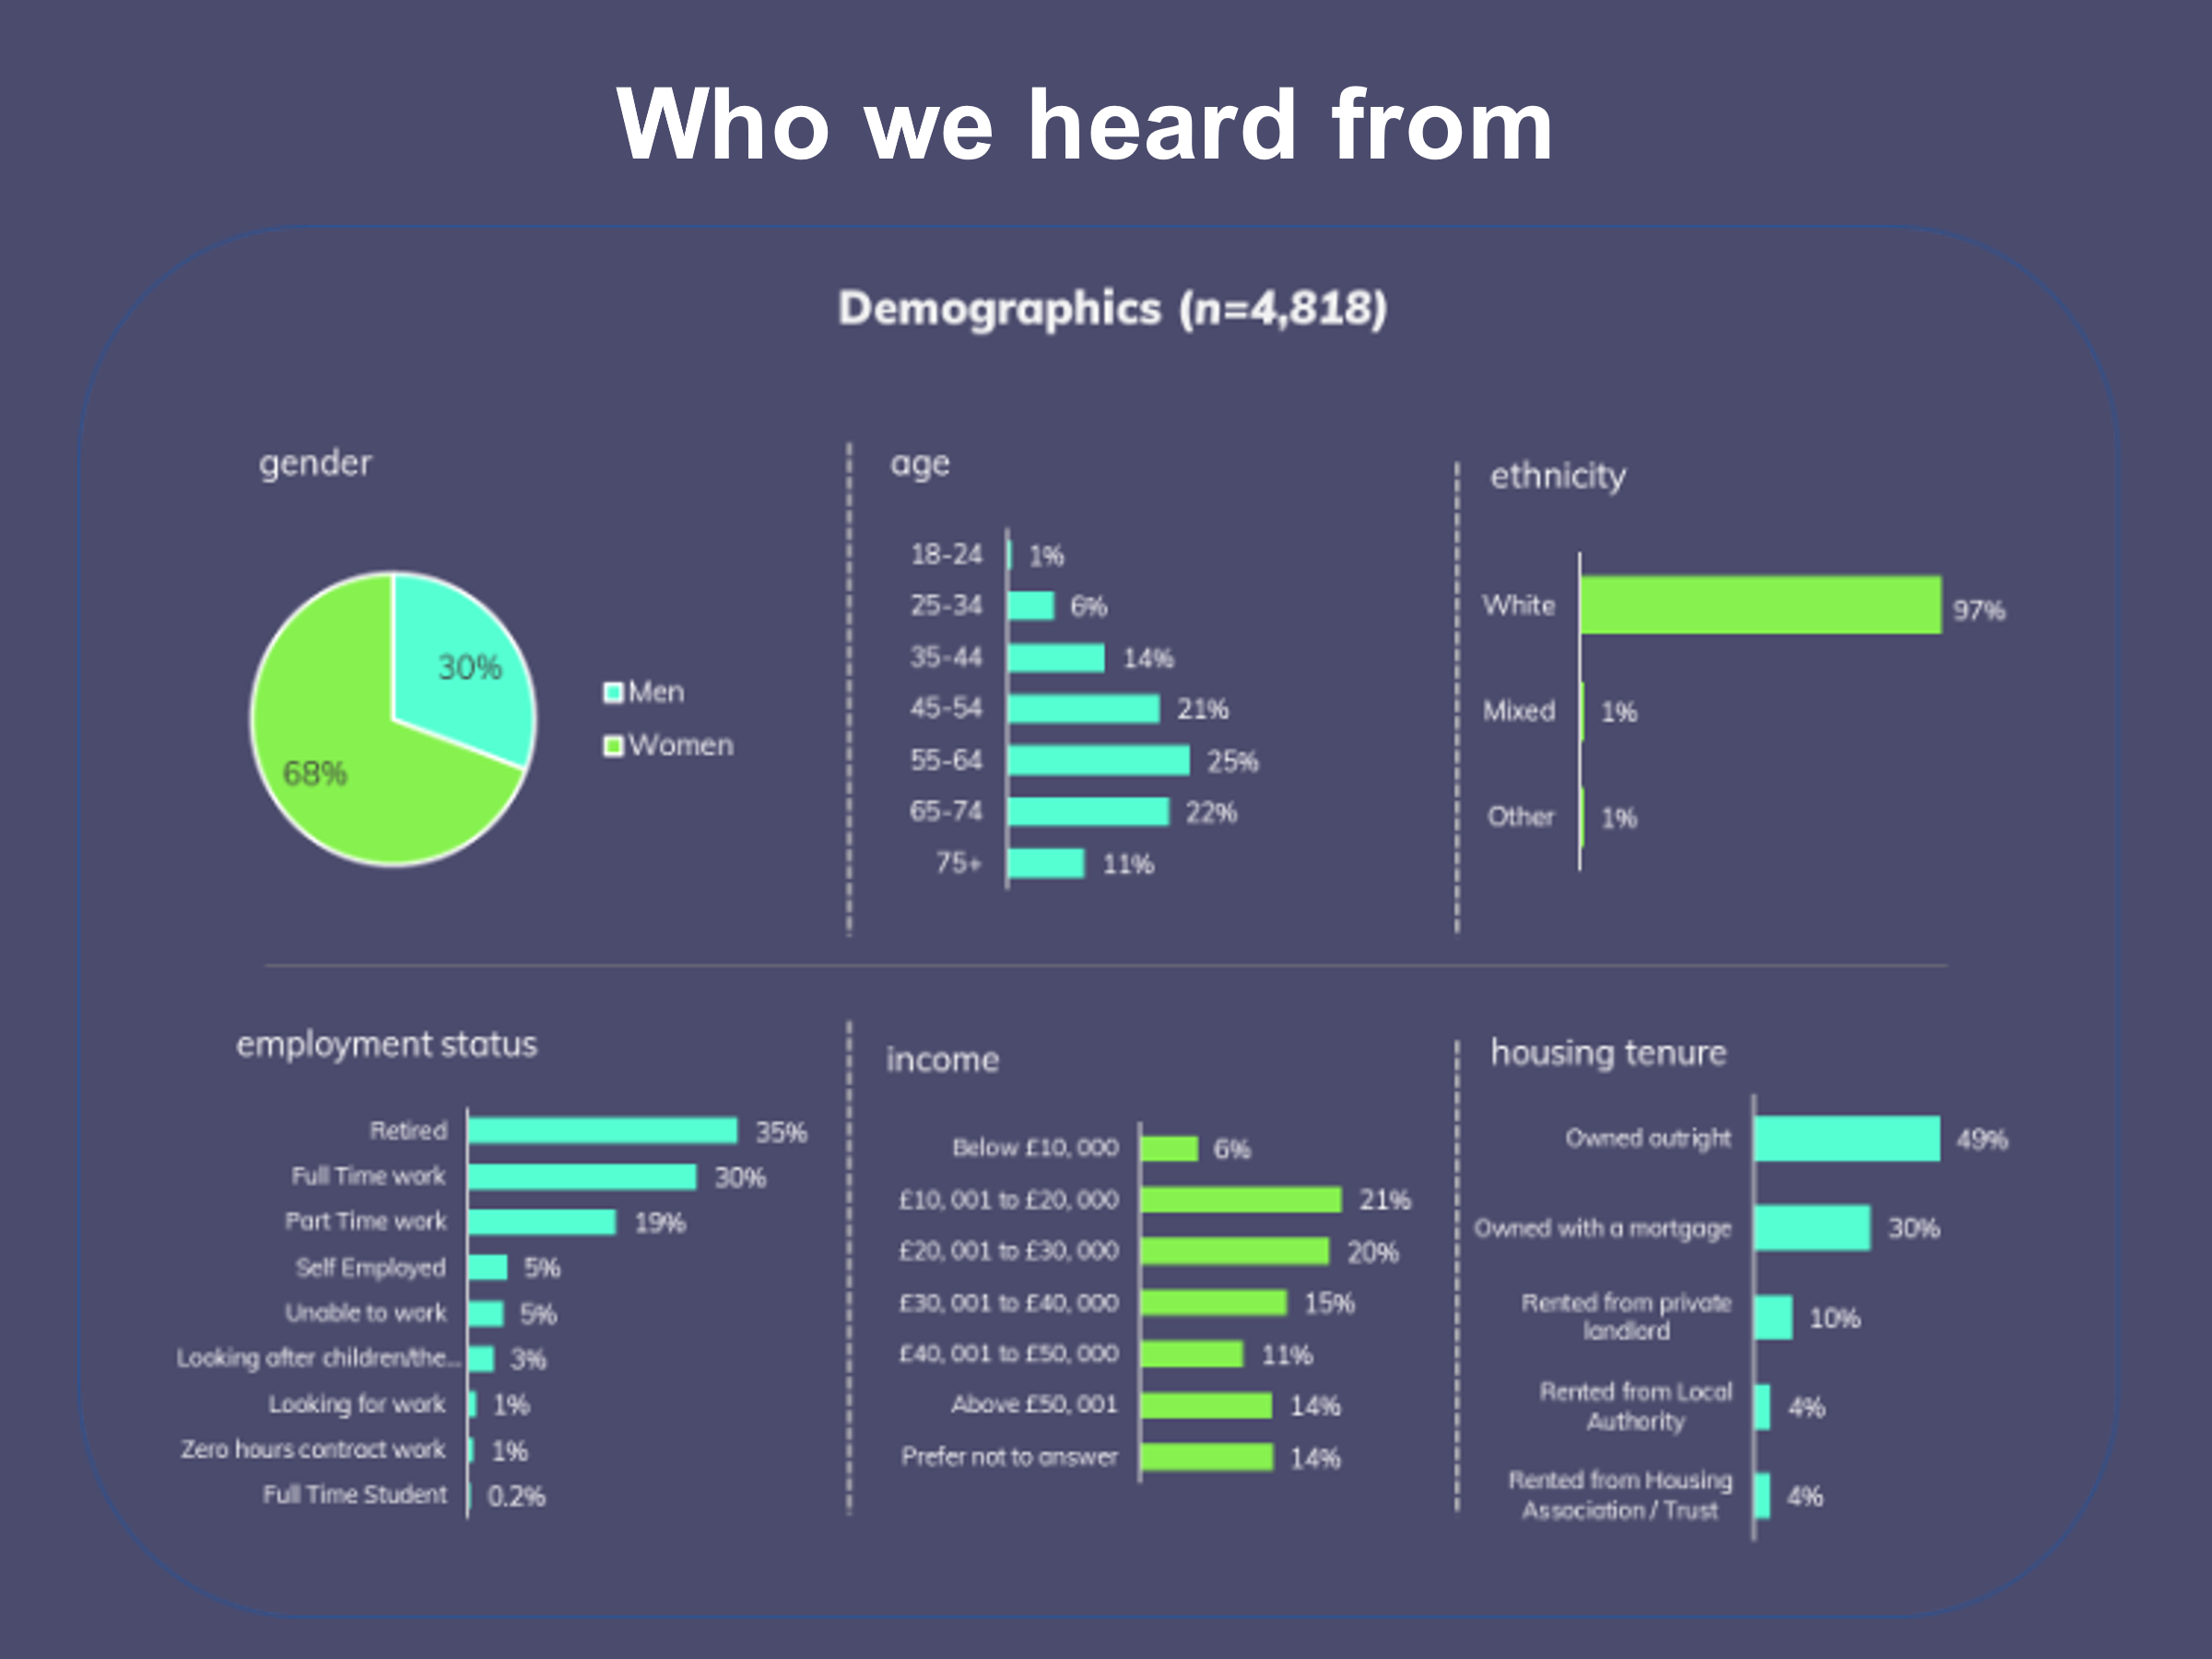

Figure 8

We compared the demography of survey respondents with the wider population to understand whether our survey responses reflected the composition of Devon’s communities.
Devon has a roughly even split between men (49%) and woman (51%), whilst our survey received significantly more responses from women (68%) than from men (30%).
The age profile of survey respondents was higher than Devon as a whole. This can, in part, be explained by the absence of responses from children and young people (the survey was not targeted at under 16s), however this was compounded by a low response from young adults aged 16-24 (1% of our survey sample, compared with 10% of the population as a whole). These two variances mean our survey sample is over-represented among older age brackets, with two-thirds of our sample coming from those aged 45-74, approximately twice the proportion of the population as a whole.

Age | 2020 population estimates | Survey | Variance
Under 15 | 15% | 0% | -15%
16-24 | 11% | 1% | -10%
25-34 | 11% | 6% | -5%
35-44 | 10% | 14% | 4%
45-54 | 13% | 21% | 8%
55-64 | 14% | 25% | 11%
65-74 | 14% | 22% | 8%
75+ | 12% | 11% | 1%

Table 4

The ethnicity of our survey sample was very close to that of the County as a whole – with the vast majority of responses coming from people from White ethnic backgrounds and a very small proportion from Black, Asian and other ethnic groups.
Area | White | Mixed/multiple ethnic groups | Asian/Asian British | Black/  Black British | Other ethnic group
Devon | 98% | 1% | 1% | 0% | 0%
Survey | 97% | 1% | 1% | 1% | 1%

Table 5

We received more survey responses from people who owned their own homes without a mortgage and fewer from residents in private rented housing. This imbalance is likely to be correlated with the older population in the survey sample. Other forms of housing tenure in survey responses closely reflected local demography.
Area | Owned outright | Owned with a mortgage | Shared ownership | Rented from council | Social rented: Other | Private rented
Devon | 38% | 31% | 1% | 6% | 8% | 18%
Survey | 49% | 30% | 0% | 4% | 4% | 10%

Table 6

The previously mentioned older age profile of survey responses, is likely to be the cause of differences in the economic characteristics within the sample compared with the County population as a whole. In Devon as a whole 13% of the population are retired, which was around one third of the proportion in survey responses (35%). The proportion of economically active survey respondents was 46% which is considerably lower than the Census figure of 78%. However average salaries were not markedly different – NOMIS figures suggest the average salary in Devon is £29,484 (based on £567 average weekly earnings). Whilst we do not have a mean figure, 41% of survey responses fell within a range of £10,000-£30,000, with one in five between £20,000-£30,000 which is broadly consistent with NOMIS figure.

Population
The survey was promoted across the County and responses were received from all Councils. The number of responses received from each Council are shown on the map below, using the first part of postcode to identify the relevant Council. However, this meant that a number of responses were not able to be plotted as the postcode provided straddled two Councils. Responses received from neighbouring Councils were not included on the map. The remaining 3,380 are shown on the map (Figure 9).
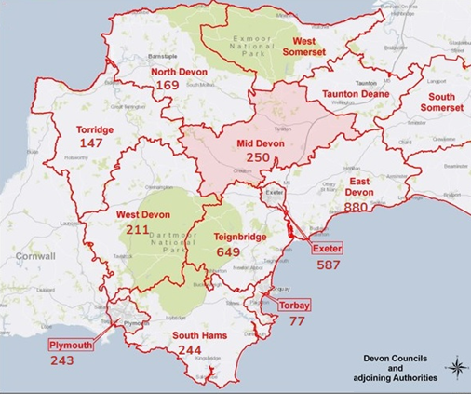

Figure 9

In Table 7 we compare the proportion of the population of Devon within each Council with the proportion of survey responses received, highlighting any variance between the two figures. These range from +12% from East Devon to -17% in Plymouth.

Area | Population | Population % | Survey | Survey % | Variance
East Devon | 148,080 | 14% | 880 | 26% | 12%
Exeter | 133,333 | 12% | 587 | 17% | 5%
Mid Devon | 83,290 | 8% | 250 | 7% | 0%
North Devon | 98,170 | 9% | 169 | 5% | -4%
South Hams | 87,946 | 8% | 244 | 7% | -1%
Teignbridge | 135,039 | 13% | 649 | 19% | 7%
Torridge | 68,719 | 6% | 147 | 4% | -2%
West Devon | 56,139 | 5% | 211 | 6% | 1%
Plymouth | 264,700 | 24% | 243 | 7% | -17%
Total | 1,075,536 |  | 3,137

Table 7

We asked people a series of questions about their homes and their connection to Devon. The responses suggest a relatively stable population, who have lived in Devon and in their current homes for a considerable period of time – likely reflecting the older age profile of our sample. We received more responses from people living in houses, particularly detached houses, than those living in flats, which may again reflect the over-representation of older respondents to the survey. Despite the underrepresentation of responses from residents in Plymouth, our sample is somewhat more urban dwelling than rural.

How many years have you lived in your current home?
46% of respondents have lived in their current homes for more than 10 years, whilst 54% have lived in their current homes for less than 10 years.

Figure 10

How many years have you lived in Devon?
The majority of participants (77%) have lived in Devon for more than 10 years, with almost two-thirds (62%) saying they’ve lived in the County for 20 years or longer.

Figure 11

How urban or rural would you describe where you live is?
(1=remote rural and 5=in a City)
Only 15% of respondents indicated that they live in a rural area, whilst 24% live in a City and over half (52%) in a predominately urban area. City population size and density means there are always likely to be more urban dwellings than rural ones. Nonetheless, the proportion of rural homes in our sample is lower than the 26% of rural homes in Devon recorded in the 2011 Census.

Figure 12

What type of home do you live in?
The majority of survey respondents live in houses, with just 9% living in flats, which is somewhat higher than Devon as a whole. 39% of those who completed the survey live in detached houses or bungalows, which is substantially higher than the Census figure of 29% for Devon.

Figure 13

 | Detached house or bungalow | Semi-detached house or bungalow | Terraced house | Flat | Other
Devon | 29% | 26% | 26% | 18% | 1%
Survey | 39% | 30% | 21% | 9% | 1%
Variance | +10% | +4% | -5% | -9% | -

Table 8

Cost of living
In order to understand how residents were feeling more generally and capture wider perceptions of the current environment, we asked a series of questions about the cost-of-living crisis and how the COVID-19 pandemic had changed people’s lives.

Thinking about your finances, which of the following best reflects your position?
Although around 40% of respondents told us that they are financially ‘comfortable’ and another 40% said they are able to ‘cover the essentials’, we found that around 1 in 5 (19%) are struggling to make ends meet and having to go without things like heating and food. Given that inflation is currently close to 10%, the proportion of the population who are unable to afford essentials may well already be increasing.

Figure 14

How do you expect your household's finances to have changed in 12 months’ time?
It’s clear that people are overwhelmingly anxious about their household finances, with 86% stating that the expect their finances to worsen over the next 12 months and around half (46%) think it will worsen considerably.

Figure 15

How much do you agree or disagree with the following statement?
Almost everyone is concerned about inflation, with 93% of respondents saying they were worried about rising prices of day to day items (57% strongly agree).

Figure 16

The impact of COVID-19
To understand the impact of the pandemic, we asked people whether various aspects of their lives had changed since COVID-19. We found that significantly more people feel their stress levels, friendships, finances and fitness have all deteriorated since the pandemic than feel they have improved, although we respondents were more likely to tell us that their diet has improved.

Figure 17

Do you have an electric vehicle?
While electric vehicle ownership/leasing is still very small – only one in 20 respondents currently – a further 9% are currently considering acquiring an electric vehicle. Nonetheless adoption is still at a very early stage.

Figure 18

Energy efficiency and retrofitting
A substantive section of the survey was dedicated to understanding residents’ attitudes, behaviours, knowledge and motivations surrounding retrofitting and making their homes more energy efficient. We also asked a series of questions about home improvements and DIY since the research literature had highlighted the significance of these in retrofitting behaviours.

Do you know what retrofitting a home is?
‘Retrofitting’ is not widely understood, with only 41% of respondents saying that they knew what it was. However, our analysis of responses to people being asked to describe what retrofitting was in their own words suggests that even this figure was an overstatement, since a proportion of responses were not an accurate reflection of the term.

Figure 19

In your own words how would you describe retrofitting?
Many respondents were able to accurately describe retrofitting:
“Installing something that was not part of the home when it was originally built.”
“Installing new technologies to existing typically older properties to either bring them to current standards or just provide a general improvement.”
“Adding/changing features once the house is already built.”
“Adapting homes with modern technologies to improve energy efficiency.”
However, other respondents expressed their negative opinions of the term, rather than defining it:
“Buzz word put out by some self-important fool”
“An expensive and unknown quantity”
Whilst others appeared to be unclear precisely what retrofitting means:
“Bringing back something from the past to fit that worked well previously”
“Bring your house up to building regs”

DIY competence
When asked how confident people were about their own DIY skills, we found a very even divide between those who felt extremely confident (33%), those who were moderately confident (32%) and those who were not confident at all (34%).

On a scale of 1 to 10 how confident would you be about using your own skills in order to make home improvements (e.g., painting and decorating, putting up shelves etc)?
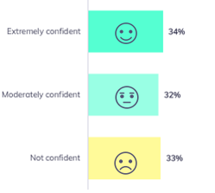

Figure 20

How would you generally go about undertaking simple home improvements such as painting and decorating or putting up shelves?
Whilst around a third (38%) of respondents said that they undertake simple some improvements themselves, almost half (47%) rely on others, such as family members (31%) or professionals (16%).

Figure 21

Do you know of any builders/ renovation contractors that you would trust to carry out work on your home?
Given the significant proportion of residents who lack confidence in their own DIY skills and who rely on the assistance of professionals to carry out simple DIY tasks, knowing a reliable and trusted builder is likely to be a key factor in decisions about improving home energy efficiency. Our sample was evenly split between those who said they know a reliable builder (51%) and those who said they do not (49%).

Figure 22

Are you planning any significant home improvements in the next 3 years?
Research literature suggests that home improvements are an important potential trigger point for installing retrofitting measures. We therefore asked residents whether they were planning any significant home improvements in the future. We found that 1 in 3 respondents reported that they are planning significant home improvements in the next 3 years.

Figure 23

What sort of home improvements are you planning?

Figure 24

Environmental behaviours

How often do you do the following things?
When prompted with a range of environmental behaviours, responses indicated that the vast majority of people engage in pro-environmental behaviours, such switching off lights (97%), swapping to LED bulbs (91%) or putting more clothes when feeling cold (95%).

Figure 25

Although we cannot determine this from responses, it may be that these figures are overstated as a result of social desirability bias – namely that respondents gave the answers they felt were most socially desirable.

Thinking about at-home energy efficiency measures, which of the following statements best applies to you?
When asked whether they were considering installing, or had already installed, retrofitting measures, we found that 72% of respondents were actively considering improving their home’s energy efficiency. Whilst 42% said they were considering doing so in the near future, 19% said that they had already made all the energy efficiency measures they wished to make and just 9% said they were not considering retrofitting measures.

Figure 26

We then asked whether people had installed or were considering installing a range of specific retrofitting measures.
We found considerable variation in the proportion of residents who had already installed different retrofitting measures, ranging from 82% who said they already had double glazed windows, down to just 12% who said they had insulated floors. Photovoltaics (solar panels) were being seriously considered by around one in five (19%) respondents, although a similar proportion (21%) had previously considered and rejected them.

Have you installed any of the following?

Figure 27

If you haven’t installed any of these measures, what are the reasons for not doing so?
- Cost
‘As always, the cost to fit.’
‘Air source heat pumps are too expensive to run.’
‘Cost of solar panel installation is too expensive.’
‘Cost outweighs benefit.’
‘Don’t have much savings for high upfront capital cost.’

- Structural factors – listed buildings
‘15th century farmhouses are hard to fit under floor insulation and have thick cob walls. That are already thermally efficient.’
‘Grade 11 listed Cottage so not easy to make some of the above listed improvements.’
‘Grade 2 listed building with unsuitable infrastructures.’

- Lack of trust towards builders
‘Finding someone reputable to carry out the work.’
‘Cost and finding reliable contractors.’
‘Lack of knowledge and not knowing reliable installers.’
‘Primarily costs plus the difficulty in finding a reliable tradesperson for specialist work.’

- Lack of time
‘Lack of time to do the research about what would be the best solution.’
‘Too busy dealing with other stuff.’

- Beliefs
‘Technology is still too embryonic.’
‘I am not an "early adopter" of new technology. My suspicion is that five years from now they'll be smaller and better.’
‘Cavity wall insulation makes buildings damp.’
‘It would create damp and moulds.’
‘Houses have to breathe. No to non-breathable insulated floors.’

- Split incentives – tenant/ landlord
‘I rent so my landlord would need to agree.’
‘I live in a rented property and the landlord has not done these things, as he doesn't have to pay the bills.’

Social norms and trusted messengers
In order to better understand the influence of others on people’s retrofitting behaviours, we asked a series of questions about whether people were having conversations about retrofitting, whether they knew people who had retrofitted their homes and sources of information that they trusted to provide reliable information on energy efficiency.

Do you know other people who have made their homes more energy efficient?
Although around one third (35%) of respondents said they did not know anyone who had made their homes more energy efficient, the majority were aware of people who had. Measures installed by friends and family were most frequently cited, but work colleagues and neighbours were also mentioned.

Figure 28

Is making your home energy efficient something you talk about? Tick all that apply
Conversations about energy efficiency appear to be relatively widespread, with just one quarter of respondents indicating this was not a topic of conversation for them. Again, we saw that friends and family were the most likely participants in retrofitting conversations, with two thirds (64%) saying they talked about home energy efficiency with their family and around half (47%) with friends.

Figure 29

Which of the following do you regard as a reliable and trustworthy source of information about improving the energy efficiency of your home?
Friends and family were by far the most trusted source of information about retrofitting, with three quarters of respondents indicating they trusted them, and just 2% saying they did not. Councils, VCS organisations and Community Energy Groups were also all seen as reliable sources of information. Advertisements, the construction industry, energy suppliers and, perhaps somewhat surprisingly, local media, were far more likely to be mistrusted than other sources.
It's worth noting that although only one third of respondents said they trusted Cosy Devon, only 3% said that they did not trust it as a source of reliable information. The vast majority (65%) neither trusted nor mistrusted it, suggesting that it may not be widely known, but among those that are aware of it, it is highly regarded.

Figure 30

Motivations
To understand what might encourage people to take up retrofitting measures, we asked them to what extent a variety of factors might motivate them to improve the energy efficiency of their homes.
Whilst being more environmentally friendly was felt to be a significant motivating factor, financial considerations were reported as being even greater influences by respondents. Three of the top five motivations related to financial factors, with 94% of respondents saying reducing the cost of energy bills was likely to influence them. Information was also a key consideration, with access to reliable information, knowing how long work would take and how much it would cost and knowing a reliable installer were all frequently perceived as being likely influences on behaviour.

Figure 31

Segmentation analysis - Understanding differences between different groups
In order to understand differences in attitudes, behaviours and characteristics of different sub-groups within our survey sample, that might help us to develop our intervention approach, we conducted segmentation analysis. We explored three different segments within the data based on responses to whether people had already installed retrofitting measures, were seriously considering doing so, or weren’t considering them. Rather than using responses to the more general question about retrofitting intentions, we used the question which asked about intentions relating to specific retrofitting measures. We looked at wall insulation, roof insulation and floor insulation separately and found considerable consistency across all three measures.
This analysis produced three distinct segments within our sample: those who had already installed retrofitting measures, those who were seriously considering them and a third group who were not considering installing retrofitting measures (comprised of those who had previously considered doing so and rejected it and those who were not considering them).
Our segmentation analysis involved looking at a range of variables for each segment to see whether they differed significantly from each other. We looked at demographic characteristics of each group, knowledge of retrofitting, whether they knew reliable builders, whether they were planning any major home improvements, trusted sources of information, their financial position and motivations for installing energy saving measures. This analysis produced some clear and distinct characteristics of each of our three segments.
Broadly, we found that attitude towards retrofitting was associated with income, housing tenure and housing type and affluence.

Our three segments
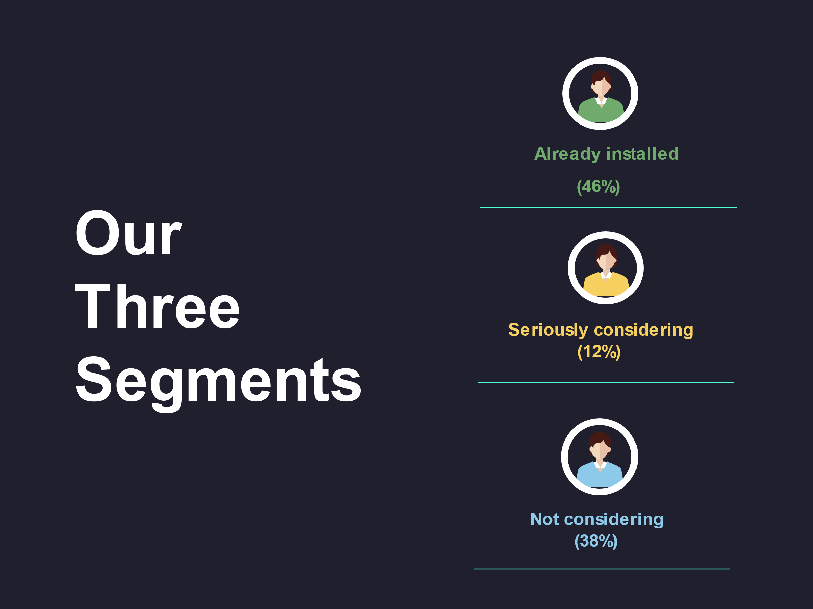

Figure 32

Already installed
Those who had already installed retrofitting measures were the largest segment in our sample, accounting for almost half (46%) of survey respondents. They tended to be home owners (owning their homes outright – i.e. without a mortgage) and live in houses, more often detached houses. They were generally more affluent than average and also more likely to be retired and aged 65 or over. They were more likely to know what retrofitting was and to know reliable builders They were also more likely than average to be having conversations about energy efficiency and to know other people who have already installed retrofitting measures in their homes. They also tended to be slightly more trusting of energy companies than other segments.
Seriously considering
Our second segment is the smallest of our three segments, accounting for 12% of our sample and comprised those who said they were currently seriously considering installing retrofitting measures. They tended to be of working age (25-44) and were more likely than average to be working full time. They were more likely to live in semi-detached or terraced houses and to have mortgages.
As with the already installed segment, they were also more likely to be aware of what retrofitting is, to say they knew reliable builders and to be having conversations about energy efficiency.
They were more likely to be planning significant home improvements in the next few years and were generally more likely to trust a range of sources of information including; local media/news, community energy groups, charities/community groups and Cosy Devon.
This segment was more likely to be motivated to install energy efficiency measures by a number of factors, but the availability of finance, being more environmentally friendly and access to reliable builders and information were particularly strong motivating factors.
Not considering
Our third segment, which accounted for 38% of our sample, comprised those who were not considering installing retrofitting measures or had previously considered them and rejected the idea. They tended to be less well off than average, with lower incomes and less job security; being more commonly on zero hours contracts, seeking work, unable to work or students. They were far more likely to rent their homes or live in social housing and more commonly live in flats. They were less likely to be planning home improvements and they were slightly less likely to be having conversations about energy efficiency or to know others who have installed retrofitting measures. They were also less likely to know a reliable builder. They are more likely to be ambivalent about a range of sources of information – being more likely to say that they neither trust nor mistrust them.

Characteristics | Already installed | Seriously Considering | Not Considering
Percentage of sample | 46% | 12% | 38%
Typical Age | 65+ | 25-44
Housing tenure | Owner (outright) | Owner (mortgage) | Renter (private or social housing)
Housing type | Detached house | Semi-detached or terraced house | Flat or maisonette
Income | Comfortable | Moderate | Less well off
Employment status | Retired | Working full-time | Less secure
Aware of retrofitting
Know reliable builder
Talking about energy efficiency
Know others with retrofit measures
Planning home improvements
Trusted sources of information | More likely to trust energy companies | Tend to be more trusting | Typically more ambivalent

Table 9

Conclusions
The findings from the local research are consistent with much of the evidence from our literature review – which should be considered reassuring.
They confirm widespread opportunities for increasing the uptake of retrofitting measures, with a significant proportion of people planning or at least open to the idea of making their homes more energy efficient.
A range of factors act as motivations for installing retrofit measures, including the availability of a range of reliable information and being more environmentally friendly, but the most significant factors are financial. Similarly, cost is the greatest barrier to take up.
Whilst concern about the cost of living crisis, rising prices and anxiety over household finances is almost universal, there are considerable differences in the levels of interest in and attitudes towards retrofitting. The strong correlation between affluence – and a range of associated variables such as housing tenure, employment status and housing type – and retrofitting intentions further underlines the importance of financial factors as an influence on behaviour.
Our segmentation analysis provides clarity on some of the key differences in motivations, trusted sources of information and trigger points that exist among our three segments. This presents opportunities for targeted engagement, framed around simplified messaging tailored to particular audiences.

Sample size calculations
Data shared with us provides the volumes of house characteristics and features relating to a range of retrofitting measures for the 10 Councils in Devon, both those within the consortium and those which are not (North Devon, Teignbridge, South Hams, West Devon, East Devon, Exeter, Torbay, Torridge, Plymouth and Mid Devon).
A total of 567,833 homes were identified across Devon within the dataset. However, for some retrofitting measures the totals given are less than this. Where this is the case, the totals are given and percentages are calculated using the total for that measure.
North Devon | Teignbridge | South Hams | West Devon | East Devon | Exeter | Torbay | Torridge | Plymouth | Mid Devon
46,763 | 62,748 | 45,554 | 25,847 | 69,902 | 58,570 | 67,745 | 32,795 | 121,399 | 36,510

Table 10

The data includes the energy efficiency classification of homes relating to a range of retrofitting measures, giving us an idea of how many households in each locality would benefit from particular retrofitting measures.
These figures enable us to determine our potential audience/sample size for each retrofit intervention/measure (or set of measures – as there will be different solutions depending on the property, eg solid wall insulation or cavity insulation).
The measures which are contained within the data are:
- Wall insulation
- Roof insulation
- Floor insulation
- Window insulation
- Doors draftproofing
- Boiler efficiency
- Heating system
Walls
Details of wall construction type (e.g. cavity, solid brick, timber frame) and volumes of uninsulated walls (total and by type). The data also classified whether properties were insulated or not – either: insulated, uninsulated, part insulated. This provides us with a total for homes that could benefit from wall insulation.
43.8% of homes are listed as uninsulated (248,488 across the County).
Roofs
Gives details of location of loft insulation – e.g. joists, flat roof, rafters, none etc – and the thickness of insulation (within a range of 12mm up to 400mm).
Government guidelines support around 270 mm of insulation (although 300mm is considered the norm in new builds). We have therefore taken 270mm of insulation to determine whether a property has an insulated and uninsulated roof (i.e. those with 270mm or above are defined as ‘sufficiently insulated’ and those with less than 270mm are classified as ‘uninsulated’).
Roof insulation figures are provided for 430,876 properties, with 11% of properties across the County being classified as unknown and just under one in eight (12.8%) recorded as insulated. This means that 76.2% of roofs (328, 264 properties) would benefit from insulation.
Floors
Includes floor construction type (e.g. solid, suspended timber etc) and whether ‘as built’ or ‘retrofitted’. Only a tiny number of properties – around 1% - are recorded as having been insulated (5,264 out of nearly 498,330).
The vast majority of properties (98.9%) are listed as ‘as built’.
Windows
This data category details the window type (e.g. single, double before 2002, double after 2002 etc) and multiple glazing proportion.
Properties with double or triple glazing (along with a very small proportion of homes which have secondary glazing) are defined as insulated whilst those with ‘single’, ‘mainly single’ or ‘some single’ are all deemed suitable for retrofitting.
16.9% of properties (95,767) are listed as uninsulated, whilst 83.1% of properties fall within the insulated classification.
Doors and draughtproofing
This includes the number of uninsulated external doors (1 or 2) and the number of homes with both draughtproofed doors and windows.
472,066 homes (83.1%) are listed as 100% draughtproofed doors and windows, meaning 16.9% (95,767) homes require some sort of draughtproofing and/or insulation to their doors and windows. 19% of homes (110,112 properties) are recorded as having 1 uninsulated door and 81% (457,721 properties) are listed as having 2 uninsulated doors. Given that all 567,833 properties in the dataset are classified as having at least one door which is uninsulated, it appears that these figures are not a reliable indication of door insulation, since it seems implausible that no properties across the entire County have completely insulated doors. Additionally, the figures for 100% draughtproofed doors and windows is precisely the same figure as that for properties with insulated windows (95,767), which suggests this figure may not accurately reflect the true nature of door insulation either.
Boiler efficiency
477,563 homes are included in this category. The boiler efficiency of each home is rated From A to G (A being the most efficient and G the least energy efficient). Boilers rated C or higher are deemed to be energy efficient, whilst those rated D to G are classified as being inefficient.
The vast majority of homes (89.7%, or 428,551 properties) have a boiler with a rating of A-C, whilst 49,012 properties (10.3%) have boilers with a rating of D or lower.
Heating system
This category contains the type of heating system (e.g boilers, storage heaters, heat pump etc), each property has. Whilst some systems, such as heat pumps, are energy efficient, others (such as boilers) may or may not be energy efficient. The majority of properties (84.1%) have boilers.
Since we cannot cross reference data in the boiler efficiency category with the type of heating system, to ascertain from this classification whether a system is energy efficient or not, the type of heating system is not considered suitable to us for analysis purposes.
Summary of energy efficiency by retrofit measure
Measure | Energy efficient | Not-energy efficient
Walls | 19,345 (56.2%) | 248,488 (43.8%)
Roofs | 55,042 (12.8%) | 328, 264 (76.2%)
Floor | 5,264 (1.1%) | 493,066 (98.9%)
Glazing | 472,066 (83.1%) | 95,767 (16.9%)
Doors and draughtproofing | 472,066 (83.1%) | 95,767 (16.9%)
Boiler | 428,551 (89.7%) | 49,012 (10.3%)

Table 11

We compared these findings with the results from survey conducted with residents to see how similar the sample was to the data for the County as a whole.
We can see that the proportion of survey respondents who said they had insulated walls and windows is very close to the figures for the County.
Though we found some variation in the figures for energy efficient floors (1% in the County data vs 12% in our survey); it is feasible that this is the result of the way an EPC assessment (which is the basis for the County data) is carried out. If the assessor is not provided with physical or documentary evidence of insultation then the property is recorded as ‘as built’. This is likely to mean the actual figure is higher than the figure recorded in the data.
The significant variation between our survey response and the County data in the propotion of homes with insulated roofs (73% in our survey compared with just 13% in the County dataset), may also be a result of methodological differences. Using 270mm of insulation as the criteria for ‘energy efficent’ within the County data resulted in only a relatively small proportion of properties being classified as sufficiently insulated.
Our survey did not ask how well insulated a roof was, merely whether their roof was insulated. In answering this question, it seems highly likely that a significant proportion of people therefore responded that they did have an insulated roof, even if it fell well below our defined standard for ‘energy efficent’.

Figure 33

Measure | County Data | Survey
Walls | 56% | 50%
Roofs | 13% | 73%
Floor | 1% | 12%
Glazing | 83% | 82%
Doors and draughtproofing | 83% | n/a
Boiler | 90% | n/a

Table 12

Other metrics which might reasonably be considered as potential outcome measures – such as current levels of engagement with retrofitting – have been difficult to quantify. Typically engagement is through local Community Energy Groups and they often do not record monitoring data that we might wish to draw on, or have been unable to provide it, and where data are recorded they are not done so in a consistent way across the County.

References
The Dragons of Inaction: Psychological Barriers That Limit Climate Change Mitigation and Adaptation. (n.d.). ResearchGate. https://www.researchgate.net/publication/254734365_The_Dragons_of_Inaction_Psychological_Barriers_That_Limit_Climate_Change_Mitigation_and_Adaptation
Abrardi, L. (2018). Behavioral barriers and the energy efficiency gap: a survey of the literature. Journal of Industrial and Business Economics, 46(1), 25–43. https://doi.org/10.1007/s40812-018-0107-z
APA PsycNet. (n.d.-a). Psycnet.apa.org. Retrieved September 14, 2022, from https://psycnet.apa.org/record/2014-15876-005
APA PsycNet. (n.d.-b). Psycnet.apa.org. Retrieved September 14, 2022, from https://psycnet.apa.org/record/2018-20934-001
APA PsycNet. (n.d.-c). Psycnet.apa.org. https://psycnet.apa.org/record/2010-02829-004
Behavioural Insights. (n.d.). Sustainable Energy Authority of Ireland. Retrieved September 14, 2022, from https://www.seai.ie/data-and-insights/behavioural-insights/
Behavioural insights for demand-side energy policy and programmes: An environment scan. (2020). Semantic Scholar. https://doi.org/10.47568/6or105
Bobrova, Y., Papachristos, G., & Chiu, L. F. (2021). Homeowner low carbon retrofits: Implications for future UK policy. Energy Policy, 155, 112344. https://doi.org/10.1016/j.enpol.2021.112344
British Library. (n.d.). Www.bl.uk. Retrieved September 14, 2022, from https://www.bl.uk/collection-items/removing-the-hassle-factor-associated-with-loft-insulation-results-of-a-behavioural-trial
Camarasa, C., Kalahasthi, L. K., & Rosado, L. (2020). Drivers and barriers to energy-efficient technologies (EETs) in EU residential buildings. Energy and Built Environment. https://doi.org/10.1016/j.enbenv.2020.08.002
Contzen, N., Perlaviciute, G., Sadat-Razavi, P., & Steg, L. (2021). Emotions Toward Sustainable Innovations: A Matter of Value Congruence. Frontiers in Psychology, 12, 661314. https://doi.org/10.3389/fpsyg.2021.661314
Cruickshank, H. J. (n.d.). The social barriers towards adopting energy efficiency measures and behaviours in the home: a Manchester and Cardiff case study. Www.academia.edu. Retrieved September 14, 2022, from https://www.academia.edu/15071072/The_social_barriers_towards_adopting_energy_efficiency_measures_and_behaviours_in_the_home_a_Manchester_and_Cardiff_case_study
De Dominicis, S., Schultz, P. W., & Bonaiuto, M. (2017). Protecting the Environment for Self-interested Reasons: Altruism Is Not the Only Pathway to Sustainability. Frontiers in Psychology, 8. https://doi.org/10.3389/fpsyg.2017.01065
de Groot, J. I. M., & Steg, L. (2010). Relationships between value orientations, self-determined motivational types and pro-environmental behavioural intentions. Journal of Environmental Psychology, 30(4), 368–378. https://doi.org/10.1016/j.jenvp.2010.04.002
Decarbonising Homes. (n.d.). Nesta. https://www.nesta.org.uk/report/decarbonising-homes-consumer-attitudes/
Earl, P. E., & Peng, T.-C. (2011). Home Improvements. Ideas.repec.org; Edward Elgar Publishing. https://ideas.repec.org/h/elg/eechap/13469_10.html
Ebrahimigharehbaghi, S., Qian, Q. K., de Vries, G., & Visscher, H. J. (2021). Identification of the behavioural factors in the decision-making processes of the energy efficiency renovations: Dutch homeowners. Building Research & Information, 50(4), 369–393. https://doi.org/10.1080/09613218.2021.1929808
Energy Behavior of US Residential Consumers. (n.d.). Deloitte United States. Retrieved September 14, 2022, from https://www2.deloitte.com/us/en/pages/energy-and-resources/articles/energy-behavior-resources-study.html
Frederiks, E. R., Stenner, K., & Hobman, E. V. (2015). Household energy use: Applying behavioural economics to understand consumer decision-making and behaviour. Renewable and Sustainable Energy Reviews, 41, 1385–1394. https://doi.org/10.1016/j.rser.2014.09.026
Hadler, M., Klösch, B., Schwarzinger, S., Schweighart, M., Wardana, R., & Bird, D. N. (2022). Surveying Climate-Relevant Behavior. Springer International Publishing. https://doi.org/10.1007/978-3-030-85796-7
Hafner, R. J., Elmes, D., & Read, D. (2020). Exploring the role of alignability effects in promoting uptake of energy-efficient technologies. Journal of Experimental Psychology: Applied, 26(2), 300–311. https://doi.org/10.1037/xap0000253
Haines, V., & Mitchell, V. (2014). A persona-based approach to domestic energy retrofit. Building Research & Information, 42(4), 462–476. https://doi.org/10.1080/09613218.2014.893161
Handbook of Research on Sustainable Consumption. (n.d.). Www.e-Elgar.com. Retrieved September 14, 2022, from https://www.e-elgar.com/shop/gbp/handbook-of-research-on-sustainable-consumption-9781783471263.html
Harris, N., Shealy, T., Parrish, K., & Granderson, J. (2019). Cognitive barriers during monitoring-based commissioning of buildings. Sustainable Cities and Society, 46, 101389. https://doi.org/10.1016/j.scs.2018.12.017
Heutel, G. (2019). Prospect theory and energy efficiency. Journal of Environmental Economics and Management, 96, 236–254. https://doi.org/10.1016/j.jeem.2019.06.005
Jackson, T. (2008). Motivating Sustainable Consumption. Undefined. https://www.semanticscholar.org/paper/Motivating-Sustainable-Consumption-Jackson/27f3f65308d9730641c70a0227a47298867bd327
Kesternich, M. (2011). What Drives WTP for Energy Efficiency When Moving? Evidence from a Germany-Wide Household Survey. Papers.ssrn.com. https://papers.ssrn.com/sol3/papers.cfm?abstract_id=1759404
Michelsen, C. C., & Madlener, R. (2013). Motivational factors influencing the homeowners’ decisions between residential heating systems: An empirical analysis for Germany. Energy Policy, 57, 221–233. https://doi.org/10.1016/j.enpol.2013.01.045
Ofgem consumer survey 2020: Decarbonisation insights. (n.d.). Ofgem. Retrieved September 14, 2022, from https://www.ofgem.gov.uk/publications/ofgem-consumer-survey-2020-decarbonisation-insights
Owens, S., & Driffill, L. (2008). How to change attitudes and behaviours in the context of energy. Energy Policy, 36(12), 4412–4418. https://doi.org/10.1016/j.enpol.2008.09.031
Pelenur, M. (2014, March 4). Retrofitting the domestic built environment: investigating household perspectives towards energy efficiency technologies and behaviour. Www.repository.cam.ac.uk. https://www.repository.cam.ac.uk/handle/1810/245221
Pelenur, M. J., & Cruickshank, H. J. (2012). Closing the Energy Efficiency Gap: A study linking demographics with barriers to adopting energy efficiency measures in the home. Energy, 47(1), 348–357. https://doi.org/10.1016/j.energy.2012.09.058
Pelenur, M. J., & Cruickshank, H. J. (2014). Motivations to adopting energy efficiency measures in the home. Proceedings of the Institution of Civil Engineers - Energy, 167(3), 103–116. https://doi.org/10.1680/ener.14.00013
Perlaviciute, G., & Steg, L. (2015). The influence of values on evaluations of energy alternatives. Renewable Energy, 77, 259–267. https://doi.org/10.1016/j.renene.2014.12.020
Pettifor, H., Wilson, C., & Chryssochoidis, G. (2015). The appeal of the green deal: Empirical evidence for the influence of energy efficiency policy on renovating homeowners. Energy Policy, 79, 161–176. https://doi.org/10.1016/j.enpol.2015.01.015
Reddy, S. M. W., Wardropper, C., Weigel, C., Masuda, Y. J., Harden, S., Ranjan, P., Getson, J. M., Esman, L. A., Ferraro, P., & Prokopy, L. (2020). Conservation behavior and effects of economic and environmental message frames. Conservation Letters, 13(6). https://doi.org/10.1111/conl.12750
Sharpe, E. (2022). Behaving Pro-Environmentally and Supporting Environmental Policy: the Common Motivational Basis of Pro-Environmental Actions. Research.rug.nl. https://doi.org/10.33612/diss.222302549
Słupik, S., Kos-Łabędowicz, J., & Trzęsiok, J. (2021). How to Encourage Energy Savings Behaviours? The Most Effective Incentives from the Perspective of European Consumers. Energies, 14(23), 8009. https://doi.org/10.3390/en14238009
Soomro, A. M., Bharathy, G., Biloria, N., & Prasad, M. (2021). A review on motivational nudges for enhancing building energy conservation behavior. Journal of Smart Environments and Green Computing. https://doi.org/10.20517/jsegc.2020.03
Stieß, I., & Dunkelberg, E. (2013). Objectives, barriers and occasions for energy efficient refurbishment by private homeowners. Journal of Cleaner Production, 48, 250–259. https://doi.org/10.1016/j.jclepro.2012.09.041
Streimikiene, D., Balezentis, T., & Alebaite, I. (2020). Climate Change Mitigation in Households between Market Failures and Psychological Barriers. Energies, 13(11), 2797. https://doi.org/10.3390/en13112797
The ROCKWOOL Group: Unlocking the Benefits of Building Renovation. (n.d.). Cambridge Econometrics. Retrieved September 14, 2022, from https://www.camecon.com/what/our-work/rockwool-group-policy-solutions-that-could-unlock-the-benefits-of-building-renovation-worldwide/
van den Broek, K., Bolderdijk, J. W., & Steg, L. (2017). Individual differences in values determine the relative persuasiveness of biospheric, economic and combined appeals. Journal of Environmental Psychology, 53, 145–156. https://doi.org/10.1016/j.jenvp.2017.07.009
Whitmarsh, L. E., Upham, P., Poortinga, W., McLachlan, C., Darnton, A., Sherry-Brennan, F., Devine-Wright, P., & Demski, C. C. (2011, January 1). Public attitudes, understanding, and engagement in relation to low-carbon energy. A selective review of academic and non-academic literatures : report for RCUK Energy Programme. Www.rcuk.ac.uk. https://orca.cardiff.ac.uk/id/eprint/22753/
Wilson, C., Crane, L., & Chryssochoidis, G. (2015). Why do homeowners renovate energy efficiently? Contrasting perspectives and implications for policy. Energy Research & Social Science, 7, 12–22. https://doi.org/10.1016/j.erss.2015.03.002
A framework for pro-environmental behaviours. https://www.gov.uk/government/publications/a-framework-for-pro-environmental-behaviours.
Trigger points: a convenient truth – A research report by the Energy Saving Trust (2015)
https://www.yumpu.com/en/document/view/44329336/trigger-points-energy-saving-trust

https://academic.oup.com/edited-volume/36322
https://www.nesta.org.uk/report/decarbonising-homes-consumer-attitudes/
https://www2.deloitte.com/us/en/pages/energy-and-resources/articles/energy-behavior-resources-study.html
https://www.e-elgar.com/shop/gbp/handbook-of-research-on-sustainable-consumption-9781783471263.html
https://link.springer.com/book/10.1007/978-3-030-85796-7
https://www.sciencedirect.com/science/article/abs/pii/S030142150800459X
https://www.kent.gov.uk/__data/assets/pdf_file/0007/116683/Climate-Change-Behavioural-Insights.pdf
https://www.sciencedirect.com/science/article/abs/pii/S0959378013000563
https://www.e-elgar.com/shop/gbp/handbook-of-research-on-sustainable-consumption-9781783471263.html
https://www.researchgate.net/publication/254734365_The_Dragons_of_Inaction_Psychological_Barriers_That_Limit_Climate_Change_Mitigation_and_Adaptation
https://www.sciencedirect.com/science/article/abs/pii/S0960148114008465
https://psycnet.apa.org/record/2017-48563-017
https://www.sciencedirect.com/science/article/pii/S0272494420302310
https://www.annualreviews.org/doi/abs/10.1146/annurev-environ-110615-085947
https://www.frontiersin.org/articles/10.3389/fpsyg.2017.01065/full
https://www.frontiersin.org/articles/10.3389/fpsyg.2021.661314/full
https://www.sciencedirect.com/science/article/abs/pii/S0272494410000472
https://www.sciencedirect.com/science/article/abs/pii/S0272494418302780
https://www.frontiersin.org/articles/10.3389/fpsyg.2017.01065/full
https://psycnet.apa.org/record/2010-02829-004
https://shredecon.files.wordpress.com/2011/09/cep-home-improvements.pdf
https://www.nesta.org.uk/report/decarbonising-homes-consumer-attitudes/
https://www.ipsos.com/en-uk/reaching-net-zero-awareness-and-attitudes
https://www.gov.uk/government/publications/behaviour-change-and-energy-use-behavioural-insights-team-paper
https://www.researchgate.net/publication/42793604_Can_consumers_save_energy_Results_from_surveys_of_consumer_adoption_and_use_of_low_and_zero_carbon_technologies
https://www.sciencedirect.com/science/article/pii/S016748700200154X
https://www.sciencedirect.com/science/article/abs/pii/S0301421513000724
https://www.tandfonline.com/doi/abs/10.1080/09613218.2014.893161
https://eprints.whiterose.ac.uk/151563/
https://www.icevirtuallibrary.com/doi/10.1680/ener.14.00013
http://btckstorage.blob.core.windows.net/site621/EST%20GD%20Trigger%20Points%20report%202011%5B1%5D.pdf
https://www.sciencedirect.com/science/article/pii/S0301421515000166#:~:text=By%20offering%20a%20financing%20mechanism,it%20salient%20in%20more%20households
https://www.sciencedirect.com/science/article/pii/S2666123320300842
https://www.academia.edu/15071072/The_social_barriers_towards_adopting_energy_efficiency_measures_and_behaviours_in_the_home_a_Manchester_and_Cardiff_case_study
https://www.researchgate.net/publication/42793604_Can_consumers_save_energy_Results_from_surveys_of_consumer_adoption_and_use_of_low_and_zero_carbon_technologies
https://www.ofgem.gov.uk/publications/ofgem-consumer-survey-2020-decarbonisation-insights
https://ideas.repec.org/h/elg/eechap/13469_10.html
https://www.mdpi.com/1996-1073/13/11/2797
https://www.sciencedirect.com/science/article/pii/S1364032114007990
https://www.sciencedirect.com/science/article/pii/S0378778822001293
https://www.sciencedirect.com/science/article/pii/S1364032114007990
https://www.sciencedirect.com/science/article/pii/S0378778822001293
https://segcjournal.com/article/view/3966
https://www.gov.uk/government/publications/loft-clearance-results-of-a-behavioural-trial
https://www.semanticscholar.org/paper/Behavioural-insights-for-demand-side-energy-policy/7e892151e272a36caf5f07cc36453ee5257fcc85
2020 population estimates from Office for National Statistics (NOMIS) show that Devon has a population of 1,075,536
Figures quoted are from 2011 Census unless otherwise stated.
Those in bold are participating in the Behavioural Insights programme Retrofitting Consortium, along with the County Council.
Photovoltaics was also contained in the aggregated figures provided in a report, but the disaggregated data were not included when the data was extracted in raw form and we were therefore unable to include it in further analysis.
When carrying out an EPC, if an assessor cannot be absolutely sure that a floor is insulated (by seeing documentary or physical evidence) they enter “as built”. if the homeowner doesn’t know if the floor is insulated or can’t produce documentary evidence, then the insulation can’t be entered. If an assessor has entered “as built” for a floor, it is likely to be uninsulated in most cases.
Figures used are for the entire County, rather than just Councils within the Consortium

