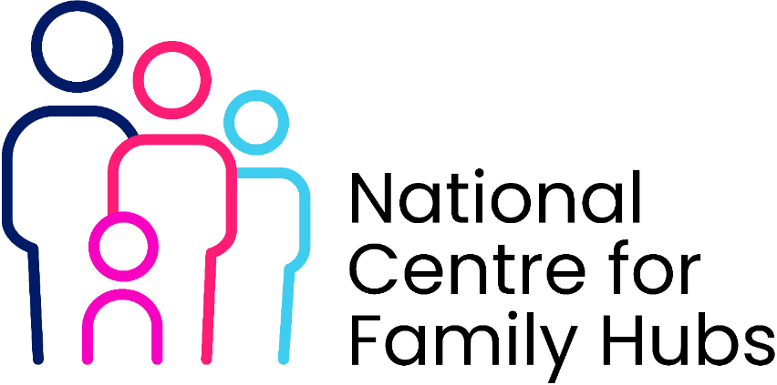
Volunteer Induction Pack – Contents
- Welcome
  - Welcome letter
  - Overview of the Family Hub
- About Family Hubs
  - Vision, values and purpose
  - Overview of services and support available
- Volunteer Programme Overview
  - Role of volunteers in Family Hubs
  - Benefits of volunteering
- Volunteer Roles and Responsibilities
  - Role description
  - Expectations and boundaries
- Policies and Procedures
  - Safeguarding children policy
  - Health and Safety policy
  - Equality, Diversity and Inclusion policy
  - Confidentiality and GDPR
  - Code of conduct
  - Complaints and whistleblowing
- Safeguarding Guidance
  - Recognising concerns
  - Reporting procedures
  - Key contacts
- Induction and Training
  - Induction checklist
  - Mandatory training requirements
  - Ongoing development opportunities
- Supervision and Support
  - Supervision arrangements
  - Key contacts
  - Wellbeing support
- Practical Information
  - Hub locations and opening times
  - Facilities and access (e.g. ID badges)
  - Expenses and travel reimbursement
- Working with Families
- Communication guidance
- Professional boundaries
- Inclusivity and cultural awareness
11.Systems and Tools (if applicable)
- Use of IT systems or booking tools
- Data handling guidance
12.Health and Safety
- Emergency procedures
- Incident reporting
13.Feedback and Recognition
- Providing feedback
- How volunteers are recognised
14.Progression Opportunities
- Training pathways
- Routes into employment
15.Forms and Templates
- Volunteer agreement
- Induction checklist
- Supervision record template
- Risk assessment summary

