No: 6
Title: Care Act Advocacy
Date: 25/03/2015 Version No: 1
System: AIS Data Controller: Chief Officer (ASC)

Purpose:

To provide instruction and guidance on how to access Advocacy for people, and their carer’s, who have ‘Substantial Difficulty’ in being involved in their care and support, or the care and support of those they care for, and who do not have an Appropriate Individual who can support that person through the care and support process.
Who will use this Guidance?

TM/ATM |  | SW |  | CSO |  | Admin |  | Assessor/  Reviewer
CP Team |  | EDT |  | OT |  | ACC

When is this Guidance to be used?
At first contact or with a client or a carer or in facilitating any of the following interventions:
- a needs assessment
- a carer’s assessment
- the preparation of a care and support or support plan
- a review of a care and support or support plan
- a safeguarding enquiry
- a safeguarding adult review
- an appeal against a local authority decision under Part 1 of the Care Act (subject to further consultation).
This does not apply in crisis situations

Expected Demand for Care Act Advocacy

Whilst likely demand for advocacy under the Care Act is currently unknown, it is expected that the number of people proving eligible for advocacy support is likely to be low.

It is unlikely that many people who are judged as having ‘Substantial Difficulty’ will not have someone who can act as their ‘Appropriate Adult’.

Therefore it is expected that referrals for Care Act Advocacy will be the exception rather than the norm and the case for an advocacy referral will need to be well documented as part of your referral.

Advocacy under the Care Act

From the 1st April 2015, Dudley MBC will be expected, under the Care Act, to provide advocacy support for anyone living within the borough who has ‘Substantial Difficulty’ that prevents them from being involved in the care and support processes, limited to those set out in the Care Act and where they do not have an ‘Appropriate Individual’ that can support their involvement.
This commitment equally applies to Carers of people living within the Borough, who meet both the ‘Substantial Difficulty’ test and who do not have an ‘Appropriate Individual’ that can support their involvement in the care processes for the person that they care for.

The eligible care and support processes are:
- a needs assessment
- a carer’s assessment
- the preparation of a care and support or support plan
- a review of a care and support or support plan
- a safeguarding enquiry
- a safeguarding adult review
- an appeal against a local authority decision under Part 1 of the Care Act (subject to further consultation).
A person will be judged to have ‘substantial difficulty’ if they have difficulty being involved in the above processes due to any one of the following:
- understanding relevant information
- retaining that information
- using or weighing that information as part of the process of being involved
- communicating the individual’s views, wishes or feelings (whether by talking, using sign language or any other means)
Dudley MBC will make arrangements for an Independent, suitably experienced advocate to be appointed as early as possible in the care and support process. The advocate will guide the person through to the point at which that process is complete. At this point the relationship will end.
Criteria laid out in the Care Act determines those who are unable to act as an ‘Appropriate Individual’.

If the Local Authority assesses that a person initially acting in the capacity of an ‘Appropriate Individual’ does not satisfy these criteria then the Local Authority should identify an alternative Appropriate Individual or failing that an independent advocate or should be appointed.

A person cannot act as an ‘Appropriate Individual’ under the Care Act if they are;
- already providing care or treatment to the person in a professional capacity or on a paid basis
- someone the person does not want to support them
- someone who is unlikely to be able to, or available to, adequately support the person’s involvement
- someone implicated in an enquiry into abuse or neglect or who has been judged by a safeguarding adult review to have failed to prevent abuse or neglect.
If the person with ‘Substantial Difficulty’ has someone who can act as their ‘Appropriate Individual’ then that persons details should be recorded in ‘Relationships’ and be flagged as the persons ‘Principle Carer’.

Where an Independent Advocate is appointed, and it becomes clear to the Local Authority or the Advocate that there is someone who can act as an ‘Appropriate Individual’ for that person then the Advocate must, at that point, hand over to that person.
For those people who access advocacy under the Care Act and it becomes clear that the individual requires support from an Independent Mental Capacity Advocate (IMCA) then under the local arrangements the same advocate, depending on capacity, may continue to provide support under the IMCA arrangements.
Likewise, where it is established that clients, who are receiving support under IMCA, require support through Care Act Advocacy again the advocate may continue the relationship but under Care Act criteria.

Provision under IMCA, IMHA and NHS Complaints Advocacy remains unaffected by these arrangements.

Charging
There will be no charge for provision of an advocate through its contracted provider.

However, if a person declines the support of an appointed independent advocate through our chosen provider and wishes to appoint their own advocate from an alternative source or provider then the Local Authority will not be liable to fund this support.
Provider

From the 1st of April Dudley MBC’s provider of Care Act Advocacy will be Dudley Advocacy.

All referrals must be made through the following process.
Referral
There will be no direct or self referral to our provider of advocacy from members of the public.

Referrals must be made either by DMBC’s Social Care Workforce or by a worker within the Mental Health Trust

By completing the following process you will generate a request for an Advocate to be appointed by Dudley Advocacy. The name and contact details of the appointed advocate will be communicated to the allocated worker by a ‘Case Note’

Importance of Getting this Right

It is important that we identify people, at first point of contact, who have ‘Substantial Difficulty’ and who do not have someone to act as their ‘Appropriate Individual’

Failure to do so may result in an appointment for an Assessment or other care and support process having to be aborted due to an advocate not being present.

Alternatively requesting an advocate for someone who has the ability to be fully involved in their care and support process or who has someone who can act as their Appropriate Individual will result in an inappropriate referral for an advocate and will

- Incur a cost to the Authority and;
- Occupy an Advocate who may be required by another eligible client

To request an Advocate or to Record Details of an ‘Appropriate Individual’

The process to request an advocate or record the details of an ‘Appropriate Individual’ the process is as follows:

From the person screen select ‘Create Case Note’ and then follow the instructions below:

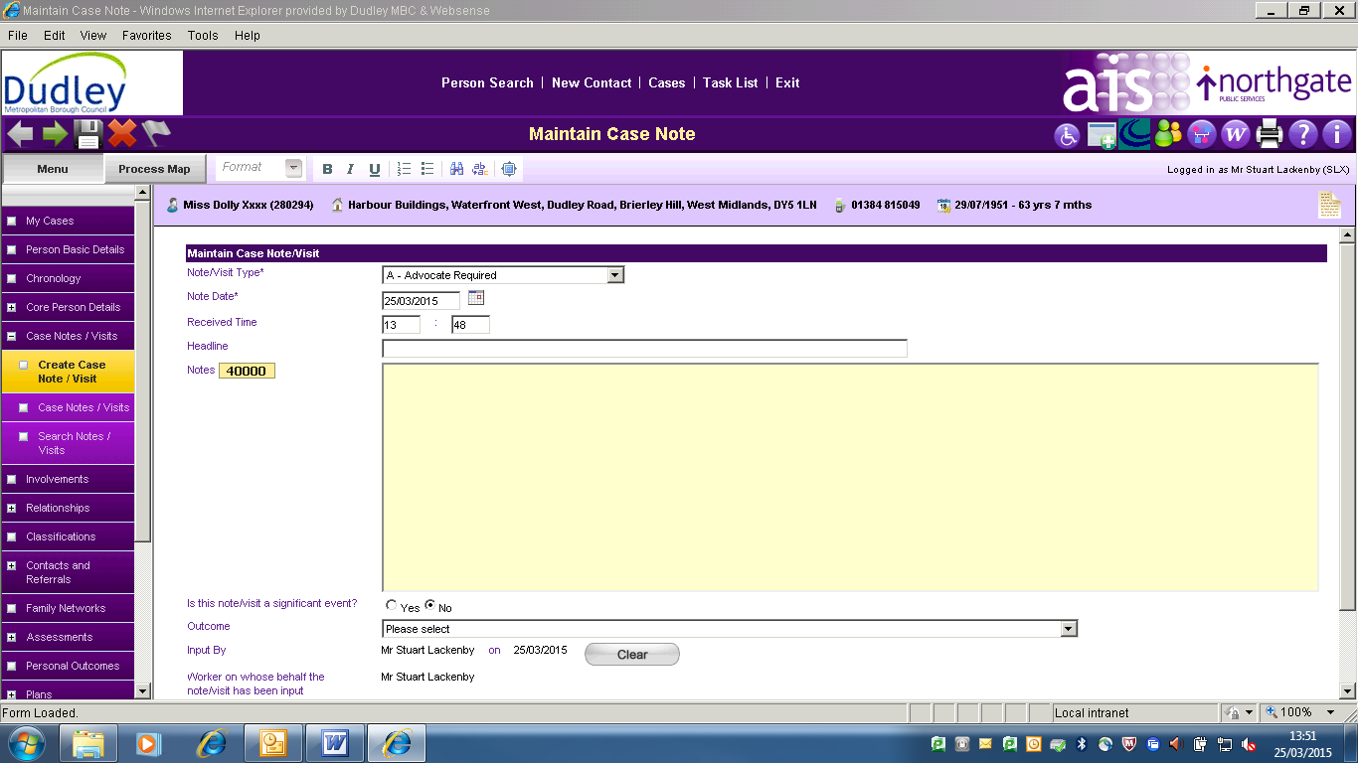
4
2
1
3

- Select case note type ‘Advocate Required’
- In the ‘Headline’ field type – ‘Advocacy Required’
- In the ‘Notes Section’ describe how the person meets the criteria for Advocacy under the Care Act and detail when the Advocate is required and the care and support process for which the person requires advocacy support.
- In the Outcome field type ‘Information Provided’
- Click ‘Save’
- Click ‘Workflow’
- Click ‘Add Action’
- In the ‘Action’ field select ‘Advocate Required’
- Add date Advocate is required
- Leave the ‘Notes’ section blank
- Add Organisation as ‘Adult Commissioning’ Pin Number 26346
- Click ‘Save’

Following Appointment of an Advocate

Once an Advocate has been appointed and logged on the clients ‘Case Notes’ then it is the responsibility of the Social Care worker to keep in contact with the appointed Advocate to ensure their availability to support the client.

During and Assessment or other ‘Care and Support Process’

If an advocate is required then this should have been requested at the point of contact. However, if this has not happened please see the process above to request an advocate to support the individual at your next visit.

If an advocate is required you must not complete or continue the assessment or other care and support process listed above until an advocate has been appointed and is present unless doing so puts the person at risk.

Process to be Followed by Commissioning Team

On receiving a ‘Task’ requesting a referral for advocacy under the Care Act the Commissioning Team shall complete a Gateway referral form (see attached).

The form will then be submitted via ‘Gateway’ to Dudley Advocacy

Dudley Advocacy will then accept the referral and provide the name and contact details of the appointed advocate.

The Commissioning Team will then add the name and contact details of the appointed advocate to the clients file as a ‘Case Note’.

