North East - Improving mental health consortium behavioural insights nudge communications

Graphic 1 (testimonial A):
The testimonial is a quote from a Kooth user which describes feeling understood after talking with a member of the team on a chat bubble graphic.
(Below, is the controlled message 'free, safe, and anonymous mental health support'.)
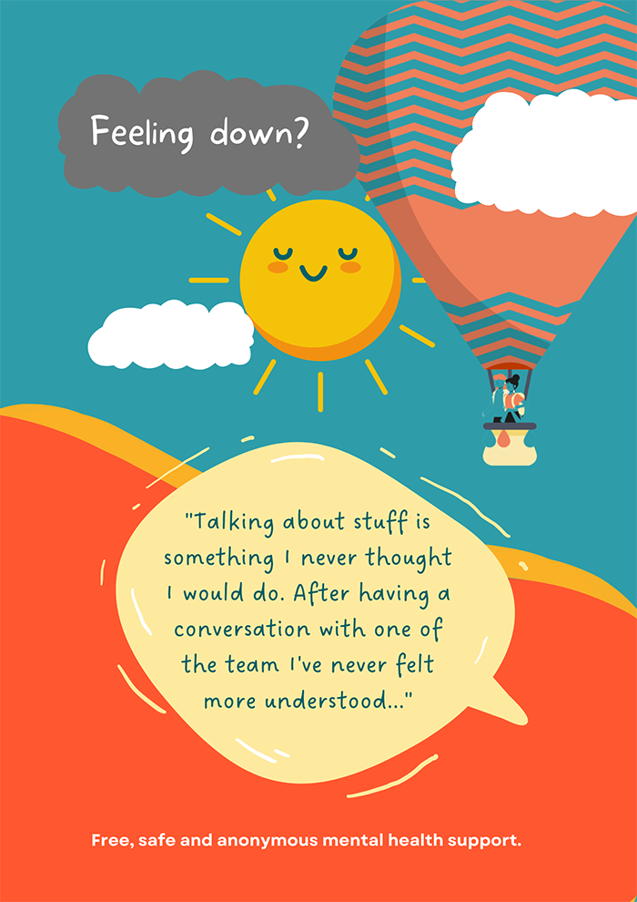
Graphics include a hot air balloon with two people in it, a smiling sun, and a grey cloud with the words ‘feeling down?’ inscribed.

Graphic 2 (testimonial b):
The testimonial is a quote from a Kooth user which describes feeling understood after talking with a member of the team
Below on colourful ovals, is the controlled message 'free, safe, and anonymous mental health support'.
Graphics include a hand holding a phone with a smiley face.
