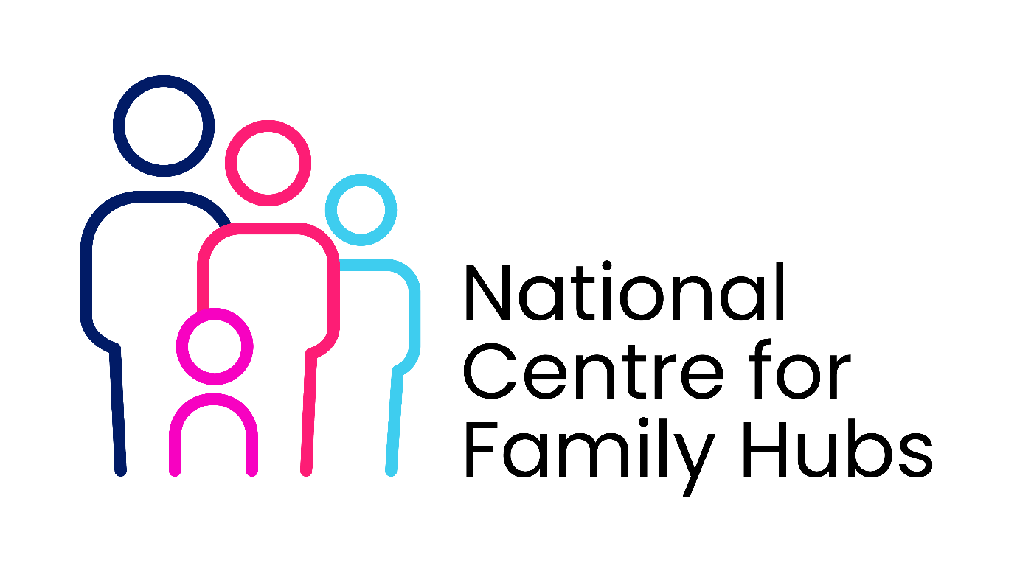This service mapping template for Family Hubs and Libraries is designed to identify local assets, bridge service gaps, and create seamless referral pathways. It visually and structurally organises multi-agency offerings so frontline staff can easily navigate and connect families with the support they need.
Part 1: Service Provider Profile
Use this section to log the core details of every organisation, service, or activity (e.g., specific library programs or Family Hub interventions).
- Service/Asset Name:
- Location/Venue: (e.g., Grove Park Library or exact Family Hub site)
- Primary Category: (e.g., Early Education, Mental Health, Welfare Advice, Housing, Parent-Infant Support)
- Target Audience: (e.g., 0-5s, parents of teens, SEN children, isolated carers)
- Operating Hours:
- Contact Details: (Website, phone, email, booking link)
Part 2: Operational Details
Captures the logistics required for staff and parents to navigate the offer successfully.
- Delivery Method: (Drop-in, appointment required, outreach, digital/virtual)
- Cost: (Free, low-cost, subsidized)
- Referral Route: (Self-referral, GP referral, school/health visitor pass)
- Language/Accessibility: (Wheelchair accessible, multilingual staff, sensory-friendly)
Part 3: Inter-Agency Network Mapping
Maps how services interact with each other to track dependencies and prevent duplication.
- Internal Capabilities (What the venue provides directly):
- External Dependencies (What must be brought in): (e.g., visiting Citizens Advice Bureau, NHS health visitors)
- Synergy with Local Libraries: (e.g., "Hub staff run baby groups in the library; librarians run weekly "Bookstart" sessions for hub users")
Part 4: Gap Analysis
Identifies unmet community needs and missing assets in the local catchment area.
- Known Community Demographics: (e.g., high rate of maternal loneliness or transient housing)
- Identified Gaps: (e.g., lack of weekend speech and language therapies)
- Capacity Status: (Waitlist, over-capacity, under-utilized)

Activity | Service Provider Profile | Operational Details | Inter-Agency Network Mapping | Gap Analysis

